
Gwangju Institute of Science and Technology
Official Press Release — https://www.gist.ac.kr

Section of Hyo Jung Kim Nayeong Lee
Public Relations Section Chief Senior Administrator
062-715-2061 062-715-2062

Contact Person Min-sun Kim, Administrator
for this Article Section of Undergraduate Administration Services
062-715-3603

Release Date 2021.01.15

GIST undergraduates win the national
University Students Contest of Mathematics

□ GIST (Gwangju Institute of Science and Technology, President Kiseon Kim) undergraduate students achieved excellent national results at the 39th University Students Contest of Mathematics.



∘ GIST College students Chan-hyuk Seong (third-year physics major) won the silver prize in the first category, Seong-won Cho (third-year student mechanical engineering major) won the silver prize in the second category, and Jae-won Shin (third-year physics major) won the bronze prize in the second category.

□ In particular, Chan-hyuk Seong has won awards for three consecutive years, having received the silver prize in both the 37th and 38th competitions. Although he is not majoring in mathematics, he entered the first category and won the silver prize. Jae-won Shin has won awards for two consecutive years now, having received the bronze prize for the second category in the 38th and 39th competitions, and he would like to enter the first category next time if he has the opportunity.

∘ Undergraduate student Seong-won Cho, who won the silver prize in the second category, said, "GIST doesn't have a mathematics major, but I was able to take several courses through the math minor program. The fact that I was able to encounter many problems through the teaching activities of the mathematics department was very helpful in preparing for the competition."

□ Every year, the national University Students Contest of Mathematics hosted by the Korean Mathematical Society is held for the first category (math and mathematics-related departments, college students) and the second category (other than the first field, including statistics) and is the most prestigious competition among college students mathematics competitions in Korea. The scope of the questions include calculus, advanced calculus, number theory, linear algebra, differential equations, and geometry with eight advanced descriptive questions.

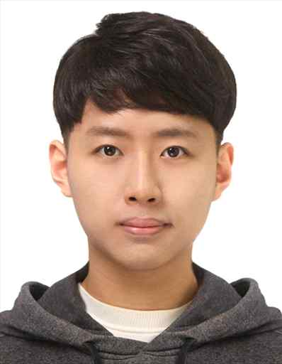
□ GIST College supports students to grow into balanced convergence specialists through various minor courses, such as humanities and social sciences, cultural technology, energy, intelligent robots, and biomedical engineering, in addition to the mathematics minor course, which is a basic discipline in all fields of science.
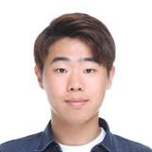

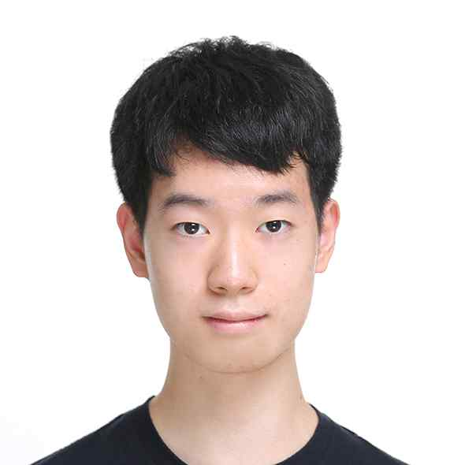
▲ Chan-hyuk Seong ▲ Seong-won Cho ▲ Jae-won Shin
(third-year physics major) (third-year student mechanical) (third-year physics major)



