
Gwangju Institute of Science and Technology
Official Press Release — https://www.gist.ac.kr

Section of Hyo Jung Kim Nayeong Lee
Public Relations Section Chief Senior Administrator
062-715-2061 062-715-2062

Contact Person Hwajung Kim, Administrator
for this Article International Environmental Research Institute
062-715-3366

Release Date 2021.01.12

GIST undergraduate student publishes results in an international journal through GIST-UN University internship

□ GIST (Gwangju Institute of Science and Technology, President Kiseon Kim) undergraduate student authored a paper during a GIST-University (GIST-UNU) intership program with the International Environmental Research Institute (IERI, Director Kyoung-Woong Kim) that was published by ELSEVIER* in the international journal Progress in Disaster Science.



* ELSEVIER: an international multimedia publishing company that provides 20,000 products to educational and professional scientific fields and medical communities worldwide

□ GIST College graduate Jiseon Lee interned at the United Nations University Institute for Water, Environment and Health (UNU-INWEH)* from January to July 2019 and studied and analyzed trends in the occurrence of water disasters and human health effects under the guidance of Dr. Duminda Perera.

* UNU-INWEH (United Nations University-Institute for Water, Environment and Health)

∘ During this internship, the occurrence of water disasters and their impact on human health were analyzed ("Water-related disasters and their health impacts: A global review"). As a result, policy directions were presented to overcome gaps with sustainable development goal (SDGs) indicators.

□ The GIST-UNU internship program is supported by the International Environmental Research Institute for GIST undergraduate students to promote cooperation with UN Universities and international organizations. Since 2016, three undergraduates have been sent as interns to Canada's UNU-INWEH, and the program has expanded its partnership with UNU-FLORES* in Dresden, Germany, as well as UNU-INWEH.

* UNU-FLORES (United Nations University-Integrated Management of Material Fluxes and of Resources)

∘ Undergraduate Jiseon Lee said, "As I experienced environmental policy research through the internship program, I realized again the importance of science and technology as well as policy in the environmental field. This experience seems to be a positive driving force for future research activities."

□ GIST International Environmental Research Institute Director Kyoung-Woong Kim said, "The GIST-UNU Internship Program aims to assist GIST undergraduate students who are dreaming of a bright future going forward. When the coronavirus situation improves, we will make continuous efforts in various activities to resolve global environmental problems through cooperation with the UN University and other international organizations located around the world."

∘ Since its establishment in 2001 with the aim of establishing a UN University Research Center, GIST International Environmental Research Institute has been contributing greatly to international research and development cooperation, training environmental experts, and strengthening capabilities to solve environmental problems in developing countries. Since 2014, it has been actively engaged in international development cooperation activities in the water sector through the Korea-UNDP project, and, recently, through the United Nations Framework Convention on Climate Change (UNFCCC) technology mechanism, it has been actively participating in international climate technology cooperation and response to climate change.
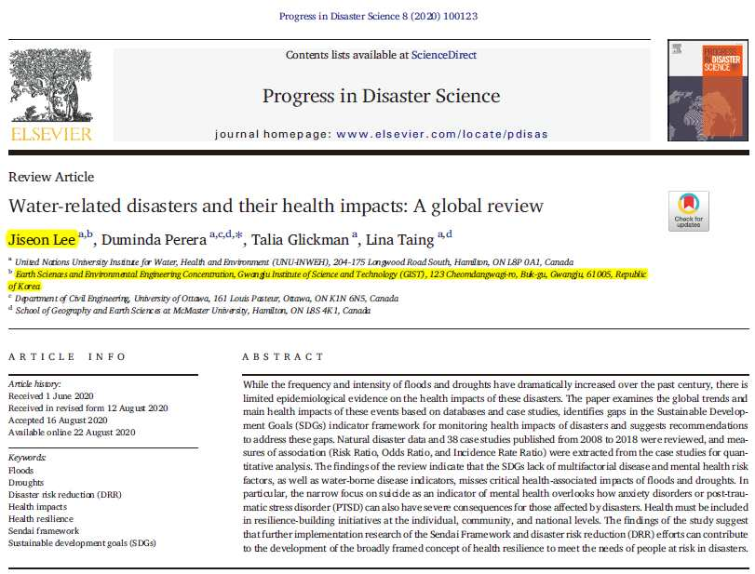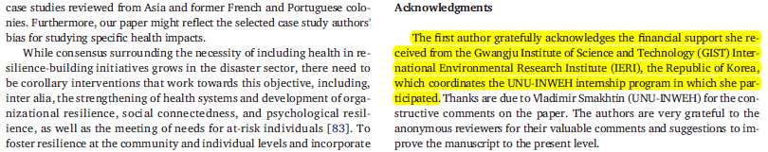
▲ [Photo 1]: Jiseon Lee as the first-author of "Water-related disasters
and their health impacts: A global review"

▲ [Photo 2]: GIST College graduate Jiseon Lee


