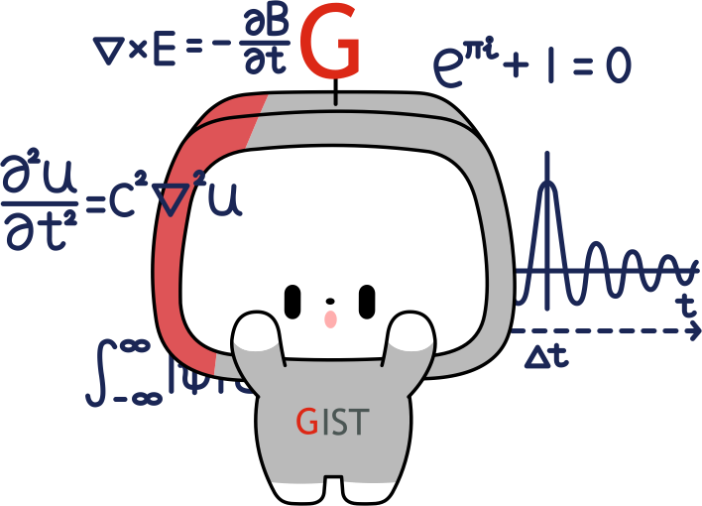
Gwangju Institute of Science and Technology
Official Press Release — https://www.gist.ac.kr

Section of Hyo Jung Kim Nayeong Lee
Public Relations Section Chief Senior Administrator
062-715-2061 062-715-2062

Contact Person Professor Solkeun Jee
for this Article School of Mechanical Engineering
062-715-2773

Release Date 2021.01.07

GIST undergraduate student Yeji Yun publishes
SCI paper as first-author after participating in G-SURF

□ GIST (Gwangju Institute of Science and Technology, President Kiseon Kim) undergraduate student Yeji Yun (senior, mechanical engineering major under advisor Professor Solkeun Jee) published a research paper as the first-author in Physics of Fluids, published by the American Physical Society.



∘ In 2019, Yeji Yun started her interest in research through the'GIST Summer Undergraduate Research Fellowship (G-SURF),' a research participation program for undergraduates in their junior year. While taking the course, she conducted research on the complex flow around moving objects, developed her ideas, and published a paper in the SCI journal.

□ Undergraduate Yeji Yun conducted a precise numerical analysis of the vortex flow that appears when non-Newtonian fluid, which appears in a liquid mixed with a mixture of water and a general Newtonian fluid*, flows around an object. There have been existing studies to analyze the vortex phenomenon of Newtonian fluid in situations where the motion of an object changes, but there is a lack of research on non-Newtonian fluids.

* Newtonian fluid: A fluid whose viscosity is constant regardless of the velocity gradient of the flow is called Newtonian fluid. Non-Newtonian fluids are fluids whose viscosity changes according to the shear rate of the velocity field and usually appears in liquids containing compounds.

□ Undergraduate Yeji Yun showed that in shear-thinning fluid, the viscosity of the body decreases locally due to movement, resulting in a large number of vortex structures. However, in shear-strengthening fluid, the viscosity increases, resulting in a small number of vortex structures. Precise numerical analysis showed that the various vortex structures that occur in shear-thinning fluids cause the force received by an object to vary greatly with time.

∘ Professor Solkeun Jee said, "Think of situations where an object moves in a fluid, such as mixing mixtures at an industrial site (processing process). In such a situation, the change in drag that the object receives due to the instantaneous and locally changing viscosity was confirmed through the most basic shape, the flow situation around a cylinder. This study regarding the flow of non-Newtonian fluid caused by the and object's movement is expected to provide a basis for the study of the unsteady flow that occurs in various situations such as the flow around a more complex shape."

□ Undergraduate Yeji Yun said, "Through the G-SURF program, undergraduate students can learn about the research process in a concise manner, and there are opportunities to experience life in the laboratory. At GIST, the department's major classes are well linked to the graduate school, so it is operated as a program that helps students make career decisions through in-depth classes in their fields of interest and from the research guidance of their advisors."

∘ This research was conducted with the support of the GIST Research Institute (GRI), and Yeji Yun received support as a research intern during the summer vacation through GIST G-SURF program. The research results were published in Physics of Fluids, an authoritative journal in the field of fluid physics and mechanical engineering in December 2020.



