
Gwangju Institute of Science and Technology
Official Press Release — https://www.gist.ac.kr

Section of Hyo Jung Kim Nayeong Lee
Public Relations Section Chief Senior Administrator
062-715-2061 062-715-2062

Contact Person Section of Public Relations
for this Article 062-715-2061 ~ 2063

Release Date 2020.12.31

GIST Professor Steve K. Cho and Professor Hisam Kim receives Ministry of Education commendation for educational
innovation in science and engineering



□ GIST (Gwangju Institute of Science and Technology, President Kiseon Kim) School of Life Sciences Professor Steve K. Cho and Division of Liberal Arts and Sciences Professor Hisam Kim were awarded the Minister's Commendation for 'Educational Innovation in Science and Technology in 2020.'

∘ The award, organized by the Ministry of Science and ICT, seeks to motivate and boost morale by discovering and awarding contributors to educational innovation in science and engineering. It is designed to recognize the educational contributions of those who strengthen the competitiveness of science and engineering universities by contributing to the development of creative students who will lead the era of the 4th Industrial Revoultion.

□ GIST Professor Steve K. Cho was appointed to GIST College at its inception in 2010 and was responsible for developing and organizing the undergraduate life science educational and experimental curriculum. In particular, Professor Cho contributed to strengthening the international competitiveness of GIST College and to enhancing the education of GIST College students by organizing and conducting the international GIST-Caltech collaborative educational STEAM program for student development.

□ GIST Professor Hisam Kim contributed to the establishment of human resources at science and engineering universities, the development of teaching methods, and the development of leading educational innovation models based on comparative activities and online education through policy research and practice. As a professor in charge of the "GIST Infinite Challenge Project," which was first introduced in 2016, he has encouraged students to challenge various objective and meaningful projects, creating a horizontal class culture that fosters social capital such as trust, communication, and cooperation. He currently serves as the head of the GIST Education Innovation Center.

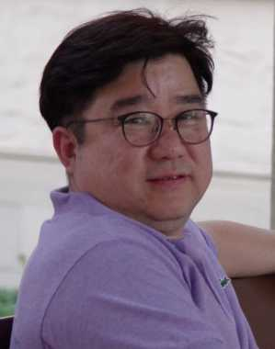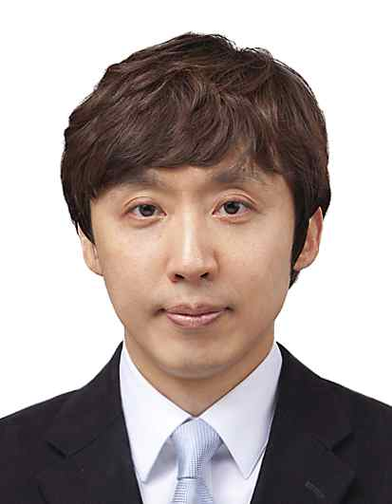
▲ From left: School of Life Sciences Professor Steve K. Cho
and Division of Liberal Arts and Sciences Professor Hisam Kim



