
Gwangju Institute of Science and Technology
Official Press Release — https://www.gist.ac.kr

Section of Hyo Jung Kim Nayeong Lee
Public Relations Section Chief Senior Administrator
062-715-2061 062-715-2062

Contact Person Section of Public Relations
for this Article 062-715-2061 ~ 2063

Release Date 2020.12.24

GIST undergraduates win the grand
prize for 'NET Challenge Camp 2020'

□ GIST (Gwangju Institute of Science and Technology, President Kiseon Kim) electrical engineering and computer science undergraduates (advisor Professor JongWon Kim, Dean of the AI Graduate School) participated in'NET Challenge Camp 2020' and received the honor of winning the Grand Prize from the Minister of Science and ICT in the student challenge league category.



∘ This competition was an event that supports the development and commercialization of innovative ideas in the field of network application and was hosted by the Ministry of Science and ICT, the Korea Information Society Agency, and the KOREN (KOrea advanced REsearch Network) Research Cooperation Forum. The awards ceremony was held online to prevent the spread of COVID-19.

□ The 'NET Challenge Camp 2020' was held in May and focused ideas related to new ICT technologies and services that can be commercialized for network applications. The process was conducted by selecting 15 student teams and 4 corporate teams and by evaluating the idea implementation process and results over about five months.

□ GIST electrical engineering and computer science undergraduate seniors Chang-ha Lee (team leader), Taewan Kim, and Jonghun Park and undergraduate juniors Jung-yoon Kim, Soo-ah Jeon, and Yura Choi formed the team 'Gather Up Cloud Class' and participated in this competition under the guidance of Professor JongWon Kim of the AI Graduate School.

∘ Members of the 'Gather Up Cloud Class' team heard about the 'NET Challenge Camp' from GIST students who participated in last year's competition and came up with the idea while taking Professor JongWon Kim's 'Computer System Theory and Experiment' course, which was opened during the spring semester of this year. Since then, they have been guided by Professor JongWon Kim's network computing system lab and implemented his ideas.

□ The 'Gather Up Cloud Class' team implemented an avatar-based online classroom platform that supports non-face-to-face interaction using cloud computing technology using the KOREN network, preventing privacy infringement by eliminating the need for direct webcam use, and, at the same time, teachers can actively interact with students by identifying their status through avatars.

∘ On this platform, the computer vision artificial intelligence (AI) model analyzes the student's webcam image and transmits it to the server, which synchronizes information between users and configures a virtual lecture room with a GUI (graphic user interface) format, which students and teachers can see making it possible to interact in online classes.

□ 'Gather Up Cloud Class' team leader Chang-ha Lee said, "We presented solutions to problems that appear in many online lecture platforms, such as the 'invasion of privacy issues' and 'difficulty in grasping class flow.' In the future, this solution will become a new standard for online lectures, not only in the current coronavirus era but also in the post-corona era."

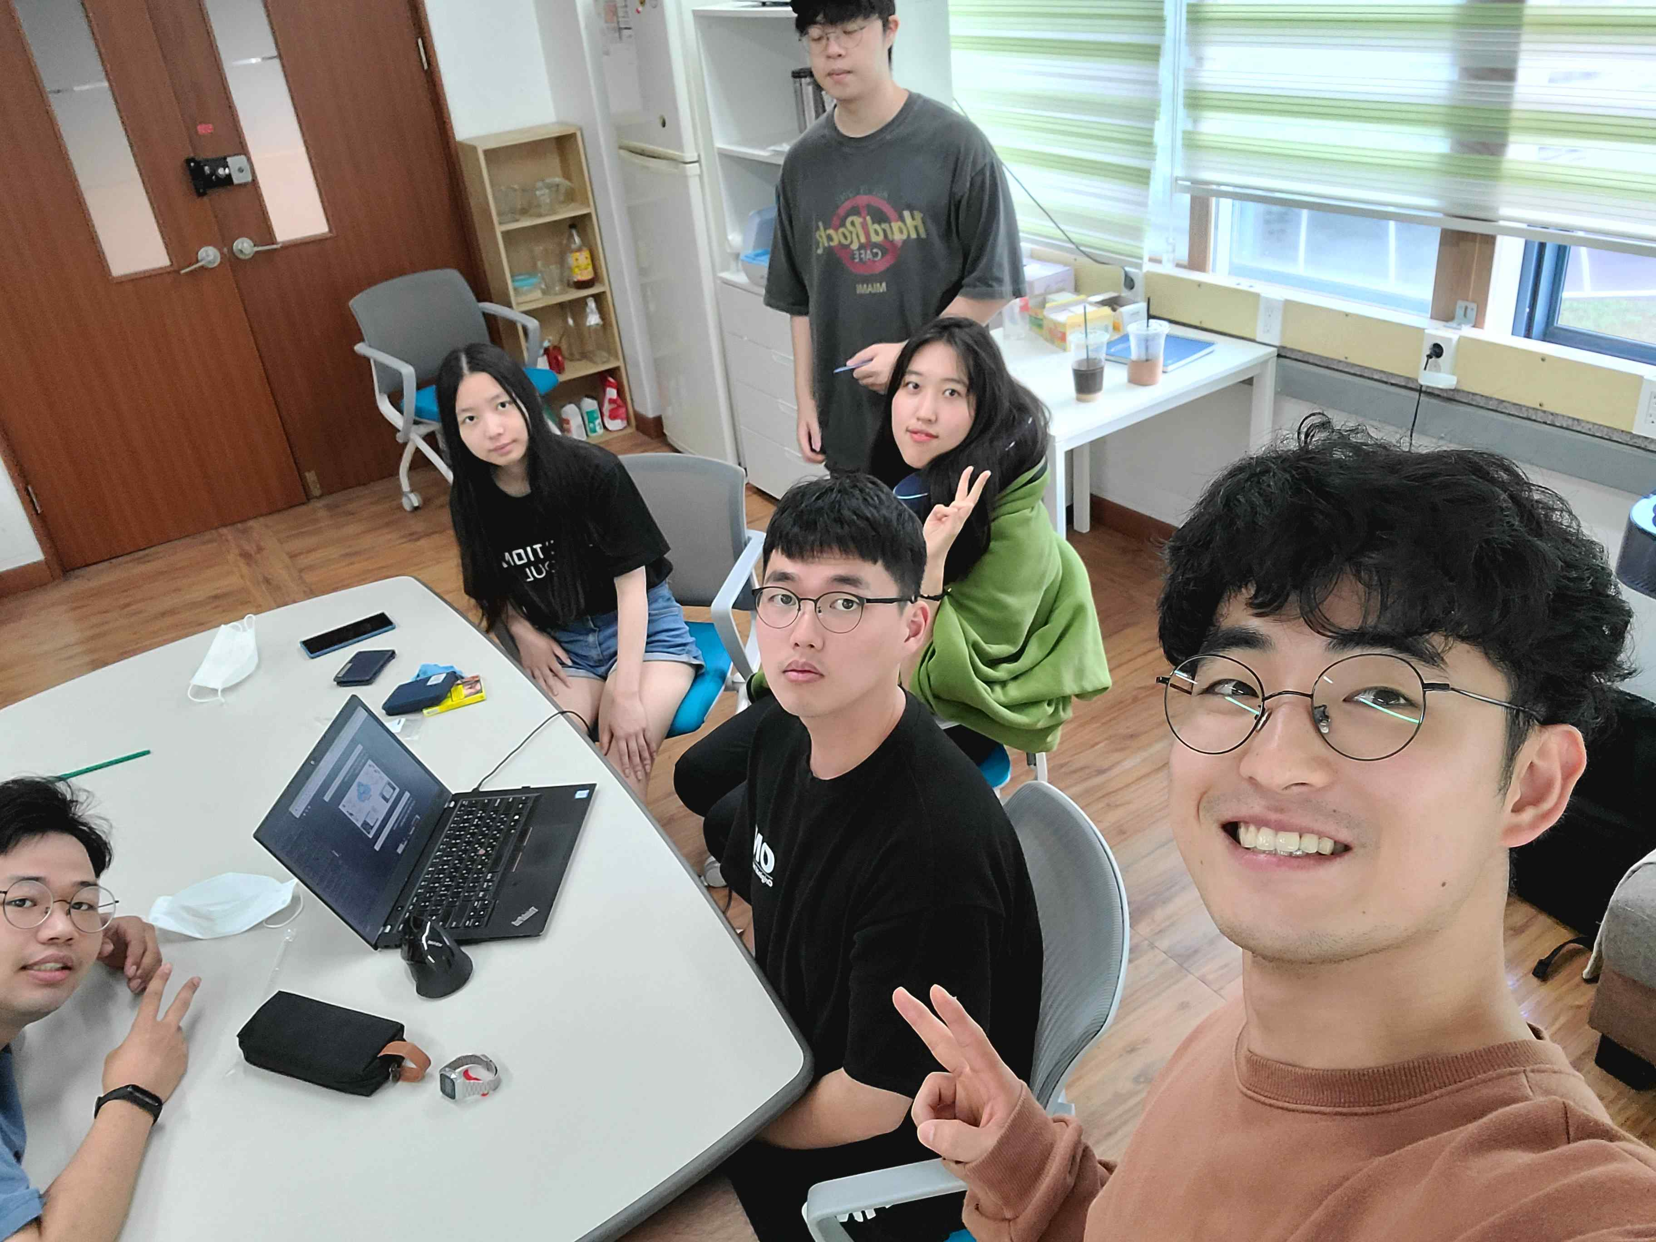
▲ Photo 1: GIST 'Gather Up Cloud Class' team meeting

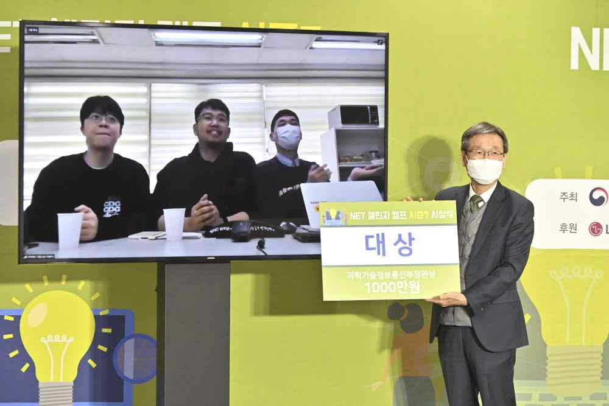
▲ Photo 2: GIST 'Gather Up Cloud Class' team wins 'NET Challenge Camp 2020' grand prize



