
Gwangju Institute of Science and Technology
Official Press Release — https://www.gist.ac.kr

Section of Hyo Jung Kim Nayeong Lee
Public Relations Section Chief Senior Administrator
062-715-2061 062-715-2062

Contact Person Suwhoan Lim, Undergraduate
for this Article GIST College
010-6313-0052

Release Date 2020.12.16

GIST undergraduates win second prize at the 2020 Science
and Technology Specialized University Debate Contest

□ GIST (Gwangju Institute of Science and Technology, President Kiseon Kim) undergraduates Suwhoan Lim (fourth year of EECS major) and Yunji Lee (third year physics major) participated in the "2020 Science and Technology Specialized University Debate Contest" and won second prize.



∘ Marking its second anniversary this year, the competition was co-hosted by DGIST and Pohang University of Science and Technology for undergraduate students who are attending the five science and technology specialized universities (KAIST, GIST, DGIST, UNIST, and POSTECH). "Korean society after the Pandemics" and the "need to expand telemedicine to respond to pandemics" were the theme of the debate, which was held online using Zoom to prevent the spread of COVID-19.

∘ The preliminary round for selecting teams to advance to the quarterfinals was conducted by reviewing the team's strategy (document review), and the participating teams submitted both the pro and con positions, and a lottery selected their role in the debate. Eight of the 22 teams were selected, and both the quarter-finals on November 20 and the semi-finals and finals on November 27 were held online.

□ GIST students Suwhoan Kim and Yunji Lee formed a team called '3C1P' and participated in the quarter-finals on the pro side and the semi-finals and finals on the con side. The main arguments of the debate for the proponents were "the need to expand telemedicine as a public platform" and an "active establishment of the public health care system."

∘ The term '3C1P' is the main philosophy of GIST's undergraduate education: Creativity, Communication, Cooperation, and Problem Solving. This was not simply meant to compete in the competition as a team, but to inform more people of the philosophy of GIST's education and to convey to everyone the potential of a liberal arts college.

□ Undergraduate Suwhoan Lim said, "The experience of participating in practice debates in the 'GS2651 Debate and Argumentation for Scientists' course at GIST and my interesting habit of contemplating 'what would I do if this was me' about current issues were a great help in preparing for this debate. I hope that GIST's culture of encouraging students to think in a variety of ways will be more active."

□ Undergraduate Yunji Lee said, "This debate was a very meaningful experience because I could strengthen my ability to see a topic from different angles while competing with students from specialized universities in science and technology. However, because it was my first tournament held online, there were trials and errors. If there are students preparing for the next debate, I would like to help them based on my experience."

∘ Based on this experience, Suwhoan Lim plans to create a student club where he can share his know-how for debate and free presentation with underclassmen, which is currently underway.

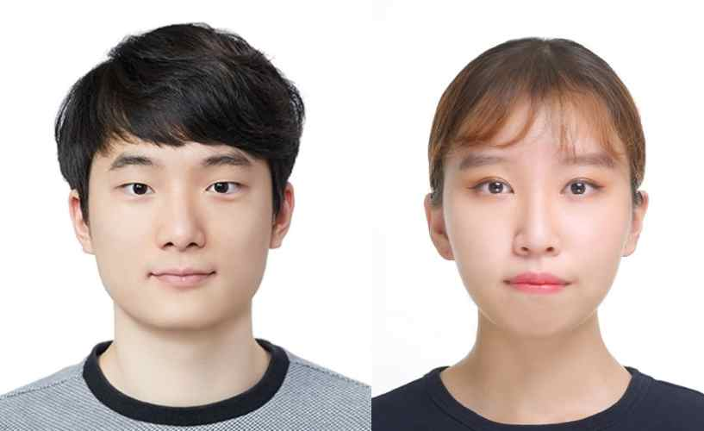
▲ [From left] GIST undergraduate students Suwhoan Lim and Yunji Lee



