
Gwangju Institute of Science and Technology

Official Press Release (https://www.gist.ac.kr/)

Section of Hyo Jung Kim Nayeong Lee
Public Relations Section Chief Senior Administrator
(+82) 62-715-2061 (+82) 62-715-2062

Contact Person Sang-Gyun Gi, Ph.D. student
for this Article School of Electrical Engineering
and Computer Science
062-715-2752

Release Date 2020.11.09

GIST graduate students receives 'The 21st Korea Semiconductor Design Competition Special Enterprise Award-Telechips' award

□ GIST (Gwangju Institute of Science and Technology, President Kiseon Kim) graduate students won the Special Enterprise Award (Telechips) at the 21st Korea Semiconductor Design Competition.

∘ School of Electrical Engineering and Computer Science graduate students Sang-Gyun Gi, Jung-Gyun Kim, Hyun-geun Lee, Woo-tae Kim, and Je-beom Kim (Advisor Professor Byung-Geun Lee) formed the 'AMIC-Neuromorphic' team (students Sang-Gyun Gi and Jung-Gyun Kim) and the 'AMIC-ImageSensor' team (students Hyun-geun Lee, Woo-tae Kim, and Je-beom Kim) to participate in the competition.

□ First, the AMIC-Neuromorphic team implemented a convolutional neural network (CNN) hardware system on-board using a memristor element array, which is a new concept using resistive memory, enabling learning and inference, and developed an image recognition system.

∘ The research team connected the memristor element array (provided by Professor Kun-wook Wang of Korea University) on the board to learn the resistance of the memristor element as a specific resistance value and developed a neuromorphic hardware system that can perform vector-matrix multiplication in the analog domain. Because the developed hardware can learn the weight of the convolutional network in real time on the hardware according to the input image, more efficient deep learning learning is possible.

□ The AMIC-ImageSensor team developed an image sensor with a high efficiency data processing function that can selectively output useful data from sensing nodes by implementing compression sensing techniques on-chip.

∘ The proposed compression sensing technique uses a deterministic matrix and weight equalization technique to remove image distortion without additional power consumption by using an image sensor with a high-speed frame rate that dramatically reduces the number of sampling times according to the compression rate.

□ The AMIC-Neuromorphic team member Sang-Gyun Gi said, "Among other excellent competing works, I am happy that the works submitted by the lab came out with good results, and I would like to continue my research on artificial intelligence semiconductors and produce good research results."

□ Professor Byung-Geun Lee's research team has won awards in the 15th, 16th and 18th semiconductor design competitions.

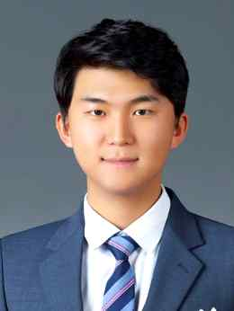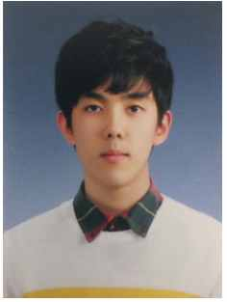
▲ AMIC-Neuromorphic team integrated students Sang-Gyun Gi and Jung-Gyun Kim
(Advisor: Professor Byung-Geun Lee)

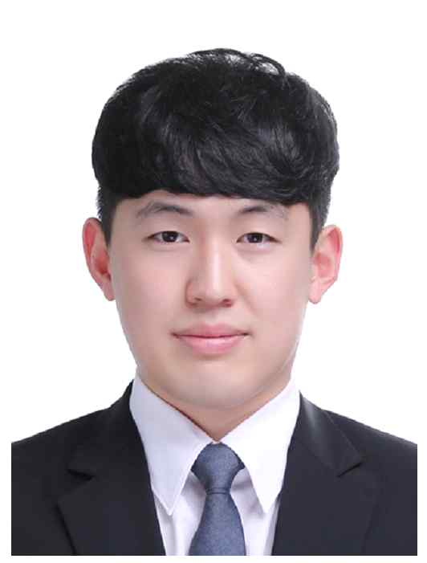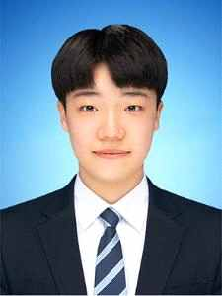
▲ AMIC-Neuromorphic team Ph.D. students Hyun-geun Lee, Woo-tae Kim,
and master's student Je-beom Kim (Advisor: Professor Byung-Geun Lee)

