
Gwangju Institute of Science and Technology

Official Press Release (https://www.gist.ac.kr/)

Section of Hyo Jung Kim Nayeong Lee
Public Relations Section Chief Senior Administrator
(+82) 62-715-2061 (+82) 62-715-2062

Contact Person Sun-kyung Kim, Administrator
for this Article International Environmental Research Institute
062-715-3366

Release Date 2020.08.25

The fruits of the Korean Wave in science:
GIST graduate becomes an international environmental researcher

□ GIST (Gwangju Institute of Science and Technology, President Kiseon Kim) International Environmental Research Institute (IERI, Director Kyoung-Woong Kim) Dr. Seah Kah Yee was selected as the final candidate for the "Collaborative Research for Early-Career Scientists" field organized by APN* in 2020 and will receive research funding for the next two years.

* Asian-Pacific Network for Global Change Research: an international organization established by the United States in 1990 with the secretariat in Kobe, Japan, and a total of 22 member countries including Korea, the United States, China, Australia, Japan, India, and Russia and supports research projects related to global climate change and related educational activities through open competition every year

□ IERI Dr. Seah Kah Yee was selected for support on her research project on 'The impacts of Himalayas glacier melting on arsenic mass balance and its mobility in Mekong and Salween sub-region groundwater.' This research will be conducted over the next two years and proposes a method to be used as a predictive model in the environmental monitoring system after measuring and comparing arsenic pollution and movement in neighboring countries caused by the Himalayan glaciers melted by climate change together with researchers in Southeast Asia (Thailand, Laos, Myanmar and Cambodia).

∘ Dr. Seah Kah Yee came to GIST as an intern through the GIST Global Intern Program (GIP) in 2013 while attending University Malaysia of Sabah. Based on that experience, she applied for an integrated master's and doctoral program in the School of Earth Sciences and Environmental Engineering and obtained her doctorate in 2019 from the Trace Metal Biogeochemistry Laboratory. Currently, Dr. Seah Kah Yee an in IERI international environmental research intern and is expanding cooperative relationships with international researchers in developing countries.

□ IERI Director Kyoung-Woong Kim said, "We hope that the GIST International Intern Program will be firmly established as a long-term program to attract talented domestic and foreign student and will serve as a venue for opportunities to become international researchers. The International Environmental Research Institute plans to play a leading role and will faithfully support it."

∘ Meanwhile, since its establishment in 2001 with the aim of establishing the UN University Research Center, GIST has operated the UN University-GIST Sustainable Science and Technology Joint Program from 2004 to 2018 while continuing to make great contributions and related activities to international R&D cooperation, fostering environmental experts and strengthening our capabilities to solve environmental problems in developing countries. Since 2014, it has been actively engaged in international development cooperation activities in the water sector through the Korea-United Nations Development Plan (UNDP) project. Since 2016, as an official member of the Climate Technology International Network (CTCN), he has been actively participating in international climate technology cooperation and response to climate change through the technology mechanism of the United Nations Framework Convention on Climate Change (UNFCCC).

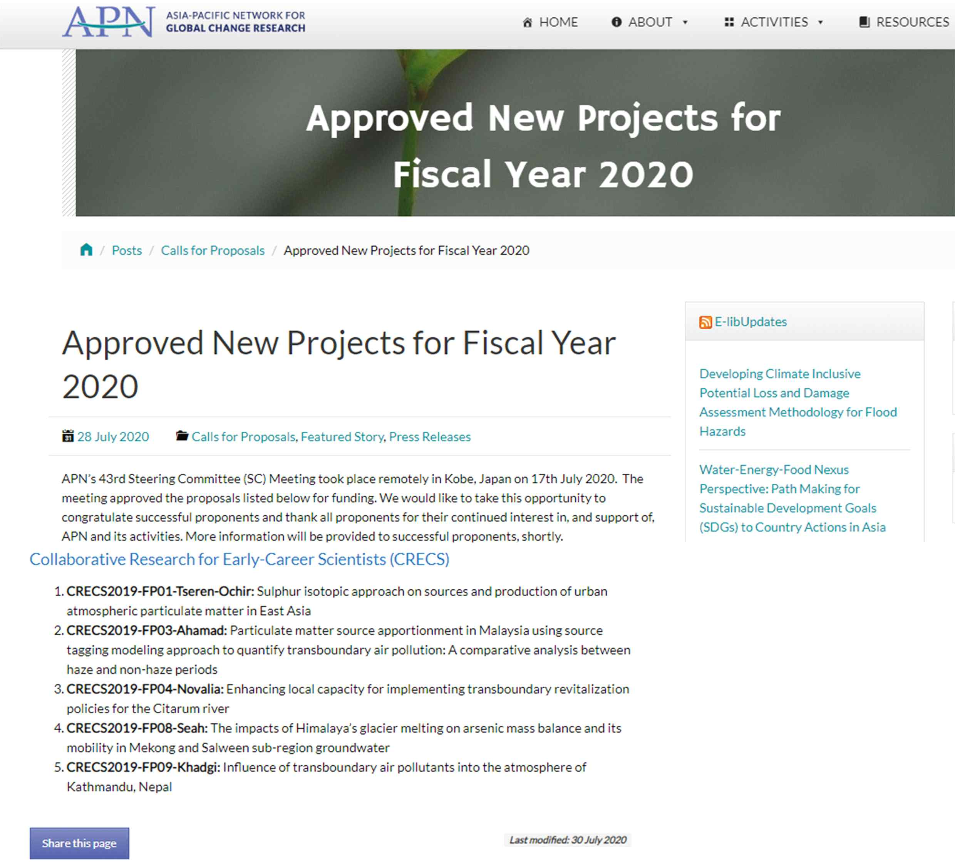
▲ [Picture 1] List of 2020 APN supported projects (Dr. Seah Kah Yee project is highlighted)


▲ [Picture 2] IERI Dr. Seah Kah Yee started as an international intern at GIST and succeeded in receiving an APN research grant after graduating from the integrated master's and doctoral degree program in the School of Earth Sciences and Environmental Engineering

