
Gwangju Institute of Science and Technology

Official Press Release (https://www.gist.ac.kr/)

Section of Hyo Jung Kim Nayeong Lee
Public Affairs Section Chief Senior Administrator
(+82) 62-715-2061 (+82) 62-715-2062

Contact Person Chang-suk Yang, Master's student
for this Article School of Electrical Engineering
and Computer Science
(+82) 62-715-2264

Release Date 2020.03.05

GIST graduate student wins first prize at the 3rd Hyundai AutoEver Barrier Free App
Development Contest

□ Gwangju Institute of Science and Technology (GIST, President Kiseon Kim) School of Electrical Engineering and Computer Science master's student Chang-suk Yang participated in the 3rd Hyundai AutoEver Barrier Free App Development Contest and won first prize (CEO award) at the final presentation.

∘ Chang-suk Yang is in the Communications and Sensor Networks Lab (advisor Professor Kiseon Kim) formed the 'You go We go' team with Dankook University students Jung-hwan Kim (4th year science education) and In-ho Yoo (Department of Applied Statistics graduate) to participate in the contest.

∘ One team won first prize (Hyundai Autoever CEO Award, 9 million won in prize money), one team won the excellence award (National Institute of Special Education, 7 million won in prize money), and two teams won the encouragement award (President of the Green Light Corporation, 6 million won in prize money). The awards ceremony was scheduled to be held at Hyundai Motor Studios in Goyang but was replaced by video presentations to prevent the spread of the COVID-19 virus.

□ The Barrier Free App Development Contest was sponsored by Hyundai AutoEver, the Seoul Community Chest of Korea, and the National Institute of Special Education as a social contribution project that supports university students to develop and distribute apps to improve the real-world convenience of the socially vulnerable.

∘ A total of 43 teams participated in the Barrier Free App Development Contest from April 15 to May 15 of last year, and 15 teams were selected after document screening. After two rounds of interviews, 10 teams were selected for production support. The apps were developed from September to January of this year with mentoring support from Hyundai AutoEver, and the app presentation was held in February after the Google Play Store launch and distribution.

□ The 'You go We go' team came up with its idea after interviewing several visually impaired people during the development process and learned that their biggest problem was with bollards, which is a bulge on the sidewalk to prevent entry of vehicles.

∘ The 'You go We go' team collected 3,000 pictures of bollards on the street and 2,000 photos of bollards on the web to process data learning. After learning about the bollards using DarkNet, it was designed to convert to the TensorflowLite model to enable real-time detection using the camera in the Android app.

∘ In addition, the team confirmed that there was no map that provided information on the location of bollards and used the Google API and Firebase database server to enable the input of bollard locations by sending them to the central server with a single button if anyone finds a bollard.

∘ Finally, if the visually impaired person falls, the post-action service was designed so that the gyro sensor could be used to detect the mathematical value of the fall. If a fall is detected, an existing guardian's contact is displayed in a pop-up window and the current location is immediately sent by SMS.

□ 'You go We go' team leader Chang-suk Yang said, "During the planning and production process over the past 10 months, I visited the Gwangju Welfare Center for the Disabled and the Welfare Center for the Visually Impaired several times, pondering the convenience of using apps by the blind and incorporating various technologies. I hope our app can help blind people walk alone."

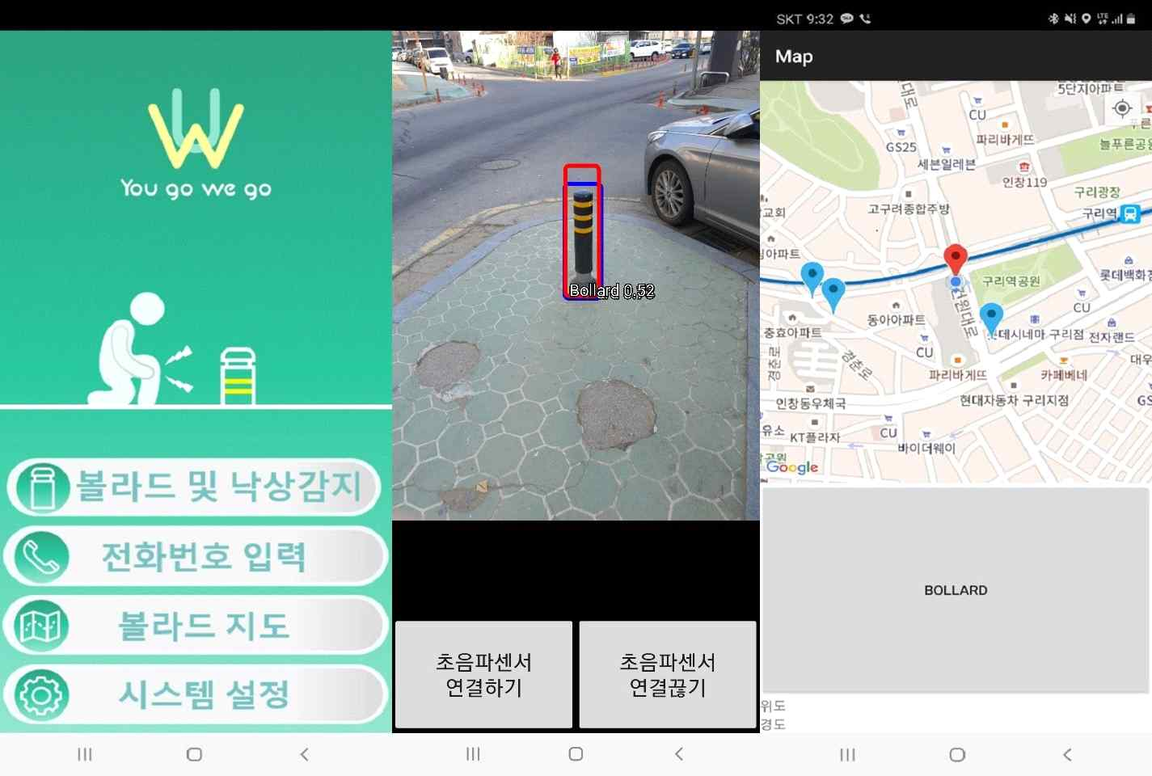
▲ [Picture 1] From the left, the main screen of the app,
bollard real-time detection AI technology, and bollard map screen

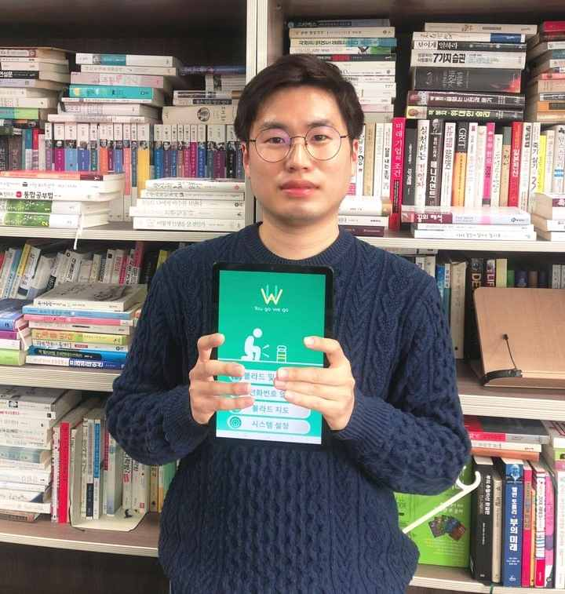
▲ [Photo 2] 3rd Hyundai AutoEver Barrier Free App Development Contest
award-winning student Chang-suk Yang

