**“Do Immune Cells Shed Their Skin Like Snakes?”**

**GIST Reveals the Secret of T-Lymphocyte Growth**

**- Prof. Jeon Chang-deok’s research team discovers a new mechanism of T-lymphocyte proliferation, the “commander of immunity.”**

**- It is necessary to shed the skin to proliferate; otherwise, death is inescapable... Published in Nature Communications.**

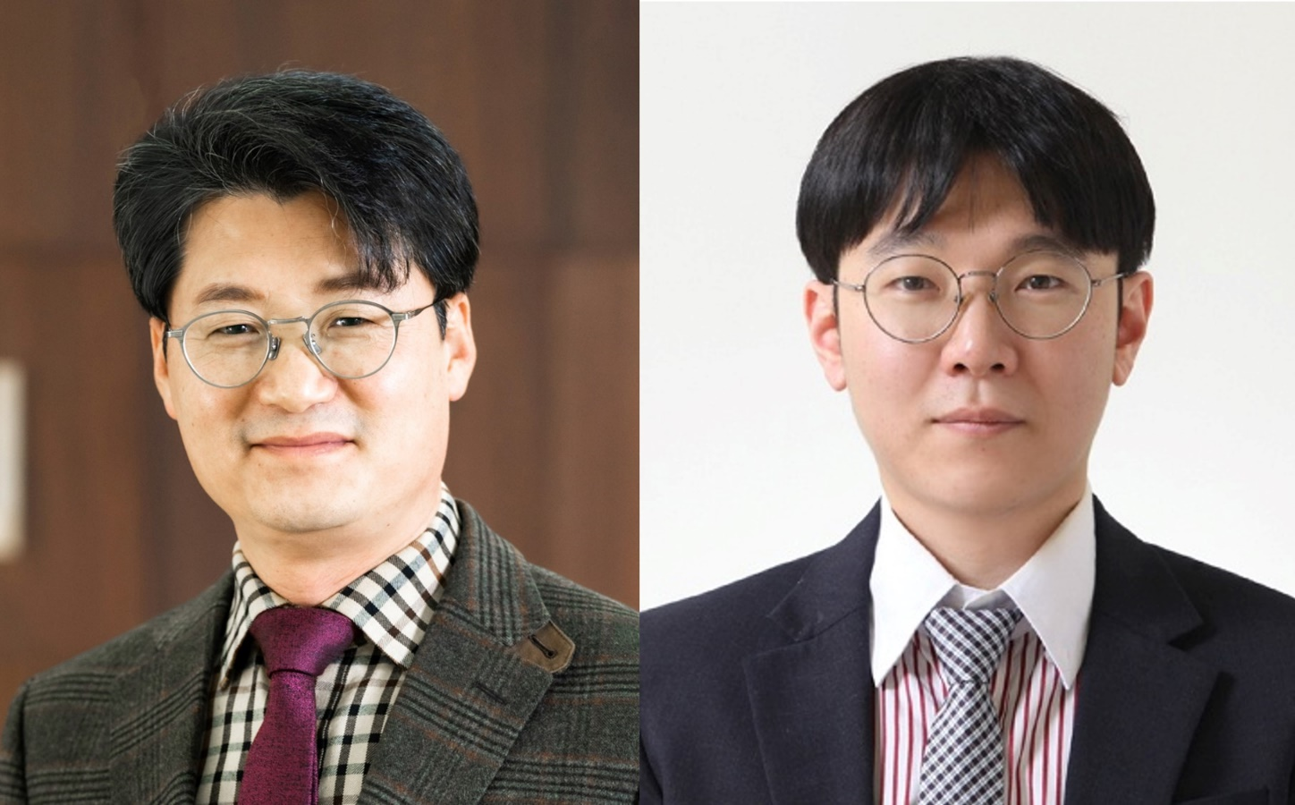

▲ Prof. Jeon Chang-Deok (left) and Dr. Park Jeong-Su of the Department of Life Sciences

GIST’s (Gwangju Institute of Science and Technology, Acting President Park Raekil) Prof. Jeon Chang-deok's research team in the Department of Life Sciences has discovered that T-lymphocytes, the “commander of immunity,” can be activated and proliferated only through molting, like that of snakes and insects. It was discovered that failure to shed the skin leads to death.

Molting is a critical process in maintaining life for animals to repeat growth and regeneration by shedding parts of their bodies. This applies not only to insects and snakes that shed their skin but also mammals and birds shed their fur and plumage, and for those that fail to shed, their lifespan will come to an end.

The research team discovered for the first time that shedding is essential for the activation and proliferation of T-lymphocytes. T-lymphocytes are a kind of immune commander that induces an immune response and attacks foreign invaders in the mammalian immune system, and the more T-lymphocytes that are produced, the better the vaccine because a proper defense requires a very large quantityof T-lymphocites.

Previously, it was only known that T-lymphocytes were activated by signals from the T-lymphocyte receptor (TCR),* which recognizes invaders or secretion of cytokines,** but the research team discovered that a part of the cell membrane must peel off when T-lymphocytes and antigen-presenting cells*** come into physical contact for T-lymphocytes cells to be activated.

Through electron microscopy, the research team was able to confirm that the shedding phenomenon occurred in such a way that microvilli of T-lymphocytes expanded and then broke off after inducing activation.

In particular, the team explained the phenomenon of the decrease in receptors on the surface of T-lymphocytes when T-lymphocytes and antigen-presenting cells come into contact with each other as being due to the molting process, and they also revealed that T-lymphocytes that do not undergo molting do not proliferate but instead die.

* T-lymphocyte receptor (TCR): A receptor formed on the surface of T cells that binds to the major histocompatibility complex (MHC) receptor formed on the surface of antigen-presenting cells to detect antigens (invaders) and transmit T-cell activation signals.

** Cytokine: A cell-activating substance mainly secreted by immune cells. It has various roles in regulating the immune response of the immune system, but if too much is secrete, it can cause a cytokine-storm.

*** Antigen-presenting cells: Cells that collect information from foreign invaders in the mammalian immune system, deliver it to T-lymphocytes, and induce immune responses specific to the foreign invaders. Dendritic cells, macrophages, B cells, and the like are included.

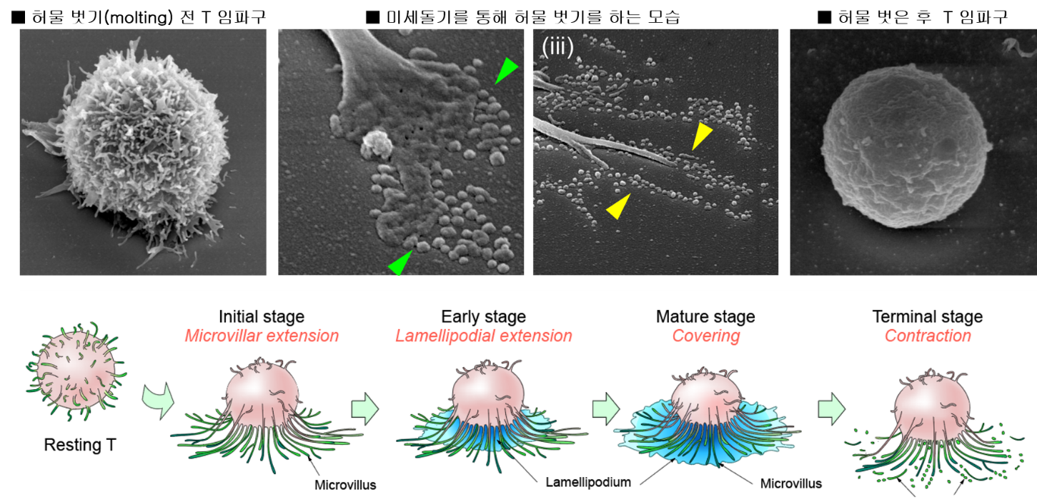

▲ Observation of the shedding phenomenon under T-lymphocyte activation conditions through an electron microscope. When T-lymphocyte activity is induced using antigens or major histocompatibility complex (MHC), the fine protrusions of the T-lymphocytes expand and then break off. The phenomenon of the fine protrusions changing back to particle form was observed through an electron microscope. This shows that a normal immune response can occur only when the surface of the cell must break off after activation of T-lymphocytes.

This mechanism can be applied not only to the development of treatments for cancer patients or viral patients with a rapidly reduced number of immune cells, but also the pieces that fall off of T-lymphocites can be directly applied to the development of anti-cancer drugs or vaccines. Research developing related platforms is underway.

Professor Jeon Chang-deok, who is conducting the Leader Researcher Support Project of the National Research Foundation of Korea, stated, “Rather than following existing research, we are forging ahead with unique research in the world.” He went on to say, “We presented a new paradigm in the field of immunology by revealing that the decrease in receptor formation that occurs in the early stages of T-lymphocyte activation is due to the shedding phenomenon, contrary to the existing claims in the academic world.”

Prof. Jeon and Dr. Hyeran Kim of the National Cancer Center supervised the study, and Prof. Lee Seon-jae of the Department of Life Sciences jointly participated in this research. It was carried out with support from the National R&D Program of the Ministry of Health and Welfare and from GIST, and was published online on May 24 in Nature Communications, an international academic journal.

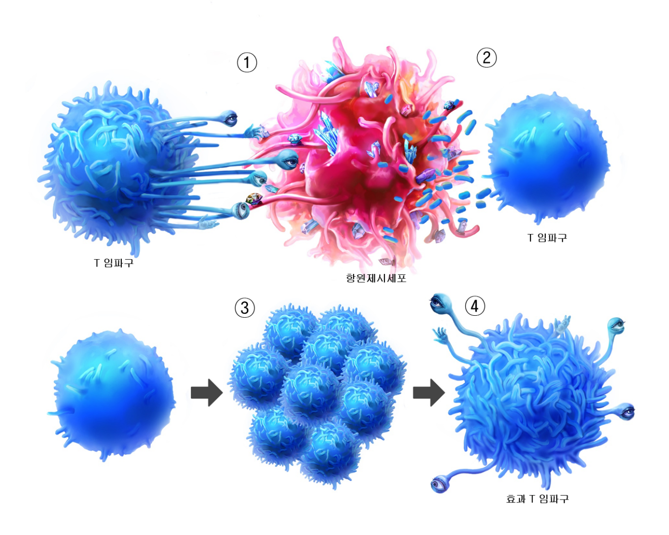

▲ Modeling the growth process of T-lymphocytes after molting