**GIST-KAIST Captures Carbon Dioxide Molecule Reaction in Real Time and Proposes an Effective Decomposition Method**

**- Real-time images of carbon dioxide chemical reactions observed in an ultra-fine dimension of 1/10 billionth of a meter in length.**

**- Expected to develop new catalysts to increase efficiency of greenhouse gas conversion... Published in Nature Communication.**



▲ From left, Prof. Mun Bong-jin of the Department of Physics and Optical Science, Gist; Prof. Park Jeong-yeong of the Department of Chemistry, KAIST; and Dr. Kim Jeong-jin of BNL (first author).

GIST’s (Gwangju Institute of Science and Technology, Acting President Park Raekil) Department of Physics and Optical Science Professor Mun Bong-jin's research team, along with KAIST’s (Korea Advanced Institute of Science and Technology, President Lee Gwang-hyeong) Department of Chemistry Professor Park Jeong-yeong's research team, proved that the surface of the ultra-fine step-like copper (Cu) catalyst can more effectively decompose carbon dioxide (CO2) molecules; it was announced on June 26.

Through using atmospheric-pressure electron tunneling microscopy technology, the research teams presented visual evidence for the first time that a step-like surface structure with a size of 1/100,000 the thickness of a human hair greatly contributes to improving the decomposition reaction of greenhouse gases. This result was evaluated as overcoming the limitations of the existing measurement technology and showing the actual detailed appearance of the catalyst as if it were alive.

This research result is drawing attention, as it is expected to be used in developing a new catalyst that can dramatically increase the conversion efficiency of greenhouse gases. Greenhouse gas conversion technology has recently been discussed greatly among the G7 countries as well as OECD member countries, and Korea is also actively promoting industry-academia-research and public-private partnership research to reach the global standards for carbon neutrality by 2050.

The carbon dioxide decomposition reaction required to synthesize methanol, a future clean fuel, while removing greenhouse gases from the atmosphere is a key technology in achieving carbon neutrality. However, since the carbon dioxide molecule is chemically very stable, its conversion into industrially useful chemicals remains a challenge.

When greenhouse gases are collected, they are generally converted in a high-temperature and high-pressure catalytic chemical reaction environment. In the case of copper-based catalyst materials, which were commercialized decades ago and are the most used, carbon dioxide molecules are broken down into carbon monoxide (CO) and oxygen atoms (O), a high-pressure reaction environment of dozens of atmospheres is required. Accordingly, it is necessary to develop a catalyst that increases the conversion efficiency of greenhouse gases by improving existing catalyst materials and inducing an optimal carbon dioxide conversion reaction.

The research team focused on the fact that the reaction activity of carbon dioxide molecules, which are only a few Angstroms (Å·1/10 billionth of a meter) in size, can vary depending on the surface structure of the catalytic material. By using the atmospheric pressure electron tunneling microscope (AP-STM), which enables high-resolution direct observation even during a reaction, the teams were able to capture in real time the decomposition process of carbon dioxide molecules reacting with the step-like ultra-fine copper surface, which is only 1/100,000th the thickness of a human hair.

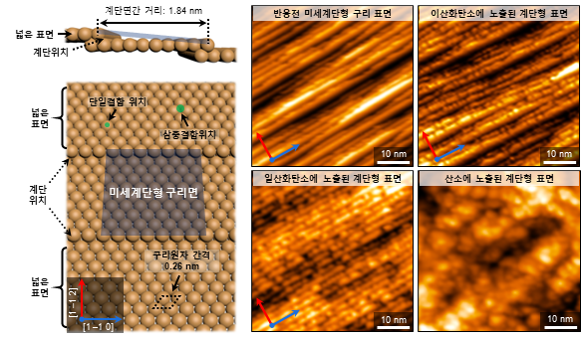

▲ Surface structure of ultra-fine step-like copper catalyst directly observed in real time.

The appearance of ultra-fine stepped copper surface directly observed in real time using an atmospheric-pressure electron tunneling microscope. Fine step-like copper surfaces with a spacing of about 1.8 nanometers (nm / 1 billionth of a meter). After being exposed to carbon dioxide molecules in an atmospheric pressure environment, each step tends to break down irregularly. This is due to the restructuring of the surface of the copper catalyst as the carbon dioxide molecules are broken down into carbon monoxide molecules and oxygen atoms through the ultra-fine step-like structure.

The surface arrangement of copper atoms with an ultra-fine step-like structure requires much lower activation energy than a wide and flat copper surface structure, making it relatively easy to break down greenhouse gases. It was found that the carbon dioxide molecules that collided with the steps on the surface of the copper catalyst were easily broken down even at room temperature, and furthermore, the separated carbon monoxide molecules and oxygen atoms could induce structural changes on the surface and affect the catalytic reaction pathway.

The research team utilized an atmospheric-pressure photoelectron spectrometer (AP-XPS) installed at the SOLEIL synchrotron facility in Paris, France, to identify in real time the chemical reactivity of the step-like copper surface and to investigate the chemical bond formed when the ultra-fine step-like copper surface reacts with with carbon monoxide. Through this, they discovered one after another the conditions of chemical bond types that induce structural change. In addition, through comparison with a wide copper surface having a flat structure, the initial decomposition reaction pathway of carbon dioxide molecules in the ultra-fine dimension was empirically presented.

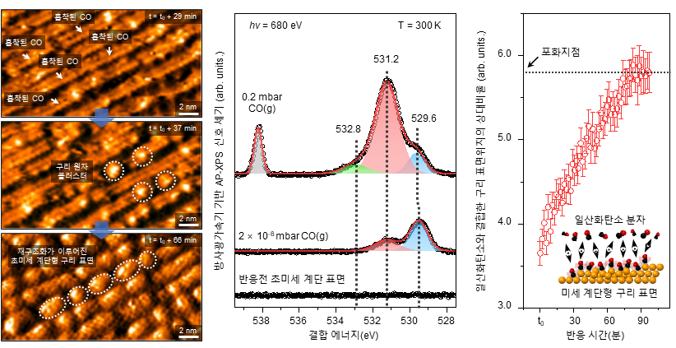

▲ Explaining the restructuring phenomenon of surface structures using the synchrotron facility.

Carbon monoxide molecules generated as a result of the decomposition of carbon dioxide molecules react strongly with the ultra-fine step-like copper surface structure and induce a restructuring phenomenon of the surface structure as directly observed. The results of energy change in chemical bonds analyzed through the synchrotron-based atmospheric pressure X-ray photoelectron spectroscopy (AP-XPS) technique vary with the pressure and exposure time of the injected gas in the carbon monoxide reaction environment.

GIST Professor Mun Bong-jin stated, “This study is a new discovery that goes beyond the understanding of the carbon dioxide catalyst phenomenon on the copper surface that has been conducted previously. We can provide important fundamental knowledge for the development of catalysts for decomposition and utilization of carbon dioxide, which is the most urgent research field in solving global warming caused by greenhouse gases.”

Professor Park Jeong-yeong of KAIST said, "This study will contribute to the development of high-efficiency carbon dioxide catalysts by gaining a clue to understanding the difference in behavior between single-crystal materials and commercially available catalysts."

This research, led by Prof. Mun Bong-jin and Prof. Park Jeongyeong and conducted by Dr. Kim Jeong-jin of Brookhaven National Laboratory (BNL) in the US, received support from the National Research Foundation (NRF) and fundamental research project in the field of science and technology, as well as the Korea-France cooperation development project (STAR). The research results were published on June 6 in the international journal Nature Communications.