Gwangju Institute of Science and Technology

Official Press Release (https://www.gist.ac.kr/)

Section of Mi-Yeon Kim Nayeong Lee
Public Affairs Section Chief Senior Administrator
(+82) 62-715-2020 (+82) 62-715-2024

Contact Person Professor Hojung Nam
Regarding Article School of Electrical and Computer Sciene
(+82) 62-715-2641

Release Date 2018.06.08

Professor Hojung Nam selected to create
an AI-based new drug development platform

□ GIST (President Seung Hyeon Moon) – Professor Hojung Nam of the School of Electrical Engineering and Computer Science has proposed a research project on a “Big Data/Artificial Intelligence Based New Drug Development Platform,” which has been selected for support by the Ministry of Science and Technology.

□ The global drug market is expected to grow by around 4 to 7% a year, with an annual market value of 1,200 trillion won. However, it is necessary to invest more than 15 years and more than 1 trillion won to develop one new drug. Entry barriers are high. On the other hand, Korea has a large amount of medical data, such as research data and hospital medical information accumulated through R&D, so it can shorten development time and cost to overcome entry barriers by applying big data/artificial intelligence (AI).

∘ The “Big Data/Artificial Intelligence Based New Drug Development Platform” project will build a large drug development database platform. The goal is to shorten the time and cost of new drug development by one-third by applying artificial intelligence technology to the 500,000 compound data produced from national R&D projects.

∘ In addition, the project is aiming to build technology based on the development of AI-based new drugs as a pilot project to explore research data and information asset accumulated in Korea as a big data development model.

□ This project is an interdisciplinary convergence of Professor Hojung Nam (School of Electrical Engineering and Computer Science), Professor Hyunju Lee (School of Electrical Engineering and Computer Science), Professor Yong Chul Kim (School of Life Sciences), and Professor Jin Hee Ahn (Department of Chemistry). The project will bring together artificial intelligence researchers and new drug developers to develop and verify candidate materials for AI-based new drugs. This research will be carried out for two years (2018-2019) with funding of 1 billion won.

⌘

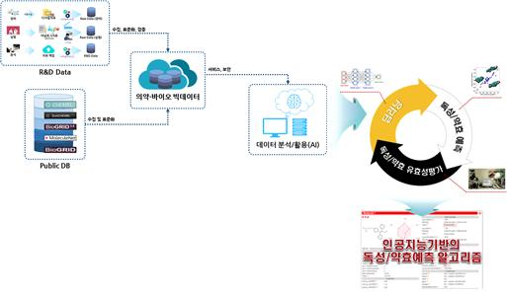
<Big Data/Artificial Intelligence Based New Drug Development Platform (plan)>
Source: Bio-Medical Technology Development Project Announcement

