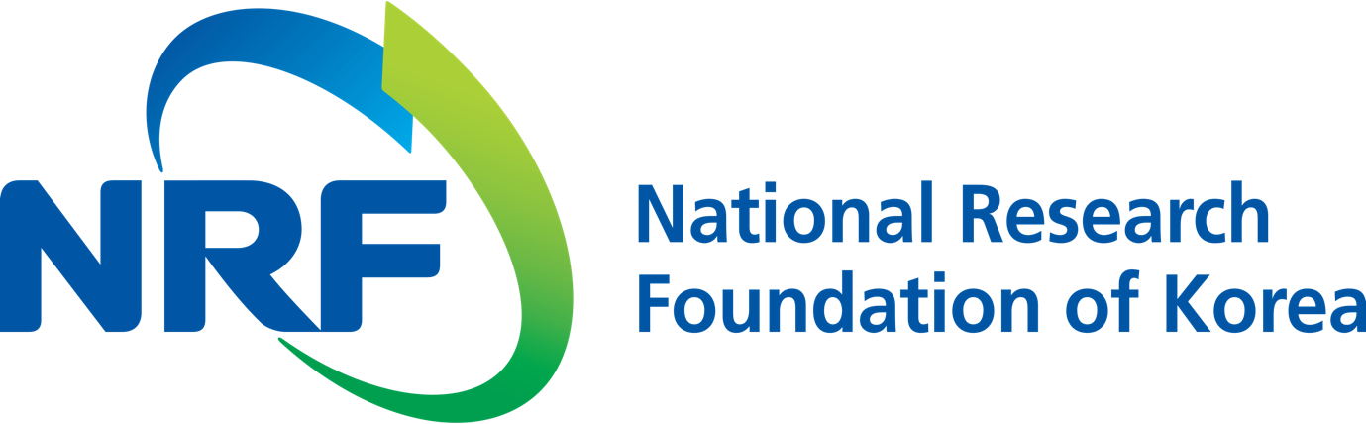

NRF PR Team Han-ki Kim Hyo-jung Jang
Department Head Administrator
(+82) 42-869-6116 (+82) 42-869-6116

Contact Person Professor Darren Williams
for this Article School of Life Sciences
(+82) 62-715-2509

Release Date 2018.07.12

Professor Darren Williams' research team identifies intercellular signals promoting cancer metastasis (National Research Foundation of Korea)

□ According to the National Research Foundation of Korea (President Jung Hye Roh), immune cells that protect our bodies are more akin to 'Mr. Hyde' rather than 'Dr. Jekyll,' and the process of promoting cancer metastasis has been revealed. Professor Darren Williams at the School and Research Professor Daoon Jung the School of of Life Sciences at GIST (President Seung Hyeon Moon) led a research team that has identified the process of promoting cancer metastasis by signal exchange between cancer cells and immune cells and fibroblasts.

□ Cancer cells have the ability to control the surrounding microenvironment to favor themselves. Macrophages, which are immune cells that have to attack cancer cells, also help cancer growth and metastasis in the tumor microenvironment. As the cancer cells communicate with the surrounding cells, the signal exchange process is very important for the growth and metastasis of the cancer, but the research is incomplete because it is too complicated.

□ The team studied signal transduction between cancer cells, fibroblasts, and macrophages. Specific signaling substances secreted from fibroblasts by cancer cells have been rapidly increased, and interleukin-6 and granulocyte macrophage-colony stimulating factor (GM-CSF) have been found to cooperatively increase tumor-promoting macrophages.

□ The researchers proposed a way to inhibit cancer metastasis by blocking signal exchange between cells. Administration of the interleukin-6 and GM-CSF antibodies to the cancer-challenged mouse model markedly reduced the number of tumor-promoting macrophages and significantly reduced cancer growth and metastasis.

□ Professor Darren Williams said, "This research has identified the key signaling exchange factors for cancer cells, fibroblasts, and immune cells and suggested a new vision for cancer metastasis-suppression strategies. In the future, it will be important to inhibit tumor-promoting macrophages as well as cancer cells. In addition, a method of controlling fibroblasts in the tumor microenvironment would be effective to inhibit the conversion of macrophages into tumor-promoting phenotypes."

□ This research was supported by the Ministry of Science and ICT, the National Research Foundation of Korea Basic Research Project (Advanced Research), and GIST Life Aging Research Project. Their paper was published in Clinical Cancer Research on June 29, 2018.

⌘

