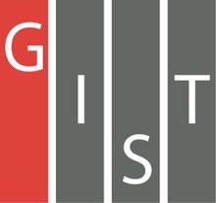
Gwangju Institute of Science and Technology

Official Press Release (https://www.gist.ac.kr/)

Section of Mi-Yeon Kim Nayeong Lee
Public Affairs Section Chief Senior Administrator
(+82) 62-715-2020 (+82) 62-715-2024

Release Date 2018.06.07

GIST is ranked third in the world for ‘citations per faculty’ in the 2018/19 QS World University Rankings

□ On June 7, 2018, QS (Quacquarelli Symonds), a global university evaluation organization in the UK, announced the 2018/19 QS World University Rankings in which GIST (President Seung Hyeon Moon) was ranked third in the world for citations per faculty.

∘ Despite the recent rapid increase in the number of professors, GIST, for the second consecutive year, was ranked third in the world among 1,233 universities that were evaluated. GIST was ranked second in the world in 2015 and 2016, which was the highest QS ranking by any Korean university.

□ The number of citations per faculty can be used to evaluate both the quantity and the quality of the research capacity of a university. The papers published by the researchers of a university are cited by other researchers in related fields. The higher the score, the greater the impact and significance of the research results.
∘ In contrast to subjective evaluations such as ‘academic evaluation’ and ‘graduation evaluation,’ this is considered the most reliable evaluation because it shows 'objective' data such as the average research results of the university and its influence on other studies in the field.

∘ For the second year in a row, King Abdullah University of Science and Technology in Saudi Arabia was ranked first in the world in this category, the Indian Institute of Science and Technology was ranked second, Gwangju Institute of Science and Technology was ranked third, and Princeton University and Caltech in California were ranked fourth and fifth, respectively.

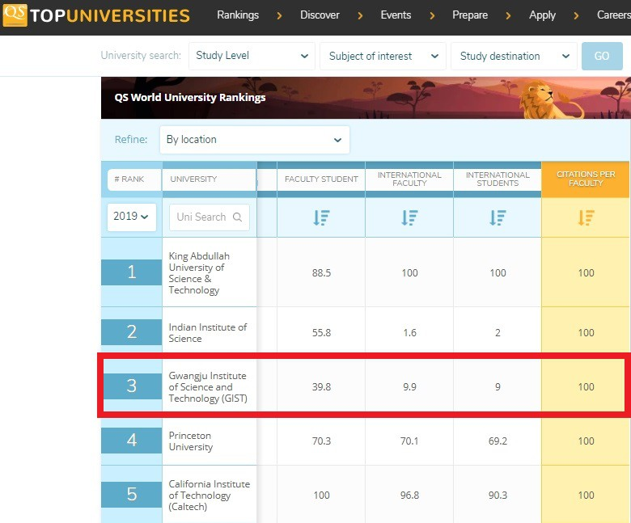

□ GIST’s research capacity has been evaluated as world-class for many years because it has attracted researchers with excellent competence and has created an optimal research environment in which they can engage in research.

∘ To create an environment where professors can concentrate on research, graduate school professors are only required to teach two courses per year to create an environment where they can focus more on research. Professors are also exempt from having to teach courses if they are engaged in large-scale projects.

∘ In addition, GIST has a “Start-up Fund,” which is one of the best in Korea, that allows professors to quickly establish their labs. After becoming a professor at GIST, new professors are exempt from teaching duties for one semester during their first year to help improve the research environment.

∘ If professors achieve excellent results in academic, research, and other activities as a world-class academic researcher, the professor will be awarded as a 'GIST Special Professor or GIST Professor,' which offers a variety of benefits.

∘ Professors with excellent educational and research achievements are offered a “chair” system that allows them to continue their lectures and research even after retirement, thereby giving incentives to excellent professors while supporting students.

□ GIST also recognizes the importance of students as being research partners withs professors, allowing students in the bachelor's, master's, and doctoral programs to participate actively in research while offer various opportunities to improve themselves.

∘ 100% of graduate students participate in research with their advisors in an environment where they can study and research. Undergraduate students can also take part in internships in GIST graduate laboratories at any time. In addition, GIST provides various research opportunities to study with professors at Caltech in America through the 'Caltech SURF Program.'

□ GIST President Seung Hyeon Moon said, “This achievement is the result of every GIST member, such as professors, researchers, and students. Based on our outstanding research capacity, GIST will lead the way to the 4th Industrial Revolution, and we will make more efforts to transfer technology and revitalize entrepreneurship in order to contribute to economic and industrial development of the local community.”

∘ For the second consecutive year after 2017, GIST was ranked first in the overall ranking for the “Best University in Korea” by the Maeil Business Newspaper.

□ GIST, which celebrates its 25th anniversary this year, aims to foster talented human resources in science and technology for the 4th Industrial Revolution while redefining its role as a science and technology institute that is actively fulfilling its social responsibilities.

⌘

