“Uncovering differences invisible in tissue images by integrating genetic data” GIST develops AI to predict gene expression and segment tissue regions
- Professor Hyunju Lee’s team in the Department of AI developed ‘ST-ConMa,’ an AI framework trained on approximately 980,000 pairs of tissue images and genetic data... The system learns both the individual characteristics of these data types and the relationships between them
- Achieved top performance in 10 out of 12 evaluation metrics for gene expression prediction and demonstrated improved accuracy in brain tissue region segmentation compared to existing models
- Published in the international journal Briefings in Bioinformatics
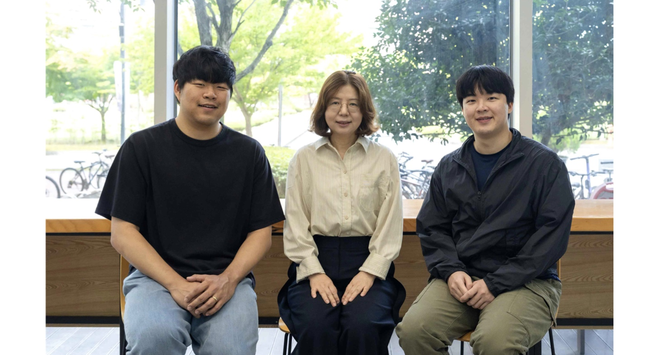

▲ (From left) Dr. Dongha Choi, Professor Hyunju Lee, and Taelim Yeom (combined MS/PhD student) from the GIST Department of AI.
The Gwangju Institute of Science and Technology (GIST; President Kichul Lim) announced that a research team in the Department of AI led by Professor Hyunju Lee has developed an AI framework named "ST-ConMa." This framework analyzes regional differences within tissues, which are difficult to discern based solely on visual appearance, by simultaneously utilizing tissue images and gene activity data.
Within a single organ, the types of cells and the genes that are actively expressed vary depending on the specific location within the tissue. By examining both "tissue images" and "gene expression" data, which indicate which genes are active and at what intensity in specific locations, researchers can gain a more detailed understanding of these location-specific differences.
ST-ConMa learns the relationship between tissue morphology and gene activity, enabling its use in various spatial transcriptomics* analyses, such as predicting gene expression from tissue images and distinguishing between regions with distinct characteristics.
* spatial transcriptomics: A technique that analyzes which genes are expressed—and at what levels—at specific locations within a tissue, in conjunction with tissue imaging.
While research utilizing AI to analyze spatial transcriptomics data has recently become active, many existing models were developed for specific tasks, such as predicting gene expression or segmenting tissue regions, making them difficult to apply broadly to other types of analysis.
AI models capable of learning from both tissue images and genetic data have been developed, but existing approaches primarily focused on learning each data type separately and then comparing how well they aligned.
Consequently, there were limitations in simultaneously learning the intricate relationships between the two, such as how specific tissue morphologies correlate with gene activity.
To address these limitations, the research team designed "ST-ConMa," a model that enables tissue images and genetic data to exchange information, thereby allowing the system to learn the relationships between them.
The model was pre-trained on approximately 981,000 "tissue image–genetic data pairs" derived from 534 samples across various human tissues; it was designed to learn from the image and genetic data individually while simultaneously distinguishing between instances where the two are related and instances where they are not.
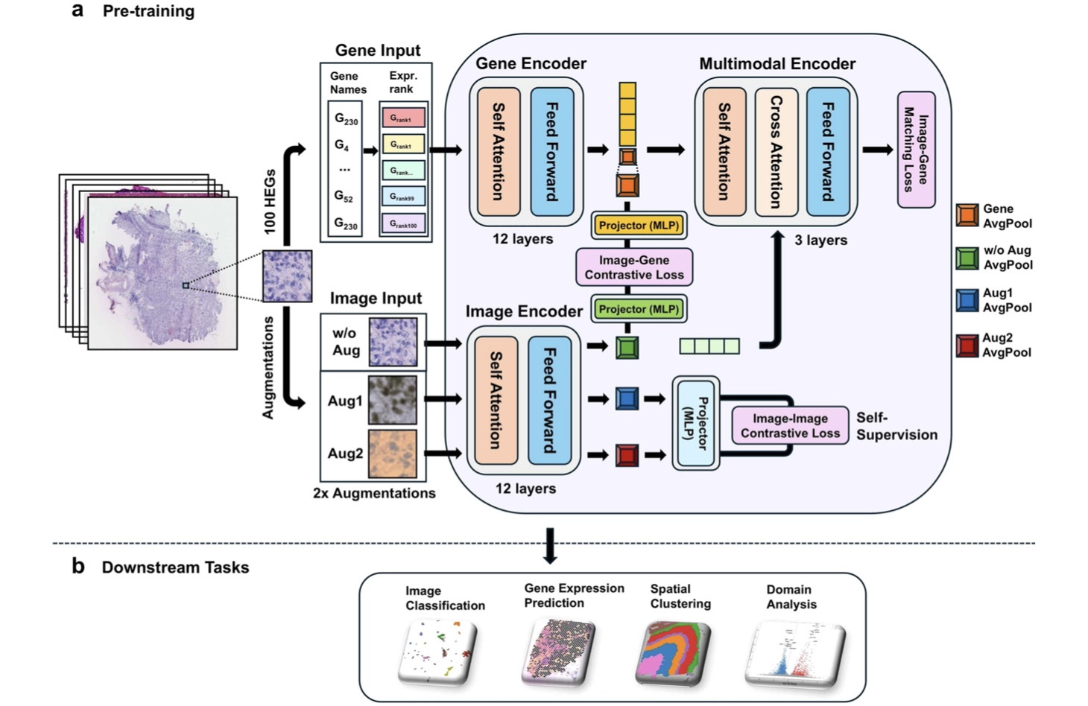

▲ The operating principle of ‘ST-ConMa,’ which learns from both tissue images and genetic information. It trains on pairs of data—images obtained from human tissue and the corresponding gene expression information—to capture the characteristics of each data type as well as the relationship between them. Once trained, ST-ConMa can be utilized for various spatial transcriptomics analyses, such as predicting gene expression from tissue images or distinguishing between tissue regions with different characteristics.
The research team first verified whether learning the relationship between these two types of information actually aids in predicting gene expression from tissue images.
They compared its performance against six existing AI models designed to predict gene expression from tissue images, using datasets from breast cancer, cutaneous squamous cell carcinoma (a type of skin cancer), and normal liver tissue.
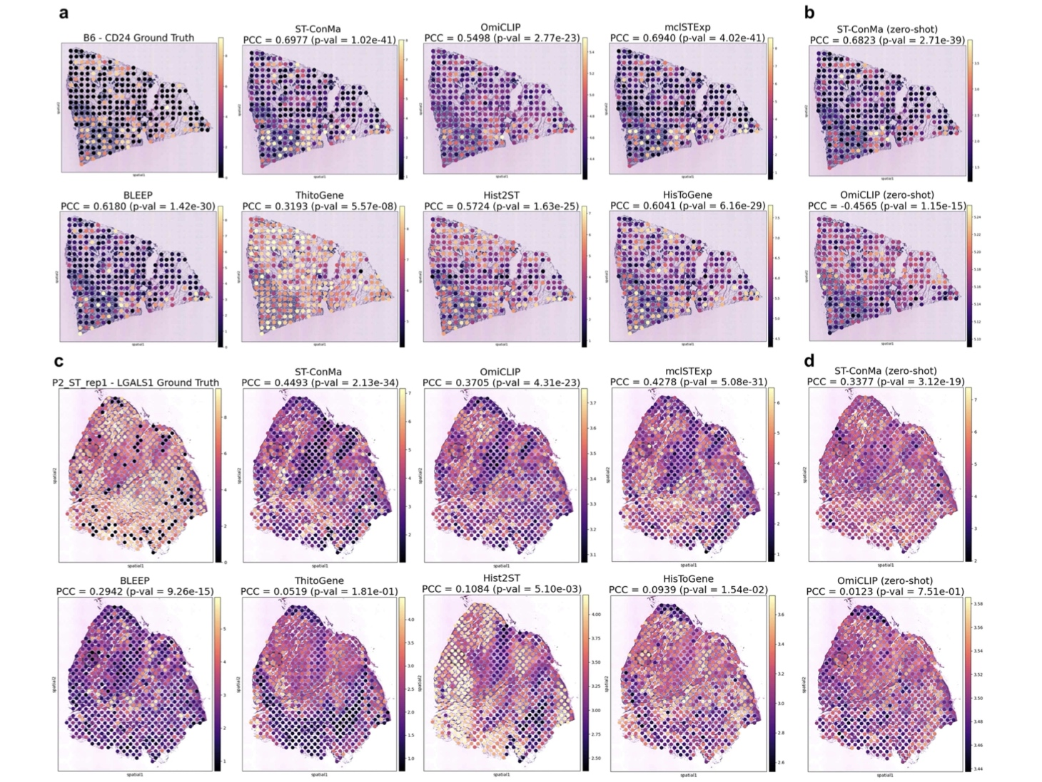

▲ Results of gene expression prediction in breast cancer and cutaneous squamous cell carcinoma tissues. This figure compares the actual spatial distribution of gene expression measured in the tissue with the prediction results from various AI models, including ST-ConMa. The left panel shows the expression results for the CD24 gene in HER2-positive breast cancer, while the right panel shows the results for the LGALS1 gene in cutaneous squamous cell carcinoma.
The results showed that ST-ConMa achieved the highest performance in 10 out of the 12 metrics used to evaluate gene expression prediction capabilities.
Specifically, for breast cancer and cutaneous squamous cell carcinoma, the model was evaluated by excluding data from a single patient during training and then predicting that patient's gene expression. This confirmed the model's ability to predict gene expression in tissue from patients not included in the training set.
The research team then investigated whether ST-ConMa could be used not only to predict gene expression but also to distinguish between different regions within the tissue.
Analysis of human prefrontal cortex tissue revealed that ST-ConMa outperformed existing comparative models by 12.9% in metrics assessing alignment with actual tissue structures. Notably, it more clearly delineated Layer 4 of the cerebral cortex, which is a region where boundaries with adjacent layers were indistinct in existing models.
ST-ConMa also successfully distinguished between different regions within breast cancer tissue. Further analysis of the gene characteristics within these regions allowed for a more granular classification of the tumor microenvironment; for instance, it could identify distinct sub-regions even within areas showing active immune responses.
Professor Hyunju Lee stated, "In spatial transcriptomics, it is crucial to understand both tissue morphology and the gene activity occurring within it. This study established a foundation for various analyses by enabling the model to learn the relationship between these two types of information." She added, "We plan to continue our research by training the model on data from a wider range of tissues and diseases, aiming to apply it to the analysis of complex tissue microenvironments."
This research, supervised by Professor Hyunju Lee of the GIST Department of AI and featuring combined master’s/doctoral student Taelim Yeom as the lead author, was supported by the Mid-career Researcher Support Program (Ministry of Science and ICT/National Research Foundation of Korea) and the AI ​​Top-tier Early-career Researcher Support Program (Ministry of Science and ICT/Institute for Information & Communication Technology Planning & Evaluation).
The findings — ST-ConMa: a multimodal foundation framework for spatial transcriptomics via image–gene contrastive and matching learning — were published online in the international bioinformatics journal Briefings in Bioinformatics on September 28, 2026.

