GIST develops new solution for overlapping neutron signals… Measuring yield by treating them as 'undetected events'
- A research team led by Professor Woosuk Bang (Department of Physics and Photon Science) has proposed a new method to measure neutron yield in laser fusion experiments—where overlapping signals occur due to the rapid generation of a large number of neutrons—without the need to distinguish individual signals
- The team presented detection conditions that minimize measurement errors, even when the number of experimental trials is limited
- The findings were published in Nuclear Fusion, a world-renowned international journal in the field of fusion research


▲ (From left) Professor Woosuk Bang (Department of Physics and Photon Science) and Youhwan Noh (combined master’s and doctoral student)
The Gwangju Institute of Science and Technology (GIST; President Kichul Lim) announced that a research team led by Professor Woosuk Bang of the Department of Physics and Photon Science has proposed a new analysis method capable of measuring total neutron yield in laser fusion experiments without the need to count individual neutrons.
The team proposed a method to back-calculate the total neutron yield based on the proportion of instances where no neutrons were detected. Since this method allows for yield measurement even when individual neutron signals overlap and are difficult to distinguish, it is expected to be useful in designing measurement and detection conditions for experiments, such as laser fusion, that generate large numbers of neutrons in a short period.
Nuclear fusion is a reaction in which light atomic nuclei combine to form heavier nuclei; this process often releases neutrons, which are electrically neutral particles. Laser fusion is a method that triggers such fusion reactions using high-power lasers.
In laser fusion experiments, neutron energy and yield are analyzed by measuring the "Time-of-Flight" (TOF), which is the time it takes for a neutron to travel from its point of origin to the detector.
When neutron production is low, the yield can be estimated by distinguishing individual signals appearing on the detector. However, when a large number of neutrons are generated simultaneously in a short time, like in as in laser fusion, a phenomenon known as "pulse pile-up" occurs, where multiple signals overlap and appear as a single signal. In such cases, a simple counting method can result in an underestimation of the actual neutron yield.
While placing the detector farther from the neutron source could reduce signal overlap, the increased distance lowers the probability of neutrons reaching the detector, necessitating more experimental runs to gather sufficient data.
To address this issue, the research team focused on the fact that as neutron production increases, the frequency of instances where "no neutrons are detected" decreases. In other words, rather than distinguishing individual neutron signals, the total neutron yield can be measured by analyzing the rate at which no neutrons are detected.
The team verified the performance of this method by applying it to an actual laser-driven nuclear fusion experiment.
They induced a fusion reaction by firing a 100-terawatt (TW) high-power laser at "deuterium clusters", which are small aggregates of molecules made of deuterium, an isotope of hydrogen, and detected the neutrons (approximately 2.45 MeV) generated during the process.
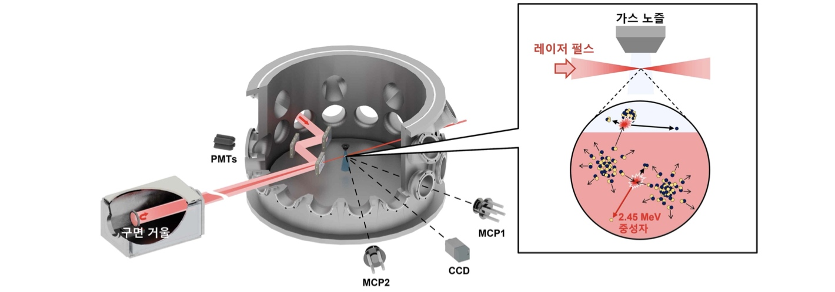

▲ Schematic of the laser-cluster fusion experiment. The diagram illustrates an experiment in which a high-power laser is fired at deuterium clusters to trigger fusion, and the resulting neutrons (approx. 2.45 MeV) are measured by a detector.
The experiment was repeated while varying the ion temperature by adjusting the laser intensity; the neutron yield was then calculated based on the proportion of trials in which no neutrons were detected at each temperature.
The results showed that neutron yield increased with higher ion temperatures, with measurements indicating the production of approximately 100 to 100,000 neutrons per laser shot.
To verify the calculation results, the research team accumulated neutron signals measured over multiple runs and compared them with a separate analysis method that calculates the neutron yield based on the average signal produced by a single neutron. The results confirmed that the neutron yields calculated by both methods were consistent with each other.
* MeV (mega-electronvolt): A unit representing particle energy; 1 MeV is equivalent to one million electronvolts (eV).
The research team further proposed conditions for more accurately measuring neutron yield within a limited number of experimental trials.
This is because the probability of detecting a neutron in a single experiment varies depending on factors such as the distance between the neutron source and the detector.
Upon analyzing the statistical error relative to the number of trials and the rate of "zero detections," the team found that as the number of measurements increased, the error was minimized when the "zero detection" rate was close to approximately 20%.
Based on this finding, they established a guideline suggesting that adjusting parameters, such as the detector distance, to align with the expected neutron yield can reduce measurement error within a fixed number of trials.
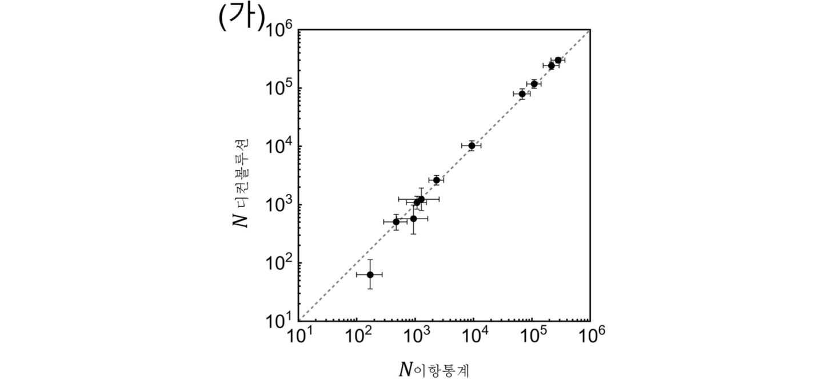

▲ Comparison of fusion neutron yields obtained via two analysis methods. The team calculated and compared neutron yields using two approaches: a binomial statistical analysis method based on the "zero detection" rate (proposed by the team) and a deconvolution analysis method utilizing the cumulative signal from the same experimental data. The results confirmed that the measurements from both methods were consistent.
Professor Woosuk Bang stated, "In laser fusion experiments, multiple neutrons are often detected almost simultaneously, causing signal overlap that makes it difficult to distinguish individual neutrons." He added, "This study is significant because it moves away from conventional approaches focused on separating overlapping signals and instead proposes a new analysis method that measures total neutron yield by focusing on instances where 'no neutrons are detected.'"
This research, supervised by Professor Woosuk Bang of the GIST Department of Physics and Photon Science and featuring combined master’s/doctoral student Youhwan Noh as the first author, was supported by the Mid-career Researcher Program funded by the Ministry of Science and ICT and the National Research Foundation of Korea.
The findings — Measurement of fusion neutron yields in laser–cluster fusion experiments using binomial statistics — were published online on September 28, 2026, in Nuclear Fusion, a world-renowned journal in the field of fusion research published by the International Atomic Energy Agency (IAEA).

