GIST, Seoul National University, and Seoul National University Hospital identify gut microbiome associated with increased visceral fat
- A joint research team led by Professor Hansoo Park of the GIST Department of Biomedical Science and Engineering analyzed the gut microbiota of 1,833 Koreans and identified two bacterial species specifically associated with visceral fat... Mice administered these bacteria showed increases in body weight and body fat
- Findings offer clues for developing new strategies to treat and prevent obesity and metabolic diseases
- Published in the international journal Experimental & Molecular Medicine


▲ Group photo of the joint research team from GIST, Seoul National University (SNU), and SNU Hospital. (From left) Professor Hansoo Park of the GIST Department of Biomedical Science and Engineering (CEO of Genome & Company), Professor Jin-Ho Park of SNU Hospital (SNU College of Medicine), Professor Sungho Won of SNU, Dr. Nam-Eun Kim of SNU (currently at Jeonbuk National University), and Beomki Cho, a Ph.D. student in the GIST Department of Biomedical Science and Engineering.
The Gwangju Institute of Science and Technology (GIST; President Kichul Lim) announced that a research team led by Professor Hansoo Park of the Department of Biomedical Science and Engineering (CEO of Genome & Company) in collaboration with teams led by Professor Park Jin-ho of SNU Hospital and Professor Won Sung-ho of SNU has analyzed large-scale health checkup and gut microbiome data from Koreans to identify gut bacteria strongly associated with visceral fat. Through animal experiments, they further confirmed the potential for these bacteria to induce changes linked to obesity.
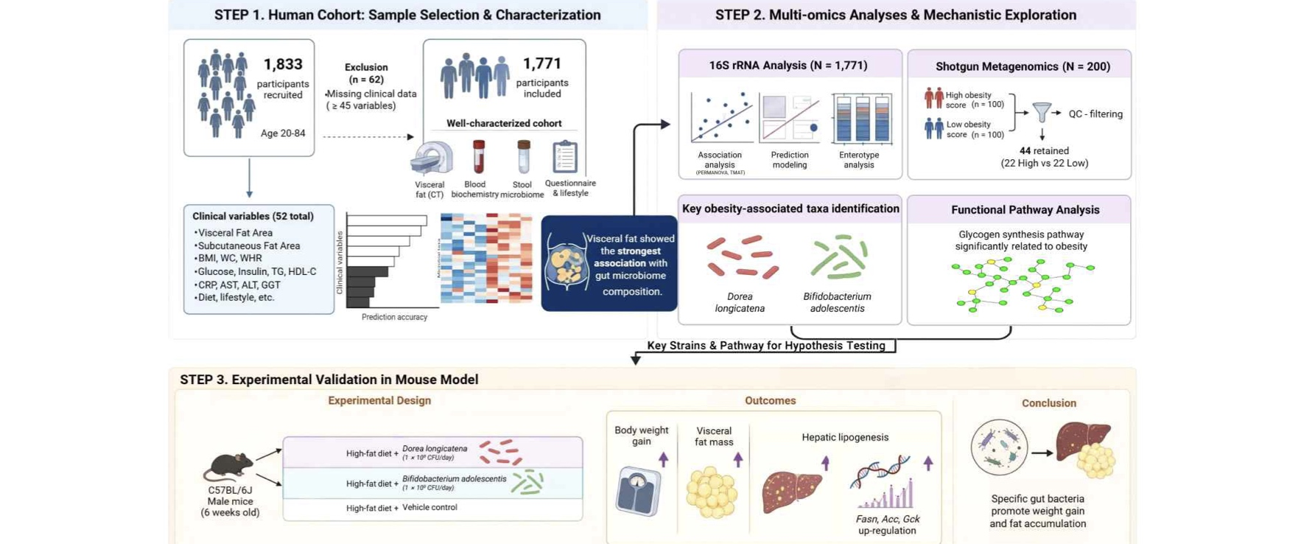

▲ Schematic diagram of the overall research process. It illustrates the research workflow: analyzing health indicators and gut microbiome data from Korean health checkup participants to identify gut bacteria associated with visceral fat, and subsequently observing the changes that occur when these bacteria are administered in animal experiments.
The research team identified that, among various obesity-related indicators, such as body mass index (BMI), total body fat mass, waist circumference, and visceral fat, visceral fat shows one of the most consistent associations with gut microbiota.
These findings suggest that obesity should be assessed not merely by body weight or BMI, but also by considering the location and amount of fat accumulation in the body; the study is expected to contribute to a better understanding of the role gut microbiota plays in obesity and metabolic diseases.
Visceral fat is fat that accumulates around the internal organs within the abdominal cavity. Unlike subcutaneous fat, excessive accumulation of visceral fat is linked to an increased risk of various metabolic conditions, including insulin resistance, type 2 diabetes, and cardiovascular disease.
While the link between obesity and gut microbiota was already known, there have been few large-scale studies analyzing this relationship with a specific focus on where fat accumulates in the body, rather than relying solely on total body weight or BMI.
The joint research team analyzed the "gut microbiome", encompassing gut microbial communities and genetic information, using data from 1,833 Koreans who underwent health checkups at Seoul National University Hospital. They examined the relationship between gut microbiota composition and 52 health indicators, including blood pressure, blood glucose and insulin levels, triglyceride and cholesterol levels, and metrics such as BMI, waist circumference, body fat mass, and visceral fat.
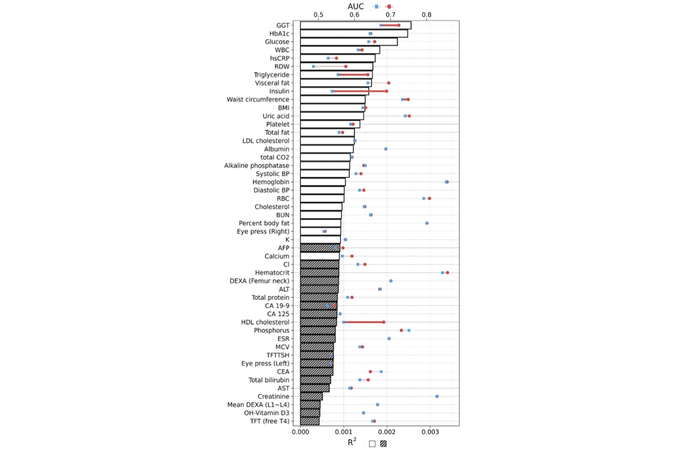

▲ Analysis of the association and predictive power regarding health markers and gut microbiota. This study analyzed the relationship between gut microbiota composition and 52 health markers and compared the predictive performance for each marker using gut microbiota data.
Additionally, the researchers utilized 21 artificial intelligence (AI) machine learning models to compare the utility of gut microbiota data in predicting each health marker.
The results showed that, among various obesity-related markers, visceral fat exhibited a more consistent association with gut microbiota than BMI, total body fat mass, or waist circumference. In fact, visceral fat showed significant associations with the highest number of bacterial species among all the markers analyzed.
To specifically identify gut bacteria associated with visceral fat, the research team created a composite "obesity score" by combining nine obesity-related markers: blood pressure, triglycerides, HDL cholesterol, insulin, waist circumference, BMI, total body fat mass, and visceral fat.
Subsequent analysis of gut bacteria that increased or decreased in correlation with this score identified Dorea longicatena and Bifidobacterium adolescentis as particularly noteworthy species linked to the obesity score and visceral fat.
Subsequent detailed analysis of the genetic information of gut microbiota revealed a link between the degree of obesity and functions related to the synthesis of glycogen, a substance used by microorganisms to store energy, with Dorea longicatena and Bifidobacterium adolescentis identified as key bacteria involved in these processes.
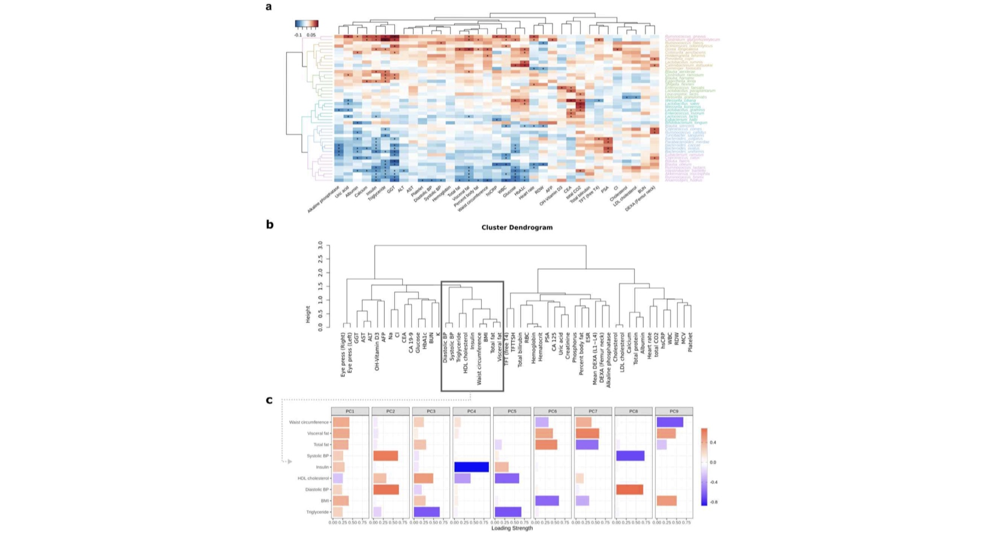

▲ Analysis of the association between obesity-related health markers and gut microbiota. This illustrates the process of comparing gut bacteria with health markers and deriving an "obesity score" by integrating nine closely related obesity-related indicators.
Following the identification of a link between two specific bacterial strains and visceral fat in human subjects, the research team conducted animal experiments using mice to determine whether these bacteria actually induce obesity-related changes.
When the two bacterial strains were administered individually to mice fed a high-fat diet, both groups of mice gained more weight than the control group that did not receive the bacteria.
Notably, mice administered Dorea longicatena showed increases in body fat mass and body fat percentage, as well as a greater increase in the weight of adipose tissue, including visceral fat, compared to the control group. In the liver, there was also increased expression of genes related to fat synthesis (Fasn, Acc) and genes involved in glucose metabolism (Gck).
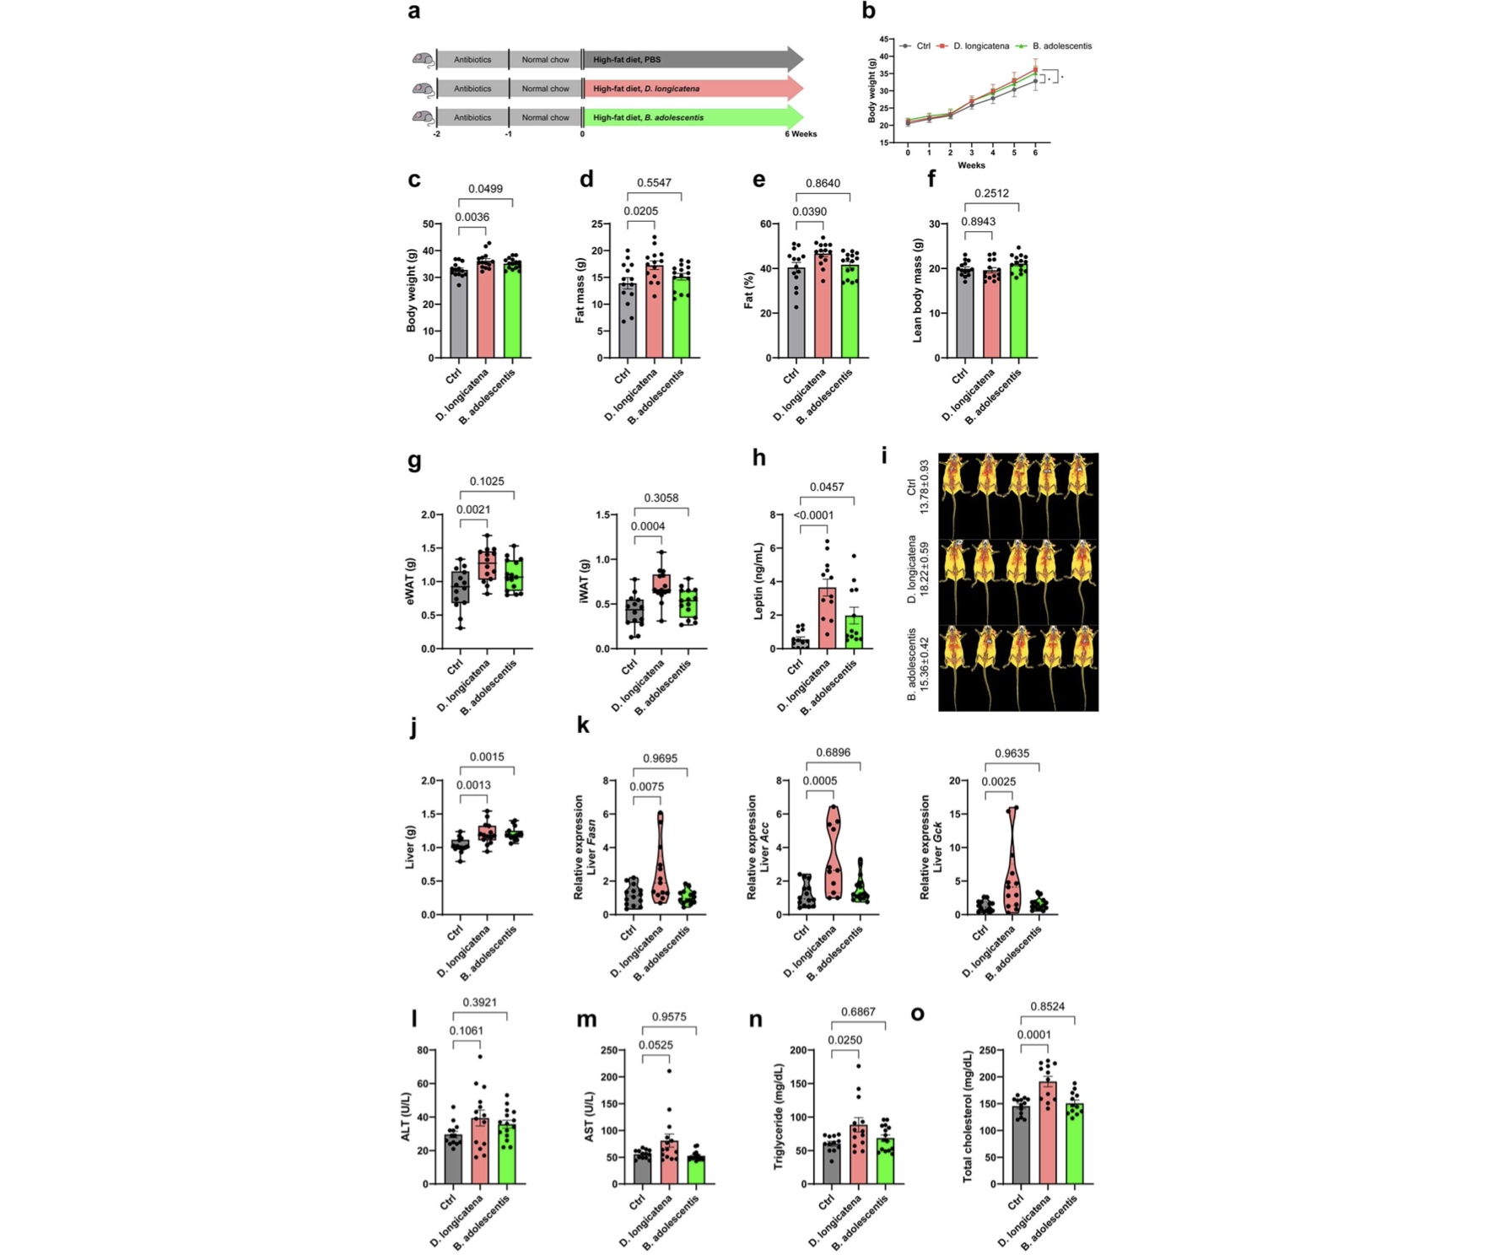

▲ Obesity-related changes in mice administered the two gut bacteria. When Dorea longicatena and Bifidobacterium adolescentis were administered separately to mice fed a high-fat diet, both groups showed a significant increase in body weight. Notably, the group administered Dorea longicatena exhibited significant increases in body fat mass, body fat percentage, and abdominal adipose tissue weight.
Mice administered Bifidobacterium adolescentis also showed weight gain, as well as increased blood leptin levels and liver weight.
However, the research team explained that the specific mechanism directly linking the glycogen synthesis function, which was identified through the analysis of human gut microbiota, to the changes in fat metabolism observed in the animal experiments has not yet been elucidated.
In particular, the specific biochemical link between glycogen synthesis by gut bacteria and increased hepatic fat synthesis in mice requires further study. Therefore, these findings offer important clues regarding the processes by which gut bacteria influence visceral fat and obesity.
Professor Hansoo Park stated, "This study is significant in that we identified gut bacteria closely associated with visceral fat by analyzing large-scale health and gut microbiota data from the Korean population, and subsequently confirmed through animal experiments that these bacteria can induce obesity-related changes." He added, "If we can uncover the specific mechanisms by which gut microbiota influence human fat metabolism in the future, it will aid in understanding obesity and metabolic diseases and in developing new strategies to address them."
This study was jointly supervised by Professor Hansoo Park (GIST), Professor Jin-Ho Park (Seoul National University Hospital), and Professor Sungho Won (Seoul National University), with Dr. Nam-Eun Kim (Seoul National University) and Ph.D. candidate Beomki Cho (GIST Department of Biomedical Science and Engineering) serving as co-first authors; it was supported by the Korea Disease Control and Prevention Agency (KDCA) and the Ministry of Science and ICT.
The research findings — Linking visceral fat accumulation to gut microbiota: key bacterial taxa and their roles in the glycogen synthesis pathway — were published online in the international journal Experimental & Molecular Medicine on September 10, 2026.

