GIST and Hanyang University develop semiconductor technology to sharpen blurred images based on light intensity
- Research teams led by Prof. Dong-Ho Kang (GIST) and Prof. Seyong Oh (Hanyang University ERICA) developed a method to adjust image signals based on light intensity, which was inspired by the retina's signal-suppressing function, thereby enhancing image contrast without the need to separately determine lighting conditions
- Pre-processing noisy images boosted the recognition accuracy of an artificial neural network from 47.7% to 97.3%
- Published in the international journal Advanced Functional Materials


▲ (From left) Professor Dong-Ho Kang (Department of Semiconductor Engineering, GIST), Professor Seyong Oh (Department of Electronic Engineering, Hanyang University ERICA), Juhwan Baek (integrated MS/PhD student, School of Electrical Engineering and Computer Science, GIST), and Junhwa Oh (integrated MS/PhD student, Department of Electronic Engineering, Hanyang University ERICA).
The Gwangju Institute of Science and Technology (GIST, President Kichul Lim) announced that a joint research team led by Professor Dong-Ho Kang of the Department of Semiconductor Engineering at GIST and Professor Seyong Oh of the Department of Electronic Engineering at Hanyang University ERICA has developed a semiconductor technology that sharpens blurry images by enhancing the contrast between bright and dark areas based on the intensity of incoming light.
Conventional cameras typically transmit captured images to a separate processor to enhance contrast or remove noise. This new technology enables a portion of such image processing to be performed directly within the sensor itself.
The human retina suppresses certain visual signals to accentuate the difference between light and dark regions, thereby aiding in the distinction of object outlines. The joint research team focused on this signal-suppression function of the retina.
"In-sensor image processing" technology, where the sensor performs image processing tasks while simultaneously detecting light, can reduce power consumption and processing latency by minimizing the volume of data that must be transmitted to an external processor. However, some existing technologies require the device to be controlled by manually selecting appropriate operating conditions based on light intensity.
To address this, the joint research team developed a transistor that mimics the retina's signal-suppression function using tungsten diselenide (WSe₂), an ultra-thin semiconductor material. The degree of signal suppression in this transistor varies depending on its operating state.
Next, the team connected a light-sensing photosensor to the transistor so that the transistor's operating state would change in response to the electrical signal generated by the photosensor upon detecting light. Consequently, the degree of signal attenuation is automatically adjusted based on light intensity, eliminating the need for separate assessments of lighting conditions.
When light is weak, the signal is significantly attenuated; when light is strong, the signal is relatively preserved, thereby enhancing the contrast between the bright and dark areas of the image.
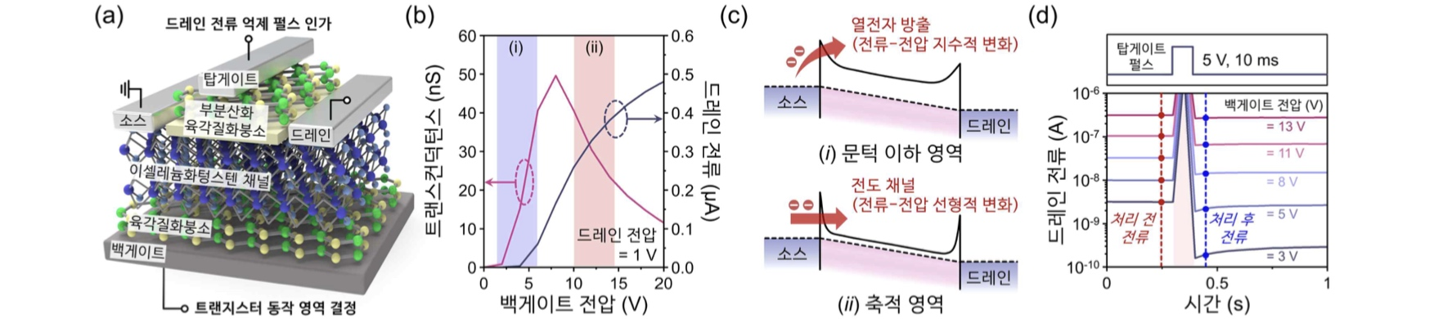

▲ Structure and operating principle of the tungsten diselenide (WSe₂) transistor that modulates image signals based on light intensity. (a) Structure of the tungsten diselenide transistor developed in this study. (b-c) Principles governing changes in the transistor's operating state and current characteristics based on voltage. (d) Illustration showing how the degree of current reduction varies depending on the transistor's operating state, even when the same voltage is applied.
The joint research team applied this image processing method to an array of photosensors to verify its functionality in images containing a mix of bright and dark regions.
When an input signal shaped like the letter "G" mixed with faint noise was processed, the strong signal forming the character was largely preserved while the surrounding weak noise was suppressed, resulting in a more distinct outline of the "G."
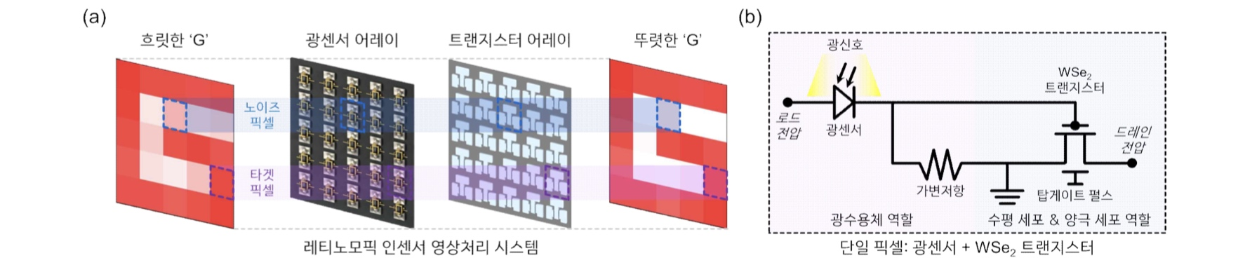

▲ Operating principle of the in-sensor image processing system combining a photosensor and a tungsten diselenide (WSe₂) transistor. (a) Illustration of the process wherein the tungsten diselenide transistor modulates the image signal based on the light intensity detected by the photosensor—suppressing weak noise while relatively preserving the strong signal that forms the character. (b) It features a structure that combines a light-sensing optical sensor with a tungsten diselenide transistor that regulates image signals.
To determine whether this image processing aids in character recognition by artificial neural networks (ANNs), which learn to identify and distinguish images, the research team conducted simulations modeling conditions where image noise arises from factors such as rain or fog. They compared recognition accuracy using images of vehicle license plate characters blurred by noise.
Simulation results showed that when an AI trained on clean character images was fed noisy images directly, recognition accuracy was 47.7%; however, when the same noisy images were processed using this new method before input, accuracy rose to 97.3%. By suppressing weak background signals and restoring the clarity of character shapes, the method made it easier for the AI ​​to distinguish the characters.
The joint research team explained that future research is needed to scale up the technology into a larger in-sensor image processing system through advancements such as large-area device fabrication and optical sensor integration.
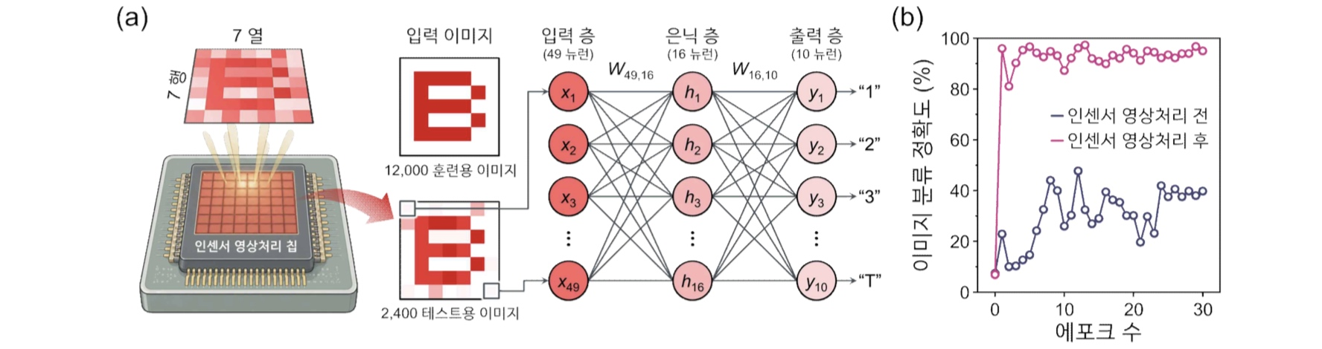

▲ Improvement in AI character recognition performance through in-sensor image processing. (a) Illustration of the process: AI is trained on clean character images, and noisy character images are processed using this technology for recognition. (b) Comparison showing a significant increase in recognition accuracy when in-sensor image processing is applied, versus inputting noisy images directly.
Professor Dong-Ho Kang stated, "This research is significant in demonstrating that image signals can be modulated at the pixel level by utilizing the intensity of incoming light itself, without the need to assess external lighting conditions." He added, "It will serve as a crucial foundation for developing ultra-low-power, high-performance AI semiconductors that require real-time image preprocessing capabilities, such as those used in autonomous driving."
This research was supervised by Professor Dong-Ho Kang(Department of Semiconductor Engineering, GIST) and Professor Seyong Oh (Department of Electronic Engineering, Hanyang University ERICA), with Juhwan Baek (integrated MS/PhD student, School of Electrical Engineering and Computer Science, GIST) and Junhwa Oh (integrated MS/PhD student, Department of Electronic Engineering, Hanyang University ERICA) participating as co-first authors. The study was supported by the National Research Foundation of Korea’s Excellent Young Researcher Program, the Ministry of Science and ICT’s UNIST-GIST-DGIST Institutional Strategic Research Group Program, and the Ministry of Science and ICT’s GIST-InnoCORE Program.
The research findings were published online in the international journal Advanced Functional Materials on September 14, 2026.
Meanwhile, GIST announced that it is accepting inquiries from companies and institutions interested in the technology commercialization and industrial application of these research results through the Technology Commercialization Center at the GIST Institute of Startup and Innovation (hgmoon@gist.ac.kr).

