GIST-MIT develops VR walking technology that simulates the sensation of walking uphill and downhill while seated
- A joint research team led by Professor SeungJun Kim (Department of AI) and MIT has developed ‘EMSWalker,’ a virtual walking system that stimulates the leg muscles used in actual walking in synchronization with foot movements
- The system distinguishes between uphill (78% accuracy), flat (72%), and downhill (58%) terrain without visual cues, showing promise for virtual walking applications in spatially constrained VR environments
- Findings are scheduled to be presented at the international conference ‘IEEE ISMAR 2026’ this October


▲ Group photo of the GIST-MIT joint research team. (From left) Professor SeungJun Kim (GIST Department of AI), Ph.D. students Juwon Um and Seongjun Kang (GIST Department of AI), Ph.D. student Bo-Cheon Kim (University of Chicago Department of Computer Science), Ph.D. students Yumin Kang and Gwangbin Kim (GIST Department of AI), Researcher Semoo Shin (GIST AI Institute), and Dr. Joseph DelPreto and Professor Daniela Rus (MIT Computer Science and Artificial Intelligence Laboratory [CSAIL]).
The Gwangju Institute of Science and Technology (GIST; President Kichul Lim) announced that a research team led by Professor SeungJun Kim of the Department of AI has jointly developed "EMSWalker," a virtual walking system. This system allows users to experience the sensation of walking on flat ground, inclines, and declines in virtual reality (VR) while remaining seated in a chair.
The system operates by linking the user's foot movements—specifically the alternating lifting and lowering of the front of the feet—to steps taken by an avatar in the virtual space, while simultaneously applying electrical stimulation to the leg muscles used during actual walking.
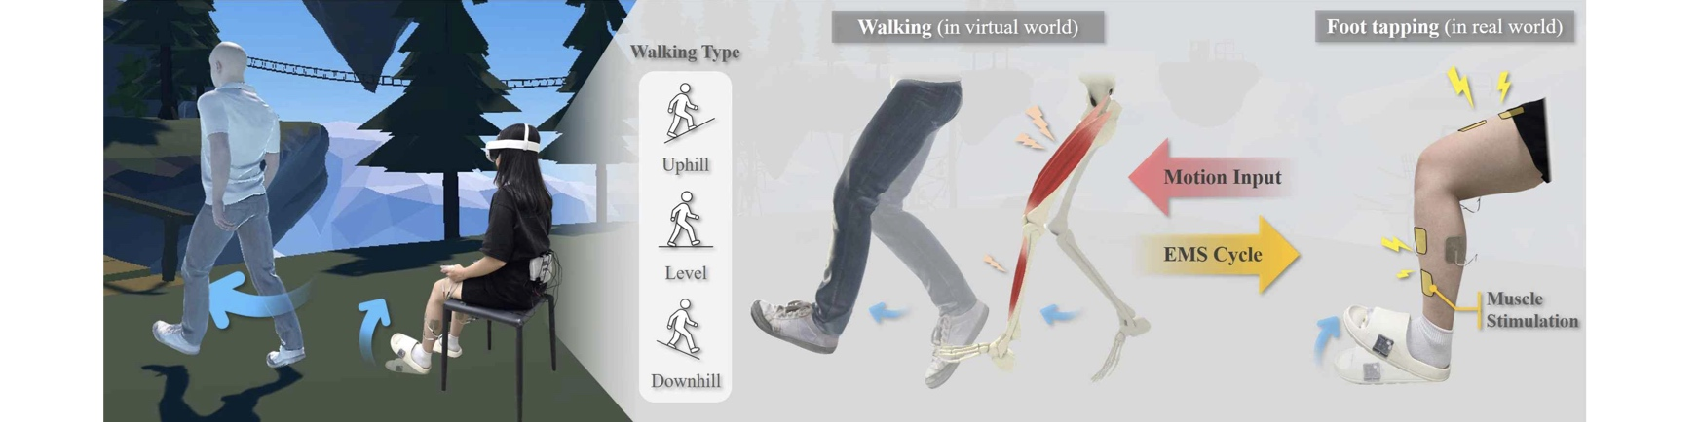

▲ Overview of the EMSWalker system. This is a virtual reality (VR) walking system where a seated user lifts and lowers their toes to make a virtual avatar walk; it provides the sensation of walking on flat ground, inclines, and declines by applying Electrical Muscle Stimulation (EMS) to the leg muscles that are activated during real-world walking.
While recent VR technology has advanced enough to create highly realistic virtual spaces, a gap remains between the visual representation of walking on screen and the physical sensation of walking.
In real-world walking, the leg muscles used and the timing of muscle exertion vary depending on whether the terrain is flat, uphill, or downhill; however, conventional methods such as simply moving one's feet while seated fail to replicate these nuances. Although specialized equipment can simulate inclined surfaces, such solutions require significant space and hardware.
The joint research team focused on the idea that by stimulating the specific muscles used during walking in sync with foot movements, even without physically walking, they could provide the user with the necessary physical sensations of walking while seated.
"EMSWalker" links a "foot-tapping" motion to the action of walking while the user lifts and lowers the front of their foot while seated. Lifting the front of the foot corresponds to swinging the leg forward in the virtual space, while lowering it corresponds to planting the foot on the ground; the walking speed adjusts according to the speed of the foot movement.
Synchronized with these foot movements, Electrical Muscle Stimulation (EMS)* is applied to key muscles involved in walking, such as the quadriceps (front of the thigh), tibialis anterior (shin), and gastrocnemius (calf), thereby replicating the sensation of leg muscle engagement experienced during actual walking.
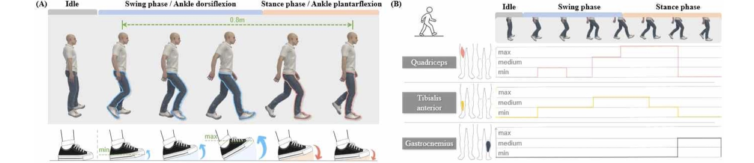

▲ Synchronization of foot movement, the gait cycle, and muscle stimulation. The action of lifting the toes corresponds to the leg-swing phase of walking, while lowering them corresponds to the stance phase (foot contact with the ground). The timing and intensity of stimulation for the quadriceps, tibialis anterior, and gastrocnemius muscles are adjusted according to the gait cycle. The timing and intensity of the stimulation were adjusted to reflect the differences in muscle usage associated with walking on flat ground, uphill, and downhill terrain.
* electrical muscle stimulation (EMS): A technology that activates specific muscles by delivering electrical impulses through electrodes attached to the skin.
The research team first conducted user experiments to determine whether applying muscle stimulation enhanced the sensation of perceiving the act of moving one's feet while seated as actual walking within a virtual space.
By stimulating leg muscles in synchronization with the phases of the walking motion, users felt as though their bodies were physically closer to their avatars in the virtual space; furthermore, the sense of embodiment where the avatar felt as an extension of one's own body was heightened compared to conditions without muscle stimulation.
Next, the researchers investigated whether users could distinguish between flat ground, uphill, and downhill terrain based solely on muscle stimulation. When provided only with muscle stimulation corresponding to the three terrains and without any visual display of walking, users identified the terrain with an accuracy rate exceeding the 33% probability of guessing correctly by chance.
Accuracy rates were 78% for uphill, 72% for flat ground, and 58% for downhill; all three figures surpassed the 33% chance-level probability.
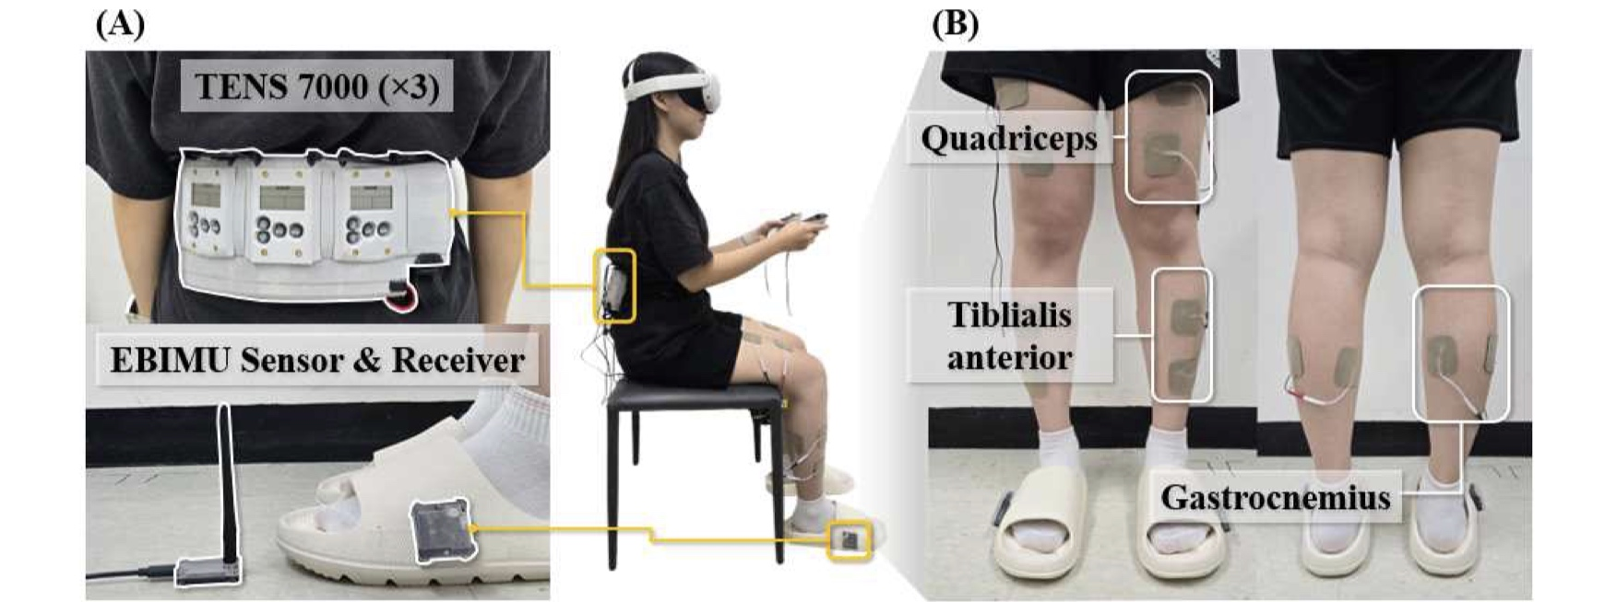

▲ Configuration of the EMSWalker system. The system consists of inertial measurement units (IMUs) to track foot movement and electrical muscle stimulation (EMS) devices. Electrodes attached to the quadriceps, tibialis anterior, and gastrocnemius muscles of both legs deliver muscle sensations synchronized with the phases of walking.
Finally, the team examined how EMSWalker influenced the virtual walking experience in a real-world VR environment featuring both flat and sloped terrain.
The researchers compared four conditions: no muscle stimulation; stimulation only upon foot contact with the ground; stimulation of the same muscles regardless of terrain; and muscle stimulation adjusted according to the terrain (flat, uphill, or downhill).
The results showed that when muscle stimulation was adjusted to match the terrain, users experienced a higher sense of "presence",the feeling of actually being inside the virtual space, compared to the other three conditions.
Conversely, there were no significant differences among the four conditions regarding VR sickness or the physical and mental strain associated with virtual walking. This study is significant in demonstrating that the physical sensations of walking on flat ground and inclines can be conveyed in virtual reality by linking user foot movements with leg muscle stimulation, without the need for large-scale equipment such as spacious walking areas or inclined floors.
It is expected that this technology will be utilized in immersive content for environments with limited physical space, such as VR games and training simulations.
Professor SeungJun Kim stated, "This research confirmed the possibility of modulating the physical sensation of walking to match the visual changes in terrain within a virtual space." He added, "We plan to expand the technology to simulate various slopes and ground characteristics, thereby creating a richer virtual locomotion experience."
This research was supervised by Professor SeungJun Kim of the GIST Department of AI and led by doctoral student Juwon Um as the first author. It was supported by the PAIR-HCI Center (Physical AI Research for Human-Centered Interaction), the Mid-career Researcher Support Program (Ministry of Science and ICT/National Research Foundation of Korea), and the ITRC (Information Technology Research Center) Support Program (Ministry of Science and ICT/Institute for Information & Communication Technology Planning & Evaluation).
The research findings are scheduled to be presented at the IEEE International Symposium on Mixed and Augmented Reality (ISMAR) 2026, an international conference taking place in Bari, Italy, from October 5 to 9, 2026. ISMAR is a premier international conference in the fields of augmented reality and mixed reality, organized by the Institute of Electrical and Electronics Engineers (IEEE).
Meanwhile, GIST announced that it is accepting inquiries from companies and organizations interested in the commercialization and industrial application of this research through the Technology Commercialization Center at the GIST Institute of Startup and Innovation (hgmoon@gist.ac.kr).

