“Creating channels in onion-like, multi-layered polymer membranes…” Joint international research team from GIST and Huazhong University of Science and Technology develops multi-layered porous particles allowing rapid molecular transport
- A joint South Korea-China research team led by Director Eunji Lee of the GIST-InnoCORE Research Group has successfully created a pore structure that fully penetrates the membrane from the inside out... Iodine adsorption capacity is approximately 1.6 times that of conventional multilayer particles
- Retains 81.6% of initial adsorption capacity even after five reuse cycles... Holds promise for applications in designing stepwise delivery systems and micro-reactors
- Published in the international journal Nature Communications


▲ (From left) Dr. Jun Ho Hwang Director Eunji Lee (Professor, Department of Materials Science and Engineering) of the GIST-InnoCORE Research Group; (Top right, from left) Professors Renhua Deng and Jintao Zhu of Huazhong University of Science and Technology (HUST).
The Gwangju Institute of Science and Technology (GIST; President Kichul Lim) announced that the research team led by Director Eunji Lee (Professor, Department of Materials Science and Engineering) of the GIST-InnoCORE Research Group in collaboration with the team of Professors Jintao Zhu and Renhua Deng from Huazhong University of Science and Technology (HUST) has successfully created novel multilayer porous particles featuring microscopic channels that allow molecules to pass through multiple membrane layers.
The "multilayer mesoporous vesosome" developed by the joint research team is a microscopic artificial particle made of polymers. Its distinctive structure features multiple membrane layers, which are arranged like the layers of an onion and compartmentalize the internal space. By incorporating tiny pores into each layer, the particle facilitates the movement of molecules from the outside, through the various layers, and into the interior.
These particles can be utilized to design delivery vehicles that compartmentalize and sequentially release various substances, or micro-reactors that facilitate a series of chemical reactions within the particle. In this study, using iodine as a test substance, the researchers confirmed that these particles absorb external molecules more rapidly than conventional non-porous multilayer particles.
* polymer: A large molecule formed by linking smaller molecules in a long chain; used to manufacture various materials, including plastics and rubber.
A "vesosome" features a structure with multiple membrane layers stacked like an onion, allowing different substances to be stored in separate layers. However, most conventional multilayer vesosomes lack pores in their membranes, making it difficult for external molecules to quickly pass through the layers to reach the interior.
It was akin to having multiple rooms but lacking the doors needed to move between them. The key lies in creating "mesopores", tiny holes measuring tens of nanometers, at regular intervals across each membrane layer to facilitate the movement of substances. A structure characterized by an abundance of such mesopores is referred to as "mesoporous."
The challenge is that creating pores in the membranes makes the structure prone to collapse, whereas maintaining membrane stability often prevents the proper formation of pores. Because the range of conditions satisfying both requirements simultaneously is extremely narrow, experimental realization is difficult.
The joint research team successfully created "multilayer mesoporous vesosomes" with regular mesopores across multiple membrane layers by simultaneously controlling the arrangement and structure of the polymers.
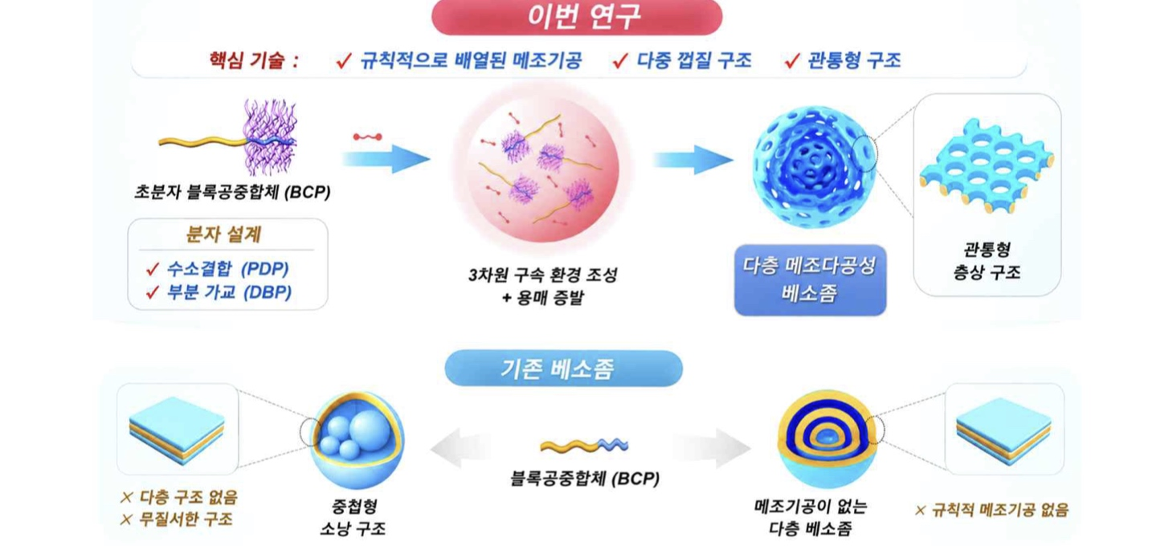

▲ Formation process of multilayered mesoporous vesosomes and structural comparison with conventional vesosomes. The diagram illustrates the process of forming multilayered mesoporous vesosomes with ordered pores across multiple membrane layers by controlling polymer arrangement and structure through 3D-confined self-assembly. The lower section highlights the structural differences between conventional vesosomes and the structures realized in this study.
The researchers attached specific components to a polymer to induce the molecules to assemble into a shape suitable for creating pores, and then cross-linked parts of the resulting multi-layered structure to stabilize it. Subsequently, by selectively removing the previously attached components, they preserved the multi-layered framework while creating microscopic pores in each layer.
To verify whether the resulting pores formed continuous channels penetrating through each layer rather than simply terminating at the particle surface, the team reconstructed the particle's interior in three dimensions. The analysis confirmed that the pores extended into channels connecting the particle's interior and exterior without being interrupted mid-layer, a structural feature observed across all the layers.
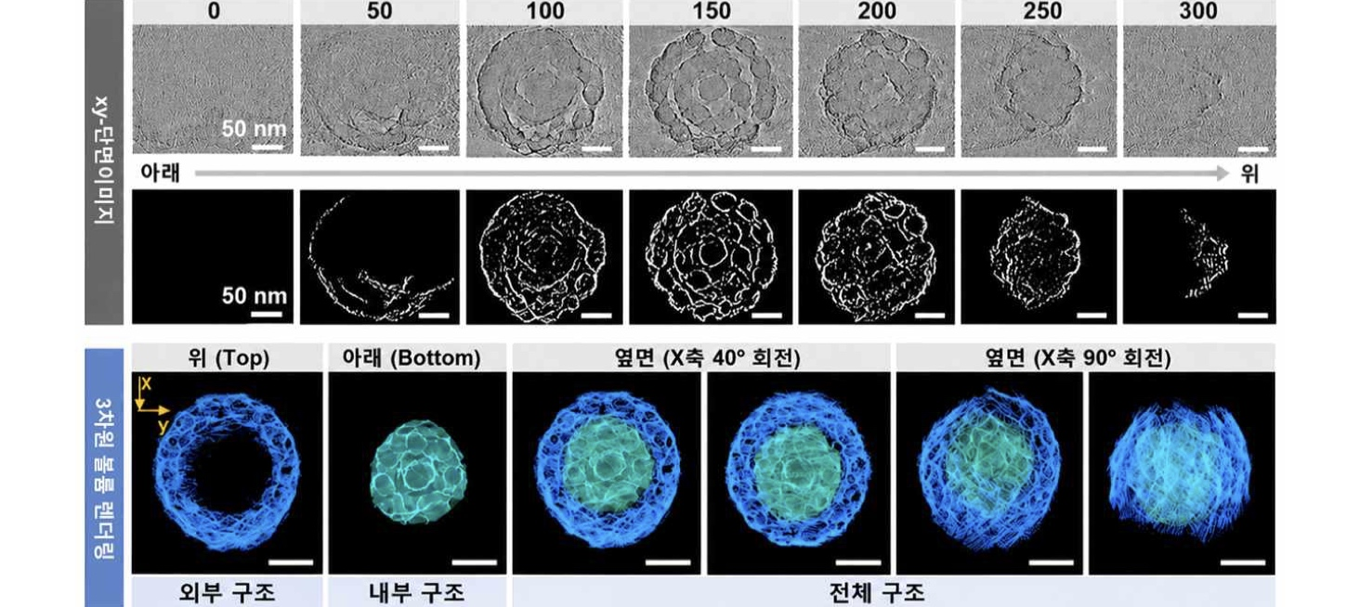

▲ 3D visualization of the multi-layered structure and penetrating pores. Electron microscopy images captured from various angles were reconstructed into a 3D model, confirming that the pores formed continuous channels penetrating from the inside to the outside across all layers.
The formation of these channels significantly increased the internal surface area of ​​the particle accessible to molecules entering from the outside. The specific surface area*, which is a measure of this accessibility, was approximately 11.2 times larger than that of conventional multi-layered particles lacking such pores. Electron microscopy revealed an average surface pore size of approximately 22.5 nanometers (nm), which is roughly one-four-thousandth the thickness of a human hair.
* specific surface area: The total surface area of ​​a given mass of material available for contact with the external environment. Generally, a higher density of pores results in a larger specific surface area.
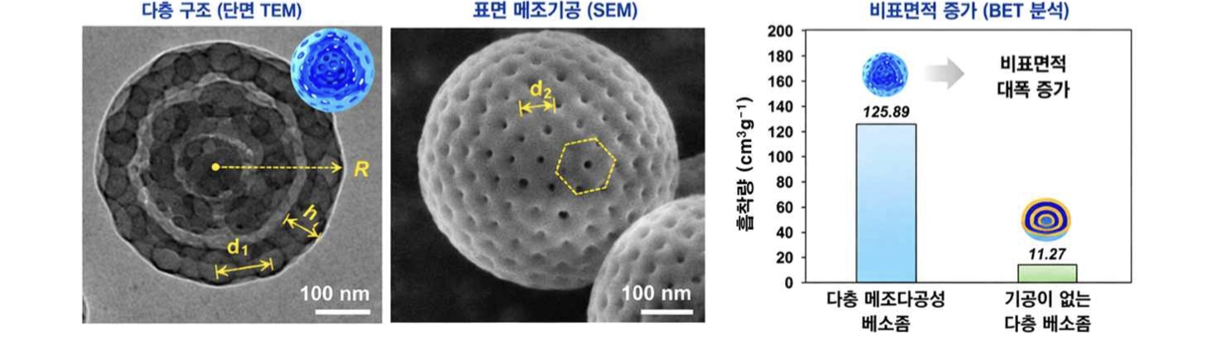

▲ Structure of a multilayered mesoporous vesosome observed via electron microscopy. Electron microscopy revealed the formation of multiple membrane layers within the particle and a regular arrangement of minute pores on its surface. The average size of these surface pores is approximately 22.5 nanometers (nm), which is about one-four-thousandth the thickness of a human hair.
To determine whether the pores penetrating the membrane layers actually facilitate the faster uptake of external molecules, the research team compared the adsorption rates of "porous particles" and "non-porous particles" using iodine, which is a substance that adheres well to the particles, as the test material.
After 30 minutes of exposure to iodine, the porous particles adsorbed 0.67 g of iodine per gram of material, taking up approximately 1.6 times more iodine than the non-porous particles (0.41 g/g) over the same period. The maximum adsorption capacity reached 1.26 g of iodine per gram of particle.
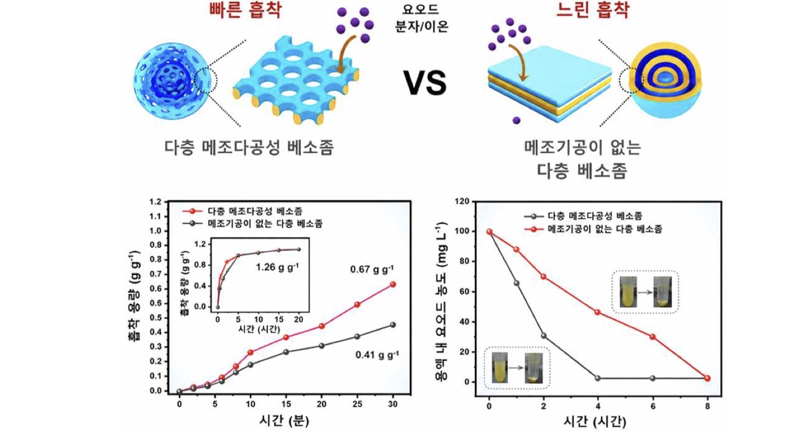

▲ Comparison of iodine adsorption rates based on the presence of through-pores. Multilayered mesoporous vesosomes featuring through-pores adsorbed iodine more rapidly than conventional multilayered vesosomes lacking such pores. After 30 minutes of exposure to iodine, the porous particles adsorbed 0.67 g of iodine per gram, which is approximately 1.6 times the amount adsorbed by the non-porous structures (0.41 g/g), and demonstrated faster adsorption rates even in water.
In experiments conducted in water, while the total amount of iodine ultimately removed by both types of particles was similar, a distinct difference was observed in the rate of adsorption.
The "porous particles" reached their maximum adsorption capacity in approximately four hours, whereas the "non-porous particles" required about eight hours. These results demonstrate that the channels created across the multiple membrane layers facilitate the rapid movement of external molecules into the particle's interior.
Even after undergoing five cycles of iodine adsorption and desorption, the "porous particles" retained 81.6% of their initial adsorption capacity.
Director Eunji Lee stated, "This study is significant for successfully creating channels that allow molecules to pass through every membrane layer while maintaining the stability of the multilayered structure." She added, "This achievement stems from our ongoing collaboration with Professor Jin-Tao Zhu—a world-renowned scholar and mentor at GIST-InnoCORE—through a joint Korea-China research program, and we intend to further advance this research through continued international collaboration."
Dr. Jun Ho Hwang, a co-first author, noted, "It was difficult to determine how the pores connected across the multiple membrane layers using only 2D electron microscopy images." He explained, "By reconstructing images taken from various angles into a 3D model, we were able to directly confirm that the pores in each layer formed continuous channels extending from the inside to the outside."
This study was led by Director Eunji Lee (Professor, Department of Materials Science and Engineering) of the GIST-InnoCORE research group and Professors Jintao Zhu and Renhua Deng of HUST (Huazhong University of Science and Technology), with Dr. Jun Ho Hwang (GIST-InnoCORE) and Mian Wang (HUST) serving as co-lead authors. The research was supported by the Korea-China Joint Research Program (funded by the Ministry of Science and ICT and the National Research Foundation of Korea) and the GIST-InnoCORE project (funded by the Ministry of Science and ICT).
The findings — Multilayer mesoporous vesosomes of block copolymer— were published online in the international journal Nature Communications.
Meanwhile, GIST announced that it is accepting inquiries from companies and organizations interested in the technology commercialization and industrial application of these research results through the Technology Commercialization Center at the GIST Institute of Entrepreneurship and Innovation (hgmoon@gist.ac.kr).

