GIST and SUNY propose 'prosthetic wrist' control method tailored to daily movements… Reduces unnecessary shoulder and elbow motion by up to 47%
- Joint research team led by Professor Jiyeon Kang (GIST Department of AI) and the University at Buffalo (SUNY) team enables real-time control of a virtual prosthetic wrist by detecting arm movements… Highlights the need for prosthetic control that accounts for both shoulder and elbow movements and user preferences
- Published in the international journal Healthcare Technology Letters


▲ (From left) Professor Jiyeon Kang (GIST Department of AI), Deepti Bharadwaj (master’s student, University at Buffalo), Ingyun Ahn (combined MS/PhD student, GIST Department of AI), and Saurabh S. Deshmukh (master’s student, University at Buffalo).
The Gwangju Institute of Science and Technology (GIST; President Kichul Lim) announced that a research team, led by Professor Jiyeon Kang of the Department of AI, has jointly developed a technology with a team from the University at Buffalo to control the wrist movements of a prosthetic hand based on specific daily activities. They also evaluated the technology's effectiveness within a virtual reality (VR) environment.
The research team controlled the prosthetic wrist to match the specific movements required for each action. For instance, they applied side-to-side tilting movements when lifting a cup or hammering, and rotational movements when turning a doorknob or a screwdriver. As a result, they observed a reduction in "compensatory movements"—unnecessary movements of the shoulder and elbow.
Powered prosthetic hands are evolving to enable a wider range of motions, such as rotating the wrist or tilting it side-to-side, in addition to simply opening and closing the hand. Consequently, controlling the prosthesis to move exactly as the user intends has become increasingly complex.
Currently, prosthetic hands are primarily controlled by using sensors to detect surface electromyography (sEMG) signals—electrical signals generated when the user moves their arm muscles.
However, as the number of controllable movements increases, the processes of switching between functions or distinguishing between multiple muscle signals can become complicated. Furthermore, sEMG signals themselves are subject to variation based on factors such as sensor placement, arm posture, and muscle fatigue.
To address these limitations, the joint research team focused on the fact that the shoulder and elbow move in conjunction with the wrist during wrist movement.
In other words, rather than controlling the prosthetic wrist solely through muscle electrical signals, the method identifies the intended direction of wrist movement based on the movement of the arm itself.
To achieve this, an inertial measurement unit (IMU)* attached to the arm measures movement; an AI system then distinguishes whether the user intends to rotate the wrist or tilt it sideways and predicts the required movement speed to operate a virtual prosthetic wrist.
* inertial measurement unit (IMU): A sensor that tracks the movement of a person or object by measuring parameters such as acceleration and rotational speed.
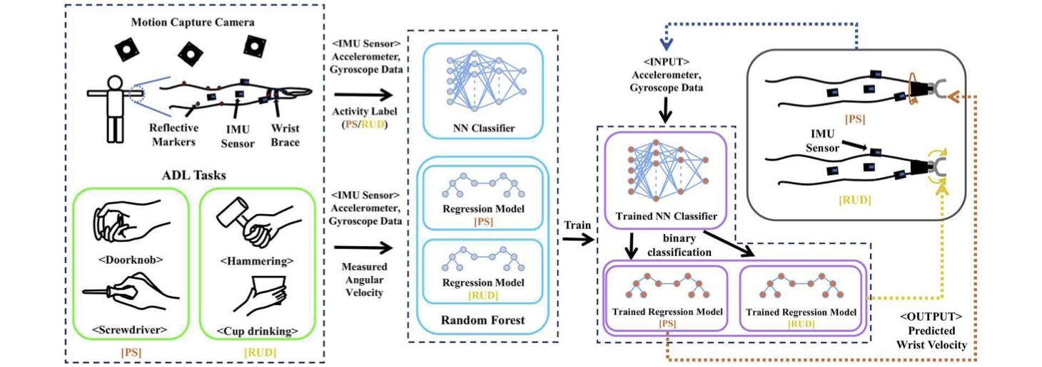

▲ Operating principle of the prosthetic wrist control technology using arm movement. The process involves measuring arm movement with an IMU to train an AI; the trained AI then analyzes arm movements to determine whether the user intends to rotate or tilt the wrist, predicts the necessary speed, and controls the prosthetic wrist accordingly.
In this study, the team implemented this prosthetic wrist control technology in real-time and evaluated which control methods were best suited for various activities of daily living.
Ten healthy adults had their wrists immobilized with a brace to prevent direct movement, and they were then tasked with performing four daily activities in a virtual reality (VR) environment, which included ▴ picking up a cup to drink, ▴ hammering, ▴ turning a doorknob, and ▴ using a screwdriver.
Participants operated a virtual prosthetic hand using three different control modes: ▴ the ‘PS mode’ (allowing only wrist rotation), ▴ the ‘RUD mode’ (allowing only side-to-side wrist tilting), and ▴ the ‘PS-RUD mode’ (allowing both movements).
Each participant used all three modes, enabling a comparison of the extent of additional shoulder and elbow movement, task completion time, and user preference for each mode.
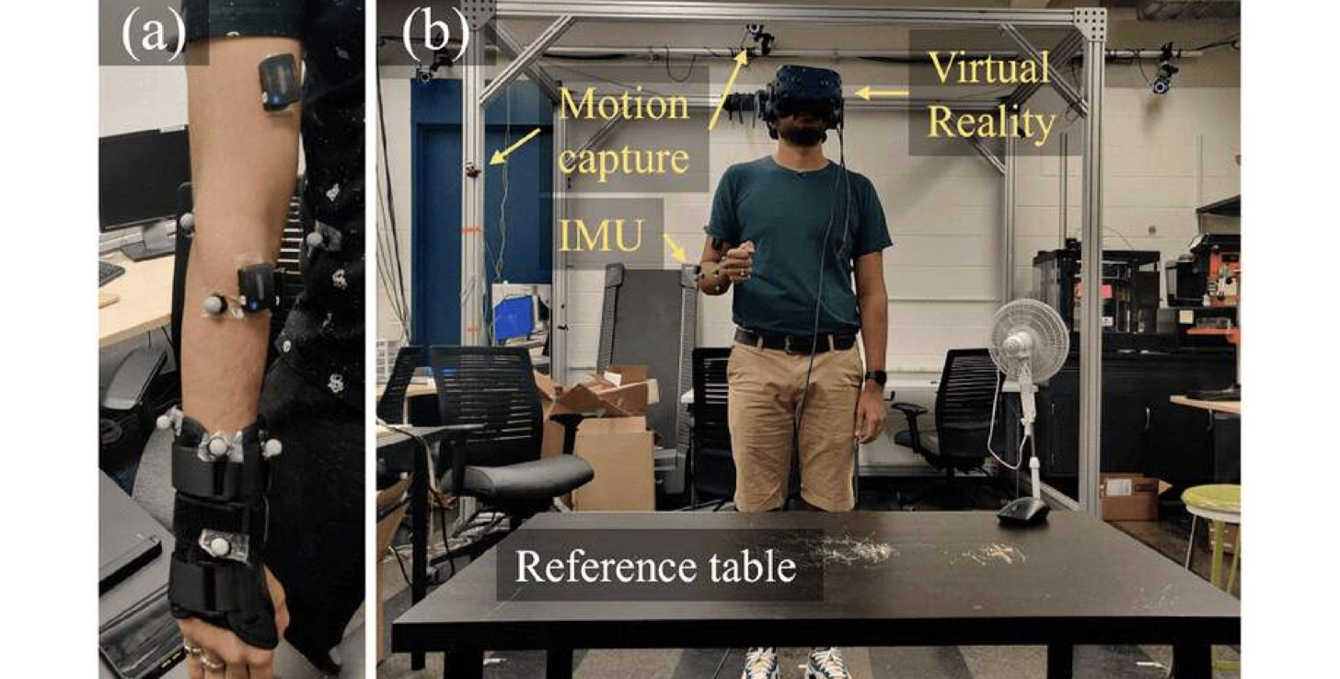

▲ Experimental setup for controlling a prosthetic wrist using virtual reality (VR). (a) The participant's wrist is stabilized with a brace, and an inertial measurement unit (IMU) and motion-tracking markers are attached to the arm. (b) The participant wears a VR headset and controls a virtual prosthetic hand using arm movements.
The results showed that unnecessary shoulder and elbow movements decreased when the prosthetic control method aligned with the wrist movements required for daily activities.
The side-to-side (RUD) method was effective for actions requiring lateral wrist tilting, such as lifting a cup to drink or hammering.
Compared to the rotational (PS) method, the side-to-side (RUD) method reduced shoulder and elbow movements by 43.86% and 27.61%, respectively, during the cup-lifting task, and by 46.94% and 22.69% during the hammering task.
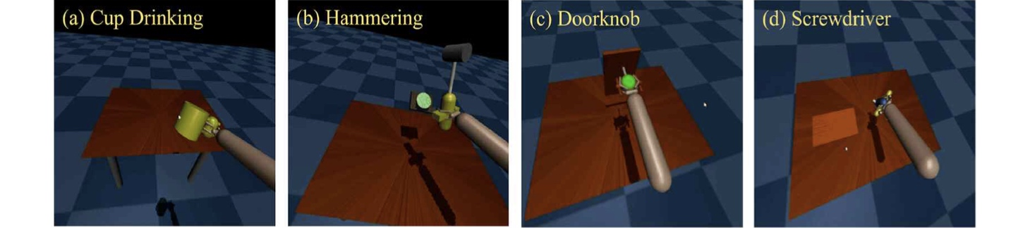

▲ Four daily living activities performed in virtual reality. The participant uses a virtual prosthetic hand to perform four daily activities: (a) lifting a cup to drink, (b) hammering, (c) turning a doorknob, and (d) using a screwdriver.
Conversely, the rotational (PS) method was effective for actions where wrist rotation is crucial, such as turning a doorknob or using a screwdriver.
Compared to the side-to-side (RUD) method, the rotational (PS) method reduced shoulder movement by 29.42% when turning a doorknob and by 27.14% when using a screwdriver. Notably, unnecessary elbow movement also decreased by 25.31% during the screwdriver task.
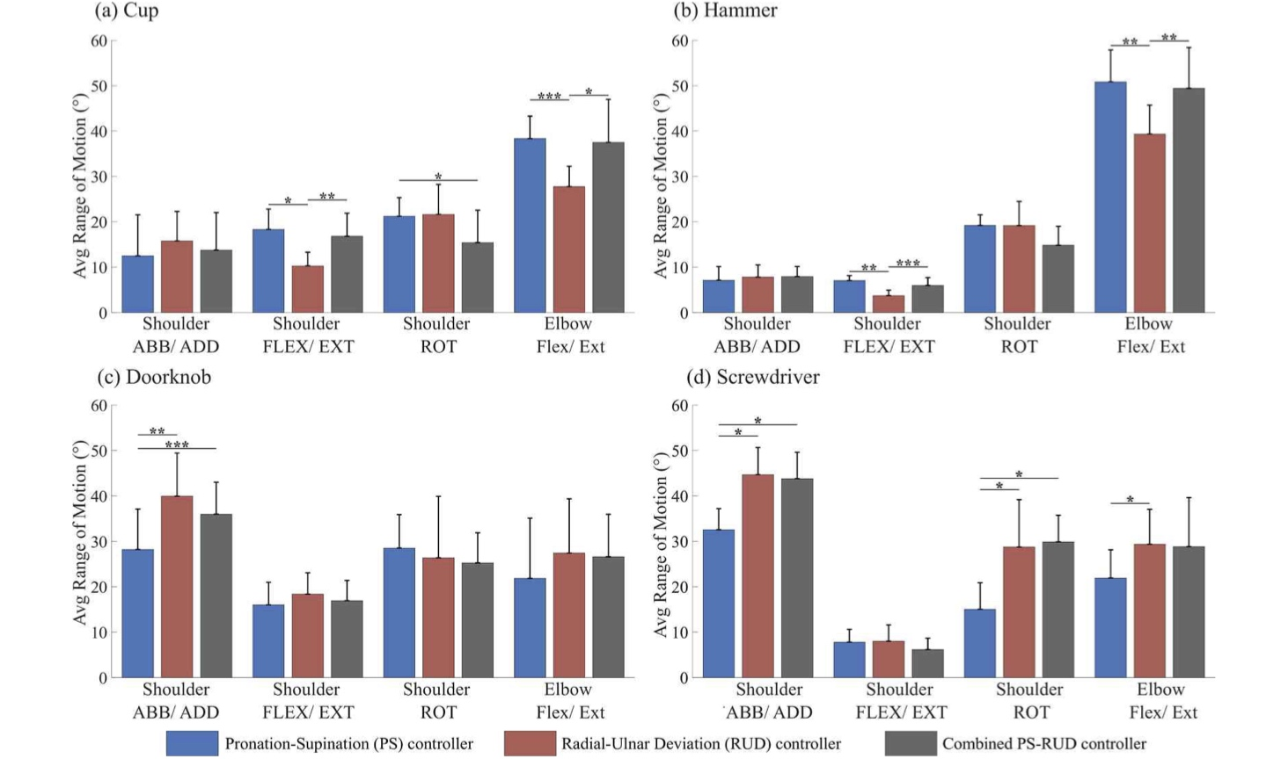

▲ Comparison of shoulder and elbow movements based on daily tasks and prosthetic wrist control methods. These results compare shoulder and elbow movements observed when participants performed four tasks—(a) lifting a cup to drink, (b) hammering, (c) turning a doorknob, and (d) using a screwdriver—using three control methods: "Pronation-Supination (PS)," "Radial-Ulnar Deviation (RUD)," and a "Combined Method (PS-RUD)" that allows for both types of movement. It was found that unnecessary shoulder and elbow movements tended to decrease when the wrist movement required for the task aligned with the control method used.
While the optimal wrist control method varied depending on the daily task, the time required to complete the movements was generally similar across all three methods.
Therefore, the significance of these results lies not in the ability to perform tasks faster with the prosthesis, but in the finding that providing wrist movements suited to the specific task can reduce the burden on users to compensate for limited range of motion using their shoulders and elbows.
However, the methods that minimized physical movement did not always align with the users' actual preferences.
Participants most preferred the combined method (PS-RUD), which allows for movement in both directions, for lifting a cup and turning a doorknob, and the radial-ulnar deviation (RUD) method for hammering. In contrast, no clear preference for a specific method emerged when using a screwdriver.
Professor Jiyeon Kang stated, "This study demonstrates the importance of designing control methods that consider not only the versatility of prosthetic movement but also the user's actual movements, preferences, and the physical burden of use." She added, "We plan to expand our validation to include actual upper-limb amputees and physical prostheses, aiming to develop prosthetic control technologies tailored to the user and their daily activities."
This research, supervised by Professor Jiyeon Kang of the Department of AI and featuring Deepti Bharadwaj (a master's student at the University at Buffalo, SUNY) as the lead author, was conducted with support from the Ministry of Health and Welfare, the Ministry of Science and ICT, the National Research Foundation of Korea (NRF), and the Institute for Information & Communication Technology Planning & Evaluation (IITP).
The findings — User-Centred Design of Multi-DoF Prosthetic Wrist Controllers: Performance and Preference in Daily Living Tasks — were published online in the international journal Healthcare Technology Letters on July 31, 2026.
Meanwhile, GIST announced that it is accepting inquiries from companies and organizations interested in the technology commercialization and industrial application of this research through the Center for Technology Commercialization at the GIST Institute for Startup and Innovation (hgmoon@gist.ac.kr).

