“Focus on ‘thin-stacking’ technology for energy-efficient memory”: GIST explores potential of next-generation magnetic control technology
- A research team led by Professor Sanghan Lee (Department of Materials Science and Engineering) reviews research trends on "multiferroic heterostructures"—systems that control magnetism using voltage rather than electric current—analyzing materials ranging from oxides to 2D materials
- The team outlines key challenges for practical device implementation, including large-area fabrication, room-temperature stability, and interface quality
- Published in the international journal Advanced Science


▲ (From left) Professor Sanghan Lee, Donghyeon Lee (combined master’s/Ph.D. student), Dr. Jiwoong Yang (postdoctoral researcher), and Inhyeok Oh (Ph.D. student) from the Department of Materials Science and Engineering at GIST.
The Gwangju Institute of Science and Technology (GIST; President Kichul Lim) announced that a research team led by Professor Sanghan Lee of the Department of Materials Science and Engineering has comprehensively analyzed a technology that reduces power consumption by controlling magnetism via electric fields, which is an alternative to the high-current methods typically used to switch magnet orientations, and has outlined the key challenges for realizing practical devices.
In particular, the team focused on paper-thin, two-dimensional (2D) materials as a solution to the limitations of conventional oxides, highlighting their potential and the advantages they offer, such as the ability to freely combine different materials and precisely control their stacking order and alignment angles.
One method of storing computer data involves using tiny magnets oriented in opposite directions to represent the binary states of "0" and "1." Technologies such as hard disk drives and magnetic memory operate on this principle.
While using magnets allows data to be retained even when the power is turned off, changing the stored data requires altering the magnet's orientation. Magnetic memory, for instance, often employs a method that relies on high electric currents to switch magnet orientations; however, this process generates heat, resulting in energy loss.
Consequently, technologies that switch magnetic states using voltage—rather than high currents—are gaining attention as low-power alternatives.
Using a water pipe analogy, voltage corresponds to "water pressure" (the force pushing the water), while current corresponds to the "volume of water" actually flowing due to that pressure. Because higher current flow leads to greater energy loss through heat, controlling magnetism via voltage can effectively reduce power consumption.
However, it is difficult to simultaneously realize both voltage responsiveness and strong magnetism within a single material.
Consequently, researchers have focused on "multiferroic"* heterojunctions, which involve creating a voltage-responsive material and a magnetic material separately and then bonding them together.
The underlying principle is that applying voltage alters the charge distribution or causes minute deformation in one material; this change is then transmitted to the adjacent magnetic layer, influencing factors such as the direction of magnetization.
* multiferroic: A system in which ferroelectricity and magnetism coexist within a single material, or where both properties are utilized in a structure combining different materials. By leveraging the magnetoelectric coupling between these two properties, magnetism can be controlled solely through voltage, making these materials promising candidates for low-power devices.
Recently, research has gained momentum on implementing these multiferroic heterojunctions using "van der Waals heterojunctions," which are formed by stacking paper-thin, two-dimensional materials layer by layer.
In conventional oxide-based heterojunctions—much like blocks that do not fit together well if their sizes or shapes differ—mismatched atomic arrangements between stacked materials can lead to structural deformation or defects.
In contrast, the layers of two-dimensional materials are held together by relatively weak forces. This allows for the precise stacking of different materials—layer by layer at the atomic scale—making it advantageous to combine materials with diverse properties and create interfaces with atomic-level precision.
Furthermore, it is possible to control not only the choice of materials but also the stacking order and the relative angles of the layers, enabling the design of diverse interactions between the two materials. Leveraging these characteristics, the researchers outlined the potential for developing next-generation spintronic devices—which utilize the electron's magnetic property known as "spin" for information storage and processing—as well as various structures capable of modulating the coupling between voltage and magnetism.
* spin: An intrinsic property of electrons that causes them to behave like tiny magnets.
*spintronics: A technology that stores and processes information by utilizing the magnetic property of electrons known as "spin."
The research team also identified key challenges that must be addressed to realize these 2D material-based multiferroic heterojunctions as practical devices.
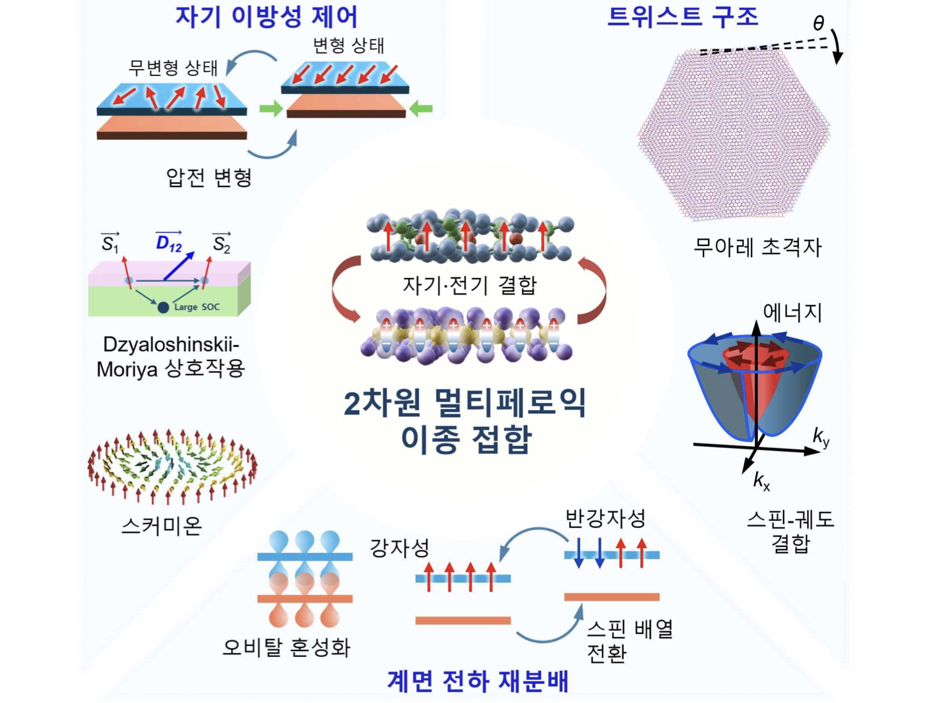

▲ Principles of magneto-electric coupling in 2D material-based multiferroic heterojunctions. (Center) Illustration of the mutual influence between electrical properties and magnetism in a heterojunction formed by stacking different 2D materials. (Surrounding) Key methods for controlling magneto-electric coupling are shown, including "magnetic anisotropy control" (altering the preferred magnetic orientation), "twisted structures" (stacking 2D materials at an angle), and "interfacial charge redistribution" (modifying charge distribution at the interface between the two materials).
First, technologies are required to produce uniform 2D materials over large areas and to maintain stable magnetic properties and voltage responses at room temperature.
Furthermore, a standardized evaluation framework is needed to objectively compare results from different studies by assessing factors such as operating temperature, the strength of magneto-electric coupling, and energy consumption.
The quality of the interface where the two materials meet is particularly critical. Because 2D materials are extremely thin—often just a few atomic layers thick—even minor contamination or defects can weaken the transmission of effects from one material to the magnetic layer. The research team emphasized the importance of securing clean, stable interfaces through fabrication processes that minimize contamination and the use of protective technologies.
Professor Sanghan Lee stated, "To reduce the escalating computing energy consumption of the AI ​​era, we need to fundamentally change the way information is stored and processed." He added, "This review paper is significant in that it comprehensively outlines the development of 'multiferroic' technology—which controls magnetism via voltage—spanning from conventional oxides to two-dimensional materials, and identifies the challenges that must be overcome to advance toward low-power memory and logic devices."
This research was supervised by Professor Sanghan Lee of the Department of Materials Science and Engineering at GIST, with Donghyeon Lee (combined MS/PhD student), Jiwoong Yang (postdoctoral researcher), and Inhyeok Oh (PhD student) serving as co-first authors. The study was supported by the Ministry of Science and ICT and the National Research Foundation of Korea (RS-2025-00563779), as well as the Ministry of Science and ICT’s InnoCORE program (1.260007.01).
The research findings — Van der Waals Heterostructures for Next-Generation Spintronics: Multiferroic-Mediated Magnetoelectric Properties — were published online in the international journal Advanced Science on August 21, 2026.

