“The AI will handle that—could you just take a look at this?” GIST develops technology that reduces data annotation burden by 46% by dividing roles between ai and humans
- A research team led by Professor Kyoobin Lee of the Department of AI has developed a data annotation system that utilizes AI-generated annotations and automates high-confidence AI predictions, allowing humans to focus on data requiring judgment
- Compared to manual annotation of all data, the system reduces annotation time by 68.4%; it also cuts time by 46.3% compared to existing "active learning + AI-assisted annotation" methods, while simultaneously improving AI image recognition performance
- The research has been published in the international journal Intelligent Systems with Applications
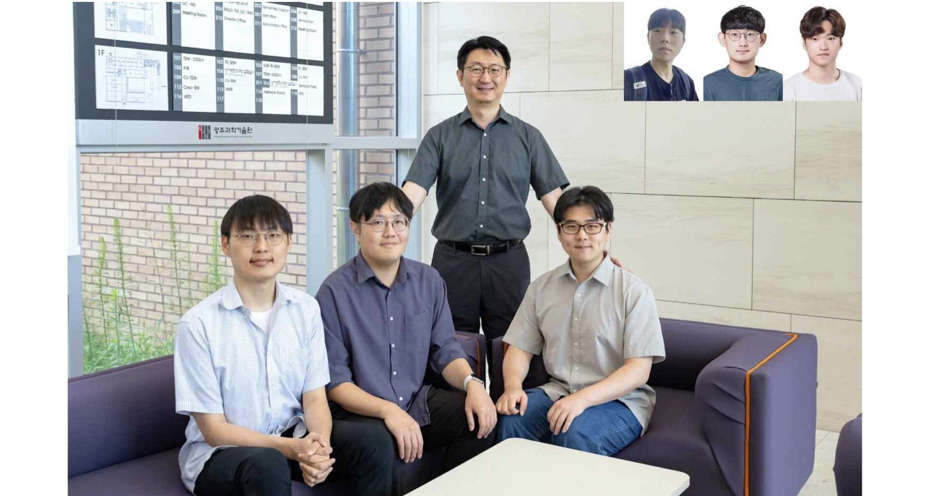

▲ Group photo of the research team led by Professor Kyoobin Lee of the GIST Department of AI. (From left) GIST undergraduate student Seunghyeok Hyun (Department of Electrical Engineering and Computer Science), PhD student Jongwon Kim (Department of AI), Professor Kyoobin Lee, PhD student Yunjae Heo; (Top right, from left) master’s student Youmin Park (Department of AI), Dr. Yeonguk Yu (ETRI), and Dr. Seongju Lee (HD Hyundai Robotics).
The Gwangju Institute of Science and Technology (GIST; President Kichul Lim) announced that a research team led by Professor Kyoobin Lee of the Department of AI has developed a technology that significantly reduces the burden of "data annotation"—the process of marking object locations and regions in images to create ground-truth data for AI training.
This technology expands the scope of data that AI can learn from autonomously; it automatically processes results where the AI ​​has high confidence while focusing human review on cases that are difficult to judge. This approach enables the construction of AI training data with less time and effort compared to conventional methods, which require humans to manually check and correct every piece of data.
For AI to be utilized in real-world environments—such as in autonomous vehicles or underwater exploration robots—vast amounts of image data covering diverse scenarios are required.
In particular, training AI to accurately recognize objects within images necessitates human intervention to manually mark the "correct answers." This process is known as "data annotation."
For instance, if a single photograph of a road contains multiple cars, each vehicle must be individually identified and marked. The research team focused on "instance segmentation," a technique that goes a step further by delineating the boundaries of each object in an image at the pixel level. This explains why processing even a single image demands significant time and effort.
To alleviate this burden, "active learning" methods have traditionally been employed. This approach involves the AI ​​selecting images that are either particularly useful or challenging for learning and then requesting human annotation for them.
However, since this method relies on training the AI ​​primarily with data that has already been annotated by humans, it suffers from the limitation that a vast number of unannotated images remain underutilized.
Furthermore, the AI's "confidence level"—an indicator of how accurately it believes it is making a judgment—does not always align with its actual accuracy. This discrepancy can widen, especially when the dataset contains an imbalance of specific object types.
To address these limitations, the research team developed a new data annotation system that combines "semi-supervised learning" with active learning and calibrates the AI's confidence levels based on data characteristics.
The method developed by the team can be understood in three main stages.
First, the system incorporates images that have not been manually annotated into the AI ​​training process. Next, it selects images that are difficult for the AI ​​to learn from or that offer valuable new information, subsequently requesting human annotation for them. Finally, AI-generated predictions are categorized based on confidence levels; high-confidence results are automatically accepted without human intervention, while only ambiguous results undergo manual review.
Notably, rather than simply relying on the raw confidence scores provided by the AI, the research team adjusted these scores by taking into account factors such as the type and frequency of objects appearing in the images. This is because actual accuracy can differ between frequently and rarely occurring objects, even when the AI ​​assigns them the same level of confidence.
* semi-supervised learning: A method of training a model using a combination of a small amount of labeled data and a large amount of unlabeled data.
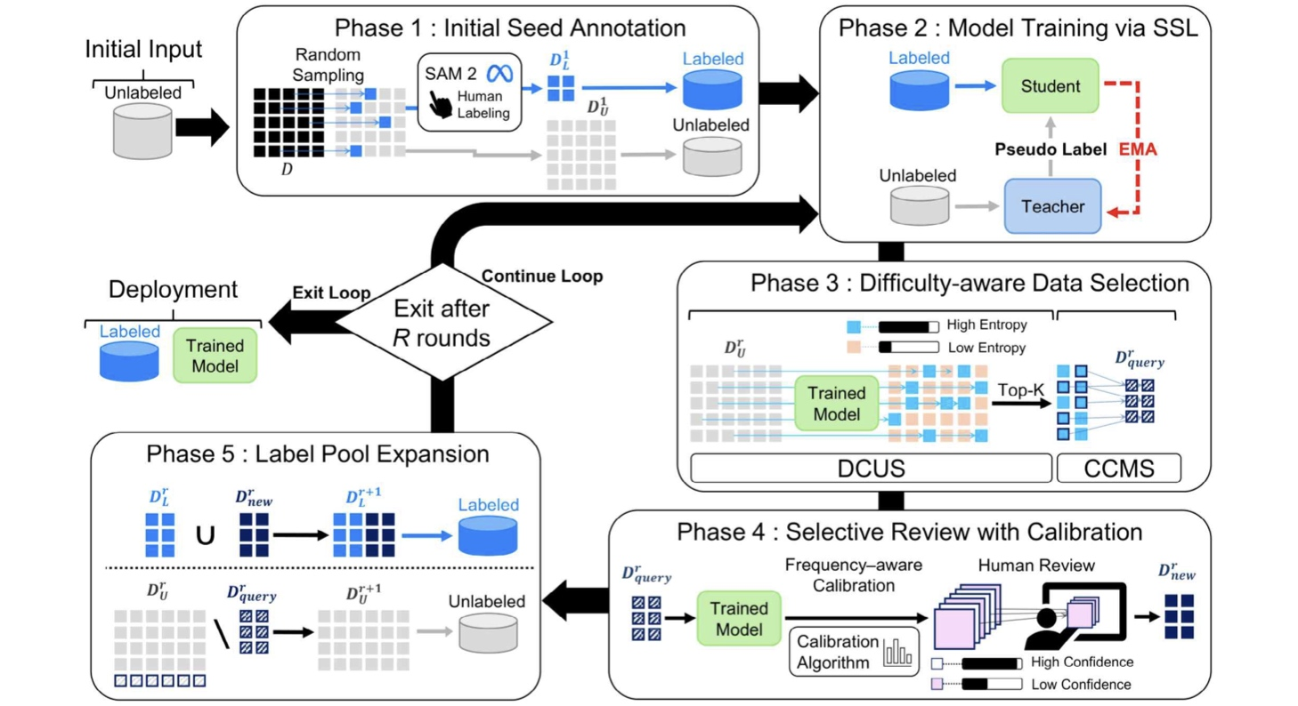

▲ The operational process of the AI ​​training data annotation system developed by the research team. The system utilizes both labeled and unlabeled images for AI training, selects images beneficial for learning, and has humans add annotations to them. AI predictions are either processed automatically based on confidence levels or reviewed by humans, and this process—incorporating the newly generated labeled data back into training—is repeated.
To verify the effectiveness of the proposed system, the research team conducted experiments using "Cityscapes," a real-world road environment image dataset commonly used in autonomous driving research.
Five participants with experience in data annotation performed annotation tasks on 150 urban road images over five rounds, comparing the performance of three methods: ▴ manual annotation, ▴ an existing method (combining active learning with AI-assisted annotation), and ▴ the method developed by the research team.
The results showed that using the research team's method reduced the time humans spent on data annotation by 46.3% compared to the existing method and by 68.4% compared to manual annotation.
At the same time, the AI's image recognition performance improved.
In the final stage, the research team's method achieved a "Mask Average Precision (mask AP)*" score of 30.3, outperforming the existing method (28.5) by 1.8 points and the manual annotation method (25.8) by 4.5 points.
* mask average precision (mask AP): A key evaluation metric representing the overall accuracy with which an AI identifies object types and contours. A higher value indicates better performance.
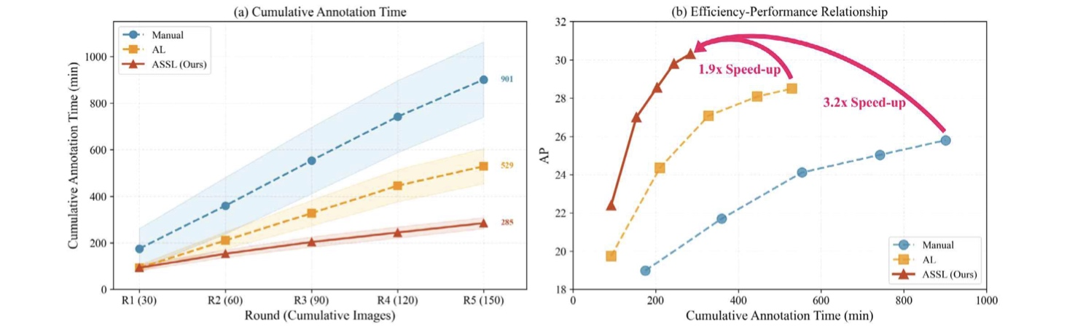

▲ Comparison of human labor time and AI image recognition performance based on data annotation methods. (Left) The research team’s method reduced the time required for humans to annotate 150 urban road images by 68.4% compared to the "manual annotation from scratch" method and by 46.3% compared to the "conventional active learning" method. The shaded areas in the left graph represent the standard deviation of task times among participants. (Right) While reducing task time, the system achieved a higher "mask Average Precision (mask AP)" than both the "manual annotation from scratch" and "conventional active learning" methods.
Furthermore, the research team’s system automatically processed 74.3% of the AI-generated predictions—those designated for subsequent review—without human intervention, achieving a precision rate of 85.8% for these automatically processed results.
This demonstrates that by selecting highly reliable AI predictions for use without human verification, the burden on humans to manually review every single prediction result can be alleviated.
To further verify the technology's potential applications, the research team also evaluated its performance in instance segmentation using underwater images. The results showed that the team's method outperformed existing methods by 1.6 percentage points.
Professor Kyoobin Lee stated, "The core of this research lies in assigning data-processing tasks to the AI ​​while allowing humans to focus solely on areas requiring critical judgment." He added, "We expect this to help reduce the time and burden associated with data generation in fields that require the continuous creation of training data for new environments, such as autonomous driving and underwater exploration robotics."
This research, supervised by Professor Kyoobin Lee of the Department of AI and featuring Ph.D. candidate Jongwon Kim as the lead author, was supported by the "Human-Centric AI Core Technology Development" project (Project No. RS-2022-II220951) funded by the Ministry of Science and ICT and the Institute for Information & Communication Technology Planning & Evaluation (IITP).
The research findings — Human-efficient annotation system via active semi-supervised learning and selective review— were published online on July 15, 2026, in Intelligent Systems with Applications, an international journal in the field of information systems.
Meanwhile, GIST announced that it is accepting inquiries from companies and organizations interested in the technology commercialization and industrial application of these research results through the Technology Commercialization Center at the GIST Institute for Startup and Innovation (hgmoon@gist.ac.kr).

