GIST and DGIST develop inorganic semiconductor wearable optical sensor capable of separately detecting red and near-infrared light
- Joint research teams led by Professors Haneol Lee (GIST) and Taehun Lee (DGIST) distinguish between red light and near-infrared light by stacking 2D semiconductor and silicon layers
- The device distinguishes the two types of light and boosts electrical signals without separate optical filters, achieving up to a 9.82-fold increase in photocurrent
- A wrist-mounted sensor enables real-time monitoring of changes in heart rate and blood oxygen saturation; findings published in the international journal eScience
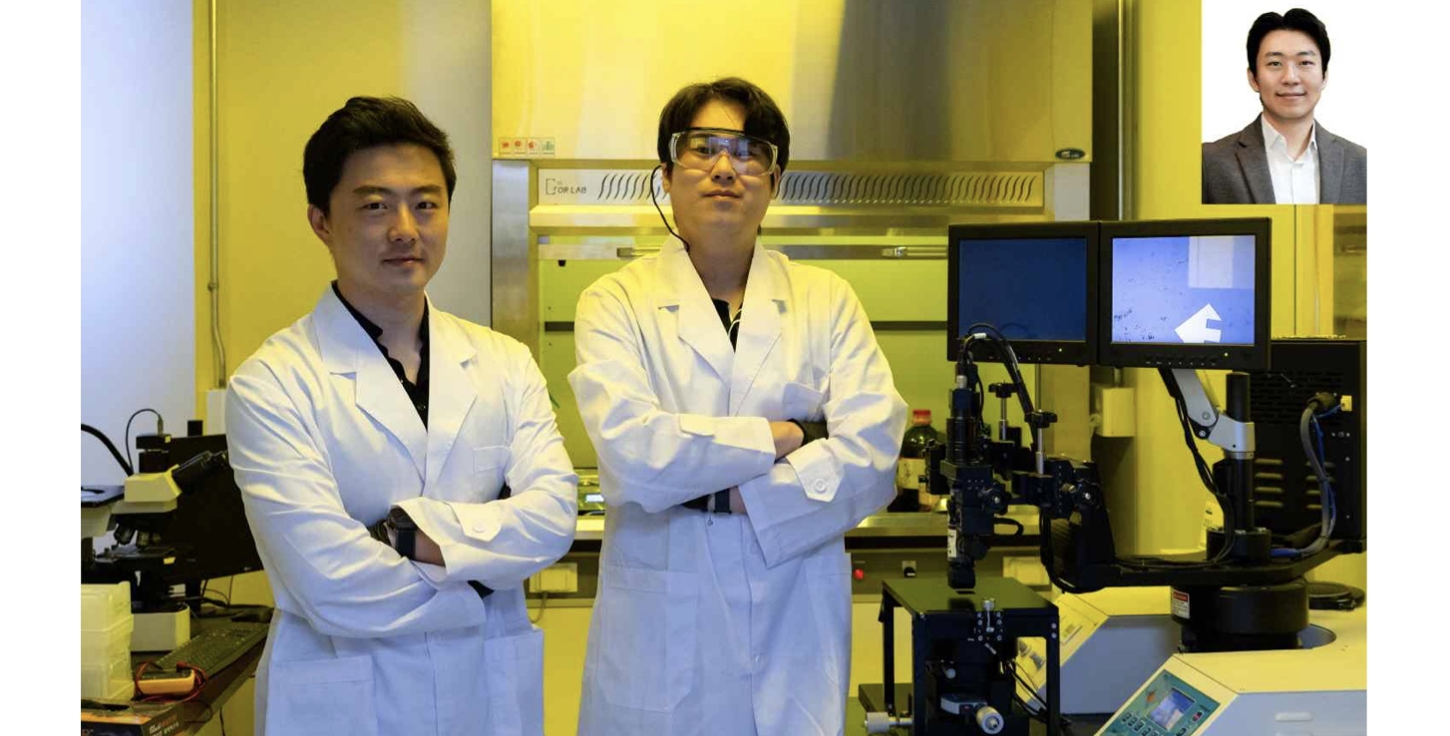

▲ (From left) Professor Haneol Lee (Department of Materials Science and Engineering, GIST), Ph.D. candidate Jeong Hyeon Kim (Division of Advanced Materials Engineering, Jeonbuk National University); (Top right) Professor Taehun Lee (Department of Energy Science and Engineering, DGIST)
The Gwangju Institute of Science and Technology (GIST, President Kichul Lim) announced that a research team led by Professor Haneol Lee (Department of Materials Science and Engineering), in collaboration with a team led by Professor Taehun Lee (Department of Energy Science and Engineering, DGIST), has developed an inorganic semiconductor-based wearable optical sensor capable of distinguishing and detecting light of different wavelengths within a single, compact device.
The joint research team stacked an ultra-thin, two-dimensional semiconductor (only a few atomic layers thick) with silicon. This structure enabled the sensor to separately detect "red light" and "near-infrared" signals while enhancing the electrical response to light.
By attaching the developed optical sensor to the wrist, the team successfully demonstrated its potential as a wearable biosignal sensor by monitoring changes in heart rate and blood oxygen saturation (SpO₂)* in real time.
* blood oxygen saturation (SpO₂): An indicator representing the proportion of hemoglobin bound to oxygen among the total hemoglobin in the blood.
When measuring heart rate or blood oxygen saturation with a smartwatch, light is shone onto the skin, and a sensor detects the reflected light, which varies based on blood volume and oxygenation levels.
In particular, measuring blood oxygen saturation relies on the fact that oxygenated and deoxygenated hemoglobin absorb red light and near-infrared light differently; therefore, it is crucial to distinguish and detect the reflected signals from these two types of light without them interfering with each other.
While inorganic semiconductors like silicon are stable and offer excellent optical sensing performance, stacking different inorganic semiconductors in multiple layers requires precise alignment of their crystal structures, making it difficult to create a single, compact sensor capable of distinguishing and detecting multiple wavelengths of light.
To overcome this limitation, the research team focused on "two-dimensional (2D) semiconductors," which can be stacked in thin layers—much like sheets of paper.
Unlike conventional inorganic semiconductors, 2D semiconductors can be layered with other semiconductors without requiring precise alignment of their crystal structures.
The joint research team created a single photodetector by stacking two 2D inorganic semiconductors—tungsten disulfide (WS₂) and molybdenum disulfide (MoS₂)—and then vertically stacked this assembly onto a silicon photodetector.
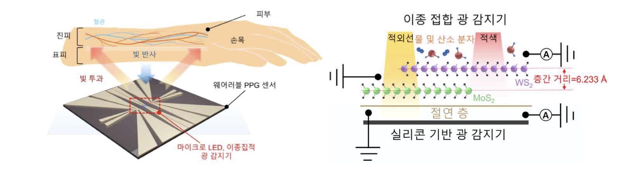

▲ Structure and operating principle of a wearable optical sensor featuring a vertical stack of 2D semiconductors and silicon. (Left) A conceptual diagram of the wearable sensor, which measures biological signals by shining red and near-infrared light onto a wrist-mounted sensor and detecting the reflected light. The heterojunction photodetector positioned at the top is created by stacking two types of 2D semiconductors—tungsten disulfide (WS₂) and molybdenum disulfide (MoS₂)—allowing it to respond strongly to red light, while near-infrared light passes through this layer to be detected by the underlying silicon photodetector. An insulating layer between the two photodetectors prevents their electrical signals from mixing, enabling the distinct detection of the two types of light without the need for separate optical filters.
This upper 2D semiconductor photodetector responds strongly to red light, whereas near-infrared light passes through the upper 2D semiconductor layer and is detected by the silicon photodetector below.
An electrically insulating layer was placed between the two photodetectors to ensure that signals from red light and near-infrared light could be measured separately without interference. This enabled the device to distinguish and detect the two types of light without the need for separate optical filters.
In addition to distinguishing between the two types of light, the research team enhanced the electrical signals generated by the sensor upon exposure to light. They achieved this by leveraging atomic-scale defects formed during the process of stacking the two 2D semiconductors.
Experimental and computational results revealed that appropriate heat treatment altered the interaction between these microscopic defects and surrounding air molecules; this changed the electronic state of the semiconductor and amplified its response to light.
As a result, the "photocurrent"—the electrical signal generated in response to red light—increased by up to 9.82 times compared to single-layer semiconductor photodetectors. Furthermore, the "responsivity"—a measure of the current (A) generated relative to the incident light power (W)—reached a peak of 97 amperes per watt (A/W).
To verify the sensor's ability to detect human biosignals, the joint research team integrated it with miniature LEDs emitting red and near-infrared light to create a wrist-worn sensor.
When worn on the wrist, the sensor continuously detected blood flow changes associated with the heartbeat and clearly captured fluctuations during experiments involving the temporary occlusion and subsequent restoration of blood flow.
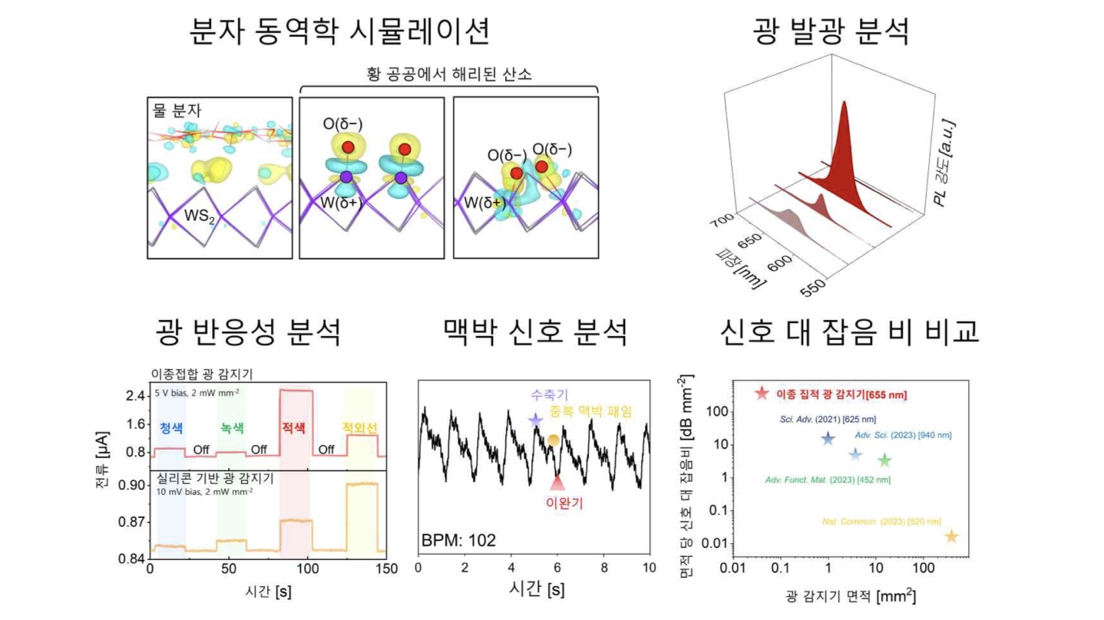

▲ Principles behind the performance enhancement of the 2D semiconductor photodetector and results of wearable biosignal monitoring. The study demonstrates the principle and experimental results of boosting electrical responses to light by controlling the interaction between ambient air molecules and microscopic defects formed during the stacking process of 2D semiconductors. The developed sensor responded to both red and near-infrared light and continuously detected blood flow changes associated with the heartbeat when attached to the wrist. Additionally, the sensor exhibited a superior signal-to-noise ratio (SNR)—adjusted for sensor area—compared to existing wearable photodetectors cited in the study.
Notably, the SNR for red light reached 14.5 decibels (dB), representing a 221% improvement over conventional silicon photodetectors; the area-adjusted SNR was 23 times higher than that of the wearable photodetectors used for comparison in the paper.
Using signals obtained from red and near-infrared light, the researchers estimated real-time changes in blood oxygen saturation (SpO₂), observing a drop during breath-holding and a recovery upon the resumption of breathing.
* signal-to-noise ratio (SNR): A value indicating the clarity of a target signal relative to background noise; a higher value allows for clearer distinction of the desired signal.
Professor Haneol Lee of the Department of Materials Science and Engineering stated, "This research is significant in demonstrating that vertically combining different inorganic semiconductors allows a single compact sensor to distinguish between light of different wavelengths while simultaneously enhancing photocurrent." He added, "We anticipate that this technology will be utilized to develop wearable healthcare sensors capable of continuously monitoring various biosignals, such as heart rate and blood oxygen saturation."
This research—supervised by Professor Haneol Lee (Department of Materials Science and Engineering, GIST) and Professor Taehun Lee (Department of Energy Science and Engineering, DGIST), with Ph.D. candidate Jeong Hyeon Kim (Division of Advanced Materials Engineering, Jeonbuk National University) serving as the lead author—was supported by the Ministry of Science and ICT/National Research Foundation of Korea, Gwangju Metropolitan City/Gwangju RISE Center, the Ministry of Education/National Research Foundation of Korea, and the POSCO Science Fellowship of the POSCO TJ Park Foundation.
The research findings — Spectrally decoupled, signal-boosted photodetection via vertical 2D/3D heterointegration for non-invasive biosignal monitoring— were published online on August 11, 2026, in the international materials science journal eScience.
Meanwhile, GIST announced that it is accepting inquiries from companies and organizations interested in the technology commercialization and industrial application of these research results through the Technology Commercialization Center at the GIST Institute for Startup and Innovation (hgmoon@gist.ac.kr).

