GIST-InnoCORE develops composite polymer material capable of distinguishing and remembering the direction of light rotation… Enabling 'electrical fingerprints' that are difficult to replicate
- Joint research team led by Professors EunjiLee (GIST) and YoungMinSong (KAIST) combines light-discriminating helical polymers with information-storing ferroelectric polymers to generate unique 256-bit information for each device
- Generates a unique "security key" for each device; potential applications in optical security and hardware authentication
- Published in the international journal Small


▲ (From left) Director Eunji Lee of the GIST-InnoCORE research group (Professor, Department of Materials Science and Engineering) and Dr. Jung-Min Ji.
The Gwangju Institute of Science and Technology (GIST; President Kichul Lim) announced that a research team led by Director Eunji Lee of the GIST-InnoCORE group (Professor, Department of Materials Science and Engineering) and Mentor Professor Young Min Song of the KAIST School of Electrical Engineering has developed a "hybrid polymer material" capable of distinguishing the rotational direction of light and storing that information as an electrical state.
Light can rotate in either a left-handed or right-handed direction. The research team developed a material that not only distinguishes between light rotating in these different directions but also retains the information as an electrical state even after the light source is removed.
Devices utilizing this material were able to generate unique "electrical fingerprints"—specifically, distinct 256-bit data sequences unique to each device—derived from the device's electrical characteristics. By leveraging minute variations that occur during the fabrication process, this technology demonstrates potential for future applications in optical security and hardware authentication.
Light propagates as oscillating electric and magnetic fields; some light travels with its electric field rotating in a specific direction—a phenomenon known as "circularly polarized light" (CPL).
Circularly polarized light is categorized into left-handed and right-handed forms based on the direction of the electric field's rotation. Being able to distinguish between these rotational directions allows them to serve as distinct information signals, enabling applications in optical communication, information processing, and security technologies.
The challenge lies in the fact that distinguishing light and retaining the resulting information are separate functions. While conventional optical materials can differentiate between left- and right-handed circularly polarized light while illuminated, they struggle to preserve that distinction once the light source is removed.
To address this, the research team integrated the ability to distinguish the rotational direction of light with the ability to electrically store that information within a single material.
The key was combining a helical polymer with a "ferroelectric polymer" capable of retaining an electrical state. The helical polymer distinguishes between left- and right-handed circularly polarized light, while the ferroelectric polymer—leveraging its property of maintaining an electrical state even after an external electric field is removed—preserves the information.
Rather than simply mixing the two polymers, the team designed a nanoscale structure that allowed them to be combined while preserving their respective functions.
First, utilizing the polymers' self-assembling nature to form ordered structures, the team created two types of helical polymer nanowires (P-type and M-type) that twisted in opposite directions. They achieved this by altering the molecular structures to control the direction of the polymer's twist.
The nanowires feature a structure in which a light-responsive polymer (P3HT) is encapsulated by an outer layer of PMMA. P3HT forms a helical structure and responds differently to left- and right-circularly polarized light, while PMMA facilitates interaction with the ferroelectric polymer to be incorporated later.
Transmission electron microscopy (TEM) observations revealed that the P-type and M-type nanowires formed helical structures with opposite chiralities; spectroscopic analysis further confirmed that their light-response characteristics differed based on the helical direction.
* nanowire: A nanometer-scale, extremely thin, wire-like structure.
Subsequently, the research team fabricated hybrid films by combining the P-type and M-type nanowires with a ferroelectric polymer.
TEM observations of the film's interior confirmed that the helical structures of the nanowires were maintained even after integration with the ferroelectric polymer.
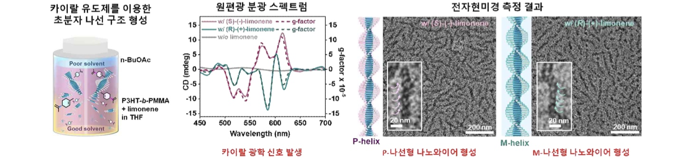

▲ Structures and chiral optical properties of ‘P-helical’ and ‘M-helical’ polymer nanowires. Transmission electron microscopy (TEM) observations reveal that the two nanowires exhibit helical structures with opposite orientations. Spectroscopic analysis also showed opposing chiral optical signals.
Measurements of electrical properties confirmed the retention of ferroelectric characteristics—specifically, the maintenance of an electrical state even after the external electric field was removed. This establishes a foundation for recording the helical polymers' selective response to circularly polarized light as electrical information.
The research team applied the fabricated hybrid polymer material to an actual device to verify whether distinct electrical states could be recorded based on the rotational direction of circularly polarized light.
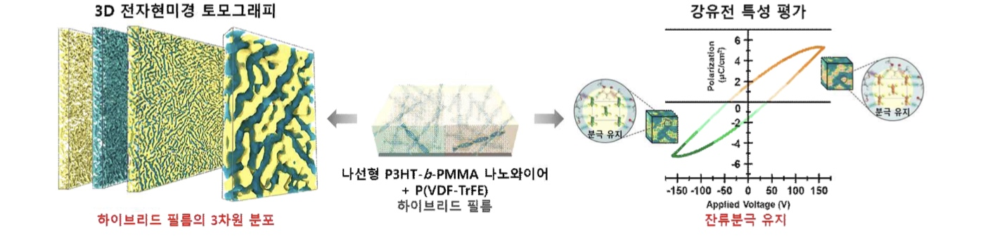

▲ 3D structure and ferroelectric properties of the hybrid film. 3D analysis using TEM demonstrates that the helical nanowires maintain their structure while distributed within the ferroelectric polymer matrix. Additionally, polarization-voltage (P-V) measurements confirmed that the hybrid film retained its ferroelectric properties and "remanent polarization."
When the device was exposed to left- and right-circularly polarized light while measuring electrical properties, the magnitude of the "remanent polarization" was found to vary according to the light's rotational direction. In other words, distinct electrical states were recorded in the device depending on the rotational direction of the incident light.
Notably, devices utilizing P-type and M-type helices (with opposite helical orientations) exhibited opposite electrical responses to left- and right-circularly polarized light. This confirmed that the helical polymer structure could be used to distinguish the rotational direction of circularly polarized light and convert that information into an electrical signal.
? * remanent polarization: An electrical state that remains within a material even after an externally applied electric field is removed.
Furthermore, the research team implemented a Physical Unclonable Function (PUF)* by converting electrical states measured at various locations within the device into 0s and 1s, thereby generating a unique 256-bit "electrical fingerprint" for each device.
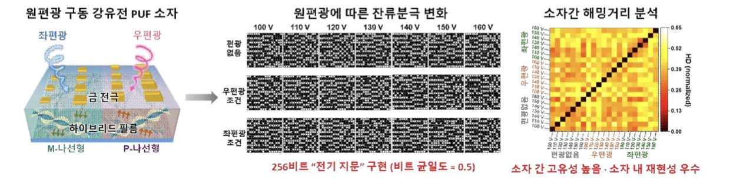

▲ Generation and identification of a 256-bit "electrical fingerprint" using circularly polarized light information. The image shows the 256-bit "electrical fingerprints" generated by converting the electrical responses of "P-helical" and "M-helical" devices—based on left- and right-circularly polarized light—into 0s and 1s, along with the results of comparisons between devices. While distinct devices exhibited different electrical fingerprints, the same device produced similar fingerprints upon repeated measurements, confirming both device-to-device uniqueness and intra-device reproducibility.
Comparisons between different devices revealed that, on average, approximately 40% of the 256 bits differed; conversely, repeated measurements of the same device consistently yielded similar electrical fingerprints.
This demonstrates that the minute variations inherent in each device's fabrication process manifest as distinct, unique information that can be consistently verified within the same device. In other words, the team successfully implemented the characteristics of a PUF, capable of generating and verifying unique security information for each device.
* Physical Unclonable Function (PUF): A technology that generates unique, difficult-to-clone security information for each device by utilizing the minute variations that naturally occur during the fabrication process of materials or devices.
Director Eunji Lee of the GIST-InnoCore Research Group stated, "This research is significant in that it integrates two functions—distinguishing the rotational direction of light and storing that information as an electrical state—into a single hybrid polymer material." She added, "We anticipate that this technology will expand into new functional materials for applications such as optical security and hardware authentication."
Dr. Jung-Min Ji remarked, "This study is the result of interdisciplinary research achieved through the GIST-InnoCore Research Group's collaborative framework (Co-Lab), combining chiral polymer self-assembly and material design technologies with optics and optoelectronic device technologies." He continued, "It is particularly meaningful for linking the material's selective response to light with the actual electrical functionality of a device."
This research was supervised by Director Eunji Lee (Professor, Department of Materials Science and Engineering) of the GIST-InnoCore Research Group and Professor Young Min Song (Department of Electrical Engineering) at KAIST, with GIST-InnoCore Fellow Dr. Jung-Min Ji serving as the lead author. The study was supported by the Basic Research Program and Korea-China Joint Research Program (Ministry of Science and ICT/National Research Foundation of Korea), the Grand Challenge (GC) Program (Korea Institute of Science and Technology, KIST), and the GIST-InnoCore Program (Ministry of Science and ICT).
The research findings — Crystallization-Driven Helical Conjugated Polymer Nanowires for Circularly Polarized Light-Addressable Ferroelectric Physical Unclonable Functions — were published online in the international journal Small on August 18, 2026.
Meanwhile, GIST announced that it is accepting inquiries from companies and institutions interested in the technology commercialization and industrial application of these research results through the Technology Commercialization Center at the GIST Institute of Entrepreneurship and Innovation (hgmoon@gist.ac.kr).

