GIST proposes antibody design principle to 'switch off' in normal tissue and reactivate around tumors
- A research team led by Professor Inchan Kwon of the Department of Materials Science and Engineering has proposed a novel design method that restores an antibody's ability to bind to cancer-targeting proteins only when needed—precisely controlling the binding affinity of a "mask" that shields the target site
- When applied to an antibody targeting the cancer-associated protein HER2, the method reduced binding affinity by approximately 125-fold prior to the action of a specific protease, while restoring it to the level of the original antibody after the enzyme's action; the findings were published in the international journal Journal of Biological Engineering


▲ (From left) Professor Inchan Kwon (Department of Materials Science and Engineering, GIST), master’s student Hyomin An, and Ph.D./M.S. integrated program student Namyeong Kim.
The Gwangju Institute of Science and Technology (GIST, President Kichul Lim) announced that a research team led by Professor Inchan Kwon of the Department of Materials Science and Engineering announced a new design principle that precisely controls the binding affinity of a small antibody protein—which masks an antibody's target-binding site—thereby enabling the antibody's binding function against the cancer-targeting protein HER2 to be activated only when needed.
The team utilized a small antibody protein as a "mask" to cover the antibody's target-binding site, effectively blocking binding under normal conditions; however, they identified conditions where the mask detaches—restoring the antibody's binding function—once proteases in the tumor microenvironment cleave the connecting region.
Notably, in experiments targeting MMP-9 (a protease with elevated activity around tumors), the team successfully applied an optimized mask to an antibody fragment. This reduced HER2 binding by approximately 125-fold prior to MMP-9 activity, while restoring binding affinity to within three-fold of the original antibody fragment's performance after MMP-9 action.
Antibodies are proteins that selectively bind to specific substances in the body; leveraging this characteristic, they are used in cancer therapies that target specific proteins highly expressed on cancer cells.
However, HER2—a prominent target for cancer therapy—is frequently found in various cancers, such as breast and gastric cancer, but is also present in normal tissues. In particular, since HER2 is present in cardiac muscle cells, cardiotoxicity can be a concern with antibody therapies that target it.
Therefore, it is crucial to develop technology that regulates antibody activity so that it attacks the target in cancer tissues while remaining inactive in normal tissues.
One method currently being researched to achieve this is the "activatable antibody." In this approach, the antibody's target-binding site is initially covered by a "mask" to prevent binding; the mask detaches only upon receiving a specific stimulus near the tumor, allowing the antibody to become active.
However, if the mask adheres too strongly to the antibody, it may fail to detach even when proteases cleave the linkage; conversely, if it adheres too weakly, it may detach prematurely—before proteases can act—thereby failing to effectively block the antibody's binding.
Ultimately, the key lies in finding the optimal binding strength: one that ensures the site remains effectively masked under normal conditions but allows for easy detachment when needed.
To identify this balance, the research team analyzed the three-dimensional structure of the interface between the antibody and the mask, pinpointing two critical amino acid positions—Y61 and W104—that facilitate strong adhesion.
Y61 refers to tyrosine (Y) at the 61st position of the mask protein, while W104 refers to tryptophan (W) at the 104th position. These two amino acids stabilize the mask's attachment by forming various interactions at the interface between the antibody and the mask.
The research team modulated the binding strength of the mask to the antibody by altering the amino acids at these two positions, either individually or simultaneously. The results showed that while altering both sites weakened the mask to the point where it failed to effectively block antibody binding, modifying only one site successfully blocked binding under normal conditions; however, once a protease cleaved the linker, the mask detached, restoring the antibody-binding function.
The research team focused on W104—one of the two sites that interacts with antibodies in a more diverse range of ways—to fine-tune the binding affinity.
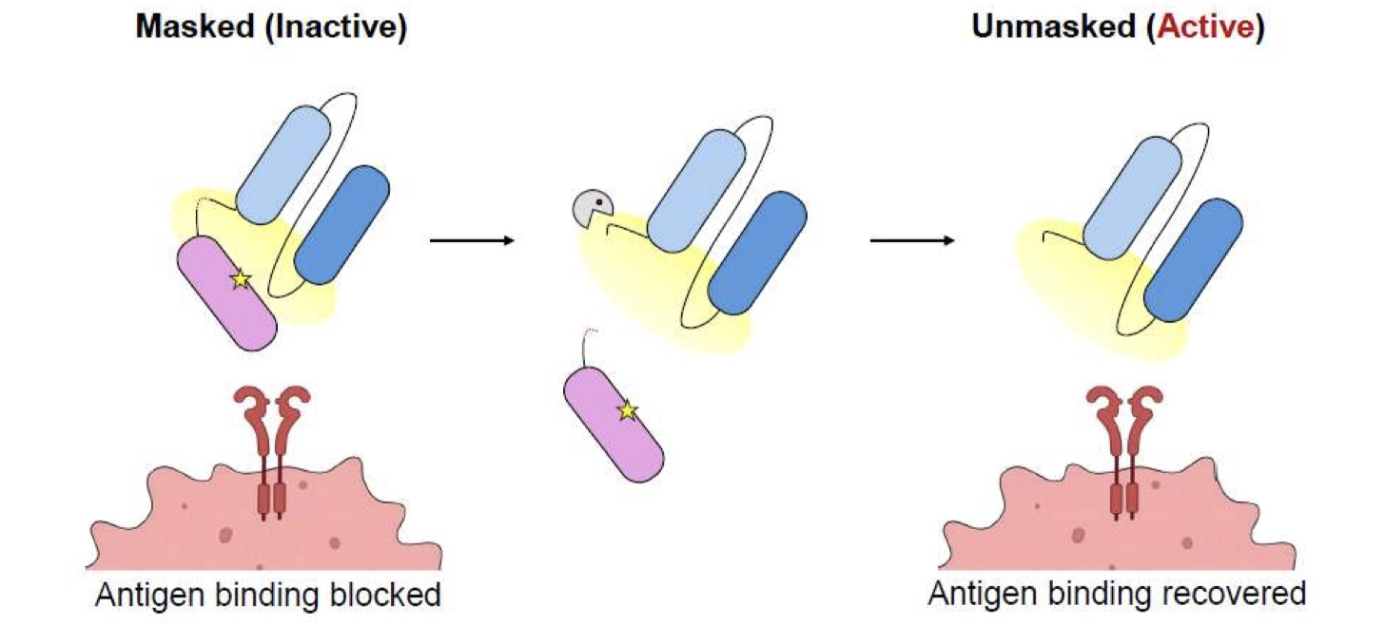

▲ Design concept and working principle of an MMP-9-activated HER2-targeting antibody. This schematic illustrates the process in which the antibody's HER2-binding site is initially masked by a small protein fragment (the "mask"); when MMP-9—a protease with elevated activity in the tumor microenvironment—cleaves the linker connecting the mask to the antibody, the mask detaches, thereby restoring the antibody's HER2-binding capability.
Comparative analysis involving the substitution of W104 with various other amino acids revealed that the phenylalanine (F) variant "W104F" demonstrated the best performance; it successfully moderated binding affinity while retaining some of the binding characteristics inherent to tryptophan.
The W104F variant effectively blocked the antibody fragment's binding to HER2 prior to protease action, yet nearly fully restored HER2-binding functionality after the linker was cleaved. Based on these results, the research team selected W104F as the optimal mask.
Subsequently, the team validated the performance of the W104F mask using MMP-9, a protease known to be highly active in the tumor microenvironment.
The system was engineered so that MMP-9 would cleave the linker; in the absence of MMP-9 treatment, HER2 binding by the antibody fragment was strongly inhibited, showing approximately 125-fold lower affinity compared to the unmasked antibody fragment.
Conversely, following MMP-9 treatment, the mask detached and HER2-binding capability was significantly restored, resulting in an affinity level within approximately three-fold of the unmasked antibody fragment. HER2 binding by the W104F antibody fragment following MMP-9 treatment was also confirmed through additional binding assays.
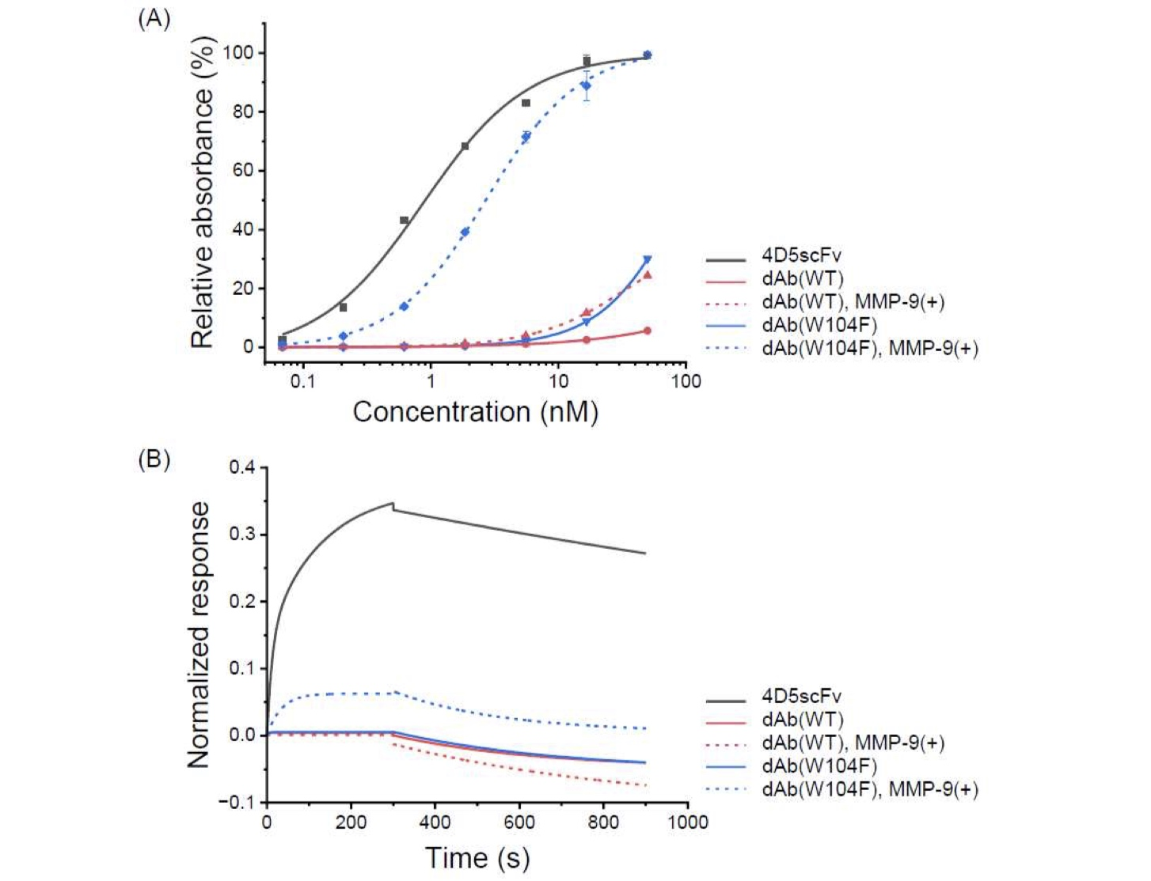

▲ Changes in the binding function of the W104F-masked antibody before and after MMP-9 treatment.
Prior to MMP-9 treatment, the mask strongly inhibited the antibody's binding to HER2, resulting in binding affinity approximately 125 times lower than that of the unmasked antibody. However, following MMP-9 treatment, the mask was cleaved off, leading to a significant recovery of HER2 binding capability; the difference compared to the unmasked antibody narrowed to within a threefold range.
This effect was also observed in HER2-positive breast cancer cells.
When the research team applied the W104F antibody fragment to HER2-overexpressing breast cancer cells (BT-474), there was virtually no binding to the cells in the absence of MMP-9 treatment.
In contrast, after MMP-9 treatment, the binding signal increased approximately twofold, recovering to a level comparable to that of the original antibody fragment. Conversely, no significant recovery in binding was observed in the control group, where the binding affinity of the mask had not been modulated.
Professor Inchan Kwon of the Department of Materials Science and Engineering stated, "This study is significant because it introduces a novel design principle that goes beyond simply masking the antibody's target-binding site with high affinity. Instead, it precisely modulates binding strength to prevent the antibody from binding to the target under normal conditions while allowing the mask to detach easily when a protease cleaves the linker."
He added, "We plan to expand this technology to full-sized antibodies to verify tumor selectivity and therapeutic efficacy, aiming to develop a system where the antibody functions within tumors while minimizing unwanted binding in normal tissues. Furthermore, we anticipate that this technology can be applied to various antibody therapeutics—such as antibody-drug conjugates (ADCs) and bispecific antibodies—to enhance treatment safety."
This research was supervised by Professor Inchan Kwon of the GIST Department of Materials Science and Engineering and conducted with master’s student Hyomin An as the lead author. It was supported by the "IP Star Scientist Support" program under the Ministry of Science and ICT’s University Technology Management Promotion Support Project and the GIST IGNITE InnoCORE Research Group (Project No. GKH1290).
The research findings were published online in the Journal of Biological Engineering, an international journal in the field of biotechnology, on August 5, 2026.
Meanwhile, GIST announced that it is accepting inquiries from companies and institutions interested in the technology commercialization and industrial application of these research results through the Technology Commercialization Center at the GIST Institute of Entrepreneurship and Innovation (hgmoon@gist.ac.kr).

