“Unfazed by scorching heat” GIST develops interface control technology to prevent high-temperature degradation in organic solar cells
- ‘Strategic Research Group for the World’s First Commercialization of Perovskite Solar Cells’ (Director Kwanghee Lee) identifies the cause of performance degradation in organic solar cells at high temperatures, revealing the migration of molybdenum oxide into the photoactive layer
- By applying interface control technology, the cells maintained approximately 18.1% of their initial photoelectric conversion efficiency for 2,000 hours at 85°C
- Successfully suppressed ‘burn-in loss’—a phenomenon involving a rapid drop in initial performance—with findings published in the international journal Small


▲ (From left) Director Kwanghee Lee of the ‘World’s First Perovskite Solar Cell Commercialization Strategic Research Group’ (Strategic Research Group), Deputy Director Hongkyu Kang of the Research Institute for Solar and Sustainable Energies, and Dr. Sanseong Lee of the Heeger Center for Advanced Materials.
The Gwangju Institute of Science and Technology (GIST; President Kichul Lim) announced that a research team led by Director Kwanghee Lee (Distinguished Visiting Professor, Department of Materials Science and Engineering) of the ‘World’s First Perovskite Solar Cell Commercialization Strategic Research Group’ has identified the cause of performance degradation in organic solar cells at high temperatures and developed a new interface control technology to mitigate this issue.
Organic solar cells utilizing the technology developed by the team maintained nearly their initial photoelectric conversion efficiency of approximately 18.1% even after operating for over 2,000 hours at 85°C. Notably, the cells did not exhibit ‘burn-in loss*’—a phenomenon involving a rapid drop in initial performance commonly observed in organic solar cells.
* burn-in loss: A phenomenon where photoelectric conversion efficiency rapidly decreases during the initial stages of exposure to heat or light.
Organic solar cells are solar cells that utilize organic materials as the core component for converting sunlight into electricity. They offer advantages such as being lighter and more flexible than silicon solar cells and can be manufactured at relatively low temperatures using solution-based processes.
However, their susceptibility to heat poses a hurdle to commercialization. In actual solar power generation environments, solar cells are exposed to high temperatures while absorbing sunlight; therefore, technology capable of maintaining performance during prolonged use is essential.
The research team focused not on the photoactive layer itself—which is responsible for power generation in organic solar cells—but on the "interface" that facilitates charge transport between the photoactive layer and the electrode.
In organic solar cells, exposure to sunlight generates electrons and "holes" (vacancies left behind by departing electrons); electricity is produced as these carriers migrate to their respective electrodes.
Molybdenum oxide (MoOₓ) is widely used in the "hole transport layer," which facilitates the movement of holes toward the electrode.
The problem, however, was that molybdenum oxide does not remain in place at high temperatures.
The research team monitored internal changes within the device while heating the organic solar cell to 85°C.
They observed that, at high temperatures, the molybdenum oxide migrated from its original position and gradually diffused into the photoactive layer.
This migration created defects within the photoactive layer that impeded charge transport, hindering the proper movement and collection of charges at the electrode. Consequently, the solar cell's electricity generation capacity declined.
Through this study, the team determined that the migration of molybdenum oxide into the photoactive layer—rather than a change in its electrical properties—was the primary cause of performance degradation at high temperatures.
The team hypothesized that stabilizing the molybdenum oxide at the interface to prevent its movement could mitigate high-temperature degradation.
To achieve this, they inserted a small molecule called "PBN" between the molybdenum oxide and the photoactive layer.
PBN contains a "nitrone functional group," a specific cluster of atoms within the molecule that exhibits distinct chemical properties. This functional group interacted strongly with unstable regions on the molybdenum oxide surface, stabilizing it and suppressing the formation of "oxygen vacancies"—defects caused by the loss of oxygen at high temperatures.
In simple terms, PBN acted as a protective layer between the molybdenum oxide and the photoactive layer, preventing the molybdenum oxide from diffusing into the photoactive layer.
When PBN was applied to actual solar cells, the devices demonstrated highly stable performance, even at high temperatures.
Organic solar cells incorporating PBN maintained approximately 100% of their initial photoelectric conversion efficiency (approx. 18.1%) even after 2,000 hours at 85°C.
In contrast, solar cells without PBN saw their efficiency drop by about 20% after just two hours of high-temperature exposure, and by approximately 25% after 24 hours.
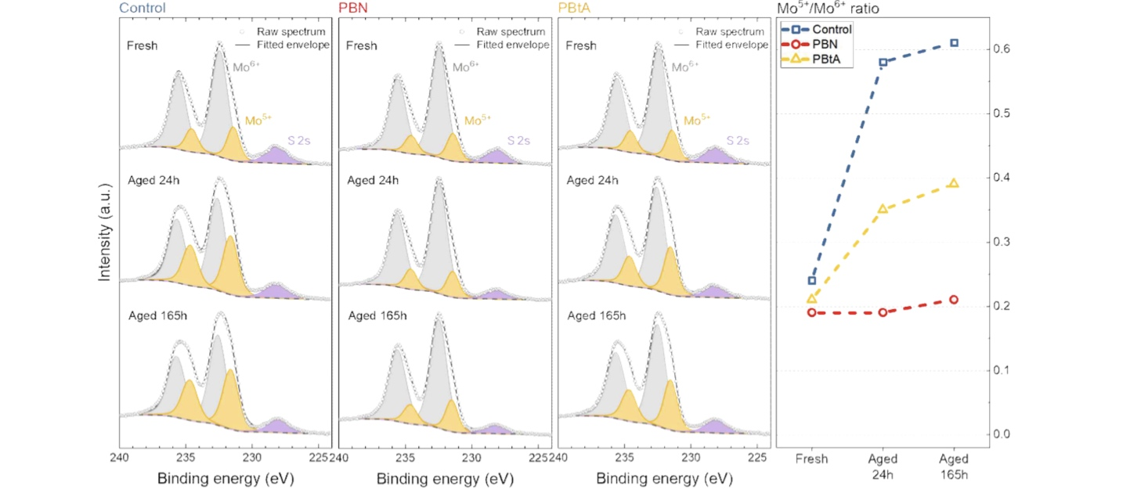

▲ Oxygen vacancies forming on the molybdenum oxide surface at high temperatures and the defect-suppressing effect of PBN. The chemical changes in molybdenum oxide under heat (85°C) were analyzed using X-ray photoelectron spectroscopy (XPS) across three groups: untreated (Control), PBN-treated, and a comparative group (PBtA). While the untreated surface showed an increasing ratio of Mo⁵⁺—an indicator of oxygen vacancies—over time, the PBN-treated surface showed almost no change in the Mo⁵⁺/Mo⁶⁺ ratio even after 165 hours. This confirmed that the nitrone functional group in PBN effectively suppresses the formation of oxygen vacancies on the molybdenum oxide surface at high temperatures.
To verify the critical role of the nitrone functional group in PBN, the research team conducted a comparative experiment using "PBtA," a material structurally similar to PBN but lacking the oxygen atom found in the nitrone group. The results showed that PBtA was significantly less effective than PBN at stabilizing molybdenum oxide, confirming that the nitrone functional group is the key element in stabilizing the molybdenum oxide interface.
To determine whether this technology was effective only with specific material combinations, the research team also applied PBN to two types of organic solar cells fabricated using different material combinations. As a result, for both types of organic solar cells, the devices incorporating PBN maintained nearly their initial efficiency at 85°C, whereas those without PBN experienced rapid performance degradation.
This demonstrated that the technology is not limited to specific materials but has the potential to mitigate high-temperature performance degradation across a wide range of organic solar cells.
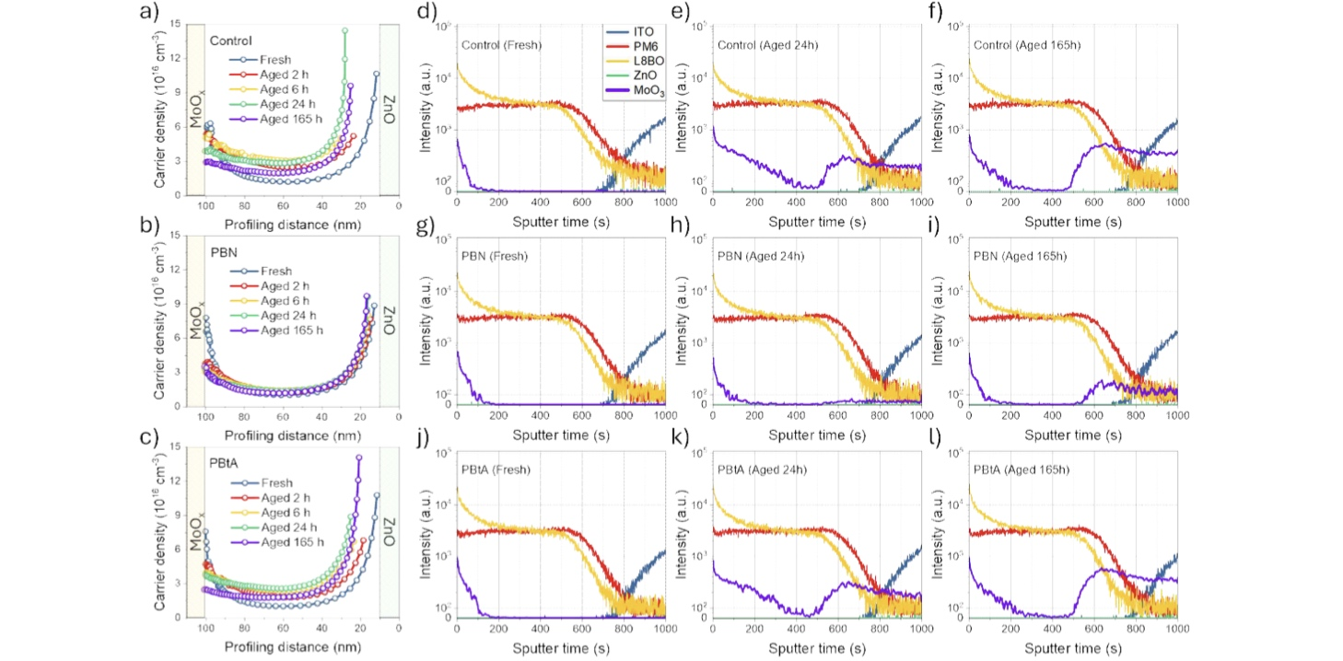

▲ The process of molybdenum oxide diffusion into the photoactive layer at high temperatures and the diffusion-inhibiting effect of PBN. (a–c) Analysis of charge density distribution within the solar cells under thermal stress at 85°C revealed that, while the control and PBtA-treated devices exhibited changes in charge density distribution and the emergence of regions near the interface where charge collection was hindered over time, the PBN-treated device maintained a relatively stable distribution. (d–l) OrbiSIMS analysis showed that in the control and PBtA-treated devices, molybdenum oxide components diffused into the photoactive layer and subsequently migrated to and accumulated at the opposite ZnO interface over time; in contrast, the PBN-treated device showed suppressed internal diffusion of molybdenum oxide even after 165 hours.

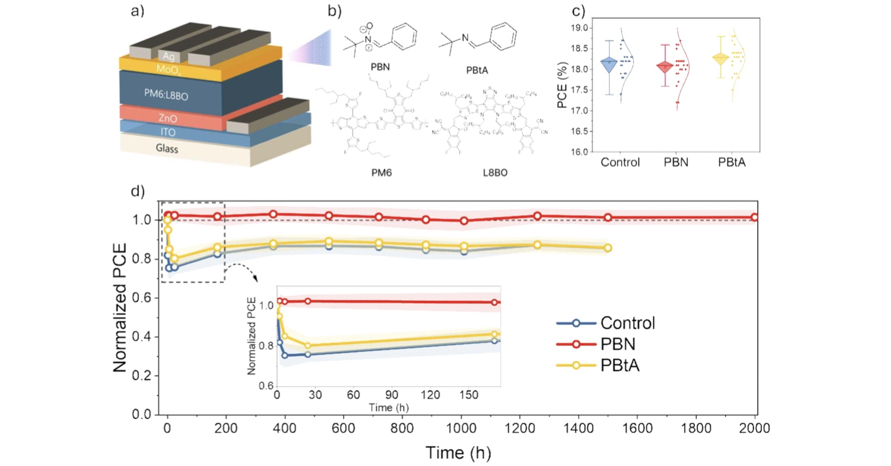

▲ Evaluation of initial efficiency and long-term thermal stability of organic solar cells based on PBN interface treatment. (a) Structure of the organic solar cells used in the study; (b) chemical structures of PBN, PBtA, and the photoactive layer materials. (c) Even after applying PBN to the interface, the initial power conversion efficiency remained at approximately 18.1–18.3%, indicating no initial performance degradation due to the interface treatment. (d) Long-term thermal stability tests at 85°C revealed that the control device and the PBtA-treated device exhibited "burn-in loss"—a rapid initial drop in efficiency—whereas the PBN-treated device maintained nearly its initial efficiency for 2,000 hours without such loss.
Kwanghee Lee, Director of the Strategic Research Group, stated, "This study is significant for identifying the root cause of performance degradation in organic solar cells at high temperatures and proposing a method to directly suppress the movement of the causative material at the interface." He added, "We expect this technology to enhance the long-term stability not only of organic solar cells but also of next-generation solar cells, such as perovskite solar cells and organic-perovskite tandem solar cells."
Hongkyu Kang, Deputy Director of the Research Institute of Solar and Sustainable Energies, said, "We plan to scale up this interface control technology—currently validated in small-area devices—to large-area modules. We will further develop it into a technology applicable to actual products through long-term reliability assessments and joint research and demonstration projects with the industry."
This study was co-authored by GIST’s Director of the Strategic Research Group, Kwanghee Lee, and the Deputy Director of the Research Institute of Solar and Sustainable Energies, Hongkyu Kang, with Dr. Sanseong Lee of the Heeger Center for Advanced Materials serving as the lead author. Researchers from POSTECH, Åbo Akademi University (Finland), Linköping University (Sweden), Kyonggi University, Chonnam National University, the Korea Basic Science Institute (KBSI), and the Korea Institute of Science and Technology (KIST) also participated in the project.
The research was supported by funding from the Ministry of Trade, Industry and Energy (MOTIE) and the Korea Institute of Energy Technology Evaluation and Planning (KETEP); the Ministry of Science and ICT (MSIT) and the National Research Foundation of Korea (NRF); the Ministry of Education and the NRF (LAMP Program); the Ministry of SMEs and Startups; and the MSIT-GIST Strategic Research Program (ISD).
The findings — Burn-in-Loss-Free Organic Solar Cells With Over 2000 h of Thermal Stability Through Nitrone-Based Interface Passivation —were published online in the international materials science journal Small on July 31, 2026.
Meanwhile, GIST announced that it is accepting inquiries from companies and organizations interested in the commercialization and industrial application of this research through the Technology Commercialization Center at the GIST Institute of Entrepreneurship and Innovation (hgmoon@gist.ac.kr).

