GIST-KENTECH develops next-generation AI semiconductor device mimicking the human brain; consumes 7 times less electricity
- Joint research team led by Professor Sanghan Lee (Department of Materials Science and Engineering, GIST) creates uniform ‘nanogaps’ through the ordered arrangement of nanoparticles
- Narrowing the gaps between particles drastically reduces the operating voltage to one-seventh… achieves performance variation of less than 9% across devices
- Demonstrates ‘short-term and long-term memory’ characteristics based on electrical stimulus intensity… holds promise for low-power neuromorphic information processing devices
- Published in the international journal Advanced Composites and Hybrid Materials


▲ (From left) Professor Sanghan Lee (Department of Materials Science and Engineering, GIST), Professor Myoung Hwan Oh (Department of Energy Engineering, KENTECH), Ph.D. candidate Inhyeok Oh (Department of Materials Science and Engineering, GIST), Dr. Jun Beom Hwang, and integrated M.S./Ph.D. student Minwoo Kang (Department of Energy Engineering, KENTECH).
A GIST (Gwangju Institute of Science and Technology) research team led by Professor Sanghan Lee (Department of Materials Science and Engineering), in collaboration with the KENTECH (Korea Institute of Energy Technology) team led by Professor Myoung Hwan Oh (Department of Energy Engineering), announced the development of a next-generation volatile memristor* that operates stably. This was achieved by regularly arranging cobalt oxide (Co₃O₄) single-crystal nanoparticles and precisely controlling the minute "gaps" between them.
This study demonstrates that the performance of electronic devices depends not only on the material properties—"what they are made of"—but also on their structural arrangement—"how the nanoparticles are organized." By precisely designing nanometer-scale structures, the research presents a new direction for the design of next-generation electronic devices.
* memristor: A next-generation electronic device capable of storing or processing information by utilizing the characteristic that its resistance state changes in response to applied voltage or current.
With the rapid increase in the volume of data requiring processing—driven by advancements in artificial intelligence (AI) and the Internet of Things (IoT)—there is growing importance in technologies that can realize electronic devices capable of low-power operation while maintaining consistent performance across individual units.
In particular, "volatile switching"—a phenomenon where resistance changes upon electrical stimulation and reverts to the original state once the stimulus is removed—can mimic the characteristics of biological neurons that temporarily store and then forget signals based on external stimuli; thus, it holds promise for next-generation information processing technologies such as neuromorphic computing*.
Conventional oxide-based volatile memristors operate by forming and subsequently dissolving a narrow "conductive path"—a channel where current concentrates—within the device upon electrical stimulation. However, because these paths can form in different locations and shapes each time, the devices suffered from inconsistent operating characteristics.
* neuromorphic computing: A next-generation computing technology that mimics the information-processing methods of the human brain and nervous system to rapidly process vast amounts of data with low energy consumption.
To address this issue, the research team focused on a method of pre-defining the current path during device fabrication rather than creating a new path during each operation. Instead of allowing current to forge random new paths, they designed a structure that directs the flow along consistent gaps between nanoparticles.
To achieve this, they arranged single-crystal cobalt oxide nanoparticles—each approximately 10 nm (nanometers) in size—in a regular, grid-like pattern, creating a structure with uniform "nanogaps" averaging about 3 nm between the particles. They then fabricated a memristor device by placing this nanoparticle array between two electrodes.
For the nanoparticle arrangement, they utilized a "self-assembly*" method, in which particles spontaneously form an ordered structure without needing to be placed individually by external means.
This process employed the "Marangoni effect"—a phenomenon also responsible for the "tears of wine" effect, where liquid forms droplets and flows down the inner wall of a wine glass. The difference in surface tension caused by evaporating solvent drove the movement of the nanoparticles, causing them to form a regular two-dimensional lattice structure over a wide area.
* self-assembly: A phenomenon in which particles spontaneously form ordered structures through mutual interactions, without being individually positioned by external forces.
To investigate how the regular gaps between nanoparticles affect memristor operation, the research team fabricated and compared two types of devices made from the same cobalt oxide material: one featuring a continuous thin film with no gaps between particles, and another with an ordered array of nanoparticles.
The results showed that while the continuous cobalt oxide thin film failed to exhibit stable memory switching, the device with regular gaps between nanoparticles demonstrated stable and repeatable volatile switching. The gaps between the nanoparticles created consistent current flow paths, thereby stabilizing the device's operation.
The developed memristor operated at a very low current of approximately 10 nA (nanoamperes) and demonstrated high operational uniformity and reproducibility, with a coefficient of variation for switching voltage of less than 9% over 100 consecutive measurements.
Actual measurements showed an average switching onset voltage of 8.75 V (volts) and an average voltage for returning to the initial state of 4.38 V, with coefficients of variation of 6.17% and 8.90%, respectively.
Notably, the research team investigated whether the memristor's operating voltage could be altered by adjusting the size of the nanogap. When the nanogap was narrowed from approximately 3 nm to about 1 nm, the average switching onset voltage dropped from 8.75 V to 1.20 V—a reduction to roughly one-seventh of the original level. This demonstrates that, even when using the same materials, simply narrowing the gap between particles can significantly lower the voltage required for device operation.
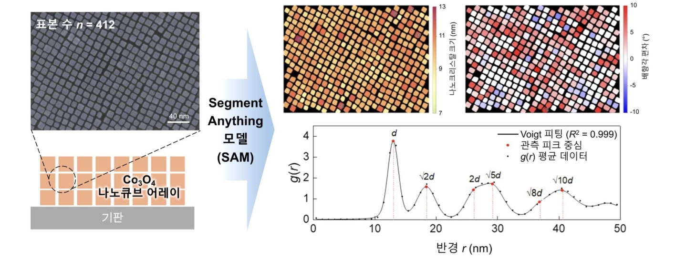

▲ Regular arrangement of nanoparticles confirmed via artificial intelligence (AI) analysis. (Left) An image and structural schematic showing cobalt oxide (Co₃O₄) nanoparticles arranged in a regular, checkerboard-like pattern through self-assembly utilizing the Marangoni effect. (Right) Analysis of nanoparticle size, orientation, and spacing in electron microscopy images—conducted using the AI ​​image analysis model "Segment Anything Model" (SAM)—confirmed that the nanoparticles had a uniform average size of approximately 10 nanometers and were arranged regularly in a square lattice pattern.
Furthermore, the developed memristor exhibited two distinct recovery characteristics depending on the intensity and duration of the electrical stimulation. After a brief electrical stimulus, the device rapidly returned to its original state within about 1–2 microseconds, whereas following a strong, prolonged stimulus, it recovered slowly over the course of more than a minute. In simple terms, a single device exhibited both a "short-term memory" that vanished quickly and a "long-term memory" that persisted for a relatively long time.
The research team interpreted the rapid recovery as being linked to electronic processes—such as the swift movement of electrons or the release of electrons trapped at interfaces—while attributing the slow recovery to the back-diffusion of ions that had migrated across the junctions between nanoparticles. These characteristics are expected to be applicable to devices such as neuromorphic information processors that handle time-varying signals.
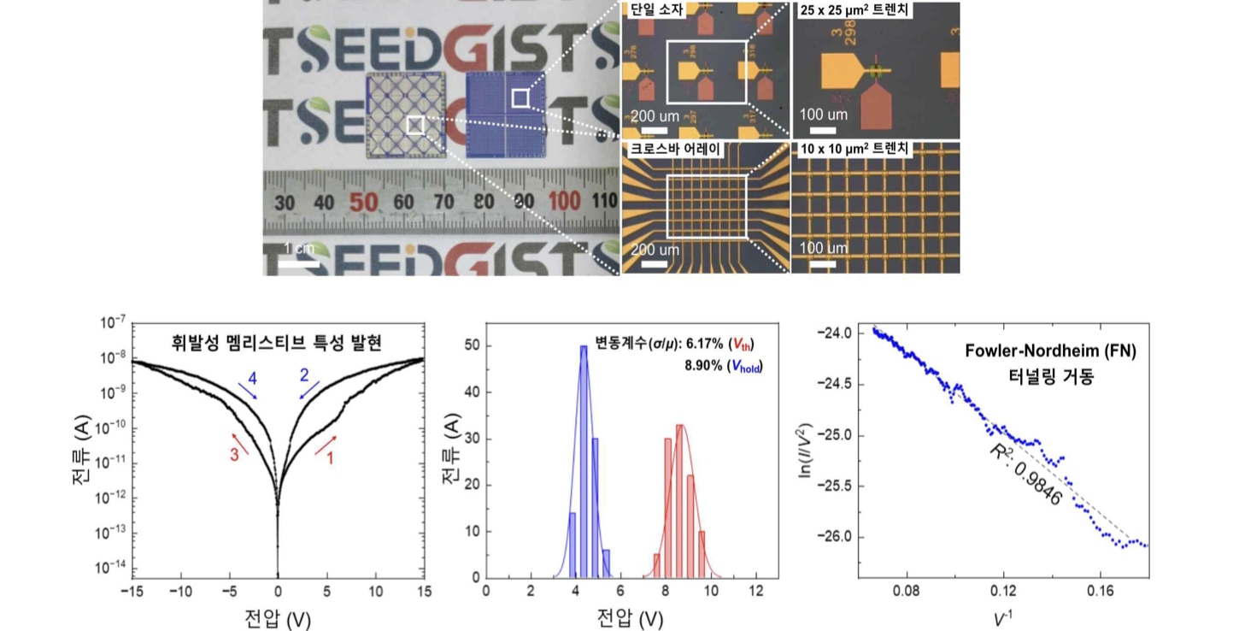

▲ Stable volatile switching in a memristor utilizing a nanoparticle array. (Top) A memristor chip fabricated using regularly arranged cobalt oxide nanoparticles; an optical microscope image shows the layout of multiple memristors. (Bottom Left) Demonstration of volatile switching—where current increases upon voltage application and returns to the original state when voltage is removed—occurring at a low current level of approximately 10 nanoamperes (nA). (Bottom Center) Comparison of operating voltages across multiple devices confirms uniform operation, with voltage fluctuations of less than 9%. (Bottom Right) Analysis of the characteristics of current flow through the narrow gaps between nanoparticles.
Professor Sanghan Lee GIST Department of Materials Science and Engineering stated, "This study is significant because it utilized the 'gaps' between nanoparticles—previously considered factors that could cause irregular current flow—as design elements to control device operation." He added, "Given that we have confirmed stable operation at low currents alongside recovery characteristics spanning different time scales, we anticipate this technology will be utilized in the future development of low-power neuromorphic devices."
Professor Myoung Hwan Oh KENTECH Department of Energy Engineering stated, "By inducing uniform nanoparticles to self-assemble into regular structures and quantitatively verifying their arrangement consistency through AI-based image analysis, we were able to precisely fabricate and analyze structures featuring repeating, uniform gaps between nanoparticles."
This research was supervised by Professor Sanghan Lee (Department of Materials Science and Engineering, GIST) and Professor Myoung Hwan Oh (Department of Energy Engineering, KENTECH), with co-lead authorship shared by Ph.D. candidate Inhyeok Oh (GIST), Dr. Jun Beom Hwang (GIST), and combined M.S./Ph.D. student Minwoo Kang (KENTECH). The study was supported by ▴ the Ministry of Science and ICT (MSIT) and ▴ the National Research Foundation of Korea (NRF) through the Future Hydrogen Core Technology Development Program and the ▴ Individual Basic Research Program, as well as by ▴ the Korea Institute of Energy Technology Evaluation and Planning (KETEP).
The research findings — Engineering structural discontinuity in ordered Co₃O₄ nanocube arrays for volatile memristive dynamics — were published online on July 30, 2026, in the international journal Advanced Composites and Hybrid Materials.
Meanwhile, GIST announced that it is accepting inquiries from companies and organizations interested in the technology commercialization and industrial application of these research results via the Technology Commercialization Center at the GIST Institute of Startup and Innovation (hgmoon@gist.ac.kr).

