“Semiconductor wiring resistance drops 45% after briefly adding and removing carbon!” GIST, Samsung Electronics, SAIT, and MIT publish next-generation semiconductor wiring material control technology in Science
- Dr. Yong-Ryun Jo of the GIST Advanced Institute of Instrumental Analysis conducted joint research with Samsung Electronics, SAIT, and MIT… Utilizing carbon as a ‘transient crystal growth accelerator’ to control ruthenium crystal size and orientation and reduce electrical resistance by 45.4%
- Confirmed applicability to 2 nm-class next-generation semiconductor wiring and complex 3D structures


▲ (From left) Dr. Youngchul Leem, Dr. Yoonhoo Ha, Researcher Young-Min Lee, and Dr. Yong-Ryun Jo of the Center for Advanced Instrumental Analysis at the GIST Advanced Institute of Instrumental Analysis (GAIA)
The Gwangju Institute of Science and Technology (GIST, President Kichul Lim) announced that research conducted by Dr. Yong-Ryun Jo of the Center for Advanced Instrumental Analysis at the GIST Advanced Institute of Instrumental Analysis (GAIA), in collaboration with researchers from Samsung Electronics SAIT (formerly Samsung Advanced Institute of Technology) and the Massachusetts Institute of Technology (MIT), has been published in the world-renowned academic journal Science.
Dr. Jo participated in this study as a co-first author, contributing to experimental design and execution, real-time microstructure analysis using a transmission electron microscope (TEM), data analysis and visualization, and interpretation of research results.
This research developed a technology that utilizes trace amounts of carbon as a "transient crystal growth promoter" to precisely align the orientation of metal crystals even on amorphous insulating substrates, and confirmed that this can significantly reduce the electrical resistance of ultra-fine wiring in next-generation semiconductors.
In particular, this achievement is significant in that it represents the fruition of follow-up research based on initial results from the industry-academia collaboration between the GIST Institute of Machinery and Materials and Samsung Electronics SAIT, which began in 2024.
* transmission electron microscope (TEM): An instrument capable of observing atomic-level structures by transmitting an electron beam (E-beam) through a sample. It provides very high resolution and is utilized for the analysis of the microstructures of nanomaterials or biomolecules.
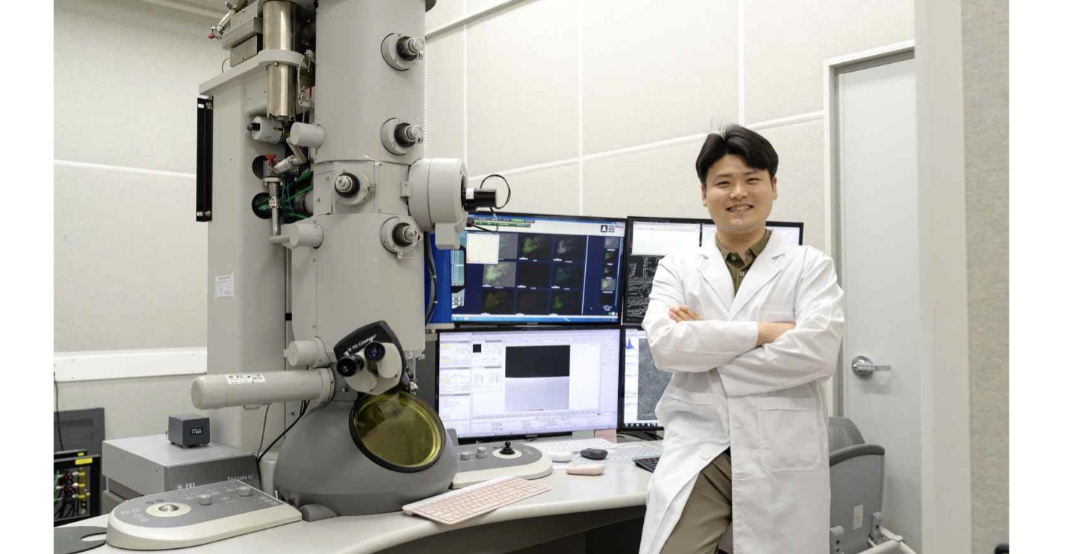

▲ Dr. Yong-Ryun Jo of the Center for Advanced Instrumental Analysis at the GIST Advanced Institute of Instrumental Analysis poses next to a transmission electron microscope (TEM).
Semiconductor chips contain densely packed, fine metal wiring that connects numerous transistors to transmit electrical signals. As the width of this wiring shrinks to the nanometer level, ruthenium (Ru)* is garnering attention as a next-generation metal material to overcome the electrical limitations of conventional copper (Cu) wiring.
However, when ruthenium is made into a very thin film, there is a problem where electrical resistance increases due to electron scattering at "grain boundaries"**, where the small crystals (grains) that make up the metal come into contact with each other.
Therefore, a critical task for utilizing ruthenium in next-generation ultrafine wiring is to grow the grains larger to reduce the number of grain boundaries that hinder electron flow, and to ensure that each crystal aligns in the same direction to minimize electron scattering occurring at the grain boundaries**.
* ruthenium (Ru): A metal being researched as a next-generation semiconductor wiring material to complement the limitations of copper due to its excellent electrical conductivity and thermal and chemical stability.
** grain boundary: A boundary where ‘grains,’ the small crystals that make up a metal, come into contact with one another. If the crystal orientations are inconsistent or there are many boundaries, the flow of electrons is hindered, which can increase resistance.
Previously, methods such as ‘epitaxy,’ which involves growing a metal thin film on a substrate with a suitable crystal structure, or high-temperature heat treatment were used to control the crystal orientation and size of the metal. However, these methods had limitations in actual semiconductor processes due to constraints on applicable substrates and process conditions.
Methods to control crystal orientation by adding trace amounts of other elements to the metal have also been attempted; however, precisely controlling the appropriate content and distribution was difficult because adding too much or too little of the added element could hinder crystal growth.
* epitaxy: A method of growing a crystal film with the same orientation on a substrate that follows the atomic arrangement of a regular crystal structure.
To overcome these limitations, the joint research team proposed a new strategy involving the addition of trace amounts of carbon to ruthenium. This strategy allows the carbon to aid in the growth and rearrangement of crystal grains during heat treatment, after which it is released.
Comparative results with varying carbon content showed that crystal grain growth and alignment were most effectively promoted when approximately 0.48 at%* of carbon was added—a mere 5 out of 1,000 atoms constituting ruthenium. Conversely, it was found that an excessive amount of carbon actually hindered the alignment of the crystal orientation.
The research team did not leave carbon in the thin film indefinitely, but rather allowed it to act temporarily only during the process of crystal growth and alignment before being released. In other words, they utilized carbon as a "temporary accelerator" to aid crystal growth.
* at% (Atomic Percent): The proportion of atoms of a specific element among the total atoms constituting a material.
The joint research team also elucidated the principle by which carbon promotes the growth and alignment of crystal grains.
It was analyzed that during the heat treatment process, carbon atoms within the ruthenium migrated to the grain boundaries—the points where crystal grains meet—forming carbon-rich regions. Subsequently, as the carbon rapidly escaped in gaseous form, a temporary empty space known as "free volume" was formed.
It was found that this empty space created around the grain boundaries facilitated the movement of ruthenium atoms and allowed the grain boundaries to shift, thereby promoting the process in which small crystals merged, grew, and rearranged in similar directions.
In particular, the research team directly observed the process of grain growth and orientation rearrangement while heating the sample inside the microscope using an ‘In-situ Heating Transmission Electron Microscope (In-situ Heating TEM)*’.
* in-situ heating transmission electron microscope (In-situ Heating TEM): An advanced analytical instrument capable of observing changes in atoms and nanostructures in real time by heating a sample inside the electron microscope.
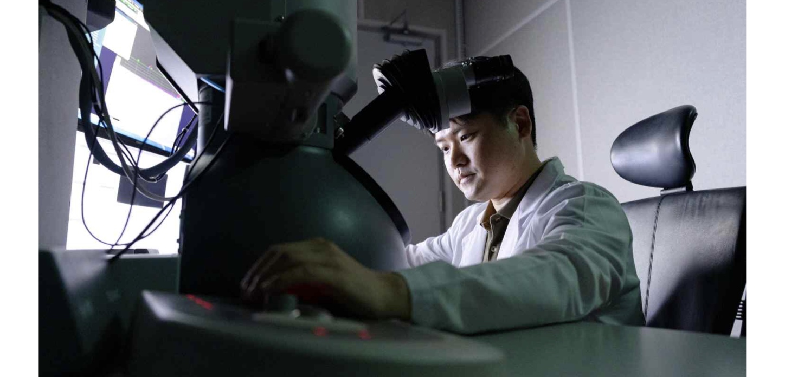

▲ Dr. Yong-Ryun Jo of the Center for Advanced Instrumental Analysis at the GIST Advanced Institute of Instrumental Analysis is observing and analyzing the microstructure of a sample using a transmission electron microscope (TEM).
As a result, the average grain size of the ruthenium thin film heat-treated at 450°C increased approximately sevenfold, from about 13 nm (nanometers) to 91.7 nm, and the degree of crystal orientation, which indicates the extent to which crystals are aligned in one direction, reached 99.3%.
As a result of increasing the crystal size and aligning the direction, electrical performance was also significantly improved. A low resistivity of 11.2 μΩ·cm (micro-ohm-centimeters) was achieved in an 8 nm thick ruthenium thin film, which is 29.0% lower than that of ruthenium without the use of a carbon promoter.
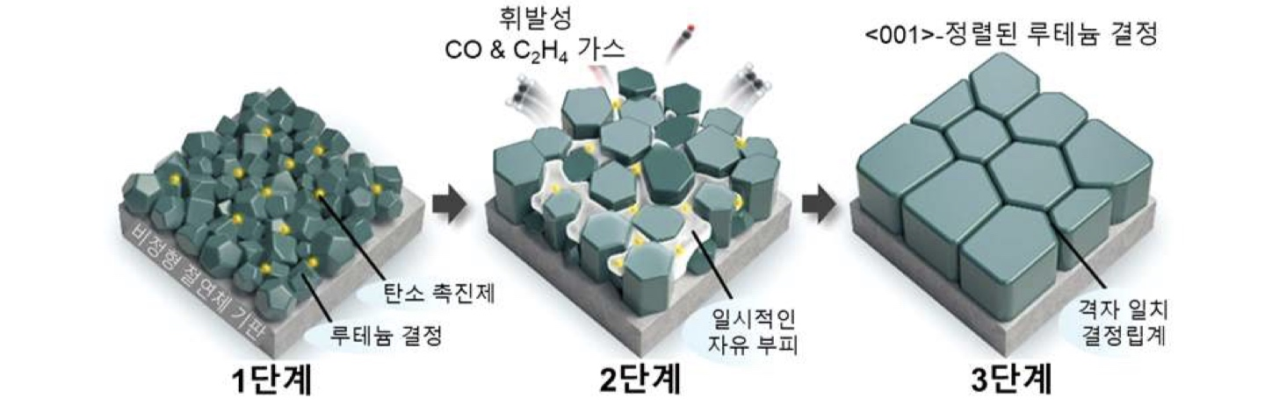

▲ The process of ruthenium (Ru) grain growth and crystal orientation alignment by a carbon promoter (C-promoter). (Step 1) Immediately after deposition, small Ru crystal grains are aligned in different directions. (Step 2) During the initial heat treatment process, carbon migrates to the grain boundaries to form a network, and as volatile substances escape, a free volume—a temporary space where atoms can move within and at the boundaries of the crystals—is created. This facilitates atomic movement, forming a metastable intermediate state. (Step 3) As the crystal grains grow and their orientations are rearranged, a ruthenium thin film is finally formed that is aligned in the specific atomic alignment direction known as the ‘<001> direction.’
Notably, when fabricated into actual ultrafine wiring structures, wiring resistance decreased by 45.4% compared to ruthenium without carbon promoters, satisfying the electrical performance requirements for next-generation semiconductor wiring with linewidths reduced to the 2 nm level.
Furthermore, the joint research team confirmed that this technology can be applied to complex three-dimensional semiconductor structures. As a result of coating a 12 nm thick layer of ruthenium onto a narrow, deep trench structure with an aspect ratio* of 33:1, the ruthenium was coated with a high uniformity of 99.1%, extending to the sides and bottom of the trench. Furthermore, it was confirmed that the orientation of the ruthenium crystals was maintained even on the sides and bottom of the complex structure.
This demonstrates the potential for applying this technology to highly integrated devices with complex structures, such as next-generation 3D memory and ultra-fine semiconductor wiring of 2 nm or less.
* aspect ratio: A value obtained by dividing the depth of a structure by its width. A higher value indicates a narrower and deeper structure, making it difficult to coat the interior uniformly.
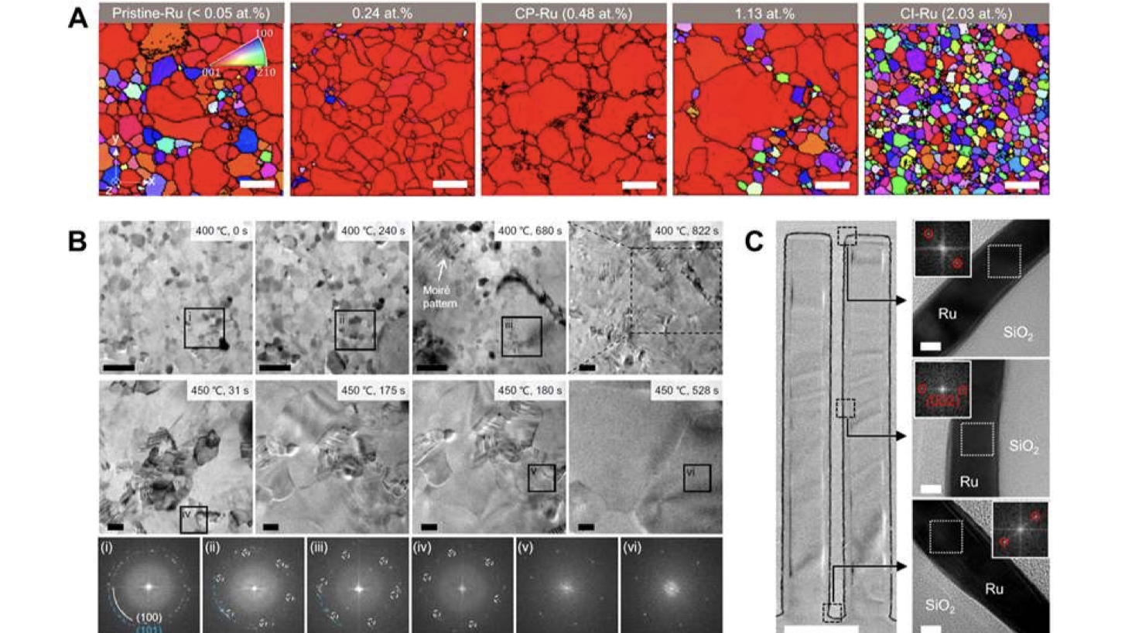

▲ The growth and alignment process of ruthenium (Ru) crystal grains driven by carbon acceleration and the results of applying a 3D structure. (A) An image comparing the crystal orientations of ruthenium thin films according to carbon content; each color represents a different crystal orientation. It was confirmed that when an appropriate amount of carbon was added, the crystal grains grew significantly and aligned in a specific direction. (B) The changes in the carbon-accelerated ruthenium (CP-Ru) thin film observed using a real-time thermal transmission electron microscope. The process of small crystal grains growing and crystal orientations rearranging was directly tracked over time as heat treatment progressed. (C) A ruthenium thin film formed in a narrow and deep 3D structure with an aspect ratio of 33 and a depth of 5.1 micrometers (μm). It was confirmed that the ruthenium thin film formed uniformly and its crystal orientation was maintained even at various locations within the complex structure.
Dr. Yong-Ryun Jo stated, “This research demonstrated that trace elements within metals can be utilized not merely as impurities to be removed, but as temporary accelerators that induce grain movement and alignment before being released.” He added, “In particular, by tracking crystal growth and rearrangement occurring during heat treatment through real-time transmission electron microscopy analysis, we have presented a new design principle capable of simultaneously controlling the structure and electrical performance of next-generation semiconductor wiring materials.”
Hyunseob Lim, Director of the GIST Advanced Institute of Instrumental Analysis (and Professor of Chemistry), said, “This research is an achievement born from a research culture that has encouraged researchers at the Institute to freely collaborate with external teams based on their expertise to conduct new research.” He continued, “We will continue to support researchers in actively collaborating with domestic and international research institutions and industries based on their respective expertise and capabilities to continuously generate world-class research results.”
This research, in which Dr. Dr. Yong-Ryun Jo participated as a co-first author alongside Dr. Youngchul Leem, Dr. Yoonhoo Ha, and Researcher Young-Min Lee from Samsung Electronics SAIT, was supported by Samsung Electronics SAIT.
The research results — Promoter-driven recrystallization affording highly textured ruthenium — were published online in Science on August 13.

