GIST, KRISS, and others reveal the identity of 'mysterious signals' within quantum materials
- World's first identification of the cause of 'beat' signals in topological insulator nanowires
- Proof of quantum interference in phase and general electronic states... Setting new standards for quantum device signal analysis and design
- Published in the international journal Nano Letters Vol. 26, No. 29, and selected as cover article


▲ This is the joint research team participating in the study on ‘Topological Insulator Nanowire Quantum Interference,’ including GIST and KRISS.
Korean researchers from the Gwangju Institute of Science and Technology (GIST, President Kichul Lim) and the Korea Research Institute of Standards and Science (KRISS, President Ho-sung Lee) announced that they have identified, for the first time in the world, the cause of ‘beat’ signals, which have been a major obstacle to quantum signal analysis in topological insulator nanowires for years.
Analysis confirmed that beats occur when different quantum vibrations created by the surface topological electronic states and the underlying general electronic states overlap. This achievement provides a standard necessary for signal analysis of topological quantum devices and the realization of desired electronic states.
Topological insulators are quantum materials in which electricity does not flow well internally, but special electronic states exist on the surface. When this is formed into a thin nanowire, surface electrons move along the perimeter, and when a magnetic field is applied, waves of electrons that have traveled different paths interfere, resulting in ‘Aharonov-Bohm (AB) oscillations,’ where conductivity changes regularly.
However, in actual topological insulators, a thin layer through which electrons flow can form just below the surface due to factors such as doping. While this layer can also serve as a pathway for electron movement, it has been unclear until now whether it participates in AB oscillations alongside the topological surface state.
The clue to resolving this mystery came from thermoelectric experiments. While verifying whether AB oscillations also appear in thermoelectric phenomena in bismuth selenide (Bi₂Se₃) nanowires doped with antimony (Sb), the research team discovered ‘beats.’
Beats are a phenomenon in which signal strength changes as vibrations with slightly different periods overlap, much like two tuning forks making a ‘humming’ sound; this served as a crucial clue that captured the existence of unexpected vibrational components.
Based on this, a re-analysis of existing electrical conductivity data confirmed the existence of the same beat phenomenon.
After years of tracking and analysis, the research team concluded that the beat occurs when vibrational components originating from the ‘Topical Surface State (TSS)’ and the ‘2D Electromagnetic Gas (2DEG),’ a general electron layer beneath the surface, overlap.
They revealed that vibrations of different periods arise because the area of ​​the electron paths passing through the two conductivity states encircling the nanowire differs slightly, and these vibrations overlap to cause the beat.
The key to verification was the frequency. Since the frequency is determined by the area of ​​the path through which electrons wrap around the nanowire, the frequency should remain constant even if the electron state is changed by the gate voltage, provided the path area remains the same. However, because adjacent vibrations overlapped, it was difficult to distinguish them using conventional frequency analysis.
Accordingly, the joint research team led by Professor Taegeun Song of Kongju National University utilized machine learning to separate vibrational components that had previously appeared clustered in existing analyses. They confirmed that while the beat pattern changes depending on the gate voltage, each frequency remains unique. Theoretical calculations also reproduced the observed characteristics, and the same phenomenon was verified in separate nanowire devices.
This research is a significant achievement that clearly demonstrates that general electronic states can also participate in AB quantum interference, which has been utilized as a primary signal for verifying phase surface states. Through this, it provides a clear standard for accurately interpreting quantum transport signals of topological insulators without error and for precisely controlling desired quantum states in the future.
Principal Researcher Myung-Ho Bae of KRISS stated, "This achievement demonstrates that electrons can interact through quantum interference by moving between general electronic states as well as phase states." He added, "To utilize only the desired phase state, it is crucial to precisely control doping and gates to prevent the intervention of general conductive states."
Professor Sang-Jun Choi of GIST explained, “This achievement demonstrates that the experimental, theoretical, and data analysis capabilities of researchers from each institution have intertwined to explain the cause of beats—a phenomenon that had remained unsolved for years—through a single physical diagram.” He added, “The principles for understanding and controlling interference between different electronic states can also be utilized in the future design of topological quantum devices.”
This research was supported by the Korea Research Institute of Standards and Science (KRISS) Basic Program, the National Research Foundation of Korea (NRF) Support Program, the Ministry of Education’s G-LAMP Program, and the National Science and Technology Council (Strategic Research Group for Hyper-connected and Extended Super-Quantum Computing).
The related findings — Aharonov–Bohm Beating Induced by Coexisting Topological Surface States and 2DEG in Sb-Doped Bi₂Se₃ Nanowires — were published in Volume 26, Issue 29 of Nano Letters, released on Wednesday, July 29, and were selected as the cover article.
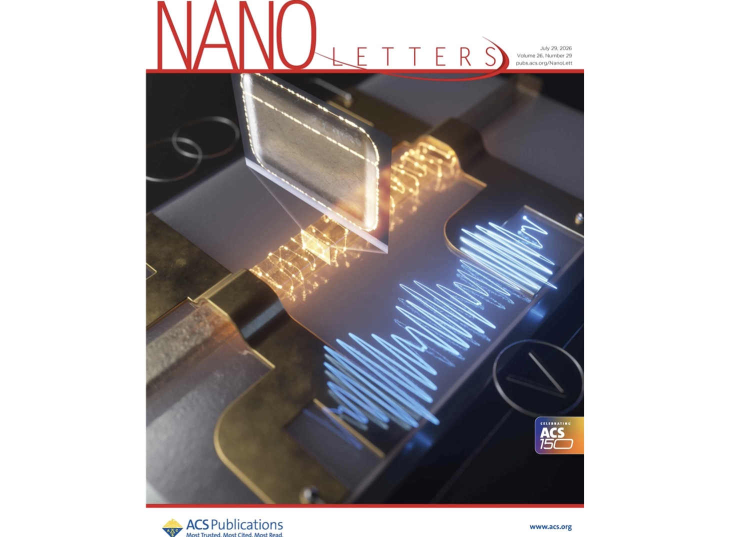
▲ The research on ‘Topological Insulator Nanowire Quantum Interference’ by a joint research team including GIST and KRISS has been selected as the cover article for Nano Letters.

