“Captures light longer to generate more electricity” GIST and Chonbuk National University develop next-generation 'self-powered optical sensor' that operates without batteries
- Professor Haneol Lee of the Department of Materials Science and Engineering at GIST, in collaboration with Professor Kwangwook Park's team at Jeonbuk National University, has realized a self-powered photosensor that operates without an external power source by combining a semiconductor heterojunction with a microhole structure that retains light for longer periods
- Enhanced light detection performance through the formation of a strong internal electric field and an approximately 1.8-fold improvement in charge retention time... Successful demonstration of assisting commercial sensors is expected to lead to applications in ultra-low-power IoT and wearable devices
- Published in the international journal Small Structures


▲ (From left) Professor Haneol Lee Lee of the Department of Materials Science and Engineering at GIST (concurrently serving at the Research Institute for Solar and Sustainable Energies), Professor Kwangwook Park of the Division of Electronics and Information Engineering, Division of Advanced Materials Engineering at Jeonbuk National University, PhD student Jeong Hyeon Kim of the Department of Materials Science and Engineering, and PhD student Ju Chan Hwang.
The Gwangju Institute of Science and Technology (GIST, President Kichul Lim) announced that Professor Haneol Lee Lee of the Department of Materials Science and Engineering (concurrently serving at the Research Institute for Solar and Sustainable Energies), in collaboration with a research team from Jeonbuk National University, has developed a self-driving optical sensor that operates without an external power source by combining different semiconductors to form a strong internal electric field.
This research enhanced light detection performance by controlling both the compositional ratio of the materials and the surface structure that traps light, presenting a new design direction for next-generation self-driving optical sensors.
Optical sensors, which detect light and convert it into electrical signals, are utilized in various fields such as the Internet of Things (IoT), wearable devices, and drones. In particular, ‘self-powered optical sensors,’ which utilize light itself as an energy source without a separate external power source, are attracting attention for their ability to reduce power consumption in small electronic devices that require long-term operation or where battery replacement is difficult.
For a ‘self-powered optical sensor’ to function properly, electrons and holes* generated by receiving light must be rapidly separated and moved without external voltage. To achieve this, a ‘heterogeneous junction’ structure is utilized, in which different semiconductors are joined to naturally form an electric field at the boundary between the two materials.
However, existing heterojunction structures have limitations, such as the potential for defects during the bonding process of different materials, and reduced sensor performance if the internal electric field is insufficient or if incoming light is not effectively absorbed, as generated charges recombine and disappear.
* hole: When a semiconductor absorbs light, electrons gain energy and move; the space left by the electrons is vacated and acts like a positive charge, which is called a "hole." Effectively separating and transporting electrons and holes determines the performance of a photosensor.
To solve these problems, the joint research team focused on "zinc-tin-nitride (ZnSnN₂, ZTN)," a next-generation semiconductor composed of abundant zinc (Zn), tin (Sn), and nitrogen (N).
Zinc-tin-nitride (ZTN) can generate charges by absorbing light, and because its crystal structure is similar to that of gallium nitride (GaN), it is advantageous for creating heterojunction structures that combine the two materials. However, to operate without an external power source, the electrical properties of ‘zinc tin nitride’ must be precisely controlled to form a sufficiently strong internal electric field at the interface between the two materials.
* Zinc Tin Nitride (ZnSnN₂): Composed of elements abundant in the Earth's crust, it is attracting attention as a next-generation eco-friendly semiconductor material due to its high light absorption coefficient in the solar spectrum.
First, the electrical properties were optimized by controlling the process conditions for creating thin films of ‘zinc tin nitride’ to precisely adjust the material's component ratios and the concentration of charge carriers involved in electricity flow.
Subsequently, when this optimized ‘zinc tin nitride’ was joined with ‘gallium nitride,’ which has a similar crystal structure but different electrical properties, a strong internal electric field (88 kV/cm) was formed at the boundary between the two semiconductors, separating and transporting electrons and holes generated by light. Consequently, a photosensor capable of converting light into electrical signals was realized without the need for a separate external voltage.
Going a step further, the research team regularly formed micro-holes on the surface of zinc tin nitride to utilize incoming light more effectively.
On a flat surface, some of the unabsorbed light is reflected or escapes, but in micro-holes, light is scattered and reflected multiple times from the sides and bottom of the holes, causing it to remain inside the material for a longer period.
As a result, the duration for which charge carriers generated by receiving light are retained increased approximately 1.8 times, from 3.5 nanoseconds (ns) in a planar structure to a maximum of 6.2 nanoseconds. This is the result of enhancing light detection performance by allowing the charge to be retained for a longer duration, even for extremely short periods measured in one-billionth of a second.
Through this combination of "material composition control" and "microstructures that trap light," the research team realized a self-driving photosensor capable of stably detecting light even at low light intensities without the application of external voltage.
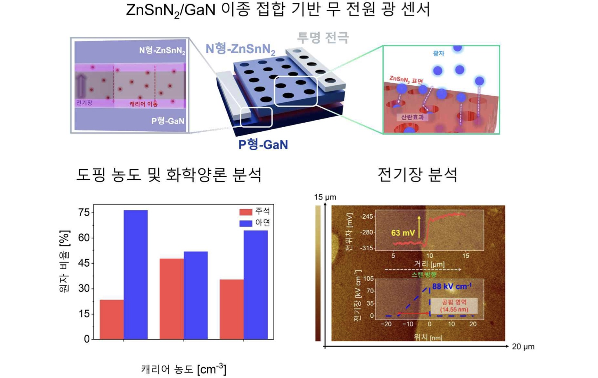

▲ Structure and internal electric field formation principle of a self-driven photosensor based on a zinc-tin nitride–gallium nitride heterojunction. (Top) Illustrates the structure of a photosensor formed by joining ‘zinc-tin nitride’ and ‘gallium nitride,’ which have different electrical properties, and the process of electrons and holes generated by light being separated. (Bottom) Shows the analysis results of the zinc-tin component ratio and charge concentration according to process conditions (bottom left), and the analysis results of the 88 kV/cm internal electric field formed at the junction of the two semiconductors (bottom right).
To verify the feasibility of practical application, the joint research team connected the developed photosensor to a commercial temperature and humidity sensor. As a result, while supplying an external voltage of 2.2 V—which is insufficient for the commercial sensor to operate—the photosensor received light and generated a photovoltaic voltage of approximately 0.6 V. By utilizing this voltage in conjunction with an external power source, the team successfully enabled the sensor to operate.
This result confirms through an actual device that ambient light can be converted into electrical energy, thereby reducing the power required for external supply. It is expected to be utilized in future ultra-low power Internet of Things (IoT) devices.
Professor Haneol Lee stated, "This research demonstrated that self-driving performance can be enhanced not only by simply joining different semiconductors, but also by designing everything from the material manufacturing stage to the path of light travel." He added, "We plan to expand the scope of application to include ultra-low power sensors and energy conversion devices for small electronic devices that can reduce reliance on batteries."
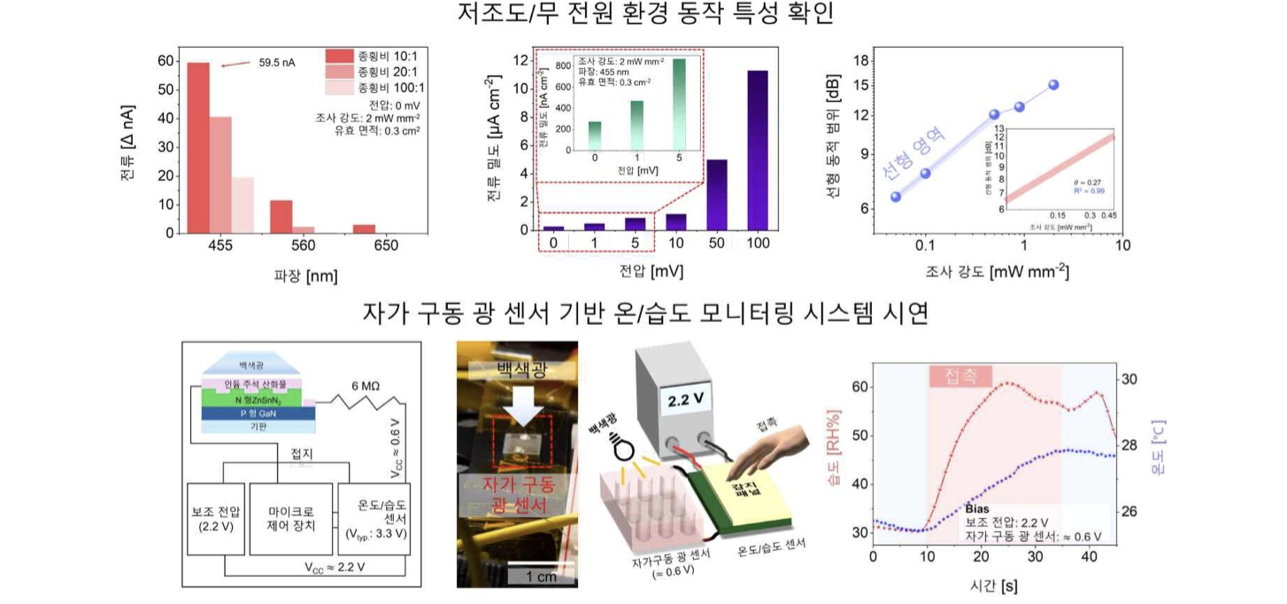

▲ Demonstration of the low-voltage and low-light operating characteristics of the self-driven optical sensor and its role in assisting the operation of a commercial temperature and humidity sensor. (Top) The developed optical sensor demonstrates the characteristic of stably generating electrical signals based on the wavelength and intensity of light, even without the application of external voltage. (Bottom) This is the result of an experiment in which a commercial temperature and humidity sensor was enabled to measure changes in temperature and humidity in real time by adding a photovoltaic voltage of approximately 0.6 V generated by the optical sensor to an externally supplied voltage of 2.2 V.
This research, supervised by Professor Haneol Lee (concurrently serving at the Research Institute for Solar and Sustainable Energies) of the Department of Materials Science and Engineering at GIST and Professor Kwangwook Park of the Division of Electronics and Information Engineering at Jeonbuk National University, and conducted by doctoral students Jeong Hyeon Kim and Ju Chan Hwang of the Department of Materials Science and Engineering, was supported by the GIST Research Institute for Solar and Sustainable Energies, the Ministry of SMEs and Startups' Technology Development Project, a government-funded project by the National Research Foundation of Korea, and the Ministry of Education and the National Research Foundation of Korea's Phase 4 Brain Korea 21 Project.
The research results — Self-Powered ZnSnN₂/GaN Photodiodes via Fine Stoichiometry Control and Photon Trapping Micropatterned Heterojunctions Under Low-Light Irradiation — were published online on July 31, 2026, in the international materials science journal Small Structures and included in the August 2026 issue.
Meanwhile, GIST stated that this research achievement takes into account both its academic significance and potential for industrial application, and that discussions regarding technology transfer can be conducted through the Technology Commercialization Center (hgmoon@gist.ac.kr).

