“Charge loss reduced by molecular ‘ordering’” GIST realizes high-efficiency large-area perovskite solar cells through novel molecular alignment control
- Suppresses charge loss by inducing a regular ‘face-to-face alignment’ through the asymmetric charge distribution of indole molecules
- Achieved 23.21% certified efficiency for large-area modules… Maintains 85% initial efficiency even after 1,800 hours of continuous light irradiation
- Expected for application in large-area manufacturing processes and modularization… Published in the international journal Advanced Materials
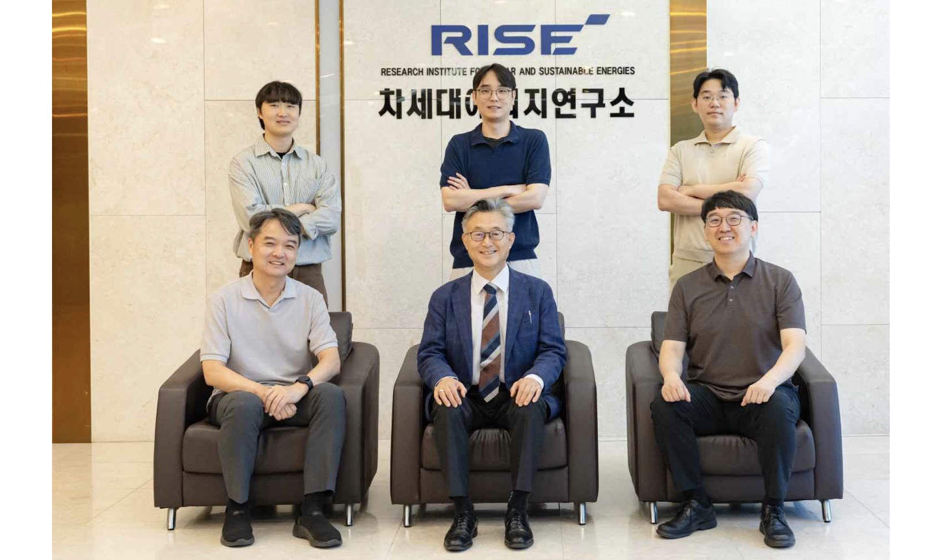

▲ (Front row from left) Professor Sukwon Hong of the Department of Chemistry at GIST, Director Kwanghee Lee of the ‘World’s First Perovskite Solar Cell Commercialization Strategy Research Group’ (Strategic Research Group), Deputy Director Hongkyu Kang of the Research Institute for Solar and Sustainable Energies, (Back row from left) Dr. Sangjin Kim of the Department of Chemistry, Dr. Taeyoon Ki of the Heeger Advanced Materials Research Center, and Researcher Sangjin Kim of the Research Institute for Solar and Sustainable Energies.
The Gwangju Institute of Science and Technology (GIST, President Kichul Lim) announced that a research team led by Director Kwanghee Lee (Distinguished Visiting Professor in the Department of Materials Science and Engineering) of the ‘World’s First Perovskite Solar Cell Commercialization Strategy Research Group’ (hereinafter the Strategy Research Group) has presented a new molecular design principle capable of reducing charge loss and mitigating performance degradation in large-area devices by controlling the arrangement of molecules at the interface* of perovskite solar cells.
Going a step further than existing methods that have focused on reducing interfacial defects, the research team realized an interfacial structure that allows for more uniform charge movement by inducing the molecules forming the interface to be arranged regularly.
* interface: The boundary surface where two different materials (layers) forming a solar cell meet, serving as a pathway for electric charges to move from one layer to another.
Perovskite solar cells are attracting attention as next-generation solar cells due to their high "photovoltaic conversion efficiency," which converts light into electricity.
For a solar cell to achieve high efficiency, charges generated in the "light-absorbing layer," which absorbs light, must move smoothly to the "charge transport layer." However, as the surface area of ​​the device increases, the state of the interface where the two layers meet varies depending on the location, leading to non-uniform charge transport and consequently a decrease in efficiency.
In particular, existing interface treatment techniques that introduce organic molecules onto the perovskite surface are effective in reducing surface defects that cause charge loss; however, if the molecules are irregularly arranged, they can hinder charge transport, potentially leading to additional losses at the interface.
To address this problem, the joint research team focused on an organic molecule called an "indole-based organic ammonium molecule" (hereinafter referred to as "indole molecule"). This molecule possesses a ring-shaped structure containing nitrogen atoms, characterized by a skewed distribution of charge within the molecule.
Reporting that this characteristic could influence the alignment of indole molecules in a specific direction, the research team analyzed the factors affecting molecular arrangement by comparing it with two types of organic molecules with different structures.
The results showed that indole molecules form a regular "face-to-face stacked structure" by stably bonding in directions facing each other. This demonstrates that the internal charge distribution plays a more significant role in inducing the regular arrangement of molecules than the size of the ring structure alone.
* indole-based organic ammonium molecule (Indol-3-ylethylammonium iodide, Ind): An organic ammonium molecule containing an indole structure; in this study, it was used as an interface-modifying material to suppress defects on the perovskite surface and induce layered arrangement between molecules.
It was found that these regularly arranged indole molecules are evenly arranged in a consistent direction and spacing on the perovskite surface, and also make the contact surface with the electron transport layer ‘C₆₀*’ formed on top uniform.
As a result, it was possible to reduce charge loss at the interface by maintaining smooth electron transfer from the perovskite to C₆₀ while suppressing ‘non-radiative recombination**’ which causes charge loss.
* C₆₀: A spherical molecule composed of 60 carbon atoms, widely used as an electron transport layer in perovskite solar cells to selectively transfer electrons.
** non-radiative recombination: A phenomenon in which charges generated by exposure to light are dissipated rather than utilized as electricity; it is a major cause of reduced voltage and efficiency in solar cells.
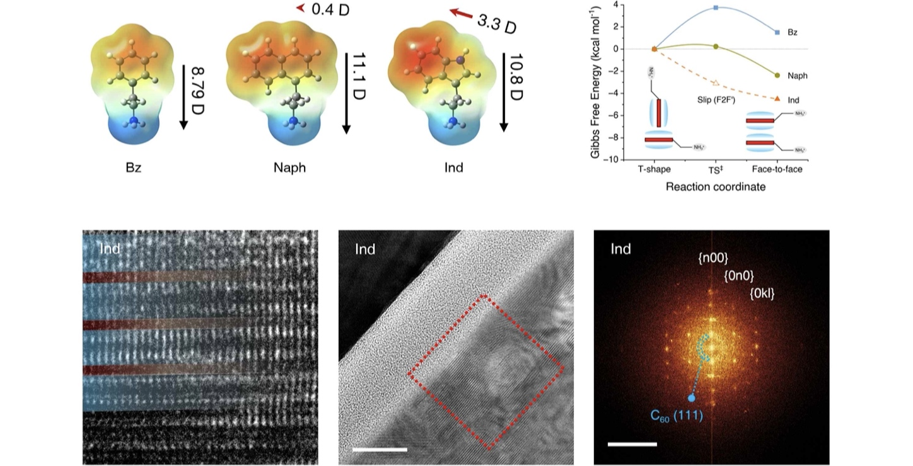

▲ Principles of regular arrangement and interfacial layered structure formation based on molecular charge distribution. The top section shows the results of comparing the energy stability of phenethylammonium (Bz), naphthylethylammonium (Naph), and indole (Ind) molecules based on their charge distribution and arrangement. It demonstrates that indole molecules form the most stable "face-to-face arrangement" due to their asymmetric lateral charge distribution. The bottom section confirms, through high-resolution transmission electron microscopy and diffraction analysis, that indole molecules form a regular layered structure and that such an interfacial structure is formed between the perovskite and C₆₀.
When these interface design principles were applied to actual perovskite solar cells, a certified photoelectric conversion efficiency of 26.94% was recorded in small-area solar cells, and a certified efficiency of 23.21% was achieved in 25 cm² large-area solar cells.
In particular, this 25 cm² large-area module was fabricated with a monolithic structure connecting 10 solar cells into one, and its performance was verified through independent certification. This demonstrates that the interface design proposed by the research team is effective in achieving high efficiency not only in small-area devices but also in large-area modules.
In addition, in long-term stability evaluations, it maintained over 93% of its initial efficiency after 1,000 hours in a high-temperature environment of 85°C, and maintained 85% of its initial efficiency after 1,800 hours under conditions where light of an intensity similar to actual sunlight was continuously shone.
It is expected that the molecular design principles presented in this study, when combined with mass production technologies such as continuous manufacturing processes, will contribute to expanding the application range of perovskite solar cells into various fields, including Building Integrated Photovoltaics (BIPV), lightweight and flexible solar cells, and mobile power sources.
Kwanghee Lee, Head of the Strategic Research Group, stated, “Achieving the high efficiency of perovskite solar cells in large-area applications is a challenge that must be addressed for commercialization.” He added, “We hope that the molecular design principles presented here will serve as a foundational technology to reduce interfacial losses occurring during the large-area fabrication process and accelerate the commercialization of perovskite solar cells.”
Hongkyu Kang, Deputy Director of the GIST Research Institute of Solar and Sustainable Energies, stated, “This achievement is significant in that it realizes the high efficiency of small-area solar cells in large-area modules.” He further announced, “We will continue to strengthen our research infrastructure and industry-academia collaboration foundations to ensure that research results lead to large-area manufacturing processes, modularization, demonstration, and industrialization.”
This research, conducted by Dr. Taeyoon Ki of the Department of Materials Science and Engineering as the first author and co-corresponding authors including Kwanghee Lee, Director of the Strategic Research Group at GIST; Hongkyu Kang, Deputy Director of the Research Institute of Solar and Sustainable Energies; and Professor Sukwon Hong of the Department of Chemistry, involved joint participation from research teams at the Institute for Basic Science (IBS), the Korea Advanced Institute of Science and Technology (KAIST), the Korea National Institute of Energy and Engineering (KENTECH), Gyeongsang National University, RIKEN and the University of Tokyo in Japan, and Linköping University in Sweden.
This research was supported by the following programs: ▴ the Climate Change Response Technology Development Project and Mid-Career Researcher Support Project of the Ministry of Science and ICT and the National Research Foundation of Korea; ▴ the University Key Research Center Support Project in Science and Engineering of the Ministry of Education and the National Research Foundation of Korea; ▴ the New and Renewable Energy Core Technology Development Project of the Ministry of Climate, Energy and Environment and the Korea Energy Technology Evaluation and Planning Institute; and ▴ the Strategic Research Project of the Ministry of Science and ICT and GIST.
The research results — Asymmetric Lamellar Templating of the Perovskite/C₆₀ Interface for Scalable Inverted Perovskite Photovoltaics — were published online on July 30, 2026, in the international materials science journal Advanced Materials.
Meanwhile, GIST stated that this research achievement takes into account both its academic significance and potential for industrial application, and that discussions regarding technology transfer can be conducted through the Technology Commercialization Center (hgmoon@gist.ac.kr).

