“Zinc battery maintains performance even after repeated charging” GIST, KIER, and Ewha Womans University identify new electrolyte principle creating 'protective layer' on zinc electrode
- A joint research team led by Professor Sangryun Kim of the Department of Chemistry at GIST suppressed electrode damage and hydrogen generation that cause performance degradation by forming a protective layer on the surface of zinc electrodes using electrolyte additives
- Achieved 96.55% initial capacity and 99.8% Coulomb efficiency after 5,000 charge-discharge cycles in an actual battery structure
- Published in the international academic journal Chemical Engineering Journal


▲ (From left) Professor Sangryun Kim of the Department of Chemistry at GIST and Huijeong Oh, a student in the integrated master's and Ph.D. program
The Gwangju Institute of Science and Technology (GIST, President Kichul Lim) announced that a research team led by Professor Sangryun Kim of the Department of Chemistry, in collaboration with the Korea Institute of Energy Research (KIER) and a research team from Ewha Womans University, has identified a new electrolyte design principle utilizing complex hydrides* to suppress electrode damage and extend the lifespan of aqueous zinc metal batteries.
They presented a new electrolyte design strategy capable of simultaneously improving both electrode stability and long-term charge/discharge performance, which were previously difficult to address together.
* complex hydride: A material with a complex structure containing hydrogen. In this study, Zn(B₁₂H₁₂), a type of complex hydride, was utilized as an electrolyte additive.
Recently, as the importance of large-scale energy storage systems (ESS) has grown, 'aqueous (7) zinc metal batteries' that possess safety and economic efficiency are attracting attention as next-generation secondary batteries.
Aqueous zinc metal batteries have the advantage of using a water-based electrolyte instead of volatile and toxic organic solvents to enhance safety, and utilize zinc, which is inexpensive and has a large storage capacity, as an electrode.
However, when charging and discharging are repeated, hydrogen is generated as water and zinc react, and byproducts such as zinc oxide (ZnO) are produced. Along with this, zinc accumulates unevenly on the surface of the electrode, causing the electrode to gradually be damaged, which limits stable long-term use.
To address these issues, the research team added a complex hydride to the electrolyte of an aqueous zinc metal battery and analyzed the changes occurring on the zinc metal surface and in the electrolyte during the charge and discharge process.
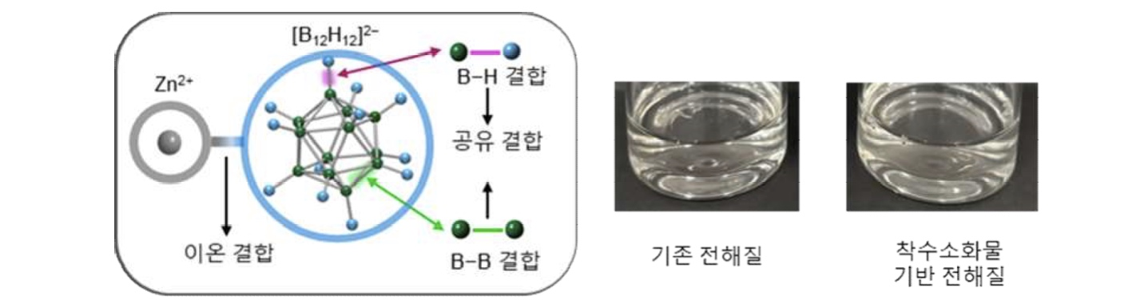

▲ Structure of the complex hydride and the electrolyte to which it was added. The complex hydride has a structure in which cations and complex anions are combined, and boron-hydrogen (B-H) and boron-boron (B-B) bonds exist within the complex anion. (Right) The ‘complex hydride-based electrolyte’ maintains a state similar to the ‘conventional electrolyte,’ demonstrating that the addition of the complex hydride does not significantly alter the properties of the electrolyte.
The complex hydride (Zn(B₁₂H₁₂)) used in this study separates into zinc ions (Zn²⁺) and complex anions (B₁₂H₁₂²⁻)* when dissolved in water. These complex anions interact weakly with water or surrounding ions, causing almost no changes to the structure of the conventional electrolyte or key properties such as ionic conductivity and viscosity.
* complex anion: A structure in which multiple molecules or ions are attached to a central atom, and it is a polyatomic ion structure with a negative charge.
On the other hand, when charging and discharging begin, the complex anions react on the surface of the zinc electrode to form a ‘hydride-rich interphase.’
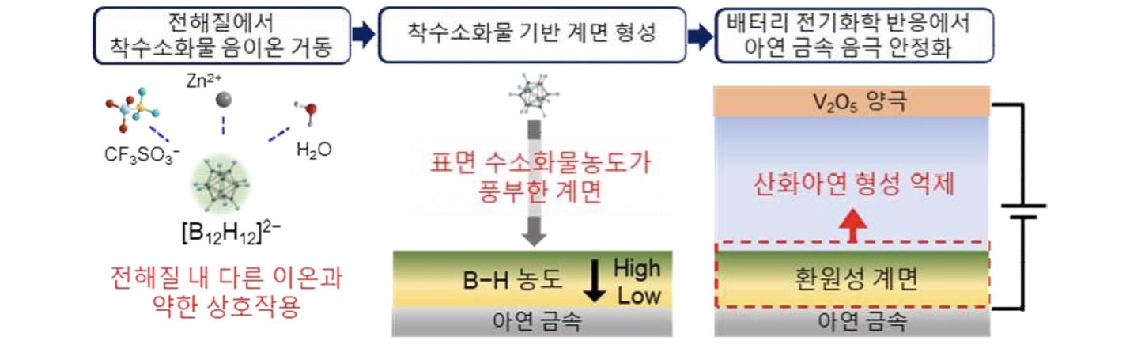

▲ Principle of zinc electrode protection using hydride. This illustrates the principle in which complex anions (B₁₂H₁₂²⁻) introduced into the aqueous electrolyte form a ‘hydride-based interface layer’ on the surface of the zinc electrode during the charging and discharging process, thereby stabilizing the electrode by suppressing the reaction between water and zinc and the formation of zinc oxide.
In other words, while the electrolyte itself remains intact, a protective layer (interface layer) is formed only on the zinc surface where charging and discharging occur. This protective layer reduces the direct reaction between water and zinc, thereby suppressing the hydrogen generation reaction* and zinc oxidation that cause electrode damage, and allows zinc to accumulate more uniformly on the electrode surface.
* Hydrogen generation reaction: An unnecessary reaction (side reaction) in which water decomposes to generate hydrogen gas during the charging and discharging process, which hinders the stable operation of the battery.
The research team confirmed the formation and distribution of this ‘hydride-based interface layer’ using X-ray Photoelectron Spectroscopy (XPS)* and Time-of-Flight Secondary Ion Mass Spectrometry (ToF-SIMS)*.
XPS analysis, which examines the chemical bonding state of materials, revealed that boron-hydrogen (B-H) bonds derived from the initial hydride (Zn(B₁₂H₁₂)) were identified on the zinc surface starting from the first charge-discharge cycle and remained intact even after 100 charge-discharge cycles. This demonstrates that the ‘hydride-based interface layer’ derived from the initial hydride was stably formed.
ToF-SIMS analysis, which examines the distribution of surface components, confirmed that hydride-derived components were concentrated on the zinc surface, supporting the formation of the ‘hydride-based interface layer.’
* x-ray photoelectron spectroscopy (XPS): An analytical technique that identifies the elements and chemical bonding states of a surface by analyzing the electrons emitted after irradiating the surface with X-rays.
** time-of-flight secondary ion mass spectrometry (ToF-SIMS): An analytical technique that identifies the chemical composition and distribution of a surface by measuring the mass of secondary ions emitted after irradiating the surface with an ion beam.
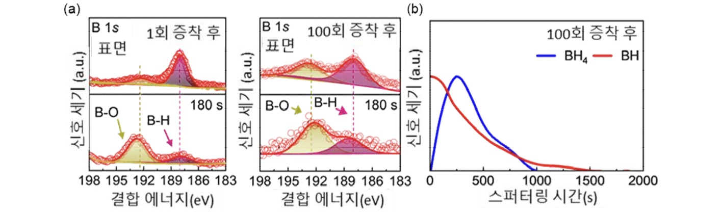

▲ Analysis results of the hydride-based interface layer formed on the zinc electrode surface. (a) XPS analysis confirmed boron-hydrogen (B-H) bonds originating from the initiator hydrate from the first zinc deposition onwards, and these bonds persisted even after 100 deposition and desorption cycles. Furthermore, B-H bonds were detected even after partial surface removal, confirming the formation of a hydride-based interface layer. (b) ToF-SIMS analysis revealed that hydride-derived components were concentrated on the zinc electrode surface after 100 deposition and desorption cycles.
Actual electrochemical experiments showed that the electrolyte containing the initiator hydrate suppressed hydrogen generation and non-uniform zinc growth. In symmetrical battery experiments evaluating the stability of the zinc electrode, the electrode operated stably for up to 3,000 hours.
Subsequently, in a zinc-vanadium oxide battery, the electrode maintained 96.55% of its initial capacity after 5,000 charge-discharge cycles and recorded a Coulombic efficiency of 99.8%. Conventional electrolyte batteries under the same conditions retained only 46.40% of their initial capacity.
* Coulombic efficiency: The ratio of the amount of charge recovered during discharge to the amount of charge stored during charging; a value closer to 100% indicates less loss during the charging and discharging process.
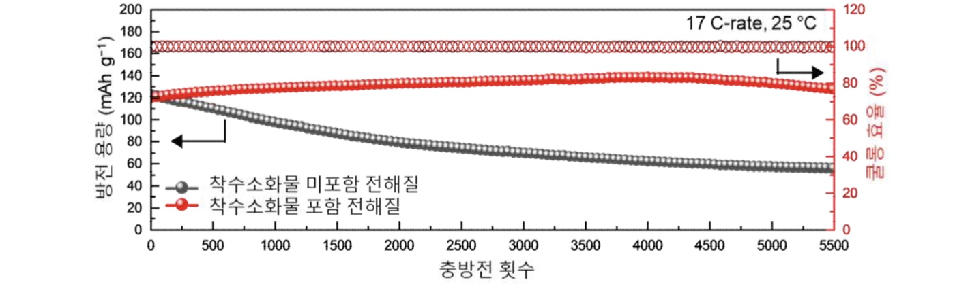

▲ Electrochemical performance of an aqueous zinc metal battery. An aqueous zinc metal battery utilizing a precipitate hydride (Zn(B₁₂H₁₂)) exhibited a Coulombic efficiency approaching 100% and a reversible discharge capacity over 5,000 charge-discharge cycles, even under high current density conditions. These results demonstrate stable battery operation through the formation of a hydride-based interface.
Professor Sangryun Kim stated, “This research is highly significant in that it elucidates the interface formation mechanism based on initiator compounds in aqueous electrolytes, thereby extending existing initiator compound research into the field of aqueous electrochemistry and presenting a new research direction for the design of electrolytes for next-generation aqueous metal batteries.”
This study, supervised by Professor Sangryun Kim (concurrently at the Graduate School of Energy Convergence) of the Department of Chemistry at GIST and conducted by Huijeong Oh, a student in the integrated master’s and Ph.D. program, as the first author, was supported by the following: ▴ the Korea Institute of Science and Technology Commercialization (KISTEC) ‘Next-Generation Promising Seed Technology Commercialization Fast Track’; ▴ the Ministry of Education and Gwangju Metropolitan City ‘Regional Innovation Center University Support System (RISE) Project’; ▴ the Ministry of Trade, Industry and Energy and the Korea Institute for Industrial Technology Promotion ‘Industrial Technology Innovation Project’; and ▴ the Ministry of Science and ICT and the National Research Foundation of Korea ‘Excellent Research - Young Researcher (Type B)’.
The research results — Closo-type complex hydride-derived interphase for stable aqueous zinc metal batteries — were published online on July 26, 2026, in the international academic journal Chemical Engineering Journal, which covers materials science and chemistry.
Meanwhile, GIST stated that this research achievement takes into account both its academic significance and potential for industrial application, and that discussions regarding technology transfer can be conducted through the Technology Commercialization Center (hgmoon@gist.ac.kr).

