“Natural products produced by gut microbes open new path for treating intractable heart failure” GIST and Chonnam National University identify new treatment mechanism targeting root cause of 'heart hardening heart failure'
- Professor Chang-Myung Oh's team at GIST's Department of Biomedical Science and Engineering, in collaboration with Professor Sang-Wook Park's team at Chonnam National University School of Dentistry, presents a novel treatment strategy for heart failure that preserves ejection fraction by co-regulating gut microbiota ceramide metabolism
- Confirmation that 'Urolithin A,' a natural metabolite derived from gut microbes, improves cardiac function and inhibits myocardial fibrosis through mitophagy activation... verified in animal models and human-derived cardiomyocytes
- Published in the international journal Experimental & Molecular Medicine (EMM)


▲ (From left) Professor Chang-Myung Oh of the Department of Biomedical Science and Engineering at GIST, Professor Sang-Wook Park of the Chonnam National University School of Dentistry, and Dr. Han-Kyul Song of the Department of Biomedical Engineering at GIST.
The Gwangju Institute of Science and Technology (GIST, President Kichul Lim) announced that through a joint study, a research team led by Professor Chang-Myung Oh of the Department of Biomedical Science and Engineering and a research team led by Professor Sang-Wook Park of the Chonnam National University School of Dentistry have identified the mechanism by which ‘urolithin A’*, a natural metabolite produced by gut microbes, restores damaged mitochondria and regulates gut microbial metabolism to inhibit the progression of ‘Heart Failure with Preserved Ejection Fraction (HFpEF).’
The heart repeatedly contracts to pump blood throughout the body and relaxes to receive blood back in. Heart failure is a heart disease in which abnormalities in these functions prevent the body from receiving sufficient blood.
Among these, ‘heart failure with preserved ejection fraction’ is a condition in which the heart maintains a relatively normal force for pumping blood, but fails to relax sufficiently and thus cannot properly receive blood.
The joint research team confirmed that urolithin A is effective in improving the decline in heart function and ‘myocardial fibrosis,’ the hardening of the heart muscle.
* urolithin A: A substance produced during the metabolic process by gut microbes of components found in pomegranates, strawberries, walnuts, etc.
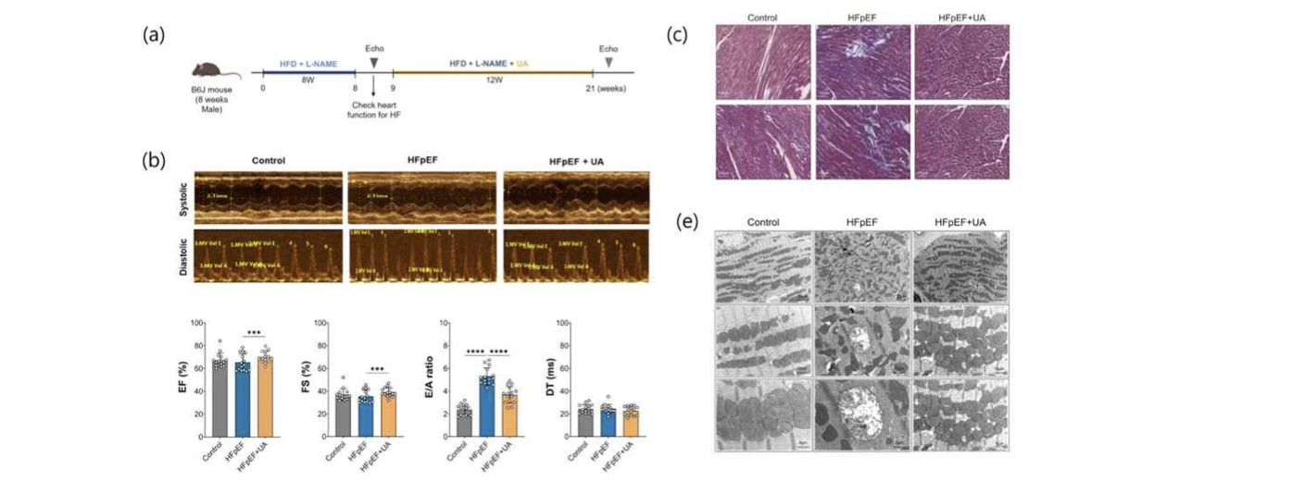

▲ Effect of ‘urolithin A’ on ‘heart failure with preserved ejection fraction (HFpEF)’. (a) An HFpEF mouse model was constructed using a high-fat diet (HFD) and L-NAME, and ‘Urolithin A’ was administered by mixing it into the diet for 12 weeks. (b) In the ‘urolithin A’ administration group, echocardiographic analysis showed that impaired diastolic cardiac function improved by approximately 32%, and (c) increased myocardial fibrosis decreased by up to approximately 42%. Additionally, (d) transmission electron microscopy analysis showed that reduced mitochondrial area recovered by approximately 42%, and the number of mitochondria increased by approximately 26%, indicating a significant improvement in damaged mitochondrial structure.
Heart failure with preserved ejection fraction accounts for approximately half of all heart failure cases and is closely associated with metabolic diseases such as obesity, diabetes, and hypertension.
It is characterized by the thickening or hardening of the heart muscle, which prevents it from receiving sufficient blood during relaxation.
However, because this is a disease resulting from the complex interplay of various causes—including myocardial fibrosis, inflammation, and metabolic abnormalities—treatments targeting the fundamental causes of the disease are still lacking.
The research team noted that as heart failure with preserved ejection fraction progresses, mitochondria*, which produce energy in heart cells, become damaged. Furthermore, the function of removing these damaged mitochondria deteriorates, leading to the accumulation of damaged mitochondria within the cells.
The accumulation of damaged mitochondria reduces energy production in heart cells and accelerates inflammation and fibrosis, which can further worsen heart function.
Urolithin A is a metabolite produced by gut microbes, and its effect in improving mitochondrial function is known in studies on aging and muscle diseases. However, its actual therapeutic effect and mechanism of action in heart failure with preserved ejection fraction have not been elucidated.
Therefore, the joint research team analyzed the therapeutic effect and mechanism of action to determine whether Urolithin A can break the vicious cycle of accumulated damaged mitochondria.
* mitochondria: Intracellular organelles that produce the energy necessary for cellular activity.
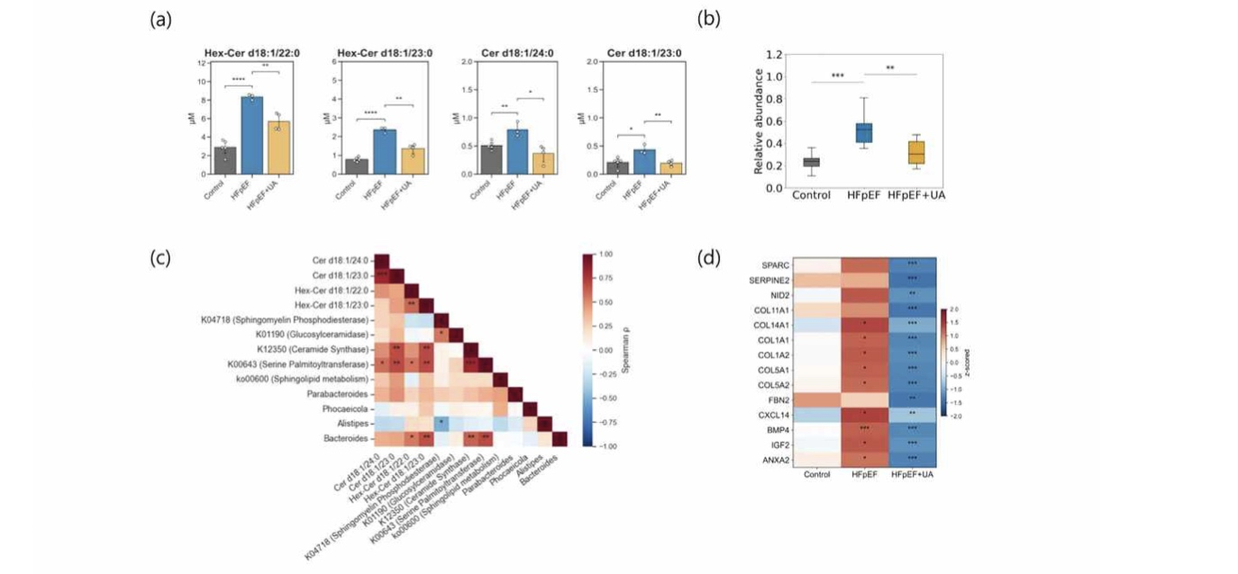

▲ The regulatory effect of ‘urolithin A’ on gut microbes and lipid metabolism. (a) Increased ceramide levels (Hex-Cer and Cer) in HFpEF mice decreased after treatment with ‘urolithin A’. (b) The diversity of the gut microbial community associated with ceramide synthesis was restored by treatment with ‘urolithin A’, and (c) the gut microbiome and sphingolipid metabolic pathways associated with ceramide synthesis showed a close correlation with ceramide accumulation. (d) ‘urolithin A’ alleviated myocardial remodeling by reducing the expression of fiber-related genes.
To confirm the therapeutic effects of urolithin A, a heart failure model with preserved ejection fraction accompanied by obesity and hypertension was established by feeding mice a high-fat diet and co-administering ‘L-NAME*’, a substance that impairs vascular function.
As a result of administering urolithin A, ▴ deteriorated cardiac diastolic function improved by approximately 32%, ▴ cardiac hypertrophy decreased by approximately 9.4%, and ▴ myocardial fibrosis decreased by approximately 42% compared to the heart failure group that did not receive urolithin A.
In cardiomyocytes created from human induced pluripotent stem cells**, gene expression related to fibrosis was reduced, confirming the possibility that a similar protective effect may appear in human cardiomyocytes.
* L-NAME: A substance used to impair vascular function and raise blood pressure by inhibiting the production of nitric oxide, which relaxes blood vessels.
** induced pluripotent stem cells (iPSCs): Cells created by reverting adult somatic cells, such as skin or blood, to a state similar to embryonic stem cells, enabling them to differentiate into various cell types.
Analysis of the mechanism of action revealed that urolithin A activates ‘mitophagy,’ a cellular cleaning function that selectively removes damaged mitochondria, thereby restoring mitochondrial structure and energy production functions.
Furthermore, it was confirmed that it alters the composition of gut microbes involved in the production of ‘ceramide,’ which, if excessively accumulated in the body, can cause inflammation and cell damage, thereby exacerbating cardiovascular disease. It also demonstrated an effect of lowering elevated blood ceramide levels in mice with heart failure.
* mitophagy: A process in which cells selectively break down and remove damaged or dysfunctional mitochondria.
** ceramide: A type of lipid that makes up cell membranes; excessive accumulation in the body can cause inflammation and cell damage, potentially exacerbating cardiovascular disease.
This study is significant in that it presents a novel treatment strategy for ejection fraction-preserving heart failure that simultaneously regulates mitochondrial function in heart cells and gut microbiota-ceramide metabolism.
Professor Chang-Myung Oh stated, "We confirmed that urolithin A, a metabolite derived from gut microbiota, facilitates the process of removing damaged mitochondria and can alleviate ejection fraction-preserving heart failure by regulating both gut microbiota and lipid metabolism." He added, "As ejection fraction-preserving heart failure is a disease with limited fundamental treatment options, we expect this research to serve as an opportunity to broaden the possibilities for treatment based on the disease's pathogenesis."
This research, led by Professor Chang-Myung Oh of the Department of Biomedical Science and Engineering at GIST and Professor Sang-Wook Park of the Chonnam National University School of Dentistry, with Dr. Hangyul Song of the Department of Biomedical Science and Engineering at GIST serving as the first author and doctoral students Chahyeon Yun and Yunju Choi participating, was supported by ▴ the Ministry of Science and ICT and the National Research Foundation of Korea’s Bio-Medical Technology Development Project; ▴ the Ministry of Health and Welfare and the Korea Health Industry Development Institute’s Korean ARPA-H Project and Health and Medical Technology Research and Development Project; and ▴ the GIST-Chonnam National University Hospital Research Cooperation Project.
The research results — Urolithin A activates mitophagy via the AMPK–mTOR axis and modulates the gut–ceramide axis to ameliorate cardiac remodeling in HFpEF— were published online in the international academic journal EMM (Experimental & Molecular Medicine) on July 10, 2026.
Meanwhile, GIST stated that this research achievement holds both academic significance and potential for industrial application, and that discussions regarding technology transfer can be conducted through the Technology Commercialization Center (hgmoon@gist.ac.kr).

