GIST, Seoul National University, and USC solve next-generation ai semiconductor challenges to realize ultra-low power, high-integration neuromorphic semiconductors with a single device

- An international joint research team, including Professor Sanghan Lee's team from the Department of Materials Science and Engineering at GIST, simultaneously resolves the nonlinearity and leakage current issues of information storage in a single device... Achieving stable information storage without a selector

- Stability of over 10 million repetitive cycles and performance proven in an 11×11 memory cell crossbar array

- Published in the international journal Nature Communications

▲ Group photo of the international joint research team from GIST, Seoul National University, and USC. (From left) Professor Ho Won Jang of the Department of Materials Science and Engineering at Seoul National University; Professor Sanghan Lee of the Department of Materials Science and Engineering at GIST; Professor J. Joshua Yang of the Department of Electrical and Computer Engineering at the University of Southern California; Youngmin Kim, a combined master's and doctoral student in the Department of Materials Science and Engineering at Seoul National University; Professor Yoon Jung Lee of the Department of Electronic Engineering at Kookmin University; and J Jiwoong Yang, a combined master's and doctoral student in the Department of Materials Science and Engineering at GIST.

The Gwangju Institute of Science and Technology (GIST, President Kichul Lim) announced that a research team led by Professor Sanghan Lee of the Department of Materials Science and Engineering, a research team led by Professor Ho Won Jang of the Department of Materials Science and Engineering at Seoul National University, and a research team led by Professor Joshua Yang of the Department of Electrical and Computer Engineering at the University of Southern California have jointly developed a neuromorphic semiconductor device that stores information linearly—that is, within a constant range—in response to electrical stimulation, while stably maintaining this data and effectively suppressing leakage current.

The developed device integrates both memory functions for storing information and self-rectifying functions that allow current to flow in only one direction into a single unit. This enables stable operation in crossbar arrays—where memory devices are arranged in a grid pattern—without the need for a separate selector, which was previously considered essential. This presents new possibilities for increasing the integration density and process efficiency of neuromorphic semiconductors.

* selector: A device that reduces data misrecording or computational errors by blocking slip-path currents caused by the low resistance of devices in a crossbar array structure.

As artificial intelligence (AI) establishes itself as a core technology for industrial innovation, "neuromorphic computing," which mimics the human brain to store and process information, is garnering attention as a next-generation AI semiconductor technology.

‘Neuromorphic computing,’ which utilizes resistance changing in response to repeated electrical stimulation as memory, is implemented using a ‘crossbar array structure’ in which memory elements are arranged in an alternating horizontal and vertical pattern.
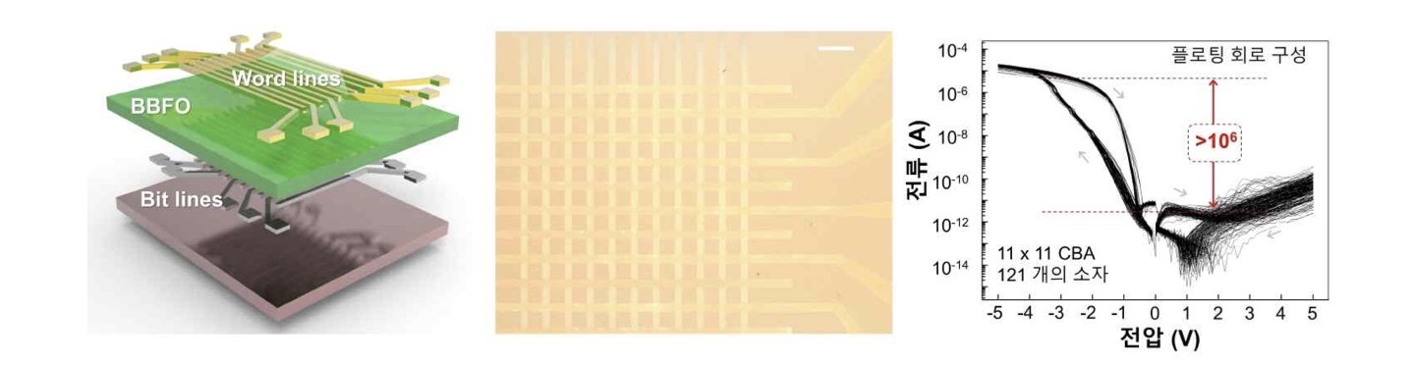
▲ The structure and rectification characteristics of a ferroelectric-based single-device neuromorphic crossbar array developed by the joint research team. (From left) A schematic diagram of the device structure, a micrograph of the fabricated device, and an electrical characteristic graph showing magnetic ‘rectification’ where current flows in only one direction.

This allows for the high-density integration of devices within a limited space and the parallel processing of large-scale data, making it a key structure for AI semiconductors that enhances computational efficiency.

However, non-linear information accumulation—where information is not stored in a uniform width even with repeated electrical stimulation—and the problem of sneak-path current, where current leaks to adjacent devices, have been pointed out as limitations that reduce computational accuracy. To resolve this, a separate selector device to block the sneak-path current had to be added to each memory device, leading to complex device structures and reduced integration density and process efficiency.

* neuromorphic computing: This is a technology that moves beyond conventional computing structures where data computation and storage are performed separately. By implementing the neurons of a biological brain into hardware, it enables ultra-low power, high-speed parallel computation of vast amounts of information.

To address this issue, the joint research team simultaneously implemented memory functions for storing information and magnetic rectification functions that allow current to flow in only one direction within a single device.

To achieve this, they designed the material by adding barium (Ba) to bismuth iron oxide (BiFeO₃), a ferroelectric material that "remembers" electrical signals. This allows for precise control of the movement of oxygen vacancies, which affect the electrical signal storage characteristics and current flow.

Oxygen vacancies are empty spaces created when oxygen atoms are removed from the oxide, and they are a critical factor determining current flow and information storage performance. By adding barium to stably control the movement of oxygen vacancies, the researchers realized linear information storage characteristics, ensuring that information is stored within a constant range even under repetitive electrical stimulation.

In addition, by implementing a self-rectification function within the memory device itself, unnecessary leakage current was effectively blocked without the need for a separate selector. This allowed for stable operation while simplifying the circuit structure.

* ferroelectric: A material with the property of remembering electrical signals. It is utilized in next-generation memory semiconductors because it can maintain its information storage state even when the power is turned off.

The joint research team verified the stability of repetitive operation, information storage characteristics, and the applicability to crossbar arrays through various experiments.

In repetitive write and erase tests, the device maintained stable characteristics even after more than 10 million (10⁷) repetitive operations.

Furthermore, by analyzing information storage characteristics with varying voltage magnitudes and the number of electrical stimuli, the team confirmed linear information storage characteristics, where information is stored within a constant range depending on the electrical stimulation.

Furthermore, by implementing a crossbar array (121 memory cells) composed of 11 x 11 memory cells using the developed device and conducting experiments on writing and erasing text and image patterns, it was proven that information in each memory cell can be stably stored and controlled without the need for a separate selector.
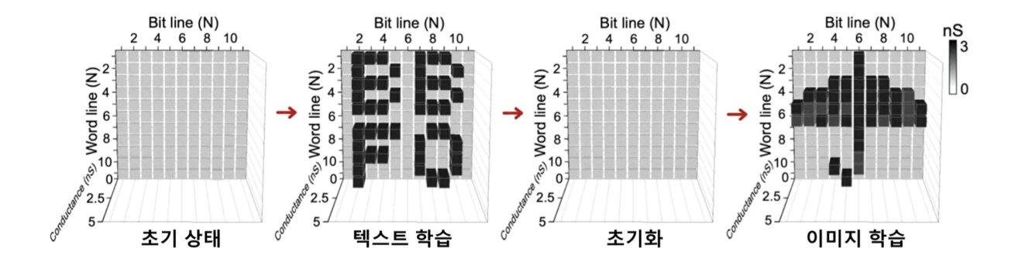
▲ Demonstration results of data learning and initialization using the fabricated 11×11 crossbar array device. It demonstrates that text and image patterns can be stored and initialized by precisely controlling conductivity.

In particular, the control capability to direct current in only one direction (rectification ratio) was increased by more than one million times, effectively blocking minute electrical leakage (leakage current).

Professor Sanghan Lee of the Department of Materials Science and Engineering stated, “This research holds great academic and industrial significance in that it simultaneously solved the nonlinearity of information storage and leakage current issues, which were major challenges in existing neuromorphic semiconductors, within a single device.” He added, “It presented a new design direction capable of achieving high process efficiency and integration density without the need for separate selector devices, and we expect it to serve as a foundational technology that accelerates the commercialization of high-performance and ultra-low-power neuromorphic semiconductors, as well as the realization of high-efficiency neuromorphic computing in the future.”

This research, jointly supervised by Professor Sanghan Lee of the Department of Materials Science and Engineering at GIST, Professor Ho Won Jang of the Department of Materials Science and Engineering at Seoul National University, and Professor Joshua Yang of the Department of Electrical and Computer Engineering at the University of Southern California, involved Youngmin Kim, a student in the integrated master's and Ph.D. program at the Department of Materials Science and Engineering at Seoul National University, Professor Yoon Jung Lee of the Department of Electronic Engineering at Kookmin University, and Jiwoong Yang, a student in the integrated master's and Ph.D. program at GIST, as co-first authors.

The study was supported by the Ministry of Science and ICT and the National Research Foundation of Korea through the Individual Basic Research Program (Mid-Career Researcher), the Nano-Materials Technology Development Program, and the Future Materials Discovery Program.

In addition, the study received support from research facilities at the Seoul National University Semiconductor Research Institute, the Korea Institute of Engineering and Technology, and the SOFT Foundry Institute.

The research results — Programmable ferroelectric rectifier for reliable and efficient neuromorphic crossbar array — were published online in the international journal Nature Communications on March 17, 2026, and the final version (version of record), after undergoing proofreading, was released this month. Meanwhile, GIST stated that this research achievement takes into account both its academic significance and potential for industrial application, and that discussions regarding technology transfer can be conducted through the Technology Commercialization Center (hgmoon@gist.ac.kr).

