“The Original Form of Gamma Rays Revived by Positron Traces” GIST successfully reconstructs energy distribution of high-energy gamma rays in an overlapping signal environment

- Research team led by Professor Woosuk Bang of the Department of Physics and Photon Science presents new analysis technique to reconstruct superimposed gamma-ray signals in high-velocity environments… Published in the international journal Radiation Physics and Chemistry

- Expected to improve the accuracy of analysis for extreme physics experiments, such as laser nuclear fusion and laser plasma accelerators

▲ (From left) Professor Woosuk Bang of the Department of Physics and Photon Science at GIST, Seongmin Lee (integrated master's and Ph.D. program), and Youhwan Noh (integrated master's and Ph.D. program)

The Gwangju Institute of Science and Technology (GIST, President Kichul Lim) announced that a research team led by Professor Woosuk Bang of the Department of Physics and Photon Science has developed an analysis technology capable of reconstructing the energy distribution and photon count of GeV* (gigaelectronvolt, 1 billion electronvolts) class high-energy gamma rays using only positron signals, even in "high-flux environments" where a very large number of gamma rays reach the detector simultaneously in a short period, causing signals to overlap.

This technology enables precise analysis of the energy distribution and generation volume of high-energy gamma rays even in high-flux environments, and is expected to be utilized to enhance the accuracy of research on extreme physical phenomena in the future, such as laser nuclear fusion, laser-plasma accelerators, and nuclear physics.

* GeV: A unit representing particle energy, where 1 GeV is equivalent to 1 billion electron volts. The gamma rays discussed in this study possess energy thousands of times higher than that of medical X-rays used in hospitals.

** photon: A fundamental particle that constitutes light; gamma rays are a type of electromagnetic wave composed of photons.

Gamma rays, which are electromagnetic waves similar to the X-rays used in hospitals, serve as an important clue for analyzing extreme physical phenomena occurring in nuclear reactions or high-power laser experiments.

In particular, the gigaelectronvolt-level "high-energy gamma rays" discussed in this study possess energy thousands of times higher than that of medical X-rays. Analyzing the distribution of gamma rays allows for verification of how energy was transferred and converted during the experiment, serving as a key indicator for validating experimental results.

However, in high-velocity environments, a limitation existed in that it was difficult to accurately measure the energy distribution of gamma rays because a large number of gamma rays are generated simultaneously in a short period, causing detector signals to overlap.

Instead of directly measuring gamma rays, the research team proposed a method to reconstruct the energy distribution of gamma rays using positron signals, which are the "antimatter" generated as gamma rays pass through a lead plate.

High-energy gamma rays generate electron (-) and positron (+) pairs as they pass through a lead plate. The research team utilized positron signals, which are relatively less affected by other particles or background signals, to calculate the relationship between gamma ray energy and positron signals through computer simulations. Based on this, they inversely reconstructed the energy distribution of the gamma rays.
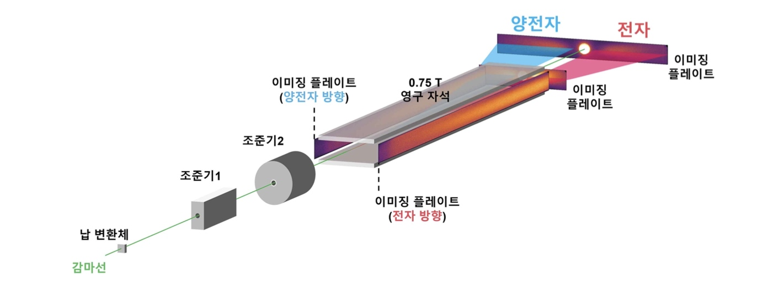
▲ Conceptual diagram for measuring the energy distribution of high-energy gamma rays. When gamma rays are incident on a lead transducer, electrons and positrons are generated. After restricting the direction of particle propagation with two collimators, the energy distribution of the electrons and positrons is measured using permanent magnets and an imaging plate.

In the analysis process, an analysis technique was applied in which the initial values ​​of the gamma-ray energy distribution were first stably estimated, and then the detailed structure was gradually refined through iterative calculations.

As a result, the energy distribution and total number of photons of high-energy gamma rays were successfully reconstructed even in high-velocity environments with severe signal overlap. This laid the foundation for more accurately analyzing gamma rays generated in extreme physics experiments and quantitatively interpreting experimental results.

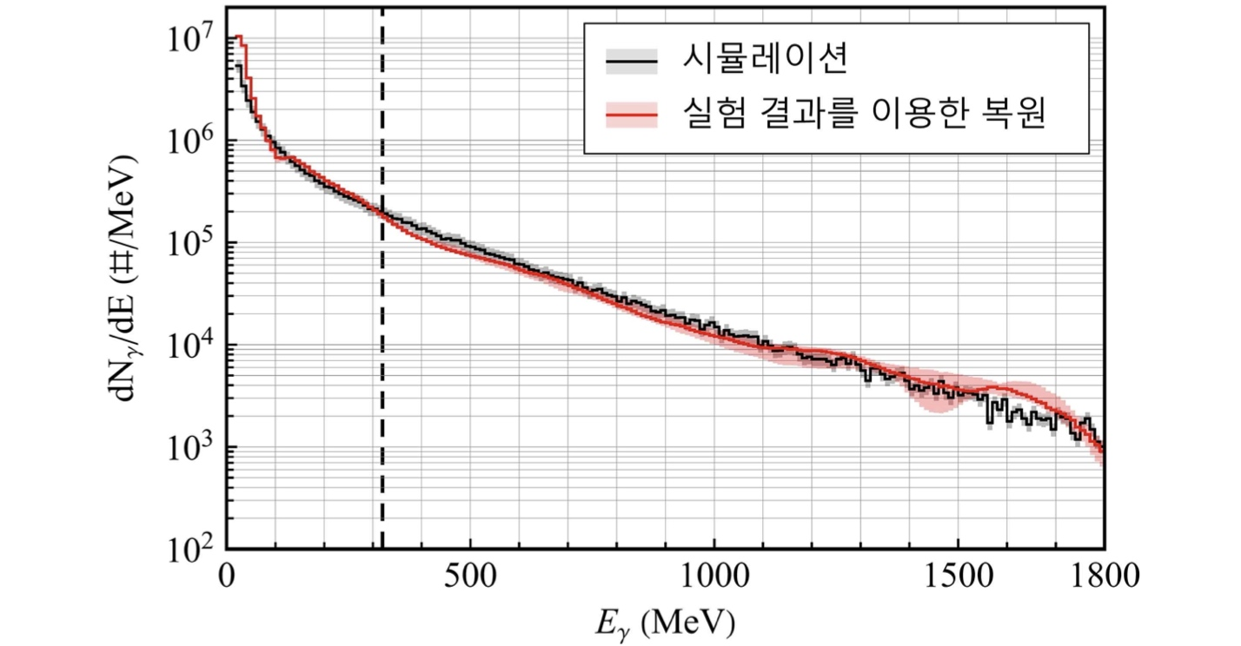
As a result of verifying performance using simulated gamma-ray data, the total 'number of photons' constituting the gamma rays was reconstructed with an error of within 2% compared to the actual value, and the 'energy distribution' of the gamma rays was also reproduced in near-perfect match with the actual value.

▲ Gamma-ray energy distribution reconstructed from the measured positron signal. The results reconstructed by the research team (red) match the computer simulation results (black), demonstrating that the proposed method can determine both the energy distribution and the number of photons of high-flux GeV-class gamma rays.

Verification based on actual high-power laser experimental data also confirmed the validity of the technology, as the reconstructed energy distribution of high-energy gamma rays generally matched the computer simulation results.

This study is expected to contribute to improving the analytical accuracy of various extreme physics experiments in the future by establishing a foundational technology for more accurately diagnosing high-energy gamma rays generated in high-flux environments.

Professor Woosuk Bang stated, "Just as it is difficult to distinguish individual voices when multiple people speak simultaneously, it is difficult to directly measure the energy distribution of high-energy gamma rays generated in large quantities over a short period because detector signals overlap." He added, "This study is significant in that it presents an analytical method that reconstructs both the original energy distribution and the total number of photons using the positron signal generated by the gamma rays."

This research, supervised by Professor Professor Woosuk Bang of the Department of Physics and Photon Science at GIST and co-authored by integrated master's and doctoral students Seongmin Lee and Youhwan Noh as first authors, was supported by the Mid-Career Researcher Program of the Ministry of Science and ICT and the National Research Foundation of Korea.

The research results — Spectral reconstruction of high-flux GeV gamma rays from pair spectra using hybrid Tikhonov–D’Agostini unfolding — were published online on July 11, 2026, in Radiation Physics and Chemistry, an international journal ranked in the top 6% of the nuclear science field according to the Journal Citation Report (JCR), a global academic journal evaluation metric.

Meanwhile, GIST stated that this research achievement was considered to have both academic significance and potential for industrial application, and that discussions regarding technology transfer can be conducted through the Technology Commercialization Center (hgmoon@gist.ac.kr).

