“Discarded electronic devices eaten and decomposed by insects” GIST and Inha University realize fully functional biodegradable electronic devices… Presenting a new alternative to reduce electronic waste
- Research teams led by Professor Myung-Han Yoon of GIST and Professor Bong Sup Shim of Inha University jointly demonstrate the possibility of decomposition at the level of actual ‘electronic devices,’ going beyond ‘materials,’ raising expectations for the reduction of electronic waste
- Presents a new direction for research on eco-friendly electronic devices
- Published in the international journal ACS Polymer Science & Technology


▲ Group photo of the GIST-Inha University joint research team. (From left) Professor Myung-Han Yoon (co-corresponding author) of GIST, Professor Bong Sup Shim (co-corresponding author) of Inha University, Hyeonjun Na (co-first author) of GIST, (co-first author) of Inha University, Il-Young Jo (co-first author) of GIST, and Da-Young Lee (co-first author) of GIST.
The Gwangju Institute of Science and Technology (GIST, President Kichul Lim) announced that a joint research team led by Professor Myung-Han Yoon of the Department of Materials Science and Engineering and Professor Bong Sup Shim of the Department of Chemical Engineering at Inha University has developed an eco-friendly electronic device* that can be decomposed by insects after use.
This research goes beyond biodegradation studies at the material level; by proving that the entire, fully functioning electronic device can decompose, it presents a new possibility for solving the problem of electronic waste from disposable electronic devices that are difficult to recover after use.
* electronic device: A component that performs the core functions of electronic devices, such as sensors, semiconductors, and memory.
With recent advancements in environmental monitoring and biosensor technologies, there is a growing demand for low-cost sensors capable of collecting data in real-time from various locations.
However, these sensors are often difficult to recover after use, frequently resulting in them becoming electronic waste. Until now, research on eco-friendly electronic devices has also been limited to verifying the biodegradability of individual materials, posing a barrier to their application in actual devices.
The joint research team focused on the 'Organic Electrochemical Transistor (OECT),' a device utilized in biosensors and environmental sensors.
While OECTs are advantageous for mass production using printing processes, the issue of disposal after use remained a challenge.
* organic electrochemical transistor (OECT): A device that amplifies electrical signals by utilizing the interaction between ions in an electrolyte and conductive polymers.
To address this issue, the joint research team focused on Montmorillonite (MMT), a clay mineral ingestible by insects. However, clay has low electrical conductivity, raising concerns about performance degradation when applied to devices.
The team combined this with PEDOT:PSS**, a conductive polymer * material widely used in OECTs, to develop a composite material that possesses both biodegradability and electrical performance.
In addition, they applied a paper substrate-based printing process and implemented waterproofing and reinforcement technologies to compensate for the weakness of paper, which is susceptible to moisture.
They fabricated an actual OECT using this developed composite material and confirmed that it operates stably even at low voltages.
* conductive polymer: A polymer that possesses electrical conductivity similar to metal conductors. Unlike typical organic polymers, it simultaneously possesses the electrical, magnetic, and optical properties of metals or semiconductors.
** PEDOT:PSS: It is a conductive polymer formed by mixing the conductive ‘PEDOT’ and the insulating polymer ‘PSS’.
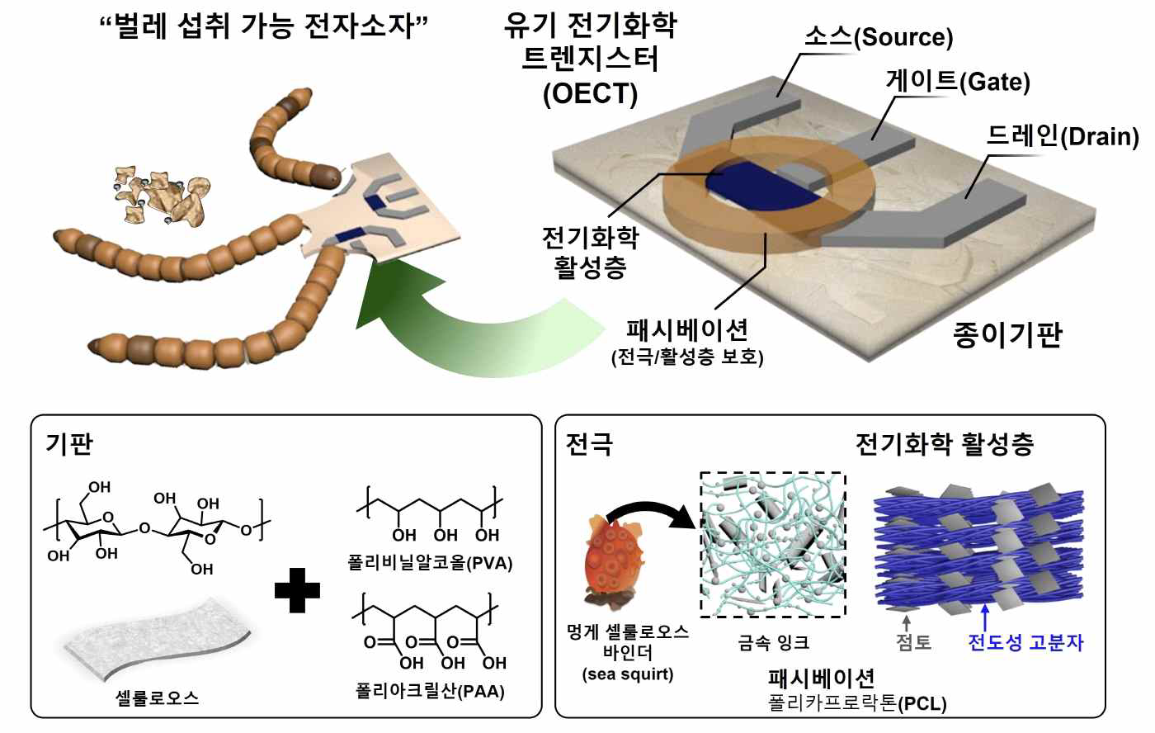

▲ Organic electrochemical transistor (OECT) components. The structure of an OECT device that can be ingested by insects and the composition of each material are shown. On a hydrophobically treated cross-linked paper substrate (left) that can be stably used in water systems, a metal electrode containing a binder derived from sea squirt cellulose and a PEDOT:PSS/MMT electrochemical active layer (right) material were used.
Next, an experiment using superworms were conducted to verify whether the worms could actually break down the element.
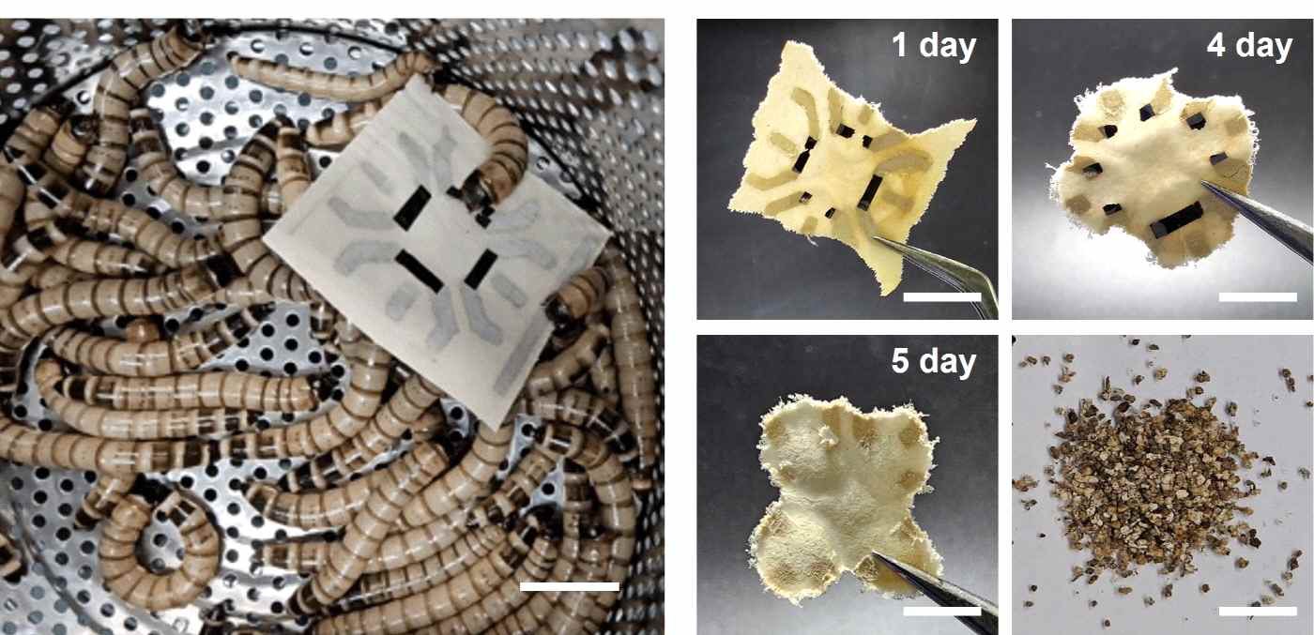

▲ The process of worm ingestion of the OECT device. (Left) The OECT device, having completed operation, provided as food for the worms, and the device gradually decreasing in size as 1, 4, and 5 days passed after ingestion; (Right) The appearance of the excrement (frass) excreted after the device was ingested.
As a result, the survival rate of the superworms remained at approximately 95% during the experiment period, and the superworms completely ingested the entire 3cm x 3cm device, including the ▴ active layer, ▴ substrate, and ▴ electrodes, within about one week.
Furthermore, analysis of the excrement (frass) confirmed that actual decomposition accompanied by chemical changes had taken place, rather than merely being broken into small pieces.
This study presents a new alternative to reduce the problem of electronic waste by applying it to fields where recovery after use is difficult, such as environmental monitoring sensors, healthcare sensors, and smart agriculture sensors.
Professor Myung-Han Yoon stated, "This study is significant in that it proved that an entire device made of eco-friendly materials can be decomposed by insects," adding, "I expect it to suggest a new direction for the development of sustainable electronic devices and research on eco-friendly electronic equipment in the future."
Professor Bong Sup Shim explained, "While previous research focused on developing individual decomposable materials, the most significant difference of this study is that it proved that insects can completely decompose an actual, functioning device."
This research, supervised by Professor of the Department of Materials Science and Engineering at GIST and Professor Bong Sup Shim of the Department of Chemical Engineering at Inha University, with GIST doctoral student Hyeonjun Na, Inha University doctoral student Yeongbeom Hong, GIST PhD student Il-Young Jo, and GIST postdoctoral researcher Da-Young Lee participating as co-first authors, was supported by the following: ▴ Basic Research Laboratory Support Program (Ministry of Science and ICT & National Research Foundation of Korea) ▴ Traditional Culture Source Technology Development Program (Ministry of Science and ICT & Ministry of Culture, Sports and Tourism) ▴ National Research Foundation of Korea Research Institute for Advanced Research (Mid-Career Researcher) ▴ National Research Foundation of Korea Leading Research Center Support Program ▴ Materials and Components Technology Development Program (Ministry of Trade, Industry and Energy & Korea Institute of Industrial Technology Planning and Evaluation) ▴ GIST-InnoCORE Program (Ministry of Science and ICT).
The research results — From Print to Soil: Superworm-Degradable Organic Electrochemical Transistors via PEDOT:PSS–Clay Composites — were published online on June 29, 2026, in ACS Polymer Science & Technology, an international academic journal in the field of polymer science published by the American Chemical Society (ACS).
Meanwhile, GIST stated that this research achievement was considered to have both academic significance and potential for industrial application, and that discussions regarding technology transfer can be conducted through the Technology Commercialization Center (hgmoon@gist.ac.kr).

