“Hidden boundaries within materials were ‘switches’ that change properties” GIST uncovers principle how nano-interfacial layers within materials control crystal structure
- GIST Professor Ji Young Jo's team identifies novel role of nano-interface layer, internal boundary region of materials
- Successful crystal structure transformation using only an electric field without changes in material composition… Paving a new path for the design of next-generation semiconductors and electronic devices
- Published in the international journal Materials Horizons
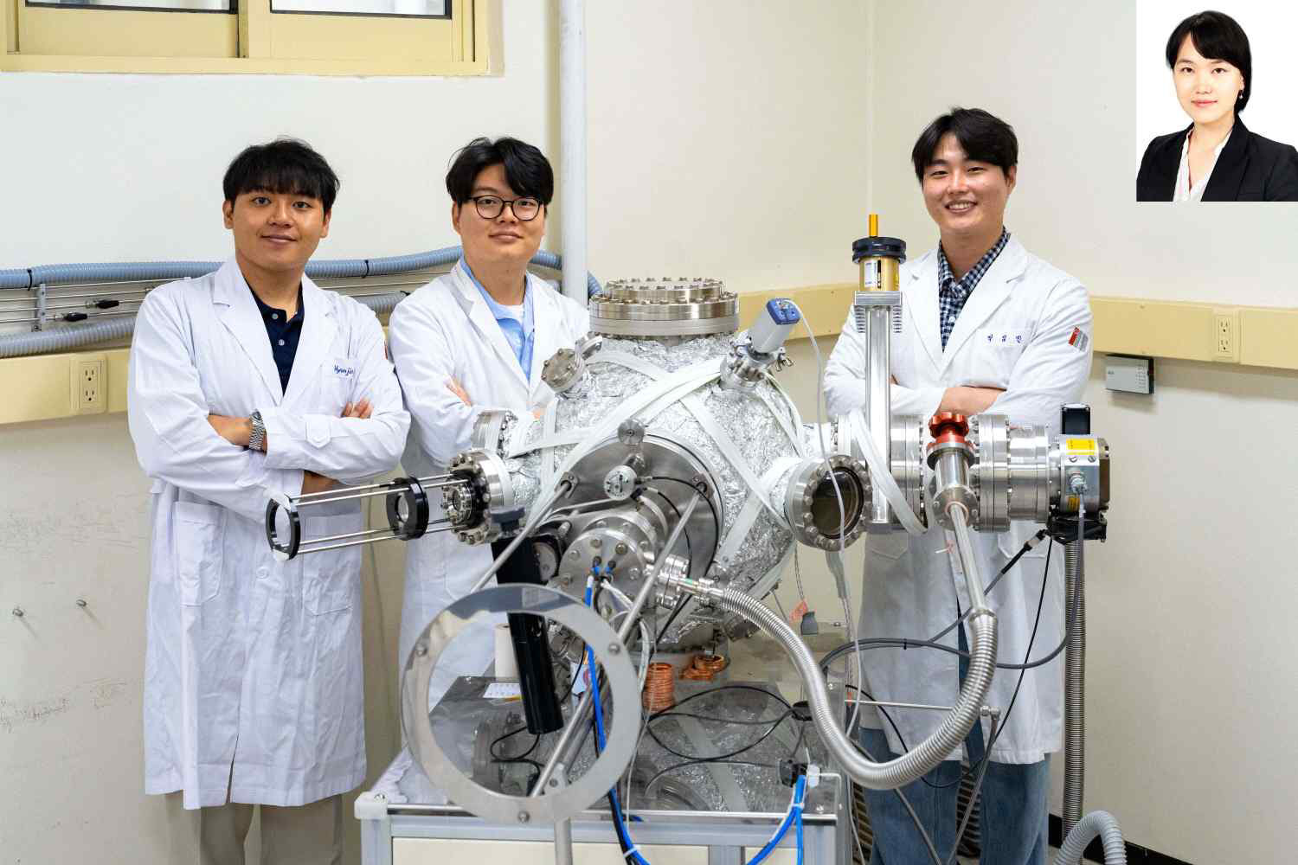

▲ Group photo of Professor Ji Young Jo's research team from the Department of Materials Science and Engineering at GIST. (From left) Hyunjin Joh, PhD student; WooJun Seol, PhD student; Seong Min Park, PhD student; (Top right) Professor Ji Young Jo.
The Gwangju Institute of Science and Technology (GIST, President Kichul Lim) announced that a research team led by Professor Ji Young Jo of the Department of Materials Science and Engineering, in collaboration with a research team led by Professor Hyeon Jun Lee of the Department of Materials Science and Engineering at Kangwon National University, has identified a new principle capable of altering the crystal structure of a material by controlling a nanometer (nm)-sized interfacial layer using only an electric field.
The research team confirmed that the boundary region (interfacial layer) where different structures meet within ultra-thin material layers (thin films), which are widely used in the fabrication of semiconductors and electronic devices, can change its structure in response to an electric field.
This finding is particularly significant in that it revealed that the interfacial layer, previously known to play a role in mitigating internal deformation, is actually a key region that controls the structure and properties of the material.
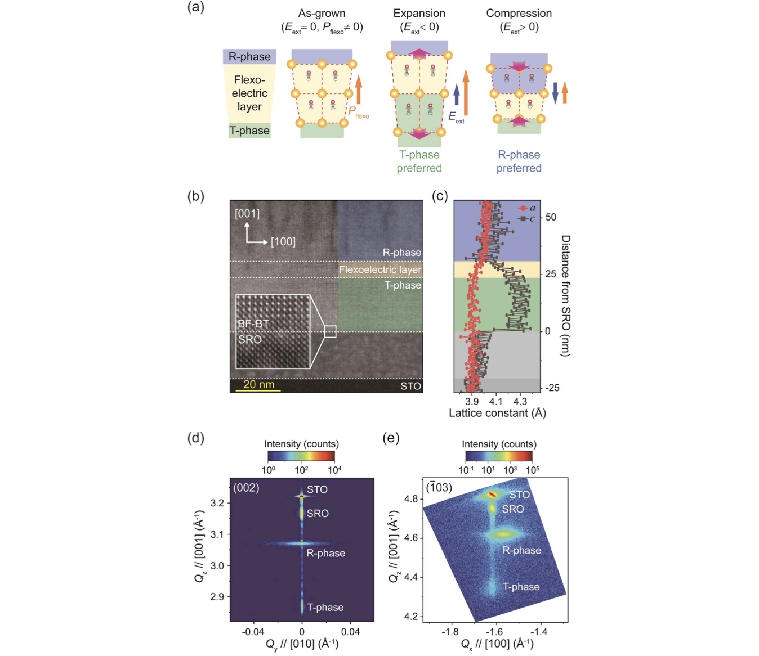

▲ Schematic diagram of the structural change of the nano-interface layer according to the electric field. BF-BT thin films consist of different crystal structures and a nano-interface layer formed between them. It was confirmed that the structure of the nano-interface layer changes depending on the direction of the external electric field and can transition into different crystal structures.
The way electricity flows or the characteristics of a material's response to light differ depending on its internal crystal structure. Therefore, technology that precisely controls the crystal structure is crucial for realizing desired functions; until now, structure control has mainly been achieved by changing the ratio of constituent components or adding impurities.
In contrast, the research team focused on the nano-interface layer that naturally forms within the thin film. The nano-interface layer refers to a very thin boundary region where different structures meet.
The research was conducted based on the observation that "flexo-electric polarization," a special electrical phenomenon occurring in this interface layer, can influence changes in the material's structure.
* flexo-electric polarization: An electrical phenomenon that occurs when the degree of internal deformation of a material varies depending on the location. In the nano-interface layer, this effect is amplified, which can influence changes in the material's structure.
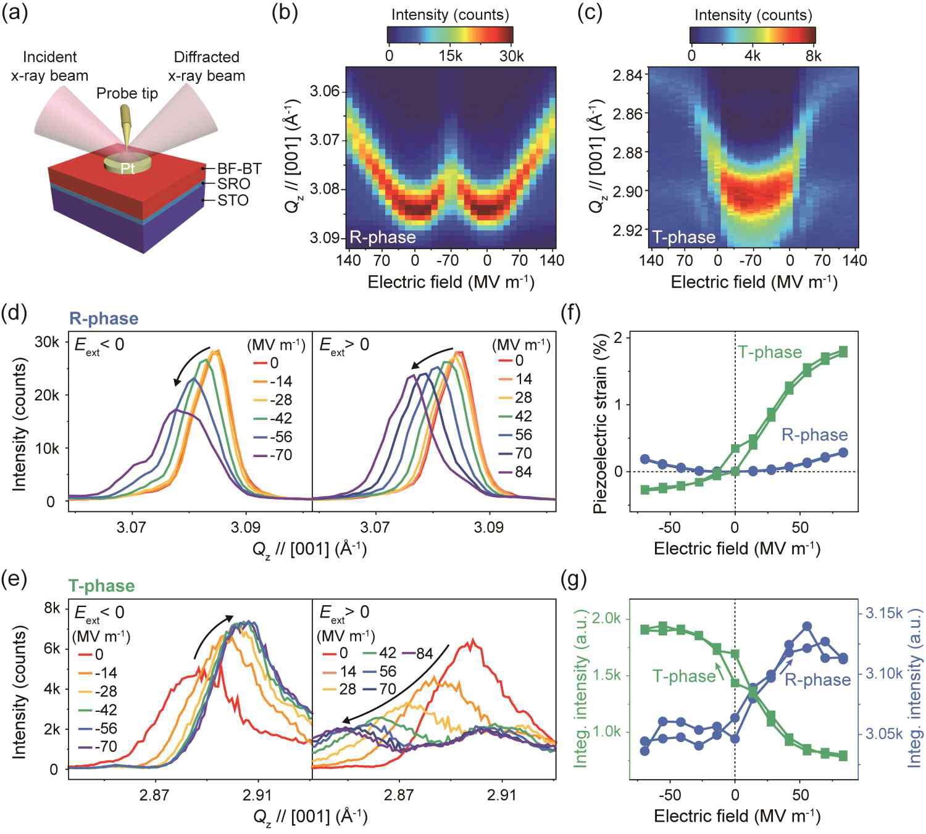

▲ Results of observing structural changes in the nano-interface layer according to an electric field. Real-time measurements of structural changes occurring while an electric field was applied confirmed that the structural changes occurred selectively only in the nano-interface layer formed between the two crystal structures, rather than throughout the entire thin film.
To verify this, the research team fabricated a bismuth ferrite-barium titanate (BiFeO₃-BaTiO₃, BF-BT) oxide thin film and observed in real-time how the structure of the interface layer changed while an electric field was applied.
As a result, they confirmed that the crystal structure of the interface layer could repeatedly switch between two different structures depending on the direction of the electric field. This result demonstrates that the structure of a material can be controlled in a desired direction using only an electric field.
In particular, these changes occurred selectively only in the interface layer, which is approximately 6 nm thick and located between the different crystal structures, rather than throughout the entire thin film. This is a size equivalent to about 1/10,000th the thickness of a human hair.
The research team discovered that the cause of these structural changes lies in the interaction between the flexoelectric polarization occurring in the interface layer and the external electric field. In other words, the special electrical properties formed in the interface layer responded to the electric field, inducing structural changes.
This achievement presents a new principle that allows crystal structures to be controlled solely by electric fields without altering the material's composition. It is expected to be utilized in the future development of various functional materials, including next-generation electronic devices, sensors, and optical devices.
Professor Ji Young Jo stated, "This research is the first to confirm that crystal structures can be altered by controlling the flexoelectric polarization present in the nano-interface layer using an electric field." She added, "It is significant in that it presents the interfacial layer, which had previously received little attention, as a new domain for structural control."
This research, supervised by Professor Ji Young Jo of the Department of Materials Science and Engineering and led by doctoral student Seong Min Park as the first author, was conducted with support from a GIST research project, the Ministry of Science and ICT's GIST-InnoCORE program, and projects funded by the Ministry of Science and ICT and the National Research Foundation of Korea.
The research results were — Flexoelectric polarization-electric field coupling-driven phase transformation in epitaxial films — published in the international materials science journal Materials Horizons on May 19, 2026.
Meanwhile, GIST stated that this research achievement takes into account both its academic significance and potential for industrial application, and that discussions regarding technology transfer can be conducted through the Technology Commercialization Center (hgmoon@gist.ac.kr).

