“A sip of ‘real coffee’ while wearing VR goggles” GIST develops ai technology that displays only necessary real-world objects while maintaining virtual reality (VR) immersion
- Research team led by Professor SeungJun Kim of the Department of AI Convergence develops 'SelfBlending' technology that selectively displays only real-world objects learned by AI in a virtual environment… Maintains VR immersion while enhancing interaction with real-world objects
- Expected to be utilized in various XR fields such as education, training, and remote collaboration… Published in the international academic journal IEEE TVCG
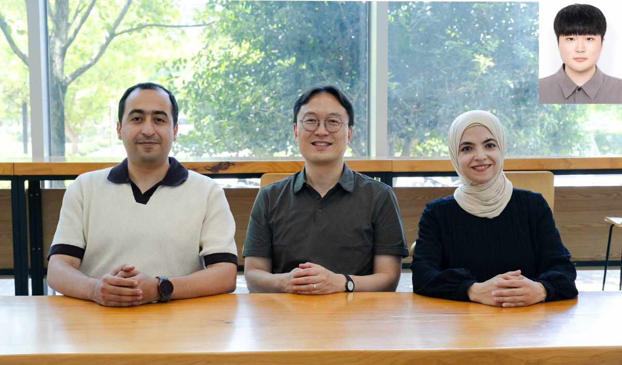

▲ Group photo of Professor SeungJun Kim's research team from the Department of AI Convergence at GIST. (From left) Ahmed Elsharqawi, postdoctoral researcher (first author) from the Department of AI Convergence at GIST; Professor SeungJun Kim (corresponding author); Aya Attaya, master's degree; (Top right) Bocheon Gim, master's degree.
The Gwangju Institute of Science and Technology (GIST, President Kichul Lim) announced that Professor SeungJun Kim's research team from the Department of AI Convergence has developed an AI-based reality-virtual fusion technology called "SelfBlending." This technology utilizes the real world as an interactive resource rather than a mere distraction during virtual reality (VR) use, allowing users to selectively display only the real-world objects they desire within the virtual environment.
Unlike the existing passthrough method**, which exposes the entire surrounding environment, this technology is characterized by its ability to support the natural utilization of necessary real-world objects while maintaining immersion in the virtual environment.
* SelfBlending: A reality-virtual fusion technology in which AI learns and recognizes real-world objects, such as water bottles or notebooks, registered by the user via hand gestures, and selectively displays only those objects within the virtual environment when needed.
** Passthrough Method: This is a feature that displays the entire real-world screen captured by the VR headset camera to the user.
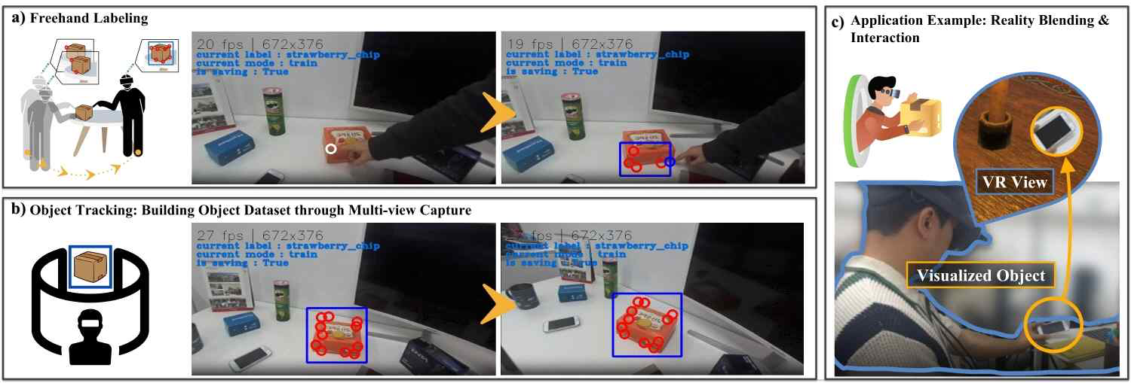

▲ The operation process of the SelfBlending framework. When a user registers a real-world object using hand gestures, the system learns the object data. Subsequently, when needed, it selectively implements only that specific object in the virtual environment, allowing for natural interaction with the real-world object while maintaining immersion.
Previously, when a user needed to use a real-world object while immersed in a VR game or virtual work environment, they had to remove the VR headset or use the passthrough function, which displays the entire real-world screen, leading to a decrease in the continuity of the virtual environment.
To resolve this issue, SelfBlending operates by allowing users to specify and register the boundaries of real-world objects using hand gestures within virtual reality. The AI ​​then learns and recognizes these boundaries, displaying only the corresponding object within the virtual environment when necessary.
For example, if a user registers a water bottle or a notepad in advance, they can selectively view and utilize only that object within the virtual space whenever needed, without having to remove their VR device. Because the visual flow remains uninterrupted, users do not have the hassle of removing the blindfolded VR device or switching back to the real-world screen.
This method is characterized by maximizing workflow continuity by bringing only essential real-world resources into the virtual world, rather than displaying the entire real-world landscape like conventional passthrough methods that disrupt the flow of the virtual environment.
The research team conducted a user evaluation comparing the VR headset removal method, the standard passthrough method, and the self-blending method with 18 participants.
The analysis results showed that self-blending demonstrated the best performance across key evaluation metrics, including: ▴ presence, which refers to the degree to which users feel as though they are actually inside the virtual environment; ▴ virtual awareness, which refers to the degree to which users perceive the virtual environment more clearly; and ▴ plausibility, which indicates the naturalness of interactions.
Furthermore, users were able to perform tasks with less effort while using real-world objects, and the time required to utilize the objects was not significantly different from the existing pass-through method, indicating that there is no need to sacrifice work efficiency for the sake of enhanced immersion.
Professor SeungJun Kim stated, “SelfBlending is a technology that selectively displays only the real-world objects the user needs within a virtual environment,” adding, “It presents a new method that allows for natural interaction with real-world objects while maintaining VR immersion, and we expect it to be utilized in various Extended Reality (XR) fields such as education, training, and remote collaboration in the future.”
This research, supervised by Professor SeungJun Kim of the Department of AI Convergence and led by Postdoctoral Researcher Ahmed Elsharkawy as the first author, included researcher Bocheon Gim and master’s student Aya Ataya as co-authors.
This research was conducted with support from the Ministry of Science and ICT and the National Research Foundation of Korea's Mid-Career Researcher Support Program and the Overseas Excellent Research Institute Cooperation Hub Establishment Project, as well as the Ministry of Science and ICT's GIST-InnoCORE project.
The research results — SelfBlending: Artificial Intelligence-driven Augmentation with Hand Interactions for Seamless Reality Blending in Virtual Environments — were published online on May 6, 2026, in the international academic journal IEEE TVCG (Transactions on Visualization and Computer Graphics), which is in the field of computer science and software engineering.
Meanwhile, GIST stated that this research achievement was considered to have both academic significance and potential for industrial application, and that discussions regarding technology transfer can be conducted through the Technology Commercialization Center (hgmoon@gist.ac.kr).

