GIST develops AI technology to track sarcopenia progression using only daily movements
- Joint research team from GIST, KIST, and Chonnam National University Bitgoeul Hospital develops 'MAISE,' a physics-based AI framework for quantitatively analyzing sarcopenia in ankles, knees, and hips during daily movements
- Analyzes movements such as standing up from a chair without sensors or equipment... Enables quantitative evaluation of muscle function based on joint torque
- Published in the international journal Journal of NeuroEngineering and Rehabilitation


▲ (From left) Professor Jiyeon Kang (corresponding author), Department of AI Convergence at GIST; master's student Jaebeom Jo (first author); Ph.D. student Kihyun Kim; Professor Junhyoung Ha, Department of Mechanical Engineering at Ulsan National University of Science and Technology (UNIST) (KIST at the time of research); Dr. Kanghyun Ryu of the Korea Institute of Science and Technology (KIST); and Professor Min-gu Kang of Chonnam National University Bitgoeul Hospital
The Gwangju Institute of Science and Technology (GIST, President Kichul Lim) announced that a research team led by Professor Jiyeon Kang of the Department of AI Convergence has developed ‘MAISE*,’ an artificial intelligence (AI) technology capable of tracking and analyzing changes in muscle function associated with the progression of sarcopenia in the elderly solely through daily movements. This was achieved in collaboration with the Korea Institute of Science and Technology (KIST) and Chonnam National University Bitgoeul Hospital.
This technology is characterized by its ability to estimate the muscle function status of the ankles, knees, and hips, and to numerically verify the degree of sarcopenia progression, based solely on everyday movements such as standing up from a chair or picking up objects, without the need for separate sensors or expensive equipment.
* MAISE (Motion-AI Integrated Surveillance for the Elderly): An AI-based analysis technology that analyzes daily movements to estimate the force required for joint movement (joint torque) and evaluates the state of sarcopenia in each joint based on this analysis.
Sarcopenia is a condition characterized by an abnormal decline in muscle mass and strength with age, which increases the risk of falls and fractures and reduces independence in daily life.
Early detection is crucial, as functional decline is often already significantly advanced by the time symptoms become noticeable. However, current methods rely primarily on indirect functional tests—such as grip strength, walking speed, and standing from a chair—or imaging tests to measure muscle mass, which limits the ability to continuously monitor the gradual decline in function that occurs during daily life.
To overcome this, a joint research team developed an AI technology called ‘MAISE’ that can detect sarcopenia in the elderly solely through the movements they perform during daily activities.
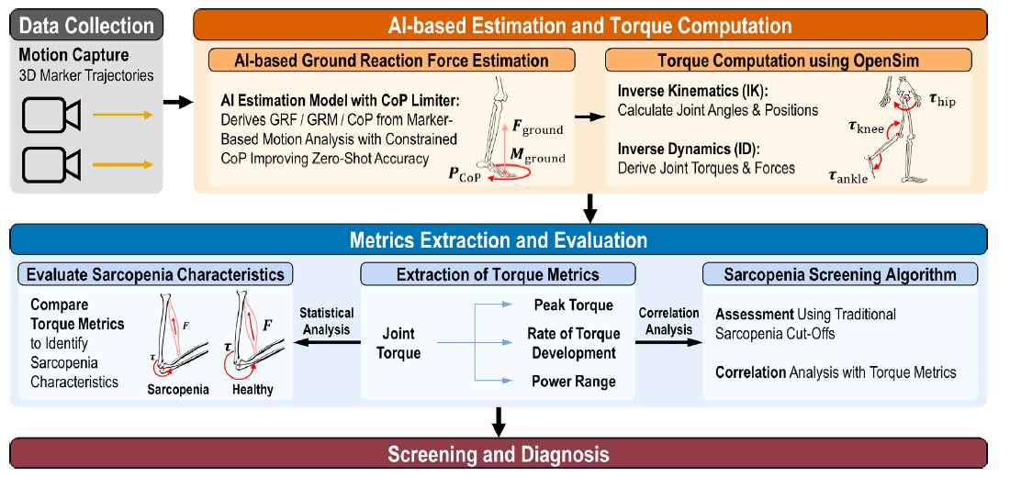

▲ MAISE (Motion-AI Integrated Surveillance for the Elderly) Framework. This illustrates the overall flow of estimating ground reaction force and lower limb joint torque based on movement data acquired from daily activities, and comparing and analyzing joint-specific torque indices with existing sarcopenia assessment indices. It presents the possibility of quantitatively evaluating muscle function status and monitoring sarcopenia solely through daily movements.
In particular, physical information was incorporated into the AI ​​model to enable the estimation of ground reaction force (the force received from the floor when a person pushes against it), which is necessary for calculating joint forces, without the need for separate measurement equipment.
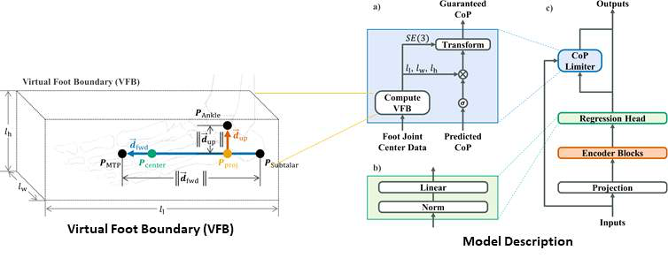

▲ AI model for estimating ground reaction force based on physical information. (a) Utilizing anatomical positional information of the foot, the center of pressure (CoP) is calculated to be located within the actual contact area of ​​the foot, and © this is reflected in the AI ​​model's CoP Limiter to estimate physically valid ground reaction force. This allows for more accurate and stable estimation of ground reaction force using only movement data, without the need for a force plate.
Generally, precise analysis of joint force requires specialized equipment such as force plates, but the research team has established a foundation for analyzing muscle function in everyday environments by enabling its estimation using only human movement data.
As a result, the model incorporating physical information reduced the prediction error for the ‘center of pressure’—indicating where the foot places on the ground—by up to 49.3% and the ground reaction force error by up to 6.5%, even on motion data from the elderly that had not been used for training.
This confirmed that AI can analyze human movements more accurately and stably estimate the actual state of muscle function.
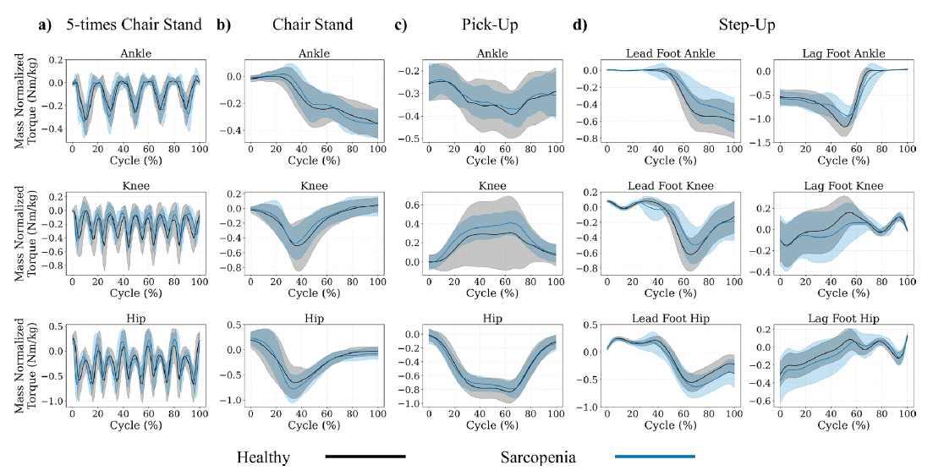

▲ Comparison of lower limb joint force patterns by daily activities based on the presence of sarcopenia. This shows the results of comparing changes in joint torque at the ankle, knee, and hip during (a) standing up from a chair five times, (b) standing up from a chair, (c) picking up an object, and (d) stepping onto a stool. Compared to the healthy group, the sarcopenia group showed a decrease in knee torque and an increase in hip use during some movements. This demonstrates that MAISE can quantitatively analyze differences in muscle function by joint using only daily activities.
The research team had a total of 28 elderly individuals—including both sarcopenic and healthy seniors—perform movements such as standing up from a chair, picking up objects, and stepping onto a platform. They then verified how accurately the joint torque (rotational force required to move a joint) information analyzed by MAISE reflected the actual state of muscle function and the degree of sarcopenia.
The analysis revealed that the joint torque index estimated by MAISE showed a clear correlation with major sarcopenia assessment indicators currently used in clinical practice, such as grip strength, walking speed, and the time taken to stand up from a chair five times.
Furthermore, distinct differences in joint torque patterns were observed between the sarcopenic and healthy groups, confirming that abnormal decline in muscle function can be quantitatively assessed based solely on daily movements.
Professor Jiyeon Kang stated, “This study demonstrated that sarcopenia can be quantitatively observed and evaluated by utilizing biomechanical information hidden within daily movements, suggesting the possibility of continuous, daily-based tracking of muscle function beyond hospital-centered, one-time examinations.” She added, “In the future, we expect to develop this into camera-based non-contact monitoring technology to be utilized for the early detection and personalized management of sarcopenia.”
This research, supervised by Professor Jiyeon Kang of the Department of AI Convergence and conducted by master’s student Jaebeom Jo, was funded by the Ministry of Science and ICT and supported by the National Research Foundation of Korea’s Bio-Medical Technology Development Project and the Korea Institute of Information and Communication Technology Planning and Evaluation’s AI Graduate School Support Project.
The research results — Joint torque estimation from daily living motion for passive sarcopenia monitoring in older adults — were published on April 5, 2026, in the Journal of NeuroEngineering and Rehabilitation, a top-tier international journal in the field of rehabilitation engineering.
Meanwhile, GIST stated that this research achievement takes into account both its academic significance and potential for industrial application, and that discussions regarding technology transfer can be conducted through the Technology Commercialization Office (hgmoon@gist.ac.kr).

