“Path opened to implement multiple functions with a single semiconductor” GIST presents new design principle of changing semiconductor properties using light trapped in mirrors
- An international research team from Korea, China, and Germany led by Professor Dongbin Shin of the Department of Physics and Photon Science at GIST has implemented a 'photonic phase control' technique that controls semiconductor electronic states and electrical properties using light trapped inside mirrors, without the need for strong external lasers
- By utilizing light like a 'switch' to realize various quantum states within a single semiconductor, applications in next-generation quantum computers and low-power semiconductors are anticipated... Published in the international journal Science Advances


▲ (From left) Professor Dongbin Shin of the Department of Physics and Photon Science at GIST, Professor Peizhe Tang of Beihang University, China, and Director Angel Rubio of the Max Planck Institute for Structure and Material Dynamics, Germany.
The Gwangju Institute of Science and Technology (GIST, President Kichul Lim) announced that a joint Korea-China-Germany research team led by Professor Dongbin Shin of the Department of Physics and Photon Science has presented a new "photon field-based phase control technique" that alters the electrical properties of semiconductor materials using light trapped inside mirrors.
The research team theoretically demonstrated that by creating an environment where light and matter are strongly coupled, the "topological phase"—which determines the movement and arrangement of electrons within a semiconductor—can be changed to a desired form.
This research presents a new possibility for controlling the quantum state of materials without continuously firing strong lasers as in conventional methods, and is expected to provide new design principles for the development of next-generation quantum computers and ultra-low-power semiconductor technology.
Recently, active research is being conducted in the fields of quantum computing and next-generation semiconductors to control the movement of electrons using the interaction between light and matter.
Representative methods include the ‘Floquet method,’ which uses a strong laser to change the state of electrons, and ‘nonlinear phonon interaction,’ which changes the state of a lattice.
However, this method had limitations: it generated a significant amount of heat because it required the continuous application of strong light, and the altered state was maintained for only a very short period. In fact, the states achieved in previous studies remained at the level of tens of picoseconds (one trillionth of a second), and issues regarding thermal damage caused by the use of strong lasers have also been pointed out.
* Floquet method: This is a photo-induced control technique that artificially alters the electronic structure and phase state of a material by irradiating it with a strong laser that changes periodically over time. While this method can induce new quantum states, it has limitations in heat generation and maintaining state stability due to the need for a continuous external light source.
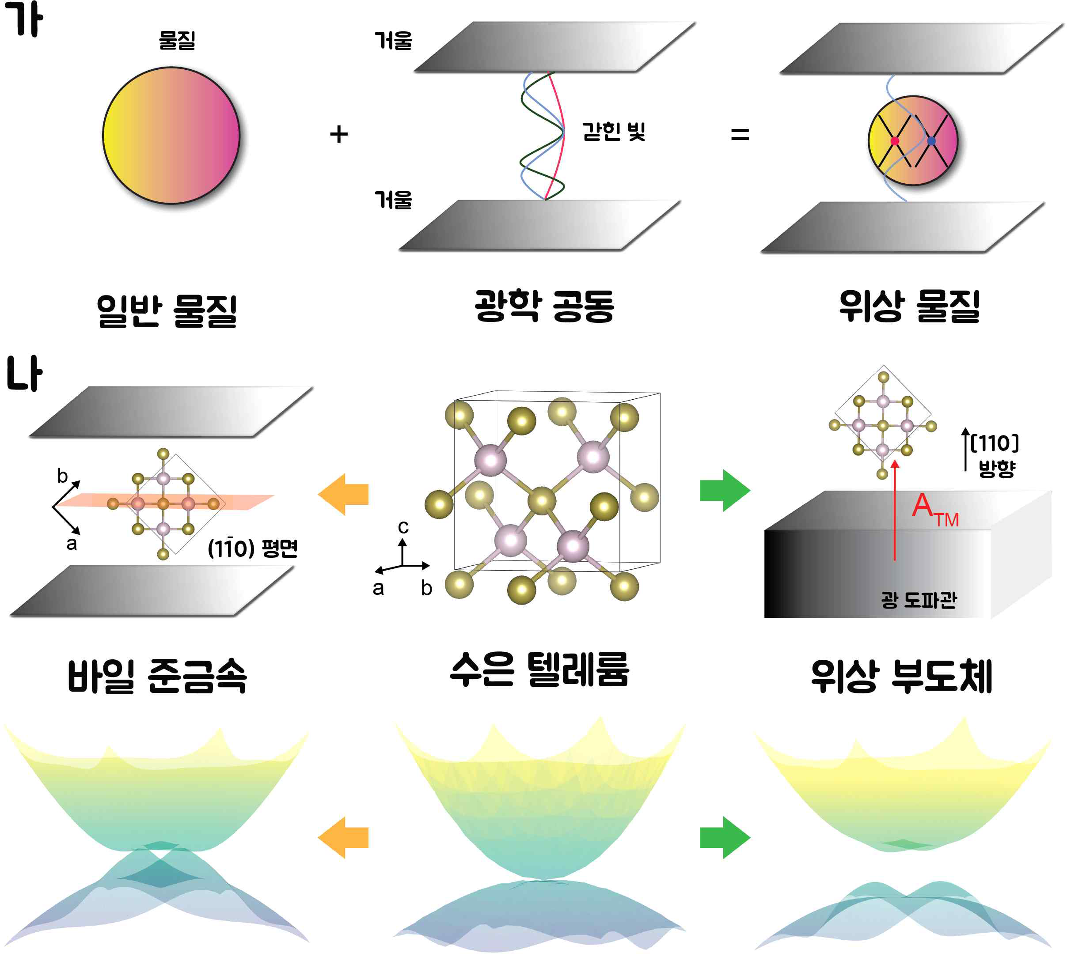

▲ Schematic diagram of the phase transition of HgTe induced by a photonic field. (a) Illustrates the phase transition of HgTe. When light is confined within a very small mirror box (optical cavity), the material and light become strongly entangled and influence each other. (b) HgTe, which was previously a material close to an ordinary metal without phase properties, transforms into a material with a completely different phase depending on how the polarization direction of the light is aligned.
To overcome these limitations, the research team proposed a new approach that confines light within a narrow space to allow it to continuously interact with the material, instead of shining a strong laser from the outside.
The team designed the system to confine light within an optical cavity—the space between two mirrors—and a waveguide, allowing the light to remain in the space for an extended period and strongly couple with the material.
The ‘photon field’ formed in this way is not merely light that illuminates the material; rather, it acts as a kind of ‘light environment’ that continuously interacts with electrons to alter the material’s properties themselves.
Recently, research results have reported that when such photon fields are strongly coupled with a material, they can influence quantum states such as superconductivity or charge density waves, and the research team applied this to the control of phase states.
The research team formed a photon field on the semiconductor material mercury telluride (HgTe) and analyzed the changes in the material using Quantum Electrodynamics Density Functional Theory (QEDFT).
By precisely tracking how the electronic structure and atomic arrangement changed while altering the direction and intensity of light, the team confirmed that the photon field changes both the electronic state and the atomic structure by altering the material's symmetry.
In particular, they theoretically proved that even a single material can transition to different phase states depending on the conditions of the photon field.
* quantum electrodynamic density functional theory (QEDFT): This is an extended density functional theory designed to describe the interaction between electrons and electromagnetic fields quantum mechanically. It is a computational method that allows for the simultaneous consideration of electronic structure and photon states in systems where light and matter are strongly coupled.
In fact, HgTe, which was in an ordinary semimetal state, was shown to transform into a material with different electrical properties depending on the conditions of the photon field.
The research team confirmed that HgTe can transition into states such as: ▴ a ‘nodal-line semimetal’ where electrons move along specific lines; ▴ a ‘weyl semimetal’ where electrons move very rapidly in one direction; and ▴ a ‘topological insulator’ where the interior acts as an insulator but current flows along the surface.
This implies that even with the same material, the way electricity flows and electronic characteristics can be freely designed depending on how the direction and intensity of light are set.
The research team expects that these results will serve as a foundation for the development of next-generation variable electronic and quantum devices capable of selectively implementing multiple functions from a single material.
This research is significant in that, unlike conventional methods that induced instantaneous state changes using strong lasers, it realized a new quantum state by utilizing the stable environment itself where a photonic field and the material are combined.
Through this, the research team presented the possibility of maintaining non-equilibrium electronic states induced by light more stably.
Furthermore, as the flow of electrons can be controlled by light, it is expected to expand into a new ultra-low power driving technology that reduces resistive heat generation and energy loss occurring in conventional semiconductor devices. Moreover, it is projected to be widely utilized across the entire spectrum of future information technology, including quantum computers, topological quantum devices, and ultra-low power electronic devices.
Professor Dongbin Shin of the Department of Physics and Photon Science stated, "This research is an achievement that demonstrates the ability to precisely control electronic structures and phase states solely through the quantum interactions between light and matter trapped inside a mirror, without the need for continuous application of strong external lasers." He added, "We expect that photonic field-based control technology can be utilized as a new design principle for topological quantum computing and next-generation semiconductor technology."
This research, jointly conducted by Professor Dongbin Shin of the Department of Physics and Photon Science at GIST, Professor Peizhe Tang of Beihang University in China, and Director Angel Rubio of the Max Planck Institute for Structure and Dynamics in Germany, was supported by the Ministry of Science and ICT, the National Research Foundation of Korea’s Outstanding Young Researcher Support Program, and the Max Planck Institute at Korea and POSTECH.
The research results — Multiple photon field–induced topological states in bulk HgTe — were published online in the international journal Science Advances on May 28, 2026, and were previously released on the research preprint platform arXiv on June 30, 2025.
Meanwhile, GIST stated that this research achievement was considered to have both academic significance and potential for industrial application, and that discussions regarding technology transfer can be conducted through the Technology Commercialization Center (hgmoon@gist.ac.kr).

