“Simplified structure and process, stronger performance and lifespan” GIST develops low-cost, high-efficiency next-generation hydrogen production electrode
- Joint research by Professor Jong Hoon Joo's team at GIST's Department of Environmental and Energy Engineering, Professor Jang Yong Lee's team at Konkuk University, and Dr. Sungjun Kim's team at the Korea Research Institute of Chemical Technology… Achieves high efficiency and durability even in high-current environments through the design of a non-precious metal porous electrode integrating catalytic and mass transfer functions
- 2,142 hours of continuous operation stability proven… Published in the international journal Nature Communications


▲ (From left) Professor Jong Hoon Joo of the Department of Environment and Energy Engineering at GIST, Dr. Hye Ri Kim (researcher at Aekyung Chemical Central Research Institute), Dr. Sungjun Kim and researcher Sang-Hun Shin of the Korea Research Institute of Chemical Technology (KRICT), and Professor Jang Yong Lee of the Department of Chemical Engineering at Konkuk University.
The Gwangju Institute of Science and Technology (GIST, President Kichul Lim) announced that a research team led by Professor Jong Hoon Joo of the Department of Environment and Energy Engineering, in collaboration with Professor Jang Yong Lee's team at Konkuk University and Dr. Sungjun Kim's team at the Korea Research Institute of Chemical Technology (KRICT), has developed an "integrated non-precious metal porous electrode" capable of enhancing the performance and durability of next-generation green hydrogen production devices.
The newly developed electrode is characterized by integrating the catalytic function, responsible for the oxygen generation reaction during the hydrogen production process, and the transport function, which facilitates the movement of water and gas, into a single structure.
Through this, the research team reduced internal electrical resistance and facilitated the smooth supply of water and release of oxygen, thereby achieving high hydrogen production efficiency and long-term stability even in high-current environments.
Recently, "green hydrogen" has been attracting attention as a key technology for realizing carbon neutrality. Green hydrogen is an eco-friendly form of hydrogen produced by electrolyzing water, and it does not emit carbon during the production process.
In particular, ‘anion exchange membrane water electrolysis (AEMWE)*’ is attracting attention as a next-generation hydrogen production technology because it allows the use of inexpensive metal catalysts, such as nickel (Ni) and iron (Fe), instead of expensive platinum group precious metals. However, existing electrodes have limitations; their multi-layered structure generates electrical resistance, and catalyst layers may detach or the movement of water and oxygen may be hindered during prolonged operation.
* anion exchange membrane water electrolysis: A water electrolysis technology that uses an anion exchange membrane to decompose water into hydrogen and oxygen in an alkaline environment. It is considered a next-generation, large-capacity green hydrogen production technology because it enables the production of high-performance hydrogen while reducing the use of platinum group precious metals.
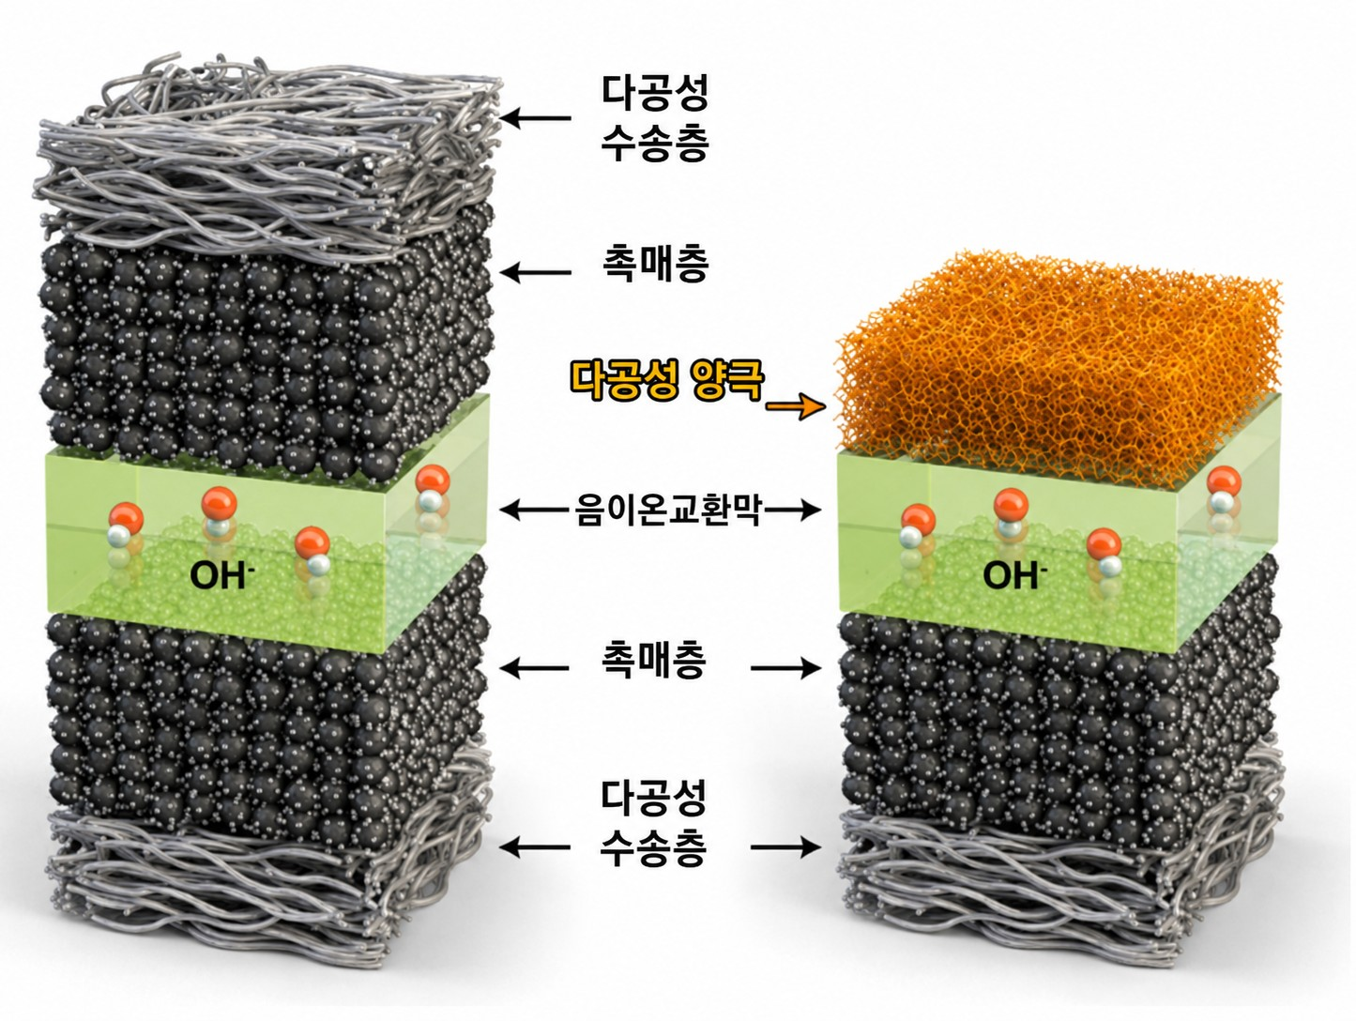

▲ Schematic diagram comparing the existing electrode structure with the integrated nickel-iron-based porous electrode developed in this study. While the existing structure separates the catalyst layer and the porous transport layer, the developed electrode integrates catalytic and water/gas transport functions into a single porous anode structure, thereby lowering membrane-electrode interfacial resistance and improving water supply and oxygen release.
To address these issues, the research team newly designed a nickel-iron alloy-based porous electrode (NiFe-f-PTL). This electrode was fabricated so that the porous structure itself, containing fine pores, simultaneously performs the roles of catalyst and transport layer.
Through this, electrical loss between the electrode and the membrane was reduced without using the separate catalyst layer and ionomer required in existing electrodes, and water supply and oxygen bubble release performance were improved. Furthermore, the stability of the electrode structure was enhanced, allowing for minimized performance degradation even during prolonged use.
The research team fabricated the electrode using a relatively simple ‘tape casting’ process*. Metal powder was formed into a thin sheet and subjected to a heat treatment process to create a porous structure with numerous fine pores, resembling a sponge.
This method allows for uniform control of electrode thickness and pore structure, making it advantageous for future large-area, mass production.
* tape casting process: This is a process that creates a sheet of uniform thickness by spreading a slurry containing metal or ceramic powder thinly over a flat substrate. It is widely used in the manufacture of electrodes and battery materials because it enables the relatively simple and economical production of large-area, thin, and uniform porous electrodes.
The research team verified the performance of the new electrode in an actual anion exchange membrane water electrolysis cell.
As a result, they confirmed that a large amount of hydrogen can be stably produced even in high-temperature and strongly alkaline environments. In an environment of 80°C and 1.0 molar (M) potassium hydroxide (KOH), which closely approximates the operating conditions of actual water electrolysis devices, a high current density of 6.73 amperes (A/cm²) was recorded at 1.8 volts (V).
Furthermore, they confirmed that the structure and performance remained stable during a test in which the same electrode was operated continuously for a total of 2,142 hours without replacement. Through this, the research team demonstrated that the new electrode maintains high durability and can operate stably for a long period, even in alkaline environments.
This research is expected to be utilized as a core technology for next-generation large-capacity green hydrogen production systems, contributing to the development of high-efficiency and low-cost hydrogen production devices.
In particular, it is significant that electrode performance and durability were simultaneously improved through a design that integrates catalytic and mass transfer functions into a single structure.
Professor Jong Hoon Joo said, "This study demonstrates that the actual performance of water electrolysis devices can be enhanced by designing them with not only the catalytic performance of the electrodes but also the processes of water and gas movement and the contact structure between the membrane and the electrodes" He added, "The integrated porous electrode can be utilized as a core technology for next-generation green hydrogen production systems that are highly efficient and long-lasting."
This research, supervised by Professor Jong Hoon Joo of the Department of Environment and Energy Engineering at GIST, Professor Jang Yong Lee of Konkuk University, and Dr. Sungjun Kim of the Korea Research Institute of Chemical Technology (KRICT), and conducted by Dr. Kim Hye-ri of GIST and researcher Sang-Hun Shin of KRICT as first authors, was supported by the Ministry of Science and ICT and the National Research Foundation of Korea's Leading Research Center Support Program and the Nano and Materials Technology Development Program.
The research results — Integrated catalyst–transport nickel-iron porous electrode for anion exchange membrane water electrolysis — were published online in the international journal Nature Communications on May 13, 2026.
Meanwhile, GIST stated that this research achievement takes into account both its academic significance and potential for industrial application, and that discussions regarding technology transfer can be conducted through the Technology Commercialization Center (hgmoon@gist.ac.kr).

