“Why do some patients experience recurrence while others do not?” GIST and Seoul National University Hospital identify, for the first time in the world, the mechanism by which beneficial bacteria boost anti-cancer immunity in endometrial cancer
- A joint research team led by Professor Hansoo Park of GIST and Professor Maria Lee of Seoul National University Hospital has revealed the mechanism by which beneficial endometrial bacteria (BM) activate anti-cancer immune cells mediated by the metabolite ‘TMAO’… Published in the international journal Microbiome
- Confirmed that the presence of specific beneficial bacteria in endometrial cancer patients is associated with differences in immune response and prognosis, suggesting the possibility of a new endometrial cancer treatment strategy through microorganism-based immune modulation


▲ (From left) Professor Hansoo Park (corresponding author), Department of Biomedical Science and Engineering, GIST; Professor Maria Lee (corresponding author), Department of Obstetrics and Gynecology, Seoul National University Hospital; Dr. Kyungchan Min (co-first author), Department of Biomedical Science and Engineering, GIST (Assistant Professor, Department of Urology, Chung-Ang University College of Medicine); Professor Se Ik Kim (co-first author), Department of Obstetrics and Gynecology, Seoul National University Hospital; and Ph.D. Student Minji Lee (co-first author), Department of Biomedical Science and Engineering and Engineering, GIST
The Gwangju Institute of Science and Technology (GIST, President Kichul Lim) announced that a research team led by Professor Hansoo Park (CEO of Genome & Company) of the Department of Biomedical Science and Engineering, in collaboration with Professor Maria Lee's team from the Department of Obstetrics and Gynecology at Seoul National University Hospital, has identified, for the first time in the world, a mechanism by which specific beneficial bacteria present in the endometrium are connected to gut microbial metabolic pathways to activate anti-cancer immune responses and participate in suppressing the recurrence of endometrial cancer.
This study confirmed the existence and role of microorganisms associated with the prognosis of endometrial cancer patients within the uterus—an environment long considered sterile—and suggested the potential for future microorganism-based treatment strategies.
Endometrial cancer is a representative cancer affecting women, ranking fourth in incidence among women in the United States. Particularly at the stages of metastasis and recurrence, there are limitations in sufficiently improving treatment efficacy and survival rates using conventional chemotherapy alone.
Although recent research results have reported that microbes may be involved in the development and progression of cancer and immune regulation, it has not yet been sufficiently revealed how microbes in endometrial tissue actually affect the anti-cancer immune response.
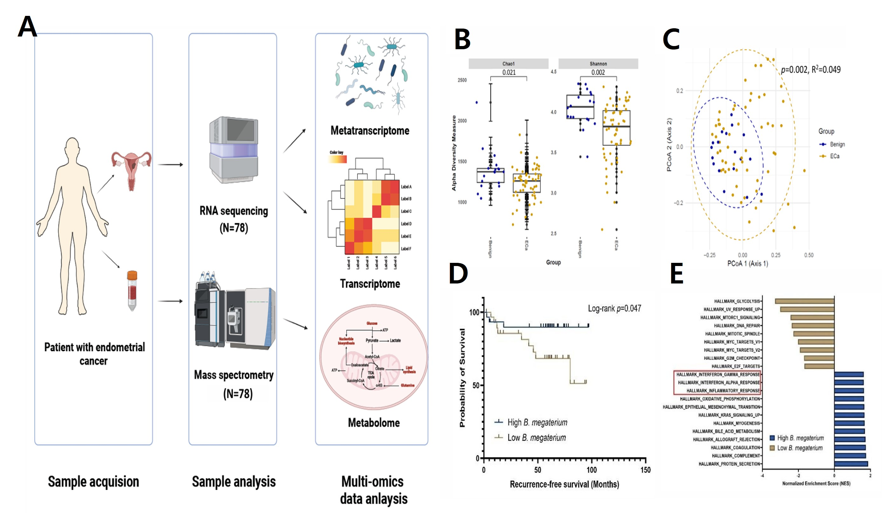

▲ Diagram of the process for identifying beneficial microorganisms (BM) based on multi-omics
As a result of performing meta-transcriptome, transcriptome, and metabolome analyses on patients' endometrial tissues and serum (A), microbial diversity and composition changed significantly in the endometrial cancer patient group (B, C). In particular, Bacillus megaterium was confirmed to be associated with recurrence suppression regardless of whether adjuvant chemotherapy was administered (D). Furthermore, in the group with high levels of BM, a set of genes related to anti-cancer immunity, such as type 1 interferon, inflammatory responses, and complement pathways, was strongly activated (E).
The joint research team conducted multi-omics analysis* (integrated analysis of genomics, transcriptome, proteome, and metabolome) on endometrial tissues of patients with endometrial cancer and benign uterine diseases to elucidate the association between microorganisms and host immune responses.
Analysis results showed that among endometrial cancer patients, a specific beneficial bacterium called ‘Bacillus megaterium (BM)’ was observed in higher numbers in the patient group with a low risk of recurrence and a long survival period.
* multi-omics analysis: A method that integrates and analyzes various biological information, such as the genomics, transcriptomics, proteomics, and metabolomics. Through this, it is possible to understand biological phenomena in multiple layers and comprehensively identify key factors and interactions related to disease.
To verify the potential of microorganism-based anticancer agents, the research team analyzed the process by which beneficial bacteria induce anticancer immune responses in endometrial cancer at the molecular level.
As a result, it was confirmed that the beneficial bacteria possess the key gene ‘cutC*’, which is essential for the production of ‘TMAO (trimethylamine-N-oxide)’, a metabolite associated with anticancer immune activity.
Furthermore, analysis of endometrial tissue and blood from cancer patients revealed a correlation in which blood TMAO concentrations increased as the abundance of the beneficial bacteria increased. This supports the fact that these bacteria play a crucial role in anticancer immune activation mediated by the TMAO production pathway.
* cutC (Choline trimethylamine-lyase): An essential enzyme for intestinal microorganisms to break down choline components found in food and convert them into a precursor of anticancer substances (TMA).
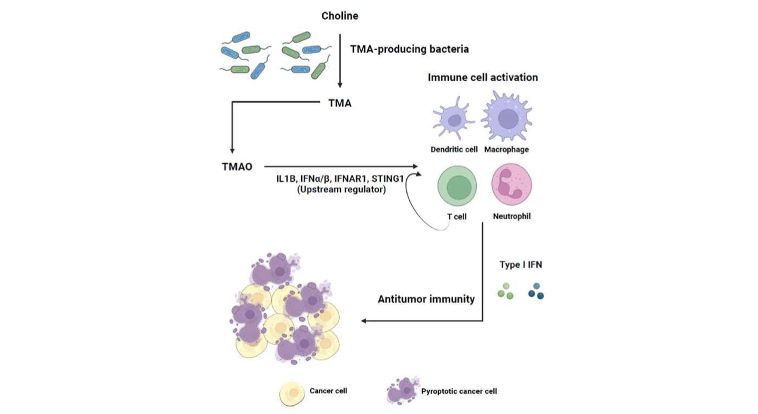

▲ Mechanism of anticancer immune activation via the choline metabolism–TMAO production pathway of Bacillus megaterium (BM). The ‘cutC’ gene, which converts choline into trimethylamine (TMA), was identified in BM, and patient analysis showed a tendency for higher blood TMAO concentrations in patients with higher BM levels. In particular, this association was observed more distinctly in the postmenopausal age group, suggesting a new ‘microbe–metabolite–host immunity’ linkage pathway in which BM promotes TMAO production through choline metabolism and activates anticancer immunity through this process.
In particular, the research team confirmed that the process by which beneficial bacteria break down choline, a component found in food, and convert it into TMAO is linked to the activation of the body's immune response.
In other words, they identified a mechanism in which TMAO, a metabolite produced by the breakdown of choline by beneficial gut bacteria, stimulates the body's immune signal (Type I Interferon)*, which in turn leads to the activation of T cells that attack cancer cells.
* Type I Interferon: A powerful defense signaling substance secreted by immune cells in the body during viral infections or tumor development. It transmits information about cancer cells to the immune system to activate T cells, which act as attackers, and leads a key anti-cancer immune response that directly inhibits the proliferation of cancer.
As a result of cell experiments and image analysis, it was observed that the anti-cancer response of immune cells was enhanced when Bacillus megaterium was applied, and the proliferation of endometrial cancer cells was suppressed while an increase in immune cells around the cancer cells was observed.
Furthermore, in the experimental group treated with beneficial bacteria, the expression of immune response-related genes, such as Type 1 interferon, increased; similar immune-activating effects were observed even when TMAO, a major metabolite, was applied alone.
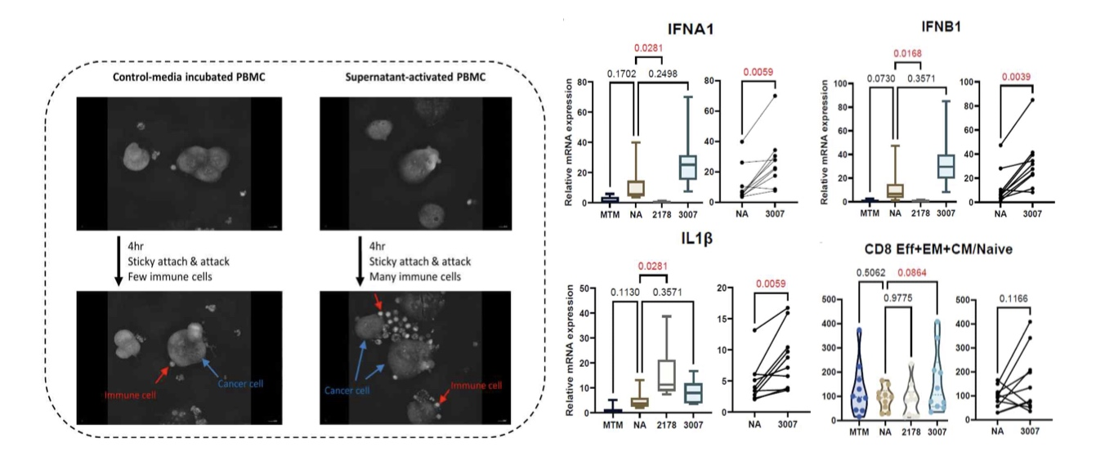

▲ Verification of the anticancer effects and mechanisms of Bacillus megaterium (BM) through in vitro experiments. The supernatant of BM culture was co-cultured with peripheral blood mononuclear cells (PBMCs) derived from healthy individuals to confirm the anticancer immune-activating effects and mechanisms of action of BM.
These results demonstrate that the beneficial bacteria can strengthen the anticancer immune response against endometrial cancer by enhancing immune cell function through metabolic processes and promoting the death of inflammatory cells, thereby indicating the potential for developing new microorganism-based anticancer treatment strategies in the future.
Professor Hansoo Park of the Department of Biomedical Science and Engineering at GIST stated, “This study is the first to systematically identify the pathways by which anticancer immunity is induced at the single-strain level by integrally tracking bacteria, metabolites, and host immune responses within a single cohort (identical patient group).” He added, “It is significant in that it presents the possibility of entirely new microorganism-based combination therapy strategies for endometrial cancer patients who show limited response to existing anticancer or immunotherapy drugs.”
Professor Maria Lee of the Department of Obstetrics and Gynecology at Seoul National University Hospital said, “Through a patient tissue and serum cohort collected over many years, we have provided a new explanation from a microbial perspective regarding the question, ‘Why do some patients recur while others do not?’” She continued, “We plan to conduct further verification across multiple institutions and patient groups of various ethnicities, and accelerate clinical application by expanding into in vivo research, such as experimental models made from patient cells and animal experiments.”
This research was jointly supervised by Professor Hansoo Park of the Department of Biomedical Science and Engineering at GIST and Professor Maria Lee of the Department of Obstetrics and Gynecology at Seoul National University Hospital. Dr. Kyungchan Min of GIST (Assistant Professor, Department of Urology, Chung-Ang University College of Medicine; Assistant Professor, Department of Urology, Chung-Ang University Hospital), Professor Se Ik Kim of Seoul National University Hospital, and doctoral student Minji Lee of GIST participated as first authors.
The research was supported by the Korean Society of Gynecologic Oncology, the Biomedical Technology Development Program of the Ministry of Science and ICT and the National Research Foundation of Korea, and the Convergence Physician-Scientist Training Program of the Ministry of Health and Welfare and the Korea Health Industry Development Institute.
The research results — Trimethylamine-producing microbe Bacillus megaterium KCTC 3007 promotes antitumor immunity in endometrial cancer via type I interferon response pathways — were published online on April 20, 2026, in Microbiome, a prestigious international journal in the field of microbiology.
Meanwhile, GIST stated that this research achievement was considered to have both academic significance and potential for industrial application, and that discussions regarding technology transfer can be conducted through the Technology Commercialization Center (hgmoon@gist.ac.kr).

