“What will we do in the car when it becomes fully autonomous?” GIST develops VR technology that utilizes vehicle movement to reduce motion sickness and enhance immersion
- Research team led by Professor SeungJun Kim of the Department of AI Convergence proposes ‘Force Mappings’ technology that reproduces a car’s actual acceleration and rotation as ground tilt and vibration within VR… Implementing an ‘active interface’ where the body and eyes align
- Next-generation XR experience transforming travel time into spaces for gaming, education, and remote collaboration… Presented at ‘ACM CHI 2026’
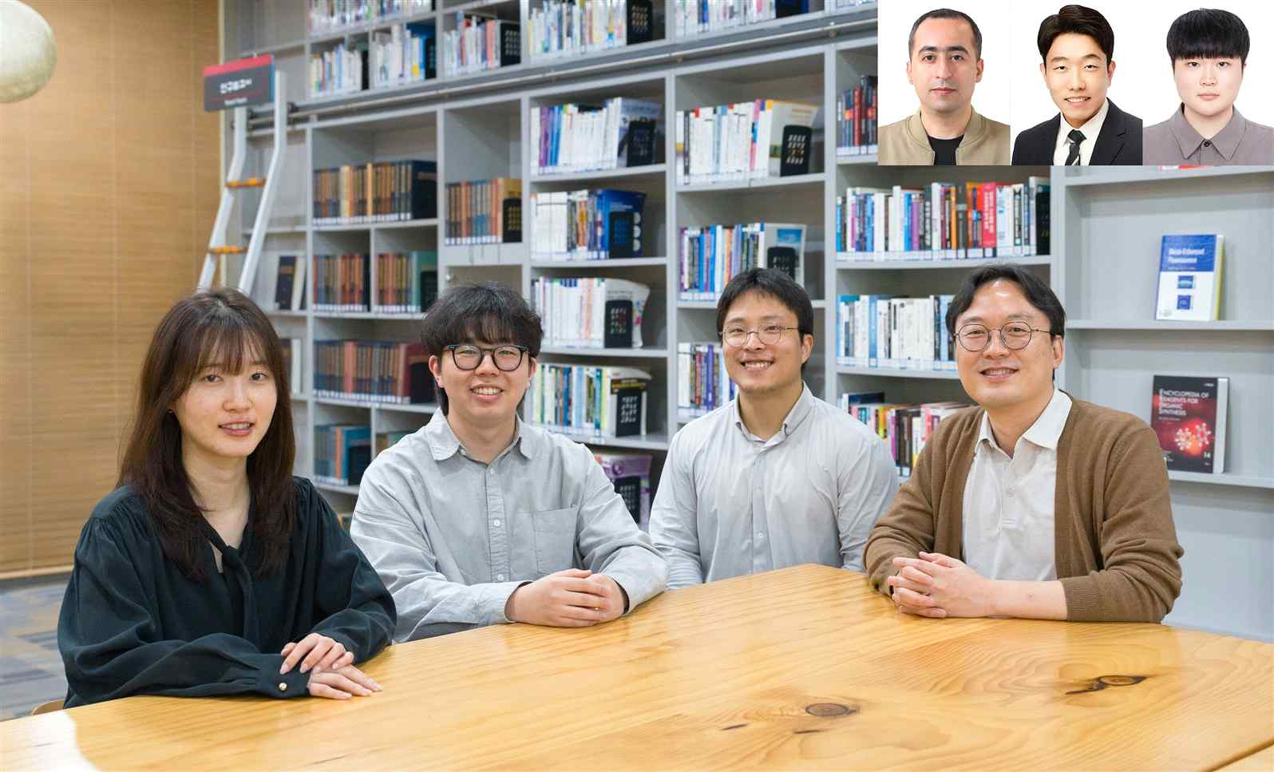

▲ (From left) PhD students Yumin Kang, Seongjun Kang, and Gwangbin Kim from the Department of AI Convergence, Professor SeungJun Kim, (From top right left) postdoctoral researcher Ahmed Elsharkawy, PhD student Dohyeon Yeo, and master's student Bocheon Gim
The Gwangju Institute of Science and Technology (GIST, President Kichul Lim) announced that a research team led by Professor SeungJun Kim of the Department of AI Convergence has proposed a new in-vehicle VR technology called "Force Mappings," which utilizes the actual movement of a vehicle as an environmental change element to enhance immersion within virtual reality (VR).
This technology is a next-generation in-vehicle extended reality (XR) experience technology that increases immersion and interactivity by converting the physical movement of a vehicle into visual and spatial changes within the VR environment.
Previous research on vehicle VR has focused on reducing motion sickness by aligning the movement of the car with virtual scenes.
However, this approach had limitations, as the content experience remained passive even while the user was inside the vehicle.
For example, while the actual body feels movement according to the vehicle's acceleration, deceleration, and turning, the virtual space on the screen did not respond sufficiently, resulting in a discrepancy between physical sensations and visual information.
To overcome these limitations, the research team proposed the concept of "Force Mappings," which connects and expresses the vehicle's actual movements (acceleration, deceleration, rotation, road surface vibration, etc.) to various visual and environmental elements within the VR screen.
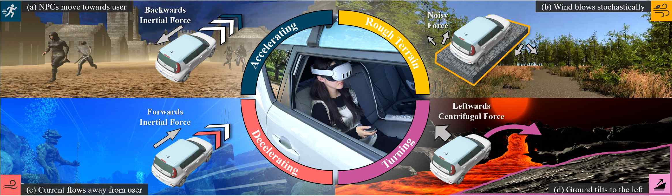

▲ Overview of Force Mappings implemented in in-vehicle VR. This method converts physical forces generated during vehicle operation into changes in the virtual environment, such as wind, water flow, the movement of surrounding objects, and ground tilt, and presents them accordingly.
This system utilizes an inertial measurement unit (IMU) and a global positioning system (GPS) module to detect vehicle movements in real time and dynamically generates effects within the VR environment based on this data.
Through this, the system enables users to naturally perceive the vehicle's physical movements even while remaining stationary in the virtual space.
The research team first conducted comparative experiments between a method that simply displays vehicle movements and a dynamic condition that expresses the vehicle's forces through environmental feedback.
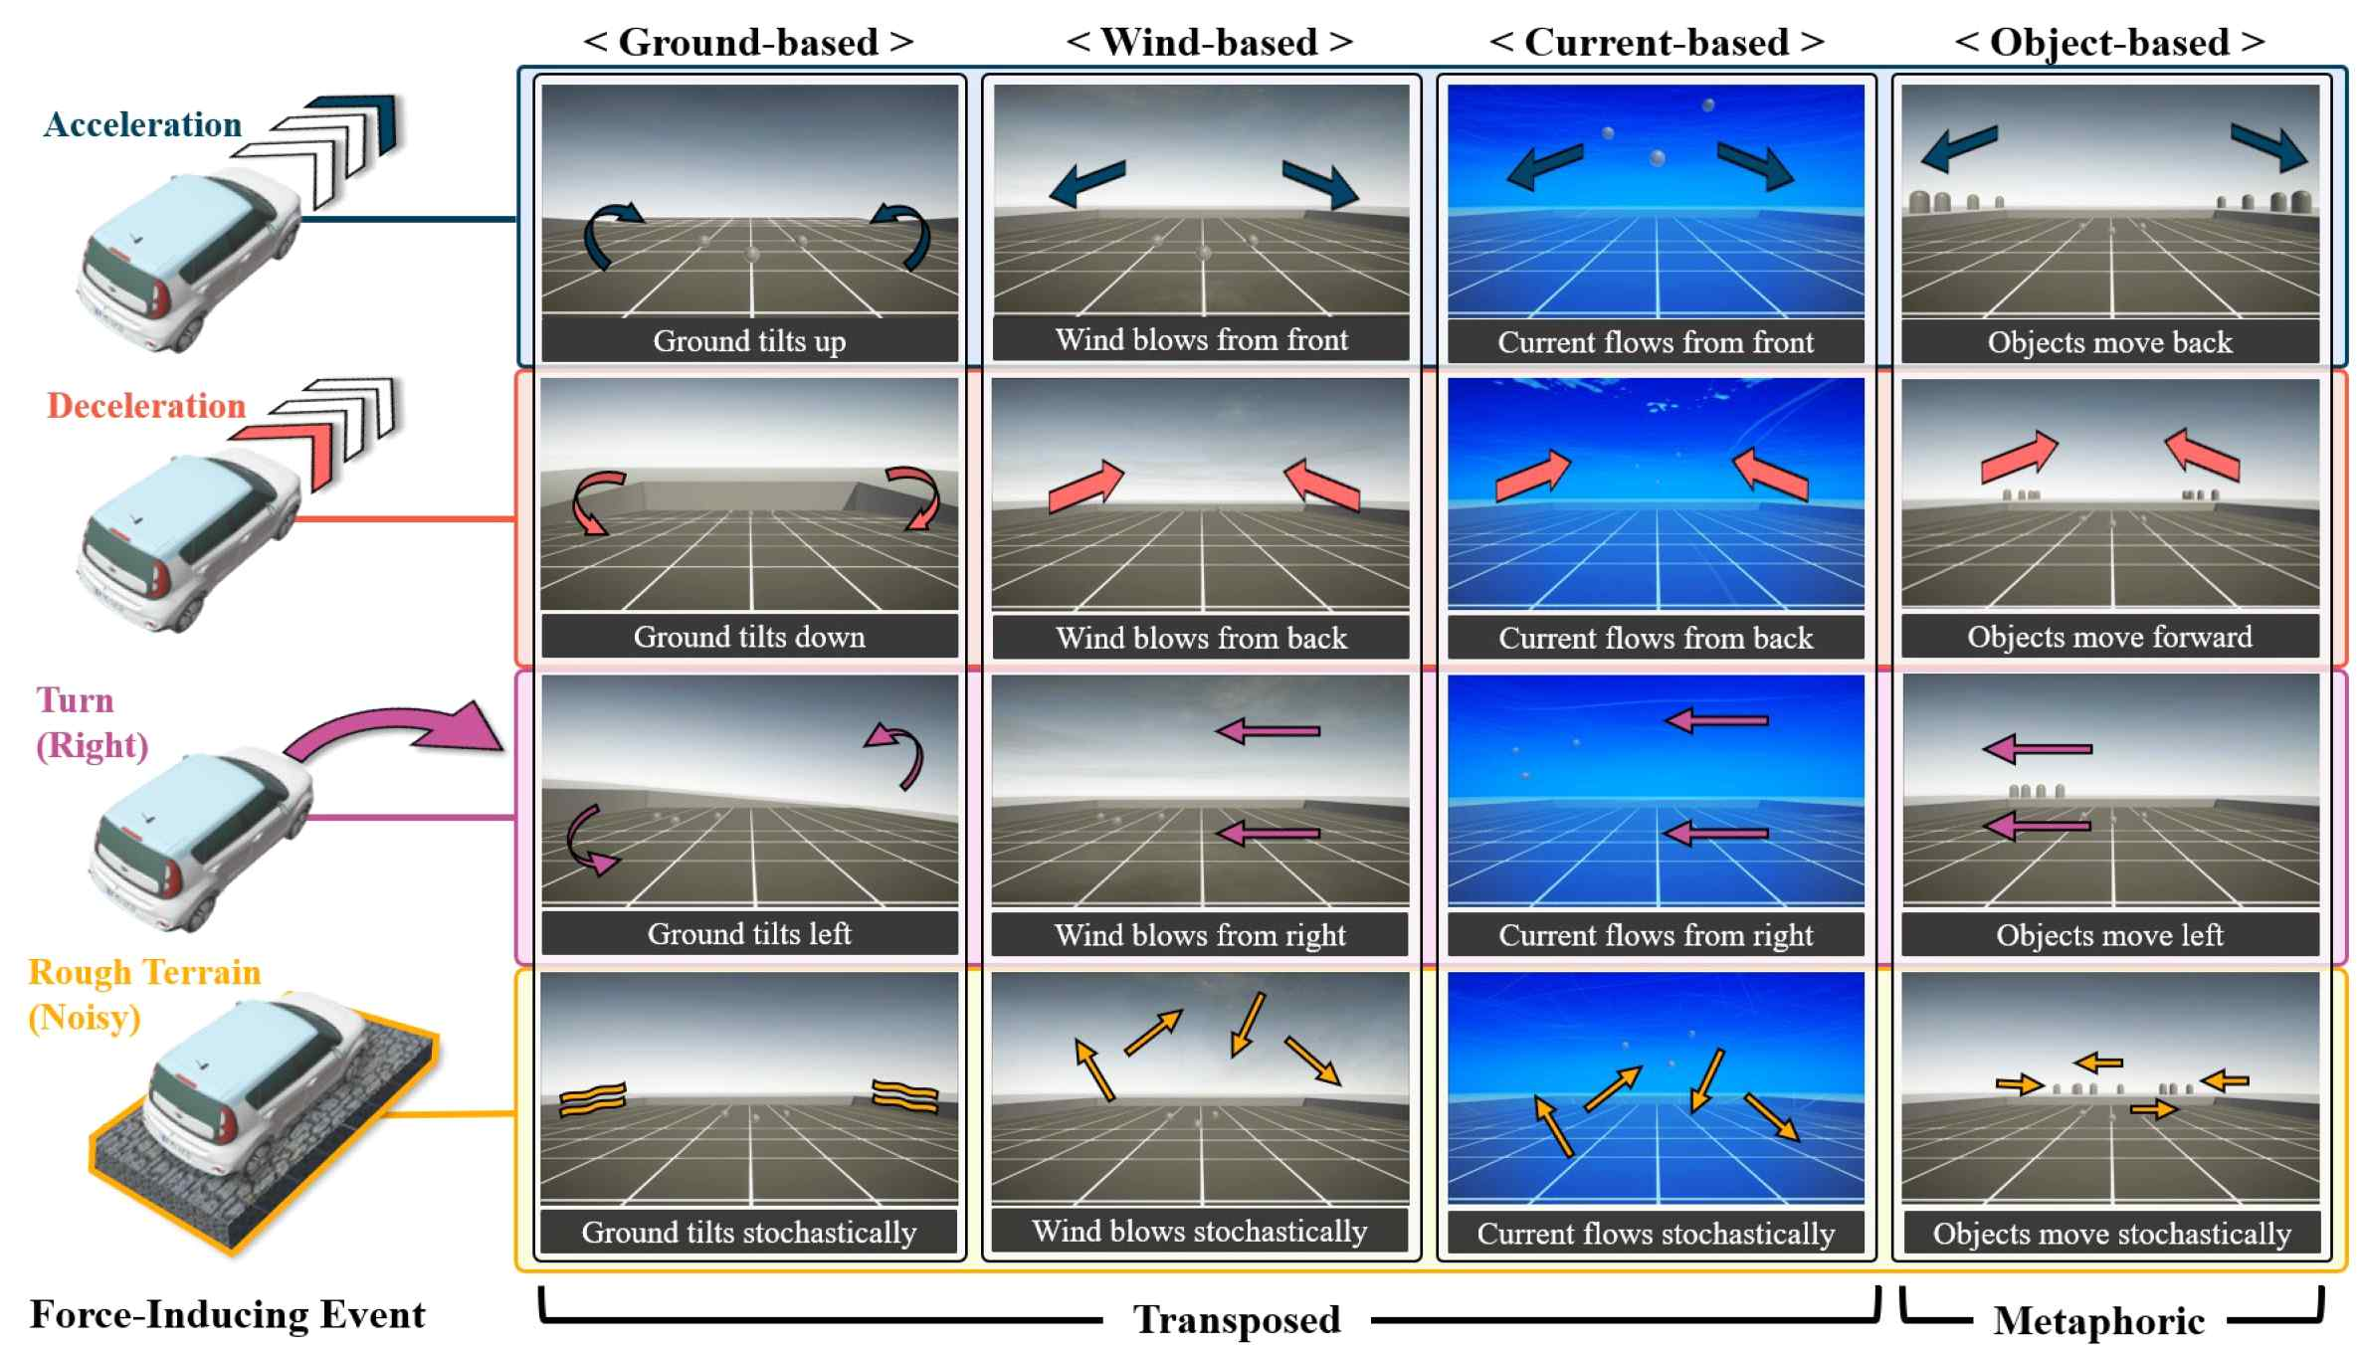

▲ An example of Force Mappings that reconstructs physical forces resulting from a vehicle's acceleration, deceleration, rotation, and road surface vibration into changes in the VR environment. It conveys actual vehicle movement as immersive feedback through the tilt of the ground, the flow of wind and water, and the movement of surrounding objects.
Dynamic conditions were implemented using ▴ falling objects, ▴ spatial shaking, ▴ waves, and ▴ wave effects.
As a result, statistically significant improvements were observed in dynamic conditions, including enhanced immersion and situational awareness, as well as reduced levels of motion sickness.
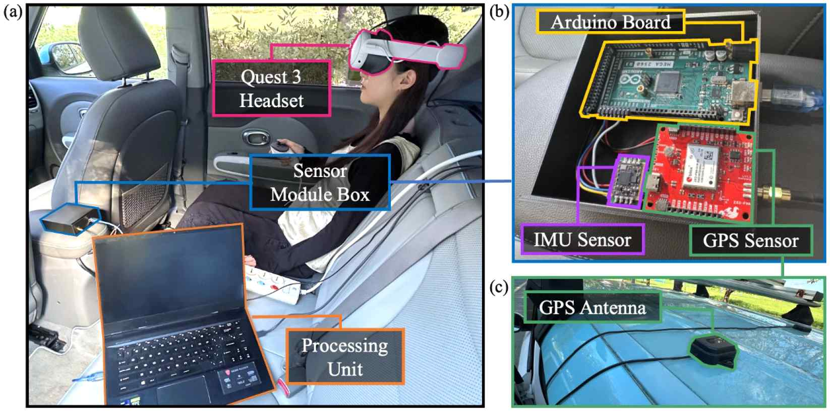

▲ Configuration of the in-vehicle VR experimental platform. Vehicle movement is measured in real-time and reflected in the virtual environment through an in-vehicle VR headset, processing unit, IMU/GPS sensor modules, and an external GPS antenna.
Furthermore, when converting vehicle movement into a VR environment, it was confirmed that expressing movement by partially emphasizing (amplifying) direction and intensity tended to be perceived more naturally than simply reproducing physical forces exactly.
In particular, the "ground tilt" and "space shaking" methods significantly improved immersion by increasing the sense of alignment with bodily sensations during acceleration and deceleration.
This demonstrates that the effect is greater when expressing movement by emphasizing it to match how humans perceive it, rather than simply reproducing it exactly.
This study is significant in that it demonstrates that in-vehicle VR can go beyond being an assistive technology for reducing motion sickness and utilize the vehicle's actual movement itself as an interface resource for a new immersive XR experience.
While existing methods focused on aligning the vehicle's movement path with the virtual space, this technology expands the very method of expression utilizing vehicle movement, enabling users to naturally perceive the vehicle's physical movement even within a single fixed virtual space.
This suggests the potential to utilize travel time within a vehicle as a new venue for experiencing diverse XR content, including games, entertainment, education, remote collaboration, and immersive storytelling.
Professor SeungJun Kim stated, “This research is a meaningful result that demonstrates how users can naturally perceive movement by converting the physical force of a vehicle into visual and spatial changes within a VR environment.” He added, “In the future, considering autonomous driving environments, we plan to develop more sophisticated and diverse environmental feedback technologies to expand the vehicle movement itself into an immersive interface.”
This research, supervised by Professor SeungJun Kim of the Department of AI Convergence at GIST and led by master’s student Bocheon Gim as the first author, was supported by the Ministry of Science and ICT, the National Research Foundation of Korea’s Mid-Career Researcher Support Program and the Overseas Excellent Research Institution Cooperation Hub Establishment Project, and the Korea Institute of Information & Communication Technology Planning & Evaluation’s University ICT Research Center Support Program (ITRC).
The research results were presented at ‘ACM CHI 2026 (Conference on Human Factors in Computing Systems),’ the most prestigious academic conference in the field of Human-Computer Interaction (HCI), held in Barcelona, ​​Spain, from April 13 to 17.
Meanwhile, GIST stated that this research achievement takes into account both its academic significance and potential for industrial application, and that discussions regarding technology transfer can be conducted through the Technology Commercialization Center (hgmoon@gist.ac.kr).

