GIST develops molecular editing technology to ‘redesign’ drug structures… Expanding horizons in new drug development
- Research team led by Professor Won-jin Chung of the Department of Chemistry designs a new reaction pathway that selectively inserts nitrogen into the core ‘indole’ backbone of pharmaceuticals… Process efficiency also improved by using safe reagents under mild conditions instead of high-temperature and hazardous reagents
- Easily and rapidly derives new drug candidates by modifying the structures of commercial drugs such as melatonin and tadalafil
- Published in the international journal Nature Synthesis
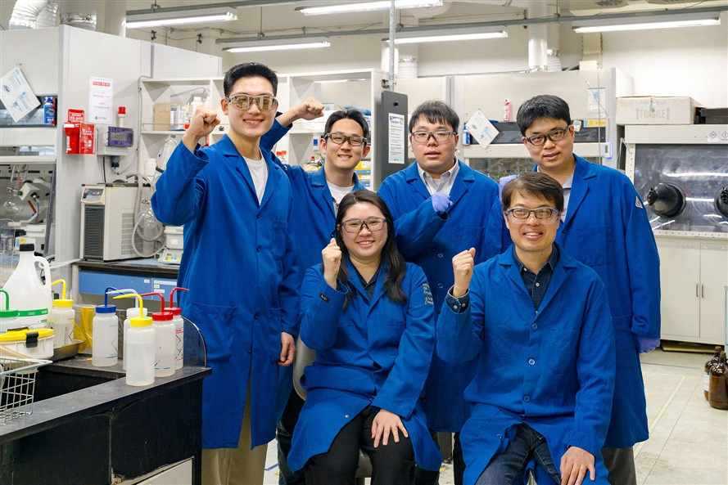

▲ (Back row from left) Chemistry PhD students Mugeon Song, Hyeon Moon, Dr. Jungi Jung, and Ha Eun Kim; (Bottom row from left) Dr. Ilju Jeong and Professor Won-jin Chung
The Gwangju Institute of Science and Technology (GIST, President Kichul Lim) announced that a research team led by Professor Won-jin Chung of the Department of Chemistry has developed a new molecular editing technology that inserts nitrogen atoms at desired locations within the indole structure, which is widely used as a core framework for pharmaceuticals.
This technology allows for the simpler synthesis of compounds with nitrogen arrangements that were previously difficult to produce, and is expected to be widely utilized in the future for the search for new drug candidates and the optimization of pharmaceutical structures.
Recently, in the field of chemistry, "skeletal editing" technology—which directly alters the central framework of already existing molecules—is attracting attention as a next-generation strategy for organic synthesis.
This method rapidly changes molecular structures by inserting or removing specific atoms instead of synthesizing molecules from scratch, offering the advantage of efficiently modifying the structures of complex bioactive substances.
In particular, indole is a nitrogen ring compound* that is very common in nature and pharmaceuticals, and is utilized as an important basic structure in new drug development.
However, conventional methods have limitations because they utilize ‘nitrene’*-based reactions that induce nitrogen atoms to enter only specific positions; consequently, the positions where nitrogen can bind are effectively fixed, resulting in products being restricted to specific structures such as quinazoline.
On the other hand, ‘quinoxaline*,’ a form in which two nitrogen atoms face each other, is known as an important group of compounds exhibiting various biological activities such as anticancer, antibacterial, and anti-inflammatory effects. However, existing synthesis methods have faced difficulties in efficiently producing various forms of these compounds due to low structural selectivity and complex synthesis processes.
* cyclic compound: A compound in which atoms are connected to form a polygonal ring structure rather than a chain. It is utilized importantly in the fields of medicine and chemistry as it influences drug stability and biological activity.
* nitrene: An electron-deficient nitrogen atom with six outermost electrons; it is a nitrogen homologous chemical species corresponding to carbon-based carbene. Due to its high reactivity, it is utilized as an intermediate in the synthesis of various nitrogen compounds.
* quinoxaline: An aromatic heterocyclic compound with a structure in which a benzene ring and a pyrazine ring are combined, featuring two nitrogen atoms facing each other (positions 1 and 4). It exhibits various biological and pharmacological activities and is widely used in the development of new drugs and functional materials.
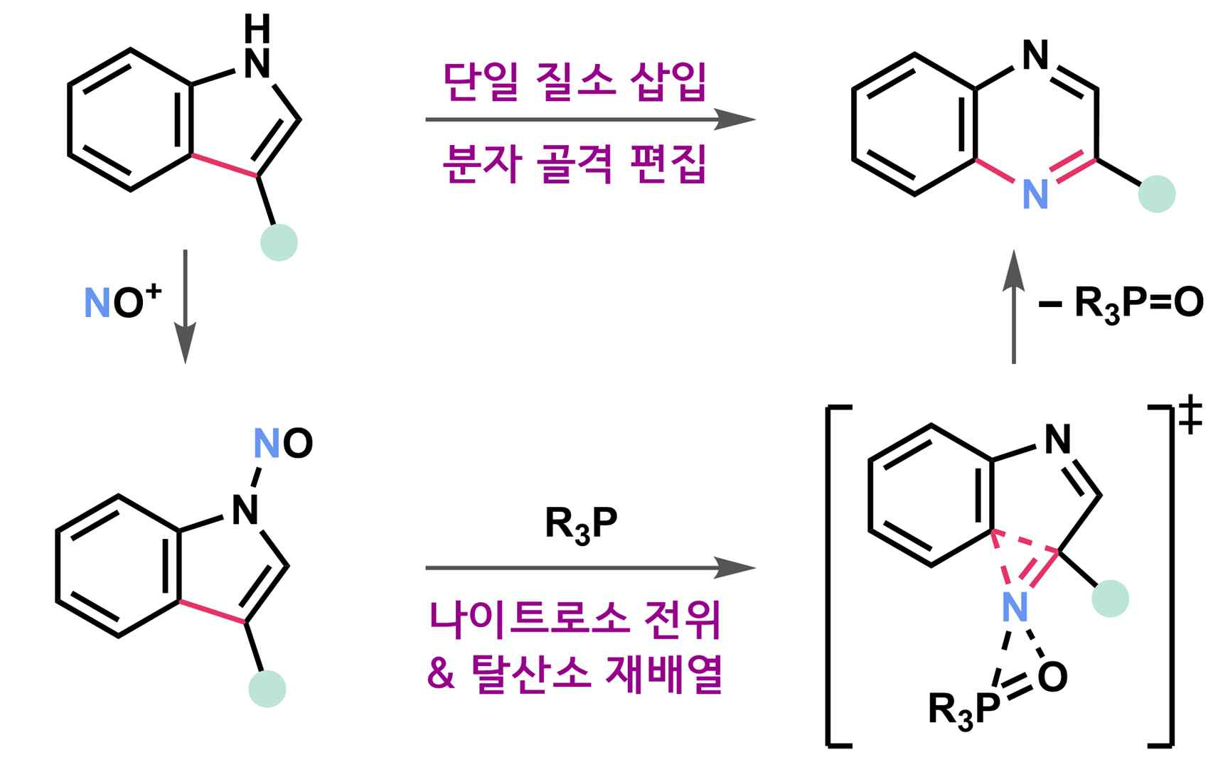
▲ Single nitrogen atom insertion reaction of indole. As a cutting-edge synthesis technique that transforms the molecular framework at the single-atom level, it achieved regioselectivity distinct from existing methods for the first time through a unique mechanism.
The research team overcame these limitations by designing a new reaction pathway entirely different from existing nitrogen insertion reactions. This process consists of three main steps.
First, a ‘nitroso group’*, which acts as a nitrogen source, is introduced into the indole, and then this functional group is induced to move to a desired position within the molecule.
* nitroso group: A functional group composed of a nitrogen-oxygen double bond (-N=O).
This technology is significant in that it allows for the selective insertion of nitrogen into locations within indole that were difficult to access using conventional methods.
In particular, unlike existing methods that require high temperatures or large amounts of hazardous reagents, this technology enables reactions at relatively low temperatures using only the necessary amount of safe reagents, allowing for the efficient synthesis of quinoxaline compounds with various structures.
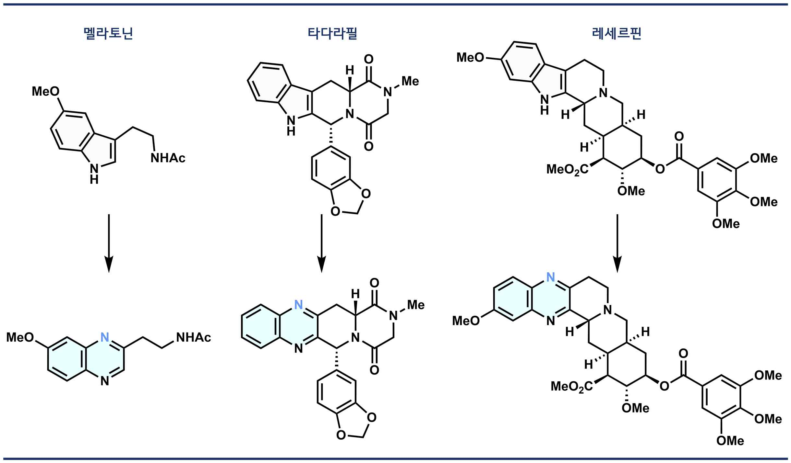

▲ Conversion of commercial drugs through single-atom backbone editing.
It can be applied to late-stage functionalization, which directly converts complex indole-based bioactive substances into quinoxaline structures.
The research team verified the applicability and practicality of this technology using actual pharmaceuticals. They applied this reaction to complex indole-based commercial drugs, such as the sleep aid Melatonin, the erectile dysfunction treatment Tadalafil, and the antihypertensive Reserpine.
As a result, they confirmed that it is possible to convert the drug into a new derivative with a quinoxaline structure while maintaining its basic framework.
By combining experiments and computational chemistry analysis, the research team also identified that this reaction proceeds via a mechanism entirely different from existing ‘nitrene’-based nitrogen insertion reactions.
In particular, they identified a new reaction pathway in which nitrogen insertion occurs after the nitroso group moves within the molecule, thereby revealing the reason why regioselectivity, which was previously difficult to achieve, is realized.
Furthermore, by analyzing the reaction rate and progression step-by-step and confirming structural and kinetic changes in the intermediate stages temporarily generated during the reaction, the validity of the new reaction pathway was supported.
This demonstrates the potential for utilizing the precise modification of the structures of existing drugs to explore new therapeutic effects or improve performance.

▲ Mugeon Song, a PhD student in the Department of Chemistry is performing the synthesis process.
Professor Won-jin Chung stated, “This research is an achievement that presents a new molecular editing strategy capable of precisely redesigning the molecular framework at the atomic level.” He added, “As it has become possible to efficiently create compound structures that were previously difficult to access through a reaction mechanism different from existing ones, it is expected to be widely utilized in the fields of new drug development and functional molecule design in the future.”
This research, supervised by Professor Won-jin Chung (corresponding author) of the Department of Chemistry at GIST and conducted by doctoral student Mugeon Song and Dr. Ilju Jeong as co-first authors, was supported by the Mid-Career Researcher Support Program of the Ministry of Science and ICT and the National Research Foundation of Korea.
The research results — Regio-orthogonal single N-atom insertion into indoles via NO translocation — were published online on April 28, 2026, in Nature Synthesis, an international academic journal ranked in the top 15% of the field of chemistry.
Meanwhile, GIST stated that this research achievement takes into account both its academic significance and potential for industrial application, and that discussions regarding technology transfer can be conducted through the Technology Commercialization Center (hgmoon@gist.ac.kr).

