GIST develops optimized ion beam design technology... Achieves 'solar-level' high temperatures while maintaining solid state
- Professor Woosuk Bang's team from the Department of Physics and Photon Science presents a reverse engineering methodology that dramatically reduces internal sample temperature variations… Confirms the possibility of precisely realizing ‘Warm High-Density Material (WDM),’ which is hotter than the surface of the sun
- Achieved ion beam heating efficiency of 99.1% and non-uniformity of 0.55%, laying the foundation for research in high-energy density physics
- Expected applications in nuclear fusion, planetary interior research, and cancer treatment… Published in the international journal ICHMT


▲ (From left) Professor Woosuk Bang of the Department of Physics and Photon Science, Seongmin Lee (integrated master's and doctoral program student), and Suji Jo (integrated master's and doctoral program student).
The Gwangju Institute of Science and Technology (GIST, President Kichul Lim) announced that a research team led by Professor Woosuk Bang of the Department of Physics and Photon Science has presented a method for inversely designing the energy distribution of an ion beam* that can heat matter in an optimal manner while maintaining high density similar to that of a solid.
A high-energy ion beam is a particle beam created by rapidly accelerating charged ions, capable of directly transferring energy into the interior of a material. Using this, it is possible to achieve a high-temperature state (on the level of tens of thousands of Kelvin (K)) that far exceeds the melting point of a solid, while maintaining high density similar to that of a solid, within a very short timeframe of less than a nanosecond (ns).
The extreme state generated in this way is known as Warm Dense Matter (WDM)*, a state of matter corresponding to the intermediate region between solids and plasma. This is an important subject of research for understanding planetary interior environments or the state of nuclear fusion fuel.
* ion beam: A beam of particles created by accelerating charged ions in a single direction. Because it can penetrate into matter and transfer energy, it is utilized in applications such as heating, material processing, cancer treatment, and nuclear fusion research.
* warm dense matter: A substance that maintains high density like a solid while possessing high temperatures; it represents an extreme state corresponding to the intermediate region between solids and plasma. This is an important subject of research for understanding extreme environments, such as the interiors of giant planets or laser nuclear fusion fuel.
However, conventional ion beam heating methods have struggled to heat samples uniformly due to the characteristic that the depth at which ions stop within the material varies depending on the ion energy.
In particular, the Bragg peak* phenomenon causes energy to concentrate at a specific depth, resulting in a problem of non-uniform temperature distribution within the sample.
Conversely, while increasing ion energy significantly can improve heating uniformity, it has a limitation in that energy transfer efficiency decreases as a large number of ions pass through the sample.
Therefore, the key challenge was to design an ion energy distribution that simultaneously satisfies both heating uniformity and energy efficiency.
* Bragg peak: A phenomenon in which the energy lost by particles as they pass through a material is greatest at a specific depth. Since this peak appears narrow and distinct in ion beams, a significant portion of the ion's energy is transferred to a narrow region near the Bragg peak.
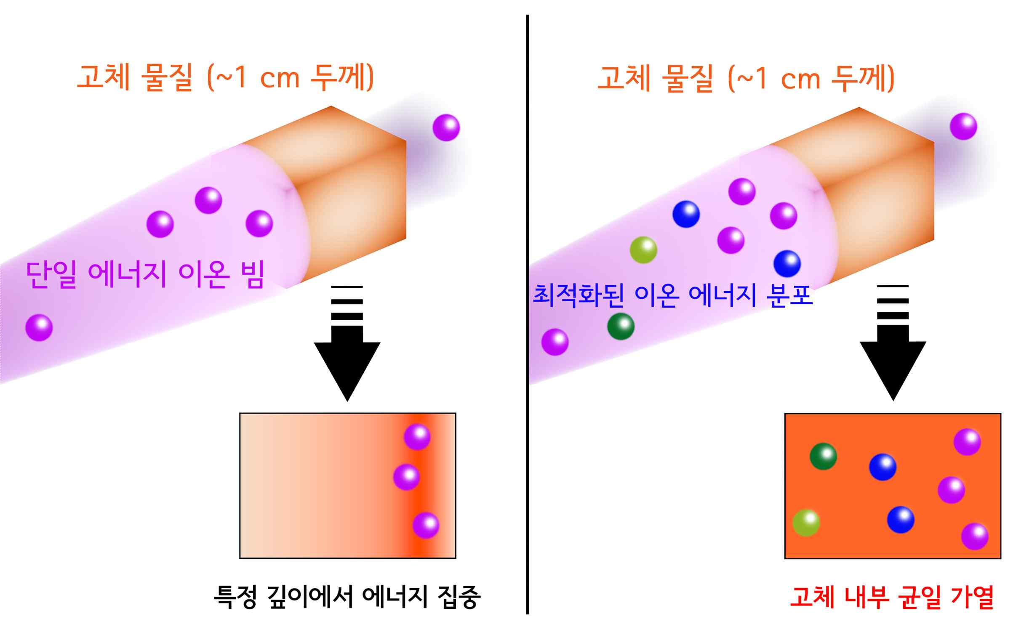

▲ A virtual diagram of the solid heating process using an ion beam. The color of the ions represents their energy; the ion beam transfers energy while losing it and decelerating as it passes through the interior of the solid material. While a single-energy ion beam heats intensively up to a specific depth within the material, an ion beam with an optimized energy distribution can heat the entire material uniformly.
To overcome these limitations, the research team proposed an "inverse design method" in which desired heating conditions are first established, and then the ion energy distribution satisfying those conditions is calculated in reverse.
To this end, Monte Carlo simulation* was utilized to calculate how energy is transferred and absorbed at different depths as carbon ions with different energies pass through a 1 cm thick solid-density aluminum sample.
Based on the calculation results, an ion energy combination that forms a uniform heat distribution across the entire sample was derived. To minimize the error from the target distribution, the Non-Negative Least Squares (NNLS)* method was applied to design the optimal energy distribution.
* Monte Carlo simulation: A method for calculating complex physical phenomena by repeating random sampling. In this study, it was used to calculate how much energy ions transfer at different depths as they pass through the interior of a material.
* non-negative least squares: A mathematical optimization method that finds the solution best matching the target value while restricting the calculation result from becoming negative.
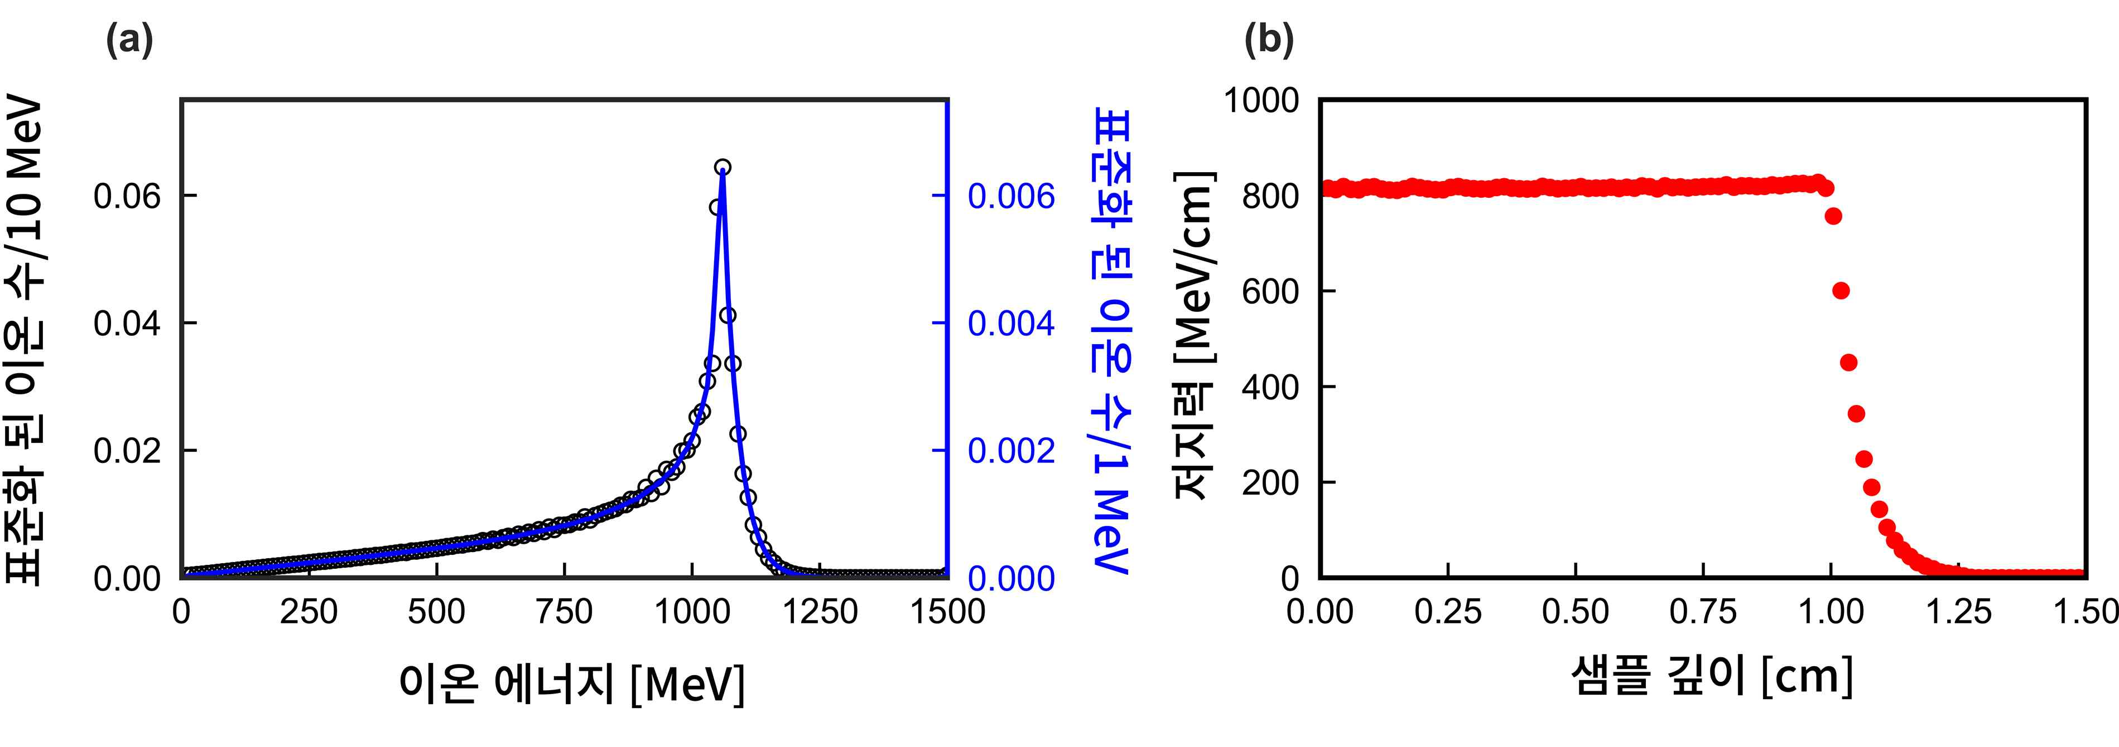

▲ The result of optimizing the carbon ion energy distribution to uniformly heat a 1 cm thick solid aluminum sample. (a), representing the optimal energy distribution, is the design value for achieving 95% high efficiency and uniform heating; it exhibits a ‘quasi-monochromatic’ appearance with particles clustered narrowly around approximately 1 GeV. (b) shows carbon ions accelerated under the conditions of (a) passing through the interior of the 1 cm thick aluminum and transferring energy uniformly. It demonstrates ‘super-uniform heating’ performance, where heat spreads evenly throughout the sample.
The research team applied this developed calculation method to a carbon ion beam to derive conditions capable of uniformly heating a 1 cm thick solid high-density aluminum sample.
As a result, a super-exponential energy distribution was derived, in which the highest concentration of energy is found around 1 billion electron volts (1 GeV) under conditions that maximize energy transfer efficiency.
Verification through computer simulations showed that the ion beam with this distribution recorded an energy transfer efficiency of 99.1% and a heating non-uniformity of 0.55%, confirming that both heating uniformity and efficiency can be maximized simultaneously.
* super-exponential: Refers to a shape that increases faster than a typical exponential function and exhibits a very steep growth trend.
* heating non-uniformity: The ratio of the standard deviation to the mean of the energy distribution across different material depths; the closer to 0%, the higher the uniformity of the distribution.
In addition, the research team examined quasi-monoenergetic ion beam conditions, where energy is distributed relatively narrowly around a specific value, confirming the possibility of uniform heating.
A quasi-monochromatic ion beam with a central energy of about 1 billion electron volts (1 GeV) achieved an energy transfer efficiency of about 95% and a heating non-uniformity of 0.42%. This demonstrates that high uniform heating is possible even with a relatively simple energy distribution.
- quasi-monoenergetic: Refers to a distribution with a narrow energy range centered around a single energy. While not a completely monochromatic energy, most ions are concentrated around a specific energy level.
The research team analyzed the results while varying heating efficiency from 94% to 99% and confirmed that as efficiency increases, ion energy is concentrated within a narrower range, and under ideal conditions, the distribution approaches one where energy is highly concentrated around a specific value.
Furthermore, using this method to calculate the temperature change of aluminum samples based on the amount of ions injected, they demonstrated that injecting a certain level of ions can achieve a high temperature state of over approximately 10,000 Kelvin (K), which is higher than the surface of the sun.
At this time, the total heating time—including the process of ions entering the material to transfer energy and achieving thermal equilibrium between electrons and ions—was analyzed to be very short, within approximately 0.1 nanoseconds (ns).
The reverse engineering method presented by the research team is a technology that allows for the direct design of corresponding ion beam conditions through calculation after first setting the desired heating conditions. This method is expected to have significant practicality and impact, as it enables the realization of target heat distributions without repetitive trial and error.
This method provides a useful foundation for research in high-energy-density physics and extreme-state materials, where precise control of desired depth and uniformity is required while creating ultra-high temperature and high-density internal conditions.
It can also be utilized in applications requiring energy delivery to specific depths while minimizing losses, such as particle beam therapy and laser fusion fuel heating.
Professor Woosuk Bang stated, "This research demonstrates that it is possible to first determine the desired heating distribution and then computationally design the optimal ion energy distribution to realize it." He added, "By presenting ion beam conditions that simultaneously satisfy uniformity and efficiency, we expect this to make a broad contribution to various research and application fields requiring precise heating of extreme-state materials while maintaining solid density."
This research, supervised by Professor Woosuk Bang of the Department of Physics and Photon Science at GIST and co-authored by integrated master's and doctoral students Seongmin Lee and Suji Jo as first authors, was supported by the Ministry of Science and ICT and the National Research Foundation of Korea's Mid-Career Researcher Support Program.
The research results — Optimized ion spectra for ultra-uniform and high-efficiency heat transfer into dense matter — were published online on April 19, 2026, in International Communications in Heat and Mass Transfer, an international journal ranked in the top 6.1% in the field of mechanics according to the Journal Citation Report (JCR), a global academic journal evaluation metric.
Meanwhile, GIST stated that this research achievement was considered to have both academic significance and potential for industrial application, and that discussions regarding technology transfer can be conducted through the Technology Commercialization Center (hgmoon@gist.ac.kr).

