“Waking up a dormant brain with ‘gentle signals’” GIST develops low-intensity ultra-high frequency magnetic stimulation technology to aid chronic stroke rehabilitation
- A joint research team led by Professors Hyoung-Ihl Kim and Hyuk-Sang Kwon of the Department of Biomedical Engineering has developed ‘UHF-LiMS,’ a non-contact, non-invasive technology that induces the brain’s natural recovery using micro-magnetic fields one-hundredth the level of conventional methods.
- 70% recovery of motor function confirmed even in the chronic phase... Simultaneous recovery of not only the damaged area but also surrounding brain regions.
- Published in 《IEEE Transactions on Neural Systems and Rehabilitation Engineering》


▲ Professor Emeritus Hyoung-Ihl Kim, Professor Hyuk-Sang Kwon, and PhD student Zohaib Atif from the Department of Biomedical Science and Engineering
The Gwangju Institute of Science and Technology (GIST, President Kichul Lim) announced that a joint research team led by Professors Hyoung-Ihl Kim and Hyuk-Sang Kwon of the Department of Biomedical Science and Engineering has developed a new magnetic stimulation technology called the "Low-Intensity Ultra-High Frequency Magnetic Stimulation System (UHF-LiMS)," which aids the brain's natural recovery using weak magnetic fields.
This research is noteworthy as a non-invasive neurostimulation technology that can be applied simultaneously with rehabilitation training while the patient is awake, without direct contact of the stimulation device to the head. It is particularly significant that the study confirmed the effectiveness of motor function recovery even in chronic stroke conditions where natural recovery is difficult.
Stroke is a representative disease that causes long-term disability and can leave permanent damage to motor, sensory, and language functions. In particular, there is a limitation in that treatment options for recovering damaged functions are restricted once the condition enters the chronic phase.
Repetitive transcranial magnetic stimulation (rTMS), a representative brain stimulation therapy currently in use, is a method that directly stimulates nerve cells with a strong magnetic field. However, it has limitations in that it is difficult to apply simultaneously with rehabilitation exercises due to the high stimulation intensity, large equipment, and the need for precise positioning.
The research team focused on a method that assists the brain's self-recovery process rather than strongly stimulating the brain. To this end, they developed an "Ultra-High Frequency Low Intensity Magnetic Stimulation System (UHF-LiMS)" that induces brain function recovery using an ultra-high frequency magnetic field at a level much weaker than conventional magnetic stimulation.
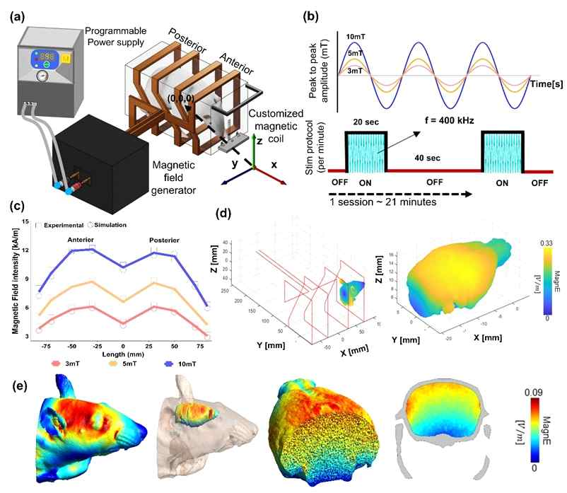

▲ Overview of the UHF-LiMS system and electromagnetic field characteristics. (a) Schematic diagram of the stimulation system consisting of a programmable power supply, a magnetic field generator, and a custom quadruple square coil. (b) Stimulation waveforms in the form of 400 kHz sinusoids (3·5·10 mT) and a stimulation protocol applied for approximately 21 minutes with a ‘20-second stimulation - 40-second rest’ cycle. (c) Experimental and simulation results of the magnetic field distribution measured along the coil central axis (anterior-posterior direction, 150 mm). (d) Three-dimensional magnetic and induced electric field distributions with skull and brain models positioned around the coil. (e) Finite Element Method (FEM)-based induced electric field distribution within the brain, demonstrating that this is ‘subthreshold stimulation’ at a level below the direct neuronal firing threshold.
This system utilizes a minute ultra-high frequency magnetic field of approximately 0.1 V/m (0.1 volts per meter), which is one-hundredth the level of conventional magnetic stimulation, to finely induce the spontaneous activity of neural circuits activated during rehabilitation and help these circuits connect more effectively.
In particular, it operates using a "subthreshold" method that finely regulates the state just before a response, rather than stimulating neurons to the point of direct excitation. Through this, it induces neural circuits activated during rehabilitation to connect more stably.
As a result, "synaptic plasticity," a key mechanism in memory formation and recovery, is maximized, helping the neural networks responsible for actual motor functions to be reorganized more efficiently.
The research team conducted magnetic stimulation experiments on mice with chronic stroke under conditions of 3, 5, and 10 millitesla (mT, a level stronger than everyday environmental magnetic fields but considered low intensity in medical magnetic stimulation).
Results of brain imaging tests ([¹⁸F]-FDG microPET, an imaging technique for measuring glucose metabolic activity in the brain) confirmed a tendency for overall metabolic activity in the brain to recover as stimulation intensity increased and treatment duration increased.
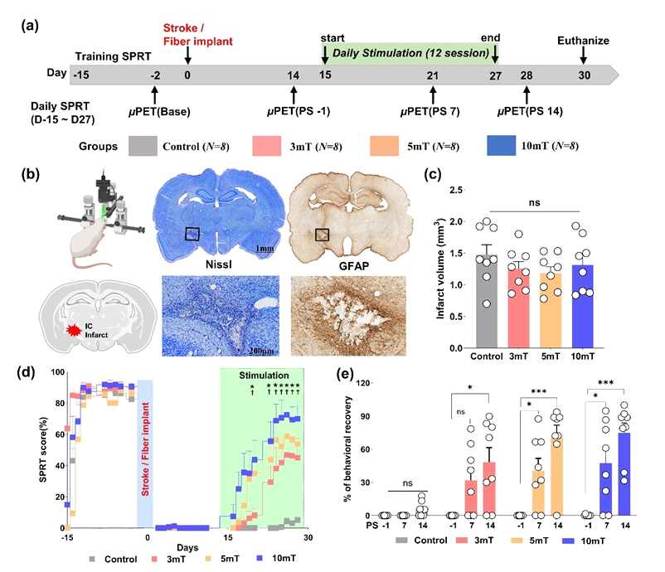

▲ Behavioral recovery in an animal model of chronic subcortical stroke. The research team conducted the experiment by dividing the subjects into a control group and 3, 5, and 10 mT stimulation groups (8 animals per group) (a). Internal capsule damage induced by photothrombosis techniques was confirmed via tissue staining (b), and there was no difference in infarct volume between the groups (c). Following stimulation, the success rate of SPRT gradually increased in all stimulation groups, whereas there was no change in the control group (d). In particular, the 5 mT and 10 mT groups showed significant behavioral improvement, recovering to approximately 70% of pre-stroke performance levels (e).
Notably, distinct recovery was observed not only in the areas damaged by the stroke but also in surrounding brain regions (diaschisis) that were functionally connected and subsequently deteriorated.
In addition, in the single pellet reaching task (SPRT*), which evaluates precise forelimb movements, the success rate of grasping food improved in all stimulus groups; in particular, the 10 mT stimulus group showed a recovery to approximately 70% of pre-stroke motor performance.
* single pellet reaching task (SPRT): A behavioral indicator that evaluates an experimental animal's ability to accurately grasp a single food pellet. It is a representative method for evaluating motor function that quantifies the degree of recovery of motor function damaged after a stroke.
Through cellular-level analysis, the research team confirmed that magnetic stimulation is actually involved in the neuronal recovery process.
The 'c-Fos protein*', a representative indicator of neuronal activity, increased significantly throughout the cerebral cortex and striatum of the stimulation group, suggesting that magnetic stimulation contributes to the activation and reorganization of neural circuits.
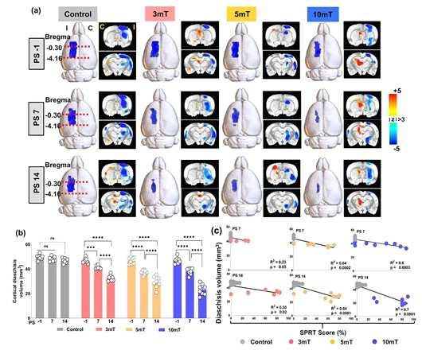

▲ Recovery of brain energy activity and reduction of distal region dysfunction as seen in [¹⁸F]-FDG microPET imaging.
(a) Metabolic changes in the cerebral cortex by group and time point (PS-1, PS7, PS14) are shown in 3D and coronal images; blue indicates metabolic decline (diaschisis) relative to the baseline, and red indicates metabolic increase.
(b) As a result of applying UHF-LiMS, the volume of distal region dysfunction (diaschisis) significantly decreased as stimulation intensity and duration increased (p<0.0001).
(c) Additionally, a strong negative correlation was observed where SPRT scores increased as the volume of diaschisis decreased, suggesting that brain metabolic recovery is closely linked to motor function recovery.
Furthermore, ‘TUNEL’ analysis, which tracks DNA damage occurring during cell injury, showed that the apoptotic response (programmed cell death) was significantly inhibited compared to the control group.
These results demonstrate that low-intensity magnetic stimulation simultaneously induces the activation of neural circuits and cell-protective effects, thereby creating a biological environment favorable for the recovery of brain function.
* c-Fos protein: A substance produced first when nerve cells are activated in response to external stimuli, serving as a representative indicator for verifying the activity or degree of change of cells. The higher the levels of this protein, the more actively the brain's neural circuits are communicating, signifying that "synaptic plasticity"—the process by which the brain reconfigures itself—is actively occurring.
Professor Hyoung-Ihl Kim stated, "This study is an achievement that presents new possibilities for neuromodulation in chronic stroke rehabilitation," adding, "It has great potential for clinical application as it reduces the safety limitations of existing high-intensity magnetic stimulation while allowing it to be combined with behavioral training while the patient is awake."
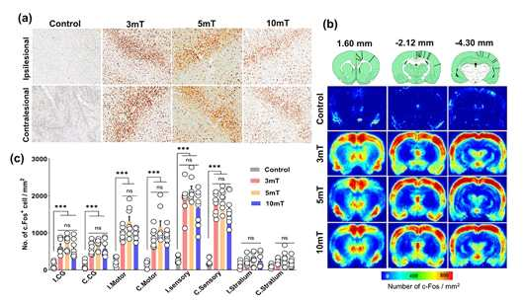

▲ Changes in c-Fos expression indicating neural activity and plasticity. (a) Compared to the control group, c-Fos expression in the bilateral sensory cortex generally increased in all stimulation groups (3, 5, and 10 mT). (b) A heatmap visualizing c-Fos-positive cell density based on standard rat brain coordinates (Bregma +1.6, -2.1, -4.3 mm). (c) The c-Fos-positive cell density of the stimulation groups significantly increased across the bilateral cingulate cortex, motor cortex, sensory cortex, and striatum (***p<0.0001), suggesting that UHF-LiMS induces widespread increases in neural activity and plasticity.
Professor Hyuk-Sang Kwon stated, “We confirmed through video and behavioral experiments that a 400 kHz ultra-high frequency magnetic field (a high-frequency region vibrating 400,000 times per second) can influence the recovery of brain neural circuits and changes in connectivity even at very weak levels.” He added, “In the future, we plan to elucidate the mechanism of action at the cellular level, optimize magnetic field conditions to enhance the precision of therapeutic effects, and establish a ‘magnetic field-based rehabilitation environment’ where patients can freely perform rehabilitation training. Furthermore, we intend to expand into animal experiments with physiological characteristics similar to humans and clinical research for application to actual patients.”
This research, supervised by Professors Hyoung-Ihl Kim and Hyuk-Sang Kwon of the Department of Biomedical Science and Engineering at GIST and conducted by doctoral student Zohaib Atif as the first author, was supported by the Ministry of Science and ICT and the National Research Foundation of Korea (NRF) through the Human Plus Convergence Research and Development Program, the Mid-Career Researcher Support Program, the Brain Science Leading Convergence Technology Development Program, and the Brain Pool Program.
The research results — Ultra-High Frequency-Low Intensity Magnetic Stimulation Enhances Functional Recovery in a Rat Model for Chronic Capsule Infarct — were published online on April 13 in IEEE Transactions on Neural Systems and Rehabilitation Engineering, a prestigious international journal in the field of neural systems and rehabilitation engineering.
Meanwhile, GIST stated that this research achievement was considered to have both academic significance and potential for industrial application, and that discussions regarding technology transfer can be conducted through the Technology Commercialization Center (hgmoon@gist.ac.kr).

