GIST realizes ‘weight and inertia’ in VR using finger-wearable haptic technology
- Research team led by Professor SeungJun Kim of the Department of AI Convergence reproduces the center of gravity and swinging resistance of virtual tools by using a small finger-worn device to adjust the position of a metal rod in real time... Enhancing VR immersion, realism, and control
- Maximizing realism through cognitive amplification technology, applications in next-generation XR environments such as gaming and education are anticipated
- Presenting potential for next-generation XR and physical AI interfaces centered on the ‘GIST-MIT Center for Physical AI Interaction’
- Presented at ‘ACM CHI 2026,’ the most prestigious academic conference in the field of Human-Computer Interaction (HCI)
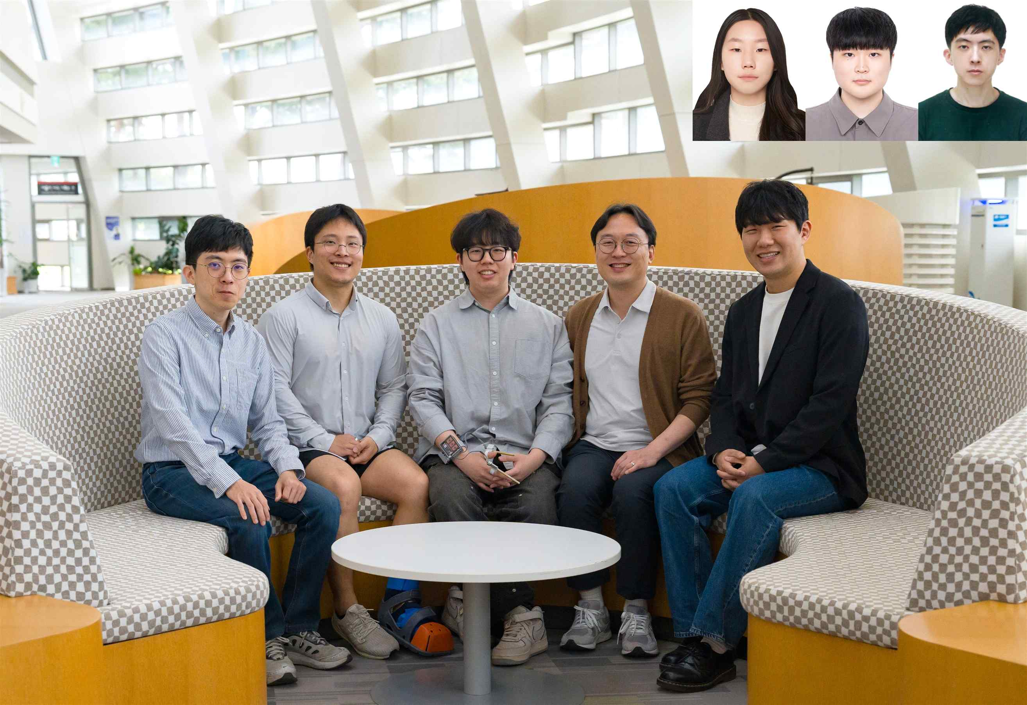

▲ (From left) Master's student Semoo Shin, PhD student Gwangbin Kim, PhD student Seongjun Kang, Professor SeungJun Kim, master's student Jeongju Park (From top right left) PhD student Juwon Um, master's student Bocheon Gim, student Chanyoung Park
The Gwangju Institute of Science and Technology (GIST, President Kichul Lim) announced that a research team led by Professor SeungJun Kim of the Department of AI Convergence has developed a finger-mounted haptic system (Finger-Mounted Extending Rod) capable of realistically reproducing the weight and swinging sensations of various tools within virtual reality (VR).
This technology is expected to significantly enhance user immersion in next-generation XR (Extended Reality) environments by precisely conveying the physical characteristics of virtual tools using only a small device worn on the finger.
While VR technology has recently advanced rapidly in terms of visual representation, there have been limitations in realizing the "sense of holding and handling" virtual objects as if they were real.
In particular, physical sensations such as heaviness, resistance, and inertia felt when wielding tools with different centers of gravity, like hammers or swords, were difficult to convey naturally using only a single controller.
To solve this problem, the research team proposed a method that extends the hand itself into a "virtual tool interface" by utilizing a small device worn on the finger.
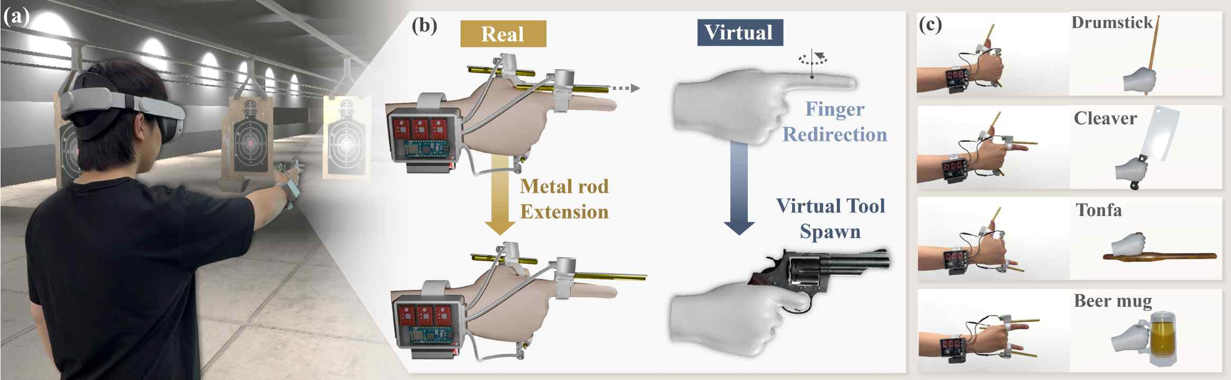

▲ Overview of the Finger-Mounted Extending Rod system. This is a wearable interface that drives a metal rod based on hand position to simulate the rotational inertia of a virtual tool, visually presenting a natural gripping posture within VR.
A small device attached to the user's finger moves the metal rod back and forth to adjust weight distribution in real time.
For example, when the rod lengthens, the center of gravity shifts toward the fingertips, delivering greater resistance and a heavier feel to the wrist, similar to swinging a long rod or a blunt weapon.
Conversely, shortening the rod allows for the sensation of handling a lighter and more agile tool.
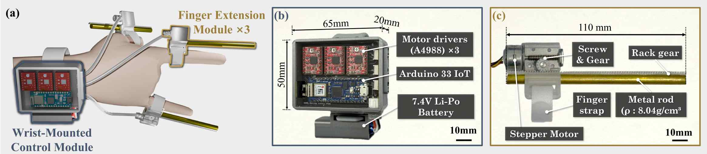

▲ Components of the Finger-Mounted Extending Rod device. It consists of a control module worn on the wrist and an extension module attached to the hand. The control module contains the battery and control circuitry, while the extension module includes a stepper motor, gear drive unit, and metal rod to simulate the inertia of the virtual tool.
The research team designed the system to synchronize these physical changes with the movement of the tool within the virtual environment in real time, ensuring that the visual scene and the tactile sensations felt by the user naturally align.
In particular, the research team confirmed through actual user experiments that the inertia felt by humans is perceived as being amplified much more than the actual physical quantity.
As a result of measuring the point of subjective equality (PSE*), the point at which users perceive different weights and resistances as identical, it was found that the inertia perceived by users was significantly greater than the actual theoretical value, ranging from approximately 4.19 times to a maximum of 10.45 times.
This implies that even with small physical stimuli, users can feel a much greater sense of weight and the presence of the tool.
* point of subjective equality (PSE): A psychophysical indicator referring to the point at which a person perceives two different stimuli as identical. In this study, it was used to measure the level of inertia at which users perceive the weight of a virtual tool or the resistance when swinging it as similar to reality.
User experience evaluations also showed that immersion and realism improved significantly as visual and tactile information matched.
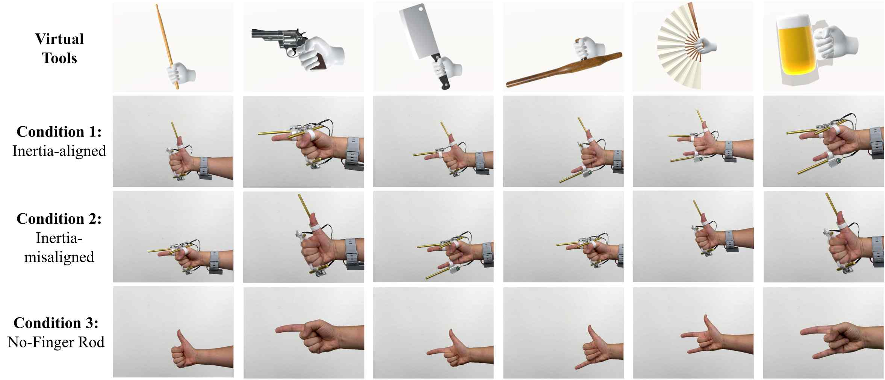

▲ The virtual tool used in the VR scenario and three experimental conditions. It compares the condition where inertia is aligned, the condition where inertia is misaligned, and the condition where only hand postures were presented without the device.
In actual VR scenario experiments, users perceived various virtual tools—such as drumsticks, pistols, kitchen knives, batons, and beer mugs—as if they were holding them in their hands, and were able to distinguish the characteristics of each tool more easily.
In particular, immersion, realism, and enjoyment all increased when the movement of the virtual tools matched the sense of inertia felt by the hands.
On the other hand, discomfort from wearing the device did not increase significantly, confirming that a high level of physical feedback can be achieved with relatively simple devices.
This study is significant in that it utilizes the user's hands and fingers themselves as part of the interface, expanding the experience of handling virtual objects from a mere "viewing" experience to a "handling experience" that feels real.
It is expected to be utilized as a technology that enhances control and immersion in the gaming sector, and provides realistic physical feedback in education, training, and remote work environments.
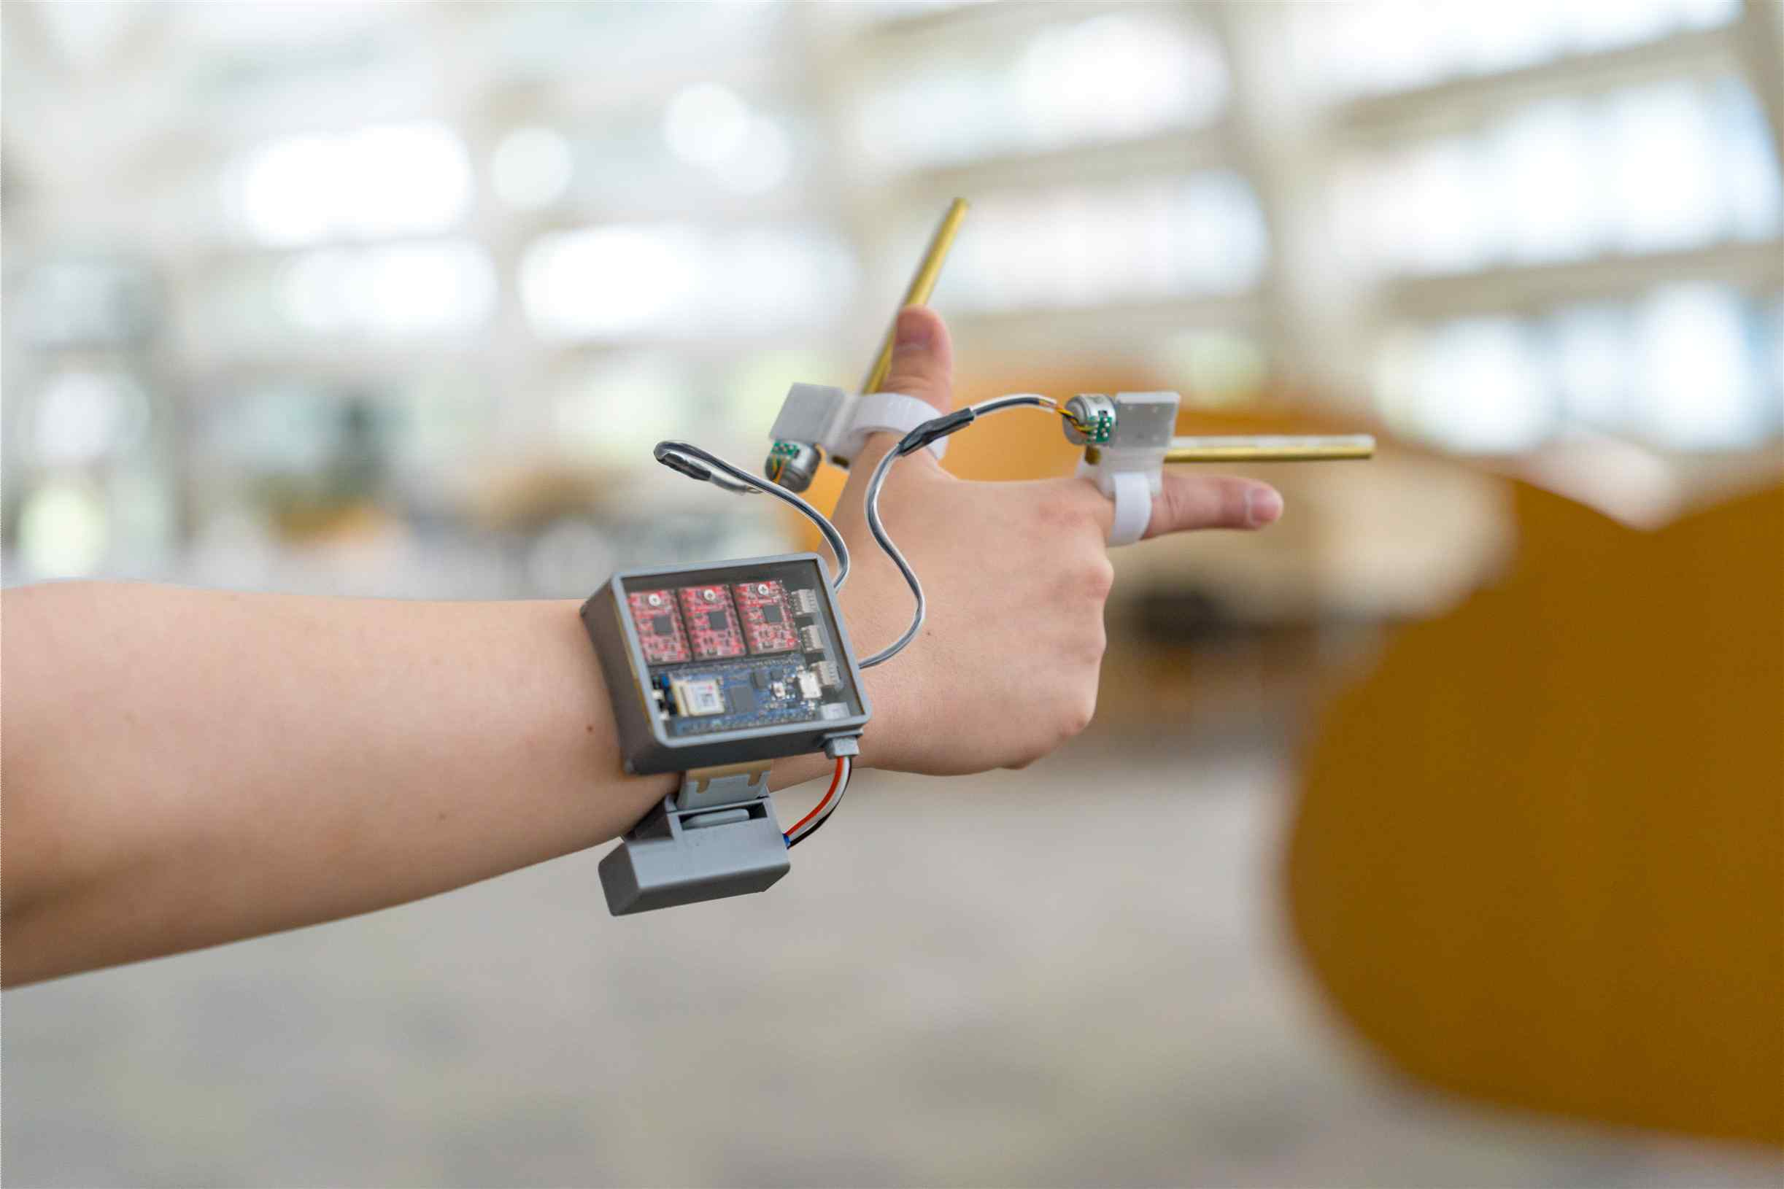

▲ A finger-mounted haptic system (Finger-Mounted Extending Rod) capable of more realistically conveying the physical characteristics of various tools in virtual reality (VR).
Furthermore, as it can implement a physical sensation similar to reality using only a simple device worn on the fingertip without the need for separate, complex equipment, it is expected to serve as a next-generation XR interface technology that blurs the boundaries between the virtual and the real world.
Professor SeungJun Kim stated, "This research is an example demonstrating that physical characteristics such as the weight and inertia of virtual objects can be effectively reproduced using only a small device worn on the finger." He added, "In the future, we plan to develop it into a lighter and more sophisticated form to apply it to various reality-virtual convergence environments."
This research, supervised by Professor SeungJun Kim of the Department of AI Convergence at GIST and featuring doctoral student Seongjun Kang as the first author, was supported by the Ministry of Science and ICT and the National Research Foundation of Korea's Mid-Career Researcher Support Program and the Overseas Excellent Research Institution Cooperation Hub Establishment Project, as well as the Ministry of Science and ICT and the Information and Communication Technology Planning and Evaluation Institute's University ICT Research Center Development Support Program (ITRC).
The research results — When Fingers Become Tools: Rendering Virtual Tool Inertia with a Finger-Mounted Extending Rod — were presented at ‘ACM CHI 2026 (Conference on Human Factors in Computing Systems),’ the most prestigious academic conference in the field of Human-Computer Interaction (HCI), held in Barcelona, ​​Spain, from April 13 to 17.
Meanwhile, GIST stated that this research achievement takes into account both its academic significance and potential for industrial application, and that discussions regarding technology transfer can be conducted through the Technology Commercialization Center (hgmoon@gist.ac.kr).

