“What if the battery forms an internal protective layer on its own” GIST, KETI, and Kyoto University develop all-solid-state battery technology that extinguishes fires and extends lifespan using 'hydrogen ions'
- A joint Korea-Japan research team led by Professor Sangryun Kim of the Department of Chemistry at GIST has elucidated the principle by which hydrogen-containing ions (BH₄⁻) form an interfacial protective layer on the surface of lithium metal… Published in the international journal Advanced Science
- By suppressing unnecessary chemical reactions, it maintains efficiency at the 100% level even after 1,000 charge-discharge cycles under high current conditions… Expected to be utilized in the development of next-generation energy storage technologies, such as all-solid-state batteries
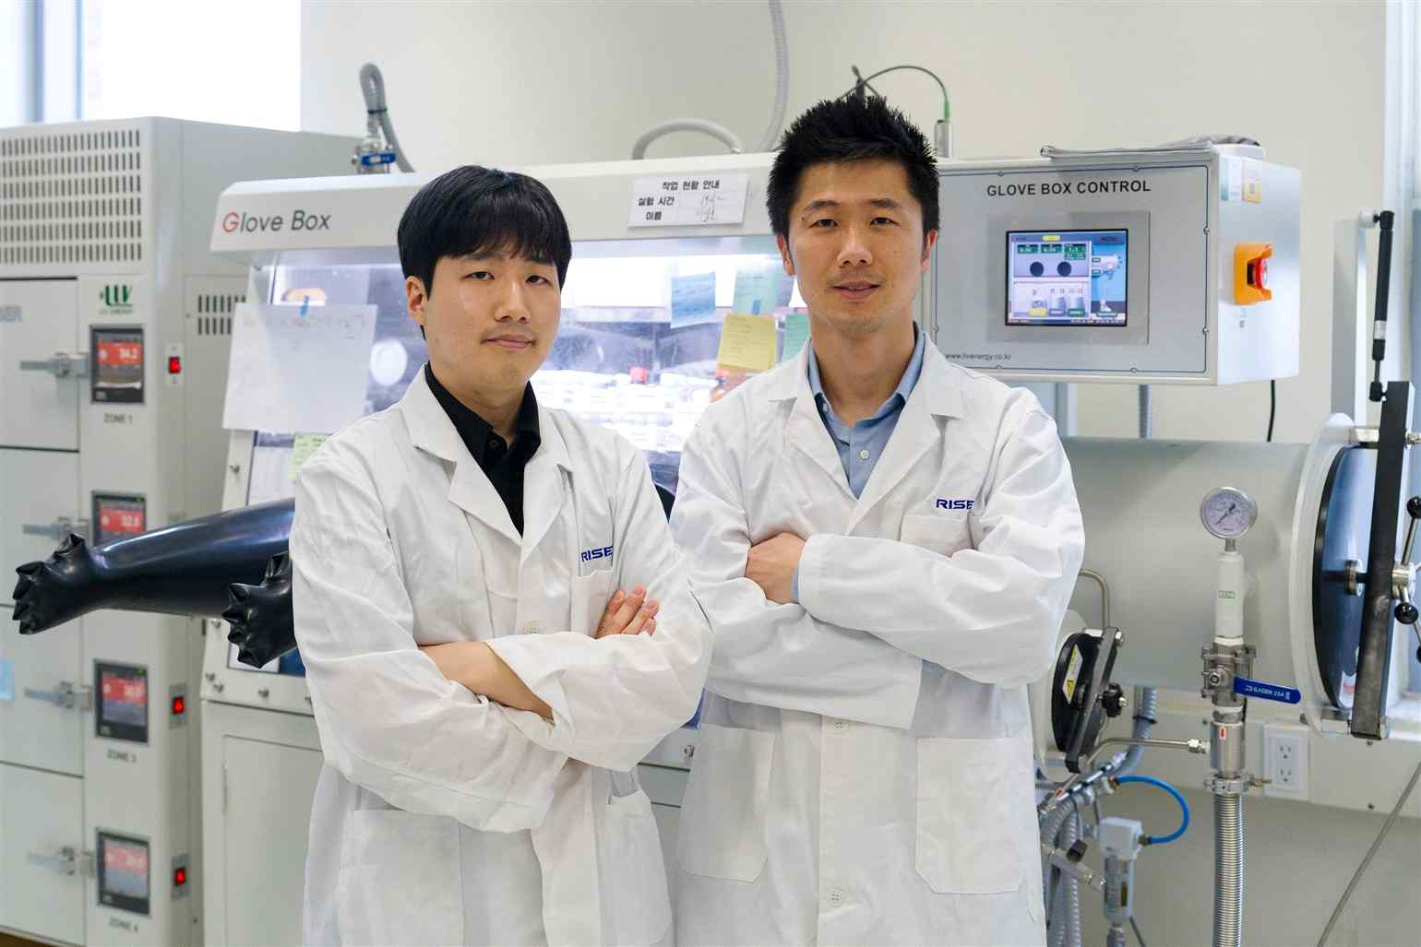

▲ (From right) Professor Sangryun Kim of the Department of Chemistry and master's student Sangho Lee
The Gwangju Institute of Science and Technology (GIST, President Kichul Lim) announced that a research team led by Professor Sangryun Kim of the Department of Chemistry and Dr. Woosuk Cho of the Korea Electronics Technology Institute (KETI), in collaboration with Kyoto University in Japan, has elucidated the principle by which special ions (complex anions*) containing a large amount of hydrogen form a thin layer that stably protects the space between the electrode and the electrolyte inside all-solid-state batteries.
The research team confirmed that these ions effectively suppress unnecessary chemical reactions that cause battery performance degradation while maintaining the smooth movement of lithium ions. Through this, they presented the potential to significantly extend battery life and reduce the risk of overheating and fire.
* Complex anion: A polyatomic ion with a negative charge, consisting of a structure in which multiple molecules or ions are attached to a central atom.
With the recent rapid growth of the electric vehicle market, competition to develop next-generation batteries that allow for longer driving distances on a single charge while lowering the risk of fire is intensifying. In particular, ‘all-solid-state batteries,’ which use solid electrolytes instead of liquids, are attracting attention as a technology capable of simultaneously enhancing safety and energy storage performance.
Among these, the ‘argyrodite structured solid electrolyte*’ is evaluated as a high-performance next-generation material because it allows lithium ions to move rapidly within the battery.
However, existing argyrodite electrolytes had problems such as the growth of ‘dendrites,’ which are tree-branch-shaped crystals, or unstable chemical reactions occurring on the surface due to direct reactions with lithium metal during the charging and discharging process. Consequently, there were limitations where battery performance deteriorated or stability decreased as the current increased.
* argyrodite solid electrolyte: A solid electrolyte that exhibits lithium ion conductivity while possessing the same structure as the ore Ag8 GeS6. This structure exhibits high lithium ion conductivity because well-formed internal pathways allow for the movement of lithium ions.
* dendrite: Crystals that grow like tree branches on the surface of metal electrodes; they reduce battery efficiency and cause short circuits, leading to performance degradation and stability issues.
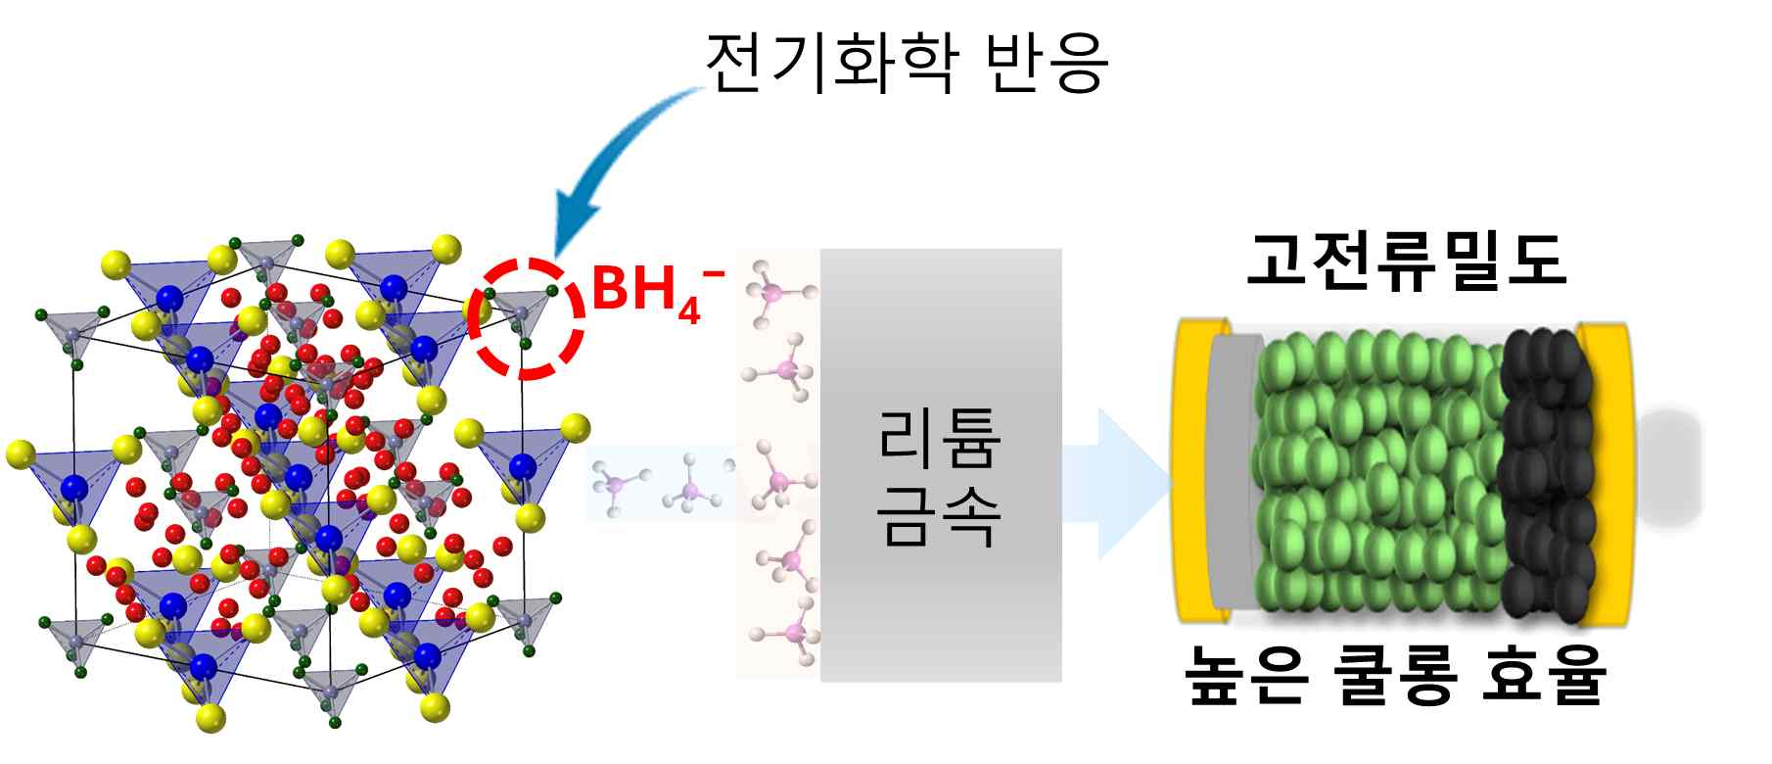

▲ Figure summarizing the research findings. High-hydrogen density complex anions (BH₄⁻) introduced into the azirodite structure preferentially react with lithium metal during electrochemical reactions to form a protective interfacial phase, enabling stable high-current operation.
To address this issue, the research team introduced ‘BH₄⁻,’ a special ion containing a large amount of hydrogen, into the solid electrolyte and precisely analyzed how it reacts with lithium metal inside the battery.
As a result, they confirmed that BH₄⁻ ions react first with lithium metal during the initial stages of charging and discharging to form a thin, stable protective film on the surface.
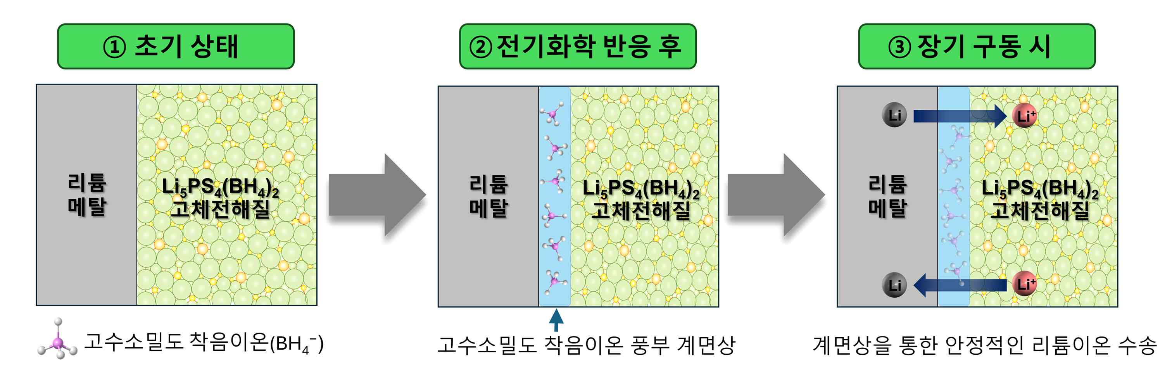

▲ Interfacial phase formed by electrochemical reaction and its effects. High-hydrogen density complex anions (BH₄⁻) react rapidly with lithium during the electrochemical process to form an interfacial phase rich in these complex anions. The resulting interfacial phase suppresses additional side reactions while facilitating the rapid movement of lithium ions, enabling stable operation even under high current density conditions.
This protective layer reduces unnecessary chemical reactions caused by direct contact between the electrolyte and lithium metal, while simultaneously facilitating the smooth movement of lithium ions, thereby ensuring stable battery operation.
Conventional all-solid-state batteries suffered from a problem where irregular reaction products accumulated between the electrode and electrolyte as charging and discharging cycles were repeated, leading to internal structural instability. However, with the introduction of BH₄⁻, it was found that these reactions were controlled more uniformly and stably.
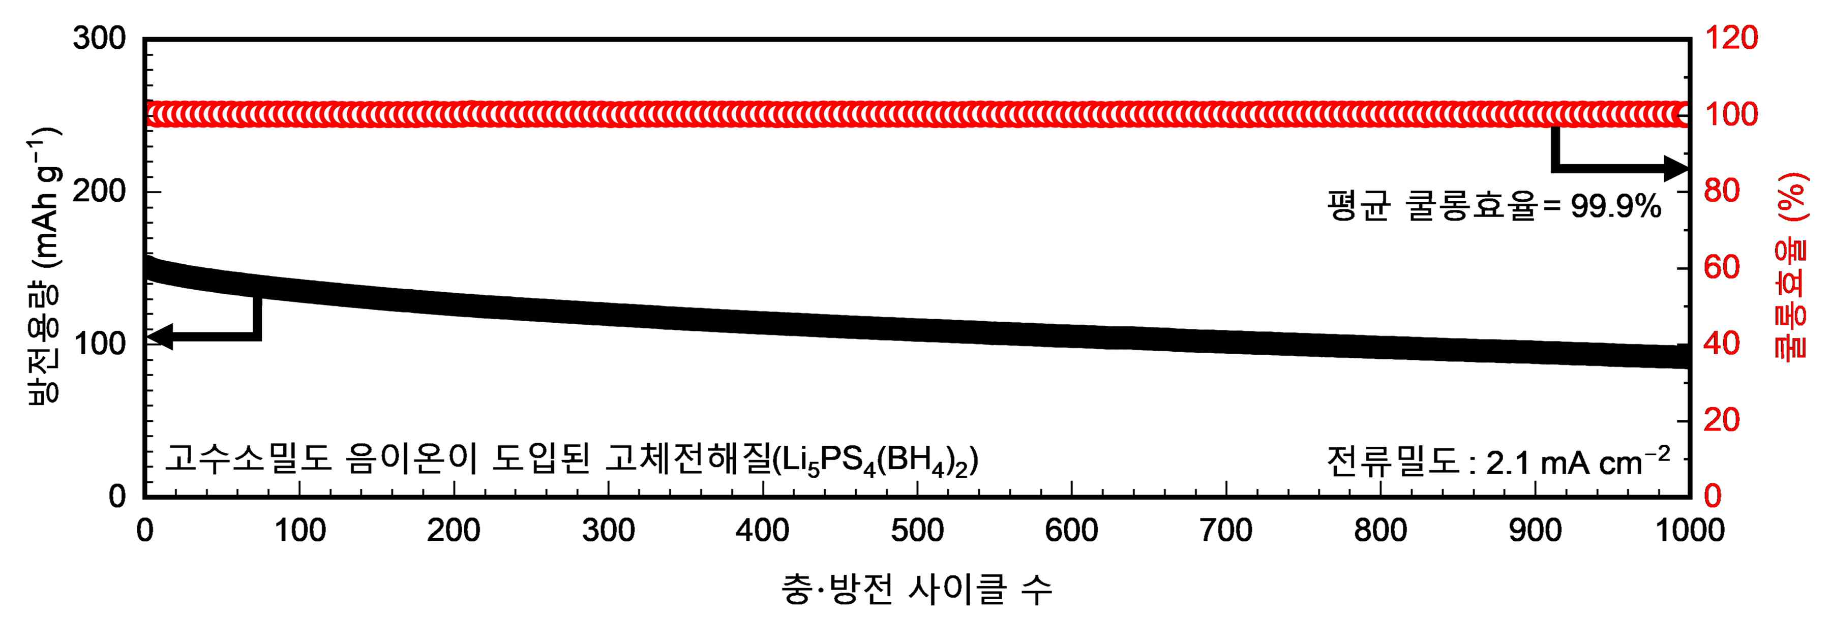

▲ Electrochemical performance of a lithium metal all-solid-state battery. A lithium metal all-solid-state battery utilizing Li_{5PS}4(BH₄)2, a solid electrolyte incorporating high hydrochloric-density complex anions, exhibited Coulomb efficiency approaching 100% and reversible discharge capacity during 1,000 charge-discharge cycles even under high current density conditions. These results demonstrate stable battery operation through the formation of electrochemical interfaces.
The research team utilized X-ray photoelectron spectroscopy (XPS)* and Time-of-Flight secondary ion mass spectrometry (ToF-SIMS)* to precisely analyze how the structure and chemical composition between the electrode and the electrolyte change during the actual charging and discharging process.
The analysis confirmed that while some reaction products are formed initially, BH₄⁻ subsequently reacts stably with lithium metal to create a protective layer structure that allows for the smooth movement of lithium ions. This interface stabilization is expected to contribute to lowering the risk of fire by reducing unnecessary chemical reactions and heat generation within the battery.
In addition, the research team demonstrated that the charge-discharge efficiency (Coulomb efficiency) remained close to 100% even in experiments where 1,000 charge-discharge cycles were repeated under high current conditions, proving that the battery can operate stably for a long period.
* x-ray photoelectron spectroscopy (XPS): An analytical technique that identifies the elemental and chemical bonding states of a material surface by analyzing the emitted electrons after irradiating the surface with X-rays.
* time-of-flight secondary ion mass spectrometry (ToF-SIMS): An analytical technique that identifies the chemical composition and distribution of a surface by irradiating an ion beam onto the surface of a sample and measuring the mass of the emitted secondary ions.
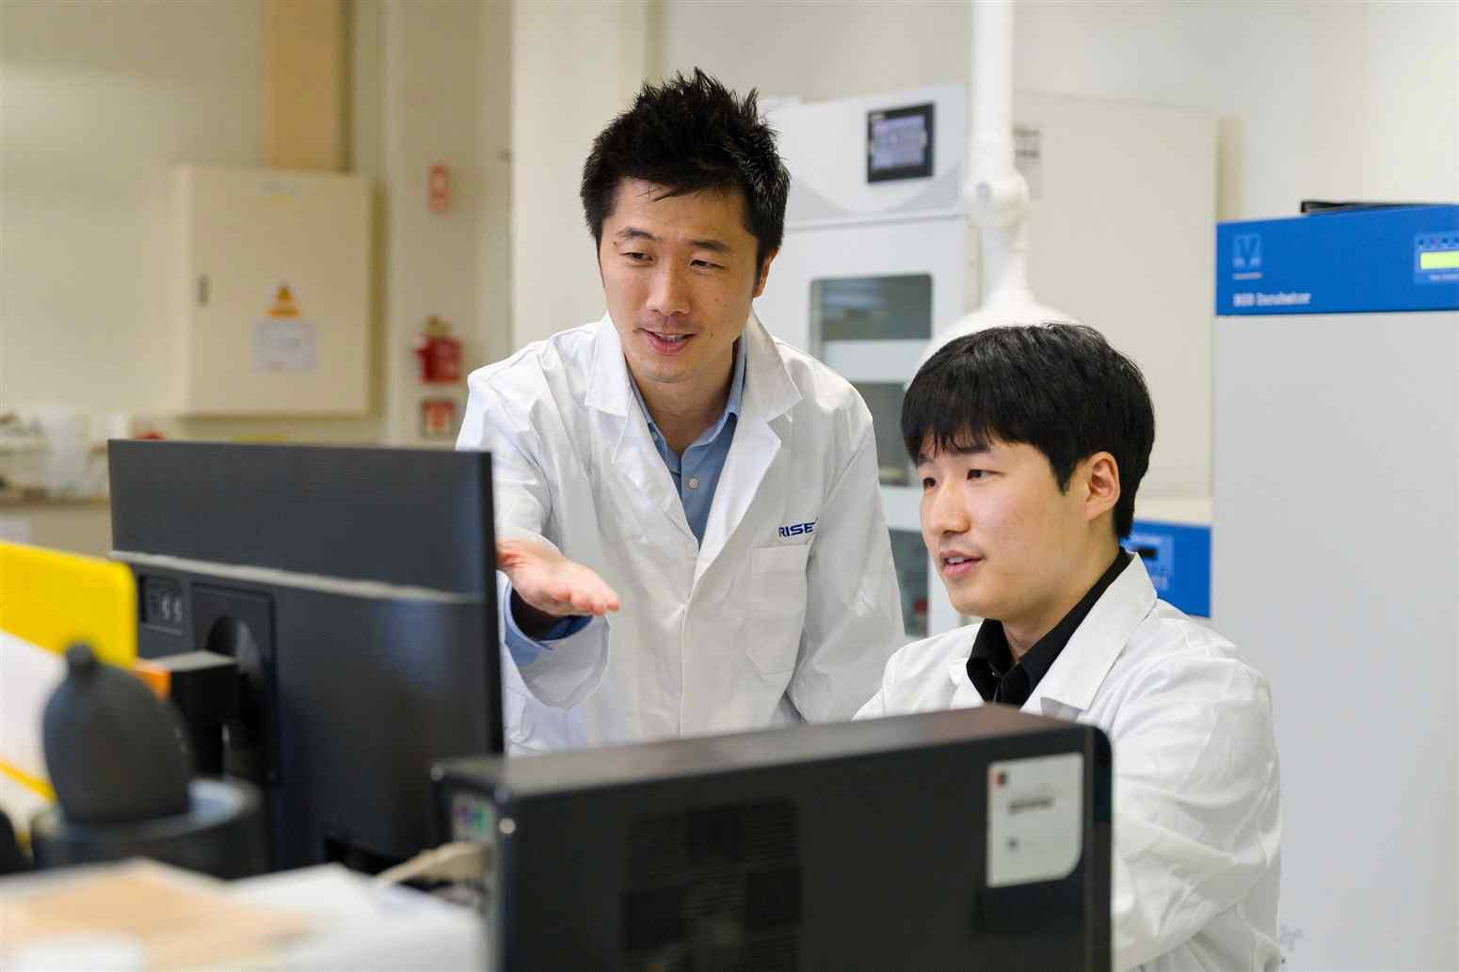

▲ (From left) Professor Sangryun Kim of the Department of Chemistry and master's student Sangho Lee
Professor Sangryun Kim stated, "This research is highly significant in that it elucidated how high-hydrogen density complex anions operate at the electrolyte-cathode interface and presented a new interface design direction capable of reacting stably with lithium metal." He added, "We expect this to be utilized in the future development of various energy electronic devices, including next-generation all-solid-state batteries."
This research, jointly supervised by Professor Sangryun Kim of the Department of Chemistry at GIST and Dr. Woosuk Cho of KETI, with Sangho Lee, a master's student in the Department of Chemistry at GIST, participating as the first author, was supported by the Ministry of Science and ICT and the National Research Foundation of Korea's Individual Basic Research Program; the Ministry of Science and ICT and the Korea Institute of Science and Technology Commercialization's Next-Generation Promising Seed Technology Commercialization Fast Track; the Ministry of Education and Gwangju Metropolitan City's Regional Innovation Center University Support System (RISE) Project; and the Ministry of Trade, Industry and Energy and the Korea Institute for Industrial Technology Promotion's Industrial Technology Innovation Project.
The research results — Electrochemically Induced Interphase by Complex Hydride Anions in Argyrodite Solid Electrolytes for Stable Lithium Metal All-Solid-State Batteries — were published online on May 9 in Advanced Science, an international academic journal in the field of materials science and chemistry.
Meanwhile, GIST stated that this research achievement was considered to have both academic significance and potential for industrial application, and that discussions regarding technology transfer can be conducted through the Technology Commercialization Office (hgmoon@gist.ac.kr).

