“Extracting hydrogen using only sunlight and water without carbon emissions” GIST, Sungkyunkwan University, and Chonnam National University develop high-efficiency solar hydrogen production technology that operates even underwater
- GIST Senior Researcher Chang-Lyoul Lee and a team led by Professors Jaekyum Kim of Sungkyunkwan University and Tae-Hoon Kim of Chonnam National University developed a composite photoelectrode that simultaneously secures stability and charge transfer efficiency by encapsulating water-vulnerable nanomaterials, 'quantum dots,' with ultrathin silica
- Successful 2.2-fold improvement in hydrogen production efficiency and 12 hours of continuous operation... Published in the international journal SusMat


▲ (From left) Chang-Lyoul Lee, Senior Researcher at the Advanced Photonics Research Institute, GIST; Jung Kyu Kim, Associate Professor of Chemical Engineering at Sungkyunkwan University; Tae-Hoon Kim, Professor of Materials Science and Engineering at Chonnam National University; Won Tae Hong, PhD Student in Chemical Engineering at Sungkyunkwan University; and Researcher Yuankai Li.
The Gwangju Institute of Science and Technology (GIST, President Kichul Lim) announced that a joint research team consisting of Senior Researcher Chang-Lyoul Lee of the Advanced Photonics Research Institute (APRI), Professor Jung Kyu Kim of the Department of Chemical Engineering at Sungkyunkwan University, and Professor Tae-Hoon Kim of the Department of Materials Science and Engineering at Chonnam National University has developed a high-efficiency ‘quantum dot composite photoelectrode (PQD@SiO₂ /WO₃)’ that operates stably even underwater.
This technology is expected to serve as a core source technology capable of accelerating the commercialization of ‘solar hydrogen production,’ which produces hydrogen without carbon emissions using only sunlight and water.
To decompose water into hydrogen (H₂) and oxygen (O₂) using sunlight, a ‘photoanode’ is essential; it receives light to generate electricity and induce the water splitting reaction.
Tungsten oxide (WO₃), a representative photoanode material, is stable even underwater but has the limitation of low efficiency in converting light into electric charge.
On the other hand, perovskite quantum dots (CsPbBr₃), a nanomaterial that absorbs light well, have been criticized for their instability, which causes them to decompose easily when exposed to water and light.
To overcome the disadvantages while combining the advantages of these two materials, the research team designed a "core-shell" structure in which light-absorbing nanoparticles called "quantum dots" are encased in a very thin protective layer.
The perovskite quantum dots were wrapped in a silica (SiO₂) protective layer* with a thickness of approximately 0.7 nanometers (nm, hundreds of thousands of times thinner than a human hair) to protect them from water while maintaining their structural and optical properties. This structure was then arranged on a tungsten oxide electrode and utilized as a photoanode.
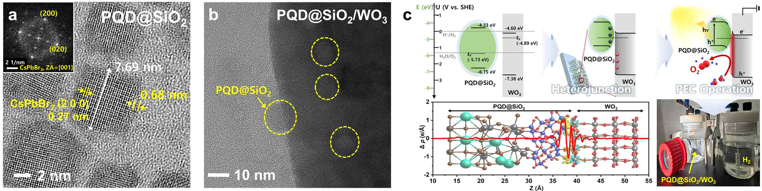

▲ Structure and interfacial characteristics of the heterojunction photoelectrode. (a) High-resolution transmission electron microscope (HR-TEM) image of CsPbBr3 quantum dots encased in a silica (SiO2) protective layer, confirming a protective layer approximately 0.7 nm thick and a lattice spacing of 0.27 nm. (b) High-resolution transmission electron microscope image of a PQD@SiO2/WO3 heterojunction structure in which quantum dots are bonded to a WO3 nanofilm. (c) Illuminating the photocharge separation and hydrogen generation processes under an internal electric field.
This protective layer is thin enough to allow charges to pass through while blocking the penetration of water and electrolytes, thereby ensuring stability without compromising electrical performance.
In other words, a ‘micro-engine (quantum dot)’ that converts light into electricity was fabricated into a core-shell structure encased in an ultra-thin waterproof coating and introduced onto a conventional photoelectrode.
* silica protective layer (SiO₂ shell): A layer that protects the material from external environments, such as moisture and electrolytes, by enveloping the surface of perovskite quantum dots with a very thin, dense protective film. It is thin enough to allow charges to pass through, so it does not hinder photocharge transport while playing a role in stably maintaining the material's structural and optical properties.
In particular, this structure went beyond simple protection and created an effect that strengthens the "internal electric field," which induces electrons to move in one direction due to the energy difference between the quantum dots and tungsten oxide.
In this process, "recombination," where light-generated charges disappear, was reduced, and positive and negative charges rapidly separated in opposite directions.
As a result, the efficiency of the water splitting reaction was significantly improved, raising the possibility of realizing high-efficiency photoelectrodes.
Significant improvements were also confirmed in actual performance evaluations.
The composite electrode developed by the research team generated a current approximately 2.2 times higher (3.08 mA·cm⁻², milliamperes per square centimeter) than conventional tungsten oxide under the same acidic conditions and standard sunlight environment.
In addition, it was confirmed that long-term stability is maintained in an underwater environment, as there was almost no decrease in current even after operating continuously for 12 hours.
It also demonstrated high efficiency in the hydrogen production performance evaluation.
In an experiment to produce hydrogen and oxygen by electrolyzing water, hydrogen and oxygen were generated in amounts of 80.05 and 40.01 (μmol·cm⁻², micromoles per square centimeter) respectively under standard solar conditions (conditions in which the reaction was maintained for 3 hours using 1.23 volts (V), the theoretical minimum voltage required for water splitting).
This implies that most of the generated charge was used in the actual hydrogen and oxygen production reaction, and the Faraday efficiency*, which indicates how efficiently the input electricity was utilized, was recorded at 85.5%.
* Faraday efficiency: An indicator representing the ratio of the target product (hydrogen, oxygen, etc.) actually produced relative to the amount of charge actually input in an electrochemical reaction. A higher value indicates that the current was used effectively for the desired reaction (water splitting), signifying fewer side reactions or charge losses.
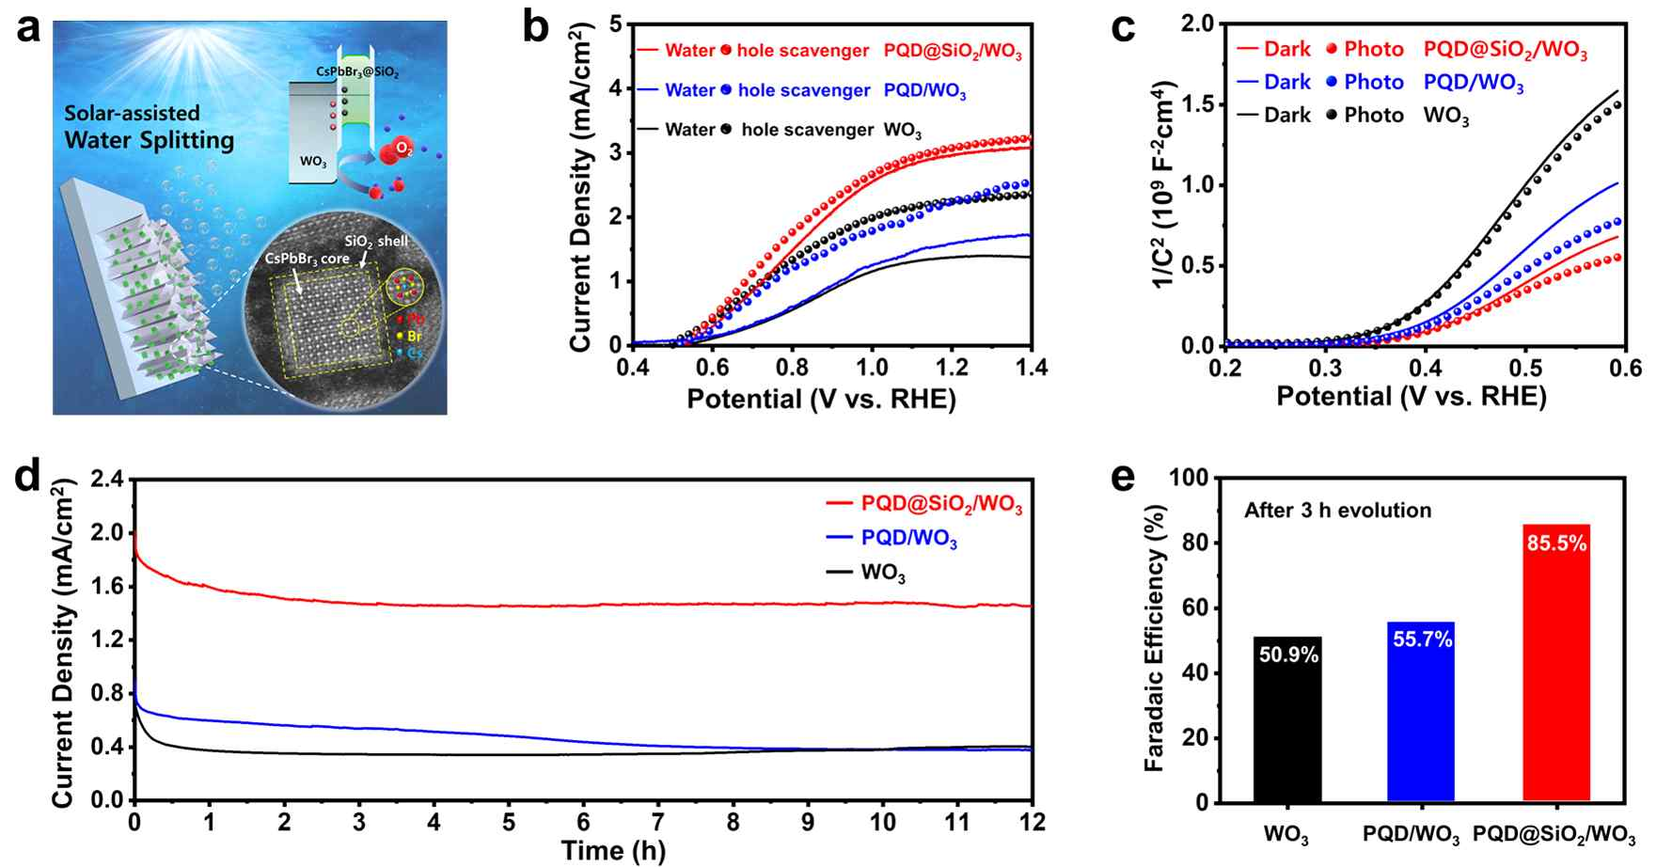

▲ Comparison of photocurrent enhancement and high-efficiency hydrogen production performance. (a) Under solar conditions, PQD@SiO_{2/WO}3 demonstrated a photocurrent density approximately 2.2 times higher than that of conventional WO₃, indicating a more efficient charge generation capability. (b) Electrochemical analysis revealed that increased charge density and internal electric field led to more active charge transport. (c) In the evaluation of long-term stability and hydrogen production efficiency, PQD@SiO_{2/WO}3 recorded high stability and a Faraday efficiency of 85.5%.
This study is a case of applying perovskite quantum dots, which have previously been difficult to utilize due to their instability in water, to an actual photoelectrochemical water splitting system. It revealed that the quantum dots do not directly participate in the reaction but rather act as a ‘promoter’ that assists in light absorption and charge transport.
In particular, the study confirmed structural improvements achieved by utilizing quantum dots to enhance the electric field on the surface of tungsten oxide, thereby facilitating charge transfer upon light irradiation and activating the oxygen generation reaction.
Through this, a new design strategy was presented for realizing high-efficiency, low-cost solar hydrogen production systems.
Chang-Lyoul Lee, Senior Researcher at the Advanced Photonics Research Institute, stated, “This research is the first instance of applying perovskite quantum dots—which were previously difficult to utilize due to their instability in underwater environments—to actual water-splitting photoelectrodes, simultaneously improving charge transfer and interfacial structure.” He added, “Through the design of quantum dot-based photoelectrodes, we have presented a new direction for the development of high-performance solar hydrogen production materials.”
Professor Jung Kyu Kim of Sungkyunkwan University remarked, “This study improved the stability of perovskite quantum dots, which were previously unstable underwater, and enhanced the efficiency of transition metal oxide-based photoanodes, thereby expanding the scope of quantum dot utilization from existing solar cells and light-emitting devices to energy conversion fields such as hydrogen production.”
Professor Tae-Hoon Kim of Chonnam National University stated, “This achievement demonstrates that it is possible to simultaneously secure the underwater stability and photoelectrochemical performance of perovskite quantum dots by precisely controlling the interface structure of nanomaterials, and it will serve as an important foundation for the structural design of various energy conversion materials in the future.”
This research, supervised by Senior Researcher Chang-Lyoul Lee of the GIST Institute of Advanced Photonics, Professor Jung Kyu Kim of the Department of Chemical Engineering at Sungkyunkwan University, and Professor Tae-Hoon Kim of the Department of Materials Science and Engineering at Chonnam National University, and conducted by doctoral student Won Tae Hong and researcher Yuankai Li of the Department of Chemical Engineering at Sungkyunkwan University as first authors, was supported by the Ministry of Science and ICT, the National Research Foundation of Korea (NRF) Mid-Career Researcher Support Program, the Supercomputing Center, the GIST Future Geometry Specialization Research Project, and the Korea Electric Power Corporation (KEPCO) Open R&D Program.
The research results — All-Inorganic Perovskite@SiO₂ Quantum Dots for Amplifying the Interfacial Electric Field on WO₃ Toward Enhanced Photoelectrochemical Water Splitting — were published online on April 5, 2026, in SusMat, a prominent international journal in the field of sustainable materials. Meanwhile, GIST stated that this research achievement takes into account both its academic significance and potential for industrial application, and that discussions regarding technology transfer can be conducted through the Technology Commercialization Center (hgmoon@gist.ac.kr).

